Multiple Choice Questions

- Decide which of the choices best completes the statement or answers the question.
- Locate that question number on the separate answer sheet provided.
- Use the procedure described by your teacher to answer each question. For example, “fill in the circle that corresponds to your choice” or “make an X over the letter corresponding to your choice.”

1. Identify the type of neuron that carries impulses toward the central nervous system (CNS).
a. sensory neuron
b. motor neuron
c. interneuron
d. parasympathetic neuron

2. Which part of the brain is primarily responsible for controlling balance, posture, and coordination?
a. pons
b. medulla oblongata
c. cerebral cortex
d. cerebellum

3. Which row below identifies the first and last elements in a reflex arc?
Row | First Element | Last Element
a. | axon | dendrite
b. | sensory receptor | muscle (effector)
c. | brain | gland (effector)
d. | motor neuron | sensory neuron

4. Which of the following statements is INCORRECT?
a. The central nervous system integrates and processes information sent by nerves.
b. The autonomic system controls glandular secretions and the functioning of smooth and cardiac muscles.
c. The somatic system consists of sensory receptors, nerves that carry sensory information to the CNS.
d. The peripheral nervous system consists of the brain and the spinal cord.

5. The transmission of the nerve impulse across a synapse is accomplished by the release of a neurotransmitter
a. from the cell body of the pre-synaptic neuron to the Schwann cell of the post synaptic neuron.
b. from the Schwann cell of the pre-synaptic neuron to the cell body of the post synaptic neuron.
c. from the dendrite of the pre-synaptic neuron to the axon of the post synaptic neuron.
d. from the axon of the pre-synaptic neuron to the dendrite of the post synaptic neuron.

6. The two divisions of the autonomic nervous system are called the
a. central nervous system (CNS) and the peripheral nervous system (PNS).
b. somatic nervous system and the skeletal nervous system.
c. sympathetic nervous system and the parasympathetic nervous system.
d. myelinated nervous system and the unmyelinated nervous system.

Use the following diagram to answer the next two questions.
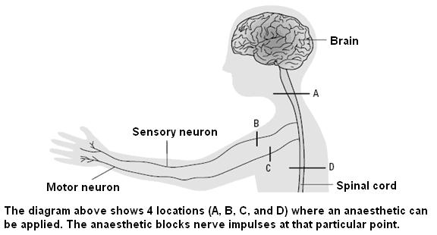

7. Which statement below is INCORRECT?
a. A patient with a blockage at location B would be able to move her hand but would not be able to perceive the pain from a paper cut on her thumb.
b. A patient with a blockage at location C would be able to perceive the pain from a paper cut on her thumb but would not be able to move her hand.
c. A patient with a blockage at location A would be able to perceive the pain from the paper cut and be able to move her hand.
d. A patient with a blockage at location D would be able to perceive the pain from the paper cut and be able to move her hand.

Use the additional information to answer the next question.
Paraplegia and Quadriplegia

Paraplegia is the paralysis of the lower extremities and part or all of the trunk muscles. Usually there is a loss of sensation in paralyzed limbs and other effects such as muscle spasms, pain, and loss of bowel and bladder control. Paraplegia occurs when there is an impairment at or below the T1 Thoracic level. Quadriplegia occurs when there is damage to the spinal cord in the cervical region. This will cause impairment to the hands and arms in addition to the effects of paraplegia.

8. A person with paraplegia would have had damage in the area labelled _____ in the diagram on page 2.
a. A
b. B
c. C
d. D

9. The spinal cord communicates with the brain via
a. tracts of white matter.
b. tracts of grey matter.
c. the sympathetic nervous system.
d. sensory neurons in the spinal cord.

10. Which of the following is NOT one of the structures or mechanisms designed to protect the human brain?
a. the cerebrospinal fluid that circulates through the brain and spinal cord
b. the medulla oblongata that is found in the hindbrain area
c. the meninges that surround and enclose the brain
d. the blood-brain barrier that prevents some materials from passing from the blood into the brain

11. Which of these statements correctly describes the distribution of ions on the inside and outside of a neuron with a resting membrane potential of – 70 mV?
a. more positive ions outside and more negative ions inside
b. more negative ions outside and more positive ions inside
c. equal numbers of positive and negative ions both inside and outside
d. chloride ions (Cl–) outside and Na⁺ and K⁺ inside

12. When an action potential begins, sodium gates open, allowing Na⁺ ions to cross the membrane. Now the polarity of the membrane changes to
a. neutral outside and positive inside.
b. positive outside and negative inside.
c. negative outside and positive inside.
d. there is no difference in charge between outside and inside.

Use the following information to answer the next two questions.
Opiate Drugs

The human body naturally produces its own opiate-like substances and uses them as neurotransmitters. These substances include endorphins, enkephalins, and dynorphin, often collectively known as endogenous opioids. Endogenous opioids modulate our reactions to painful stimuli. They also regulate vital functions such as hunger and thirst and are involved in mood control, immune response, and other processes.

The reason that opiates such as heroin and morphine affect animals so powerfully is that these exogenous substances bind to the same receptors as our endogenous opioids. There are three kinds of receptors widely distributed throughout the brain: mu, delta, and kappa receptors.

These receptors, through second messengers, influence the likelihood that ion channels will open, which in certain cases reduces the excitability of neurons. This reduced excitability is the likely source of the euphoric effect of opiates and appears to be mediated by the mu and delta receptors.

This euphoric effect also appears to involve another mechanism in which the GABA (gamma-aminobutyric acid) -inhibitory interneurons of the ventral tegmental area come into play. By attaching to their mu receptors, exogenous opioids reduce the amount of GABA released. Normally, GABA reduces the amount of dopamine released in the nucleus accumbens in the brain. By inhibiting this inhibitor, the opiates ultimately increase the amount of dopamine produced and the amount of pleasure felt.
Source: The Brain from Top to Bottom
http://www.thebrain.mcgill.ca/flash/i/i_03/i_03_m/i_03_m_par/i_03_m_par_heroine.html#drogues

13. The two receptors thought to be involved in the euphoric effects of opiate drugs are
a. mu and delta.
b. exogenous and endogenous.
c. dopamine and GABA.
d. endorphins and enkephalins.

14. Which of the following naturally occurring substances regulate hunger and thirst?
a. mu, delta, and kappa receptors
b. exogenous opioids
c. endogenous opioids
d. dopamine

Use the following diagram to answer the next question.
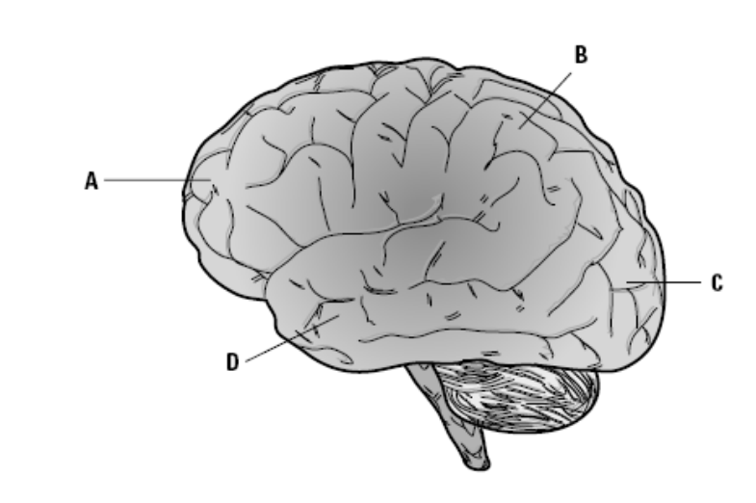

15. Which of the following rows INCORRECTLY identifies a lobe of the brain and its primary function?

Row | Lobe of the brain | Function
a. | parietal lobe | primary sensory area
b. | frontal lobe | primary motor area
c. | occipital lobe | primary taste area
d. | temporal lobe | auditory and speech

16. Identify the area of the brain that is responsible for maintaining homeostasis by regulating processes such as hunger, thirst, body temperature, and water balance.
a. thalamus
b. cerebellum
c. pons
d. hypothalamus

17. Which of the following is responsible for carrying impulses from the external sensory receptors to the CNS as well as carrying motor commands to the skeletal muscles?
a. parasympathetic system
b. somatic system
c. sympathetic system
d. central nervous system

Use the following diagram to answer the next question.
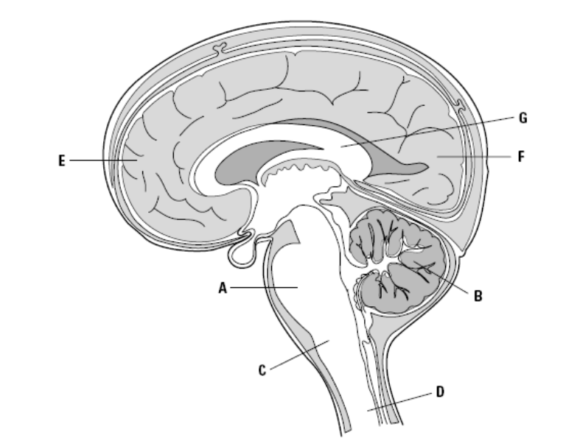

18. Identify the two areas of the brain that work together to coordinate the movement of skeletal muscles.
a. E and B
b. A and F
c. G and D
d. E and F

19. Which of the following rows correctly identifies functions of the lobes of the cerebral cortex?

Row | Temporal Lobes | Occipital Lobes | Frontal Lobes
a. | associated with vision | associated with taste | associated with speech
b. | associated with vision | associated with hearing and understanding speech | associated with voluntary movement and use of language
c. | associated with hearing and understanding speech | associated with vision | associated with voluntary movement and use of language
d. | associated with voluntary movement and use of language | associated with vision | associated with hearing and understanding speech

Use the following information to answer the next question.
Selective Serotonin Re-uptake Inhibitors (SSRIs)

The complexity of the brain has always formed a barrier to the treatment of disorders of the mind. An understanding of the brain’s neurotransmitters allows scientists an opportunity to treat a number of neurological problems. Selective serotonin re-uptake inhibitors (SSRIs) are a newer class of antidepressant medications. The first drug in this class was fluoxetine (Prozac™).

Certain neurotransmitters are associated with depression, including the neurotransmitter serotonin (ser-oh-TOE-nin). Drugs have been developed to stimulate or inhibit specific neurotransmitters. For example, Prozac™, an antidepressant, enhances the action of the neurotransmitter serotonin. Some research suggests that abnormalities in neurotransmitter activity affect mood and behaviour. SSRIs seem to relieve symptoms of depression by blocking the reabsorption (re-uptake) of serotonin by certain nerve cells in the brain. This leaves more serotonin available in the brain. As a result, this enhances neurotransmission—the sending of nerve impulses—and improves mood. SSRIs are called “selective” because they seem to affect only serotonin, not other neurotransmitters such as GABA. GABA is a neurotransmitter that acts as a natural “nerve-calming” agent. It helps keep the nerve activity in the brain in balance, and is involved in inducing sleepiness, reducing anxiety, and relaxing muscles.
Source: http://www.mayoclinic.com/health/ssris/MH00066

20. Depression has been linked to a neurotransmitter imbalance. Based on the information above, this disorder is most likely linked to
a. low levels of GABA.
b. high levels of GABA.
c. low levels of serotonin.
d. high levels of serotonin.

21. The vagus nerve regulates the function of many internal organs, including the heart, lungs, bronchi, digestive tract, liver, and pancreas. This nerve most likely belongs to the
a. sympathetic nervous system.
b. parasympathetic nervous system.
c. central nervous system.
d. somatosensory nervous system.

22. The part of the brain that connects the right and left cerebral hemispheres of the brain is called the
a. medulla oblongata.
b. thalamus.
c. temporal lobes.
d. corpus callosum.

23. Which of the following technologies or procedures would not be particularly useful when studying the brain?
a. positron-emission tomography (PET) scan
b. magnetic resonance imaging (MRI) scan
c. probing areas of the brain while the person remains conscious
d. X-ray technology

Use the following information to answer the next two questions.
Avoiding a Collision

You are driving down a highway at night when a deer jumps in front of your vehicle. You slam on the brakes and avoid a collision.

24. Which row below best describes the initial reaction of your autonomic nervous system to this situation?

Row | System Involved | Neurotransmitter | Response
a. | sympathetic nervous system | norepinephrine | heart rate increases;  pupils of eyes dilate
b. | parasympathetic nervous system | acetylcholine | heart rate increases;  pupils of eyes dilate
c. | sympathetic nervous system | acetylcholine | heart rate decreases;  pupils of eyes constrict
d. | parasympathetic nervous system | norepinephrine | heart rate decreases;  pupils of eyes constrict

25. Which row below best describes the reaction of your autonomic nervous system several minutes after the incident?

Row | System Involved | Neurotransmitter | Response
a. | sympathetic nervous system | norepinephrine | heart rate increases;  pupils of eyes dilate
b. | parasympathetic nervous system | norepinephrine | heart rate increases;  pupils of eyes dilate
c. | sympathetic nervous system | acetylcholine | heart rate decreases;  pupils of eyes constrict
d. | parasympathetic nervous system | acetylcholine | heart rate decreases;  pupils of eyes constrict

Numerical Response Questions

- Record your answer on the answer sheet provided.
- If an answer is a value between 0 and 1 (e.g., 0.25), then be sure to record the 0 before the decimal place.

Use the following information to answer the next question.
Some actions in the somatic system are due to reflexes, or automatic responses to a stimulus. A reflex occurs quickly, without your having to think about it. For example, if you touch a hot stove with your finger, you pull your hand away without thinking about it. Other actions are voluntary; and these always originate in the cerebral cortex—for example, when we decide to move a limb.

The following describes (in no particular order) the structures involved in the nervous system response when you touch your finger to a hot stove.

1. axon of motor nerve
2. sensory receptor in the skin
3. cell body of motor neuron
4. interneuron
5. axon of sensory neuron
6. skeletal muscles

1. The steps in the reflex described above are not in the correct order. The order in which the first four events listed above would occur in a reflex arc is _____, _____, _____, and _____. Record your four-digit answer in the numerical response section on the answer sheet.

Use the following information to answer the next question.
Transmission across a synapse is dependent on the release of neurotransmitters. At least 25 different neurotransmitters have been identified, but two very well-known ones are acetylcholine (ACh) and norepinephrine.

The following describes (in no particular order) the steps involved in transmission across a synapse:
1. acetylcholine molecules are released into the synaptic cleft
2. cholinesterase breaks down acetylcholine
3. nerve impulse reaches axon bulb
4. excitatory impulse is generated in postsynaptic neuron
5. gated channels for calcium (Ca²⁺) ions open
6. acetylcholine molecules bind to postsynaptic membrane
7. rise of [Ca²⁺ ion] stimulates synaptic vesicles to fuse to the presynaptic membrane
8. acetylcholine diffuses across the synapse to postsynaptic neuron

2. The steps in the transmission of a neurotransmitter across a synapse shown above are not in the correct order. The correct order for the last four events in this sequence is _____, _____, _____, and _____ . Record your four-digit answer in the numerical-response section on the answer sheet.

Use the following diagram to answer the next question.

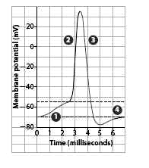
Transmission of an impulse along the axon of a myelinated neuron

- Match the events in the transmission of an action potential to the specific region on the graph. Record your four-digit response in the numerical-response section on the answer sheet.

 | ____________ | ____________ | ____________ | ____________
Region on graph: | depolarization | resting potential | hyperpolarization | repolarization

Written Response Questions

Use the following information to answer the next question.
Parkinson’s Disease

Parkinson’s disease is characterized by a gradual loss of motor control, beginning between the ages of 50 and 60. Eventually the person has a wide-eyed, unblinking expression, involuntary tremors of the fingers and thumbs, muscular rigidity, and a shuffling gait. Speaking and performing ordinary daily tasks become a physical challenge.

In people who have Parkinson’s disease, the basal nuclei (see below for a description of the basal nuclei) are over-active because of a degeneration of the dopamine-releasing neurons in the brain. Without dopamine, which is an inhibitory neurotransmitter, the basal nuclei send out excess excitatory signals that result in the symptoms of Parkinson’s disease.
(continued on next page)

Unfortunately, it is not possible to give Parkinson patients dopamine because of the impermeability of the capillaries serving the brain. However, the symptoms can be alleviated by giving patients L-dopa, a chemical that can be changed to dopamine in the body until too few cells are left to do the job. Then patients must turn to a number of controversial surgical procedures. Implantation of dopamine-secreting tissue from various sources has been tried with mixed results.

Basal Nuclei
While the bulk of the cerebrum is composed of white matter, there are masses of grey matter located deep within the white matter. The basal nuclei integrate motor commands, ensuring that proper muscle groups are activated or inhibited.
Source: Inquiry into Life, 10th edition. Sylvia Mader

1. a) Identify the neurotransmitter that is most affected by Parkinson’s disease. (1 mark)

b) Describe the role of dopamine in the brain. (2 marks)

c) Explain why researchers believe that Parkinson’s disease is linked to malfunctioning basal nuclei. (2 marks)

d) Explain why people who have Parkinson’s cannot be treated with dopamine. (2 marks)

Use the following additional information to answer the next part of the question.
Stem cells differ from other kinds of cells in the body. All stem cells—regardless of their source—have three general properties: they are capable of dividing and renewing themselves for long periods; they are unspecialized; and they can give rise to specialized cell types. Embryonic stem cells, as their name suggests, are derived from embryos. Specifically, embryonic stem cells are derived from embryos that develop from eggs that have been fertilized in vitro—in an in vitro fertilization clinic—and then donated for research purposes with informed consent of the donors. They are not derived from eggs fertilized in a woman’s body.

Regarding human stem cell therapy, scientists are developing a number of strategies for producing dopamine neurons from human stem cells in the laboratory for transplantation into humans with Parkinson’s disease. The successful generation of an unlimited supply of dopamine neurons could make neurotransplantation widely available for people who have Parkinson’s at some point in the future.

e) Describe two societal or technological obstacles that researchers have to overcome in their quest to find a cure for Parkinson’s disease. (2 marks)

