Module 1: Lesson 2

Cerebral Cortex

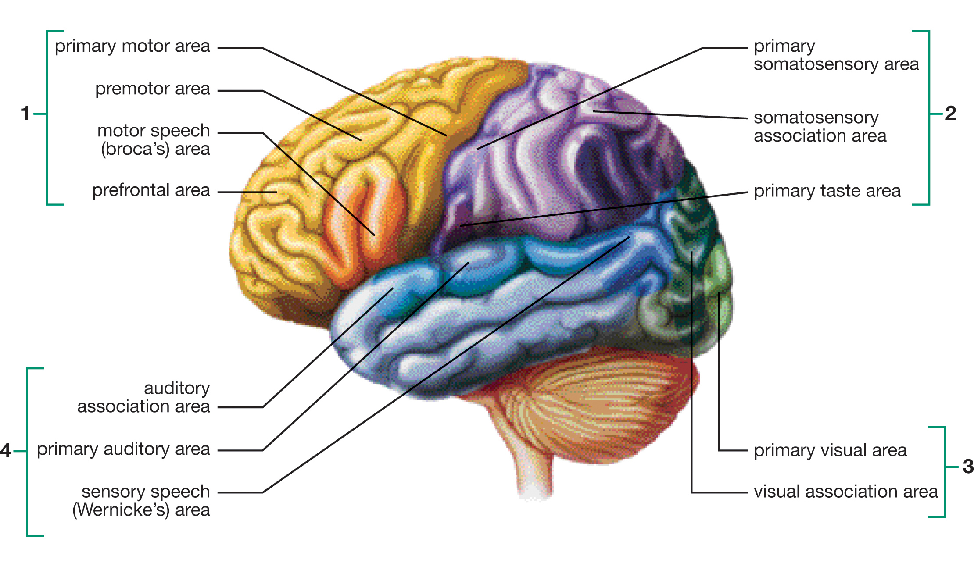
Inquiry into Biology (Whitby, ON: McGraw-Hill Ryerson, 2007), 390, fig 11.29. Reproduced by permission.

1

2

3

4

