
School Contact Teacher Contact
www.eips.nextstep.ca Cindy ONeill
ShPk 780-464-1899 cindy.oneill@eips.ca
FtSk 780-992-0101 780-410-2937

Physical Education 10
Next Step Senior High

Student Name________________ Date Submitted___________

Log Book ______ (yes/no) 50/50 (Must be complete to pass)

Number of Hours Logged _______hrs
5 strands? _____ (yes/no) or Option 4R_____(yes/no)

Assignment 1_____/10 Journal Entry
Assignment 2_____/13 Fitness and Nutrition Plan
Assignment 3_____/10 Disease Prevention
Assignment 4_____/7 CPR Awareness
Assignment 5_____/10 The Secrets of Sugar

Final Mark = Log 50/50 +Assignments _____/50 = _____/100

___ (3 credit) ___ (5 credit)

Students are required to check in and meet with their instructor weekly.

It is recommended that multiple check ins occur each week to ensure successful completion of course work.

Students not adhering to the weekly check in schedule may be removed from the course.

Course Overview

Physical education is a requirement in Alberta. PE is geared toward participation. Although skills and techniques are still taught in order to avoid injury and increase performance, they are secondary to the goal of making students comfortable in, and aware of, the benefits of a healthy lifestyle.

As a Next Step Senior High student, you have a great deal of freedom in choosing the types of activity you will participate in, and you will be responsible for your own technical learning.

We hope that you will explore new activities and, also, the techniques that will make you a more effective, as well as safer performer. To that end, please consult page 5 of this handbook, where you will find “Consideration for Safe Physical Activity”, as well as a guide to activities considered high risk or excluded from EIPS Physical Education classes.

The Curriculum

Divided into 4 broad outcomes:

  - Activity
Focus is on basic skills and the application of basic skills.

  - Health Benefits
Focus in on functional fitness, body image and general well-being.

  - Cooperation
Focus is on communication, fair play, leadership and teamwork objectives, normally related to team play and/or group activities.

  - “Do it Daily… for Life”
Focus in on effort, regular activity, safety goal setting and active living in the community.

For further details on the curriculum and helpful tools, please visit the Physical Education website:

https://education.alberta.ca/physical-education/program-of-studies/

This website contains a link which includes student self-assessment tools, safety guidelines and other suggestions. It will also take you step by step through the different dimensions (strands), explaining skills and activities which fall into each one. This is an excellent resource for the independent student.

Course Requirements

- Logbook
In general, activities are grouped into strands:
Dance
Folk Dance
Modern Dance
Jazz Dance
Social and Ballroom Dance
Square Dance
Hip Hop

Individual Activities
Aerobic Training
Calisthenics
Circuit Training
First Aid
Fitness
Posture
Weight Training
Games
Basketball
Broomball
Curling
Field Hockey
Floor Hockey
Flag Football
Ice Hockey
Lacrosse
Netball
Ringette
Rugby
Soccer
Softball
Team Handball
Volleyball

Badminton
Handball
Racquetball
Squash
Table Tennis
Tennis
Gymnastics
Artistic Gymnastics
Dual Balance
Education Gymnastics
Modern Rhythmic Gymnastics
Pyramid Building
Rope Climbing
Tumbling
Outdoor Pursuits
Backpacking/ Hiking
Camping
Canoeing
Cycling
Nordic skiing (cross-country)
Orienteering
Sailing
Snowshoeing
Wilderness living
Aquatics
Swimming
Diving
Aquafit

Students are to log a minimum of 5 hours in 5 different strands, with no more than 30 hours coming from any one strand. You need to log a total of 50 hours for (3) credits and 110 hours for (5) credits. Each activity is to be logged. Team sports, lesson, gym visits and Wii Fit are examples of ways to log hours.

4R Option

For various reasons, some students may not be able to complete 5 hours in five strands. The 4R option allows you to complete your hours in four different strands and substitute the fifth strand with an in-depth report on an activity that falls within that strand.
(See page 21 for more information).

Manually fill out the attached log sheets. The following procedures should be used in logging hours manually:

- At the end of your activity, find the right page in your logbook
- Log the precise date, the nature of the activity, and time you spent at that activity
- Have a witness in a supervisory role sign beside the activity and include their phone number. This person can be a parent, coach or the desk person at the gym, but they must be willing to confirm your participation if called.

SAMPLE

Name: _____________________________________

Strand: Outdoor Pursuits

Date | Activity Description | Time Spent | Signature | Phone #
Oct 2 | Hiking in river valley | 45 min

Considerations for Safe Physical Activity

Warm-up before and cool down after participating in physical activity. Even a light walk is a good warm-up. Stretch during cool downs, that is after your activity.
Be realistic. A two-hour workout in the weight room every day for a month is neither believable, nor safe. Over-training leads to exhaustion and injury.
Play safe. Wear the protective equipment that should be used for cycling, inline skating, skating, hockey or broomball. Check your activity area for hazards. Is the road slippery? Is your equipment in good order? It’s not a good idea to go jogging at night or in lonely alleys.
Drink water or sports drinks before prolonged physical activity. As a general rule, drink 2 cups 2 hours before exercise, another 20 minutes before exercise and continue to sip during.
Use caution in multi-use areas and carry proper equipment for safety.
Get technical instruction. Do not participate in dangerous activities without sufficient experience or an experienced coach/ guide.
Let your parents or guardians know what you will be doing.

List of Activities Excluded or Considered HIGH RISK by EIPS

Excluded Activities DO NOT log excluded activities for this course

Aviation
Small aircraft, helicopter and hot air balloon rides/ Skydiving/Parasailing
Automobiles
Car Racing/ Drag Racing/ Motocross/ Motorcycle racing/ Snowmobile Rallies/ Off Road All-Terrain Vehicles/ Boat races/ Go-karting/ Demolition Derbies
Bungee Jumping Boxing
Mechanical Bulls Mountain Climbing
Ice Climbing/ Deep Caving Rodeo Activities
Rock Climbing /Repelling Mountain Biking/ Downhill Mountain Biking
Horseback riding/Trail riding/Jumping Lake swimming and scuba diving
“Running of the bulls” events Skateboarding /Skateboarding parks
Tobogganing/ snow sledding/ Water skiing
crazy carpets/saucers/tubes Trampolines
Snow surfing Paintball/War Games

High Risk Activities (Proceed with CAUTION!!!)
- Archery
- Firearms course/ rifle range
- Downhill Skiing
- Gymnastics
- Hunter training
- Mountain biking
- Roller blading/ in-line skating
- Ziplining
- Wrestling
- Ropes courses (high and low)
- Sailing
- Scuba Diving
- Wall Climbing
- Water Skiing
- Whitewater Rafting
- Winter Orienteering/Campouts
- Martial Arts
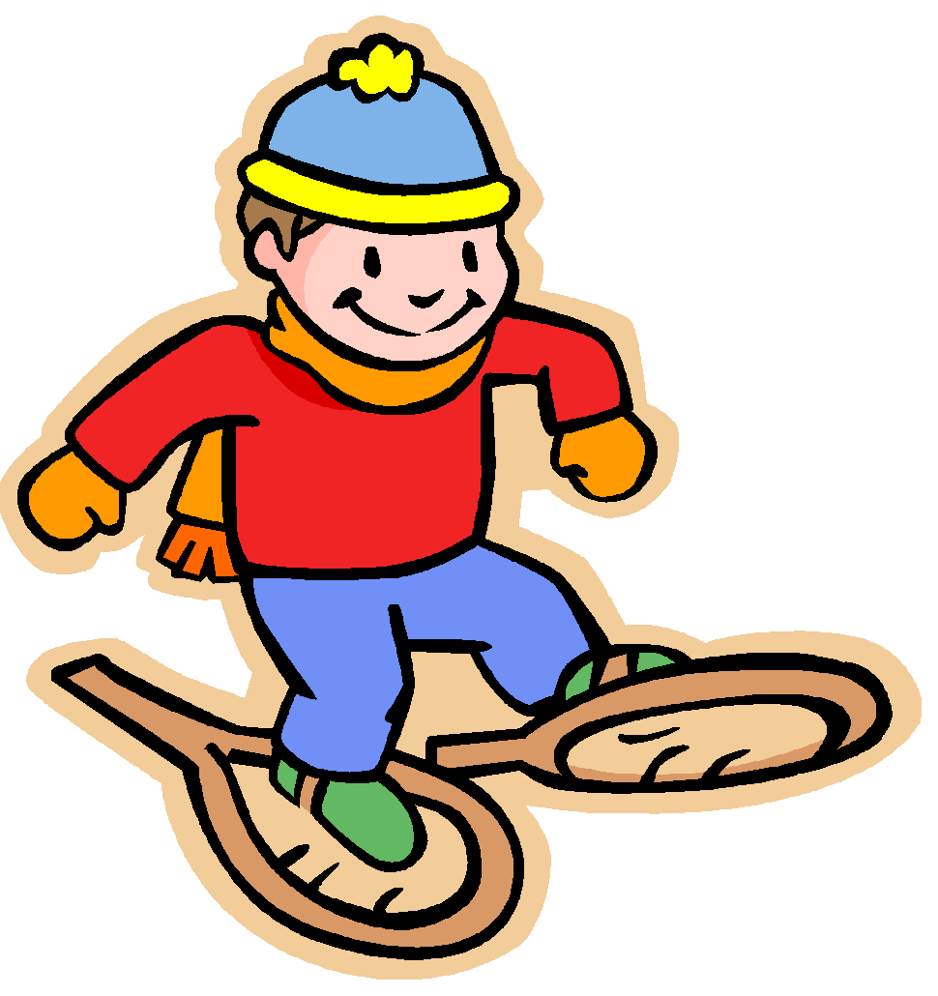
Physical Education Log

Name: _____________________________________

Strand: Outdoor Pursuits
Alpine skiing (downhill)
Backpacking/ Hiking
Camping
Canoeing
Cycling
Nordic skiing (cross-country)
Orienteering
Sailing
Snowshoeing
Wilderness living

Date | Activity Description | Time Spent | Signature | Phone #

Total Hours: _____

Physical Education Log

Name: _____________________________________

Strand: Individual Activities
Aerobic Training
Calisthenics
Circuit Training
First Aid
Fitness
Posture
Weight Training

Date | Activity Description | Time Spent | Signature | Phone #

Total Hours: ______


Physical Education Log

Name: _____________________________________

Strand: A Games (team games)
Basketball
Broomball
Curling
Field Hockey
Floor Hockey
Flag Football
Ice Hockey
Lacrosse
Netball
Ringette
Rugby
Soccer
Softball
Team Handball
Volleyball

Date | Activity Description | Time Spent | Signature | Phone #

Total Hours: ______


Physical Education Log

Name: _____________________________________

Strand: B Games (individual games)
Badminton
Handball
Racquetball
Squash
Table Tennis
Tennis

Date | Activity Description | Time Spent | Signature | Phone #

Total Hours: ______

Physical Education Log
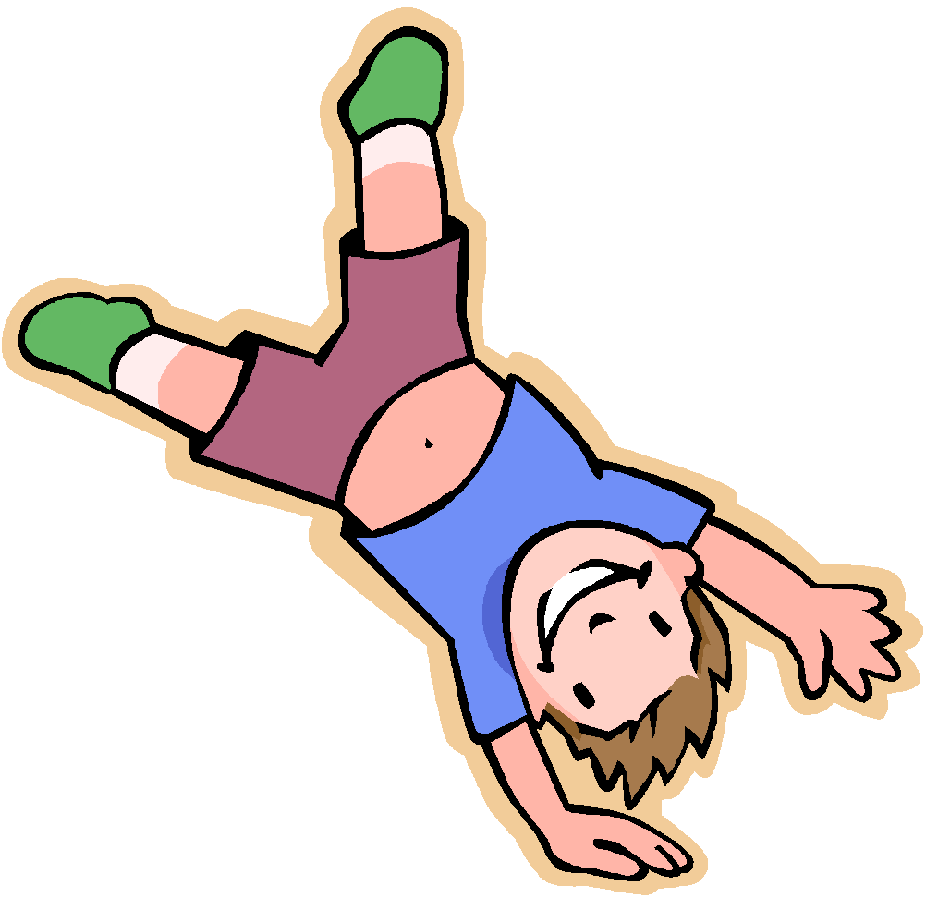
Name: _____________________________________

Strand: Gymnastics
Artistic Gymnastics
Dual Balance
Education Gymnastics
Modern Rhythmic
Gymnastics
Pyramid Building
Rope Climbing Tumbling

Date | Activity Description | Time Spent | Signature | Phone #

Total Hours: ______

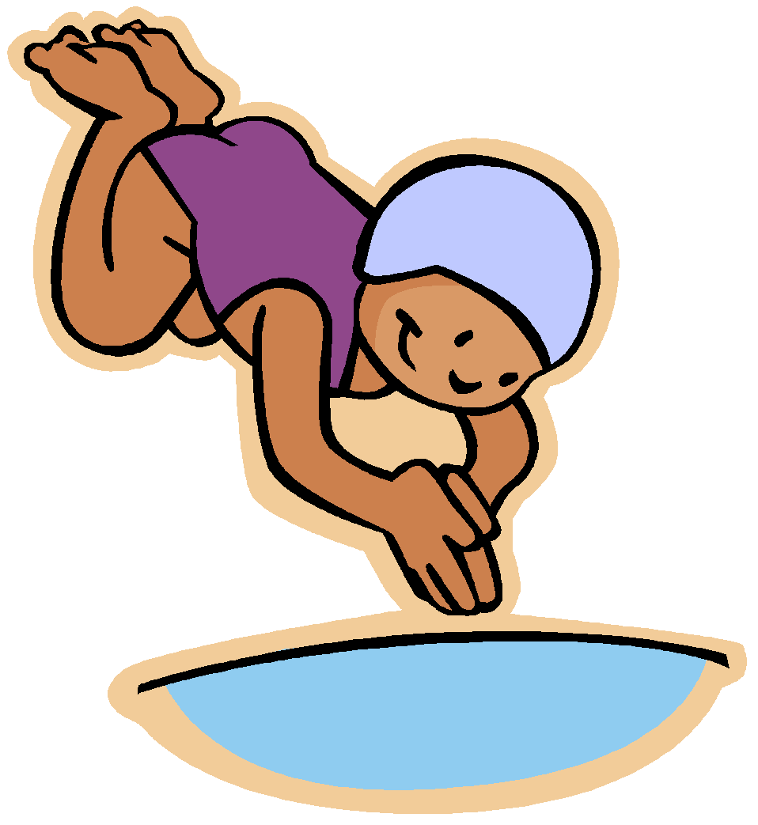
Physical Education Log

Name: _____________________________________

Strand: Aquatics
Swimming

Diving

Snorkeling

Date | Activity Description | Time Spent | Signature | Phone #

Total Hours: ______


Physical Education Log

Name: _____________________________________

Strand: Dance
Folk Dance
Modern Dance

Jazz Dance
Social and Ballroom

Dance
Square Dance

Date | Activity Description | Time Spent | Signature | Phone #

Total Hours: ______

Assignments

You must complete the following assignments.

- Journal Entry /10

The four outcomes of PE10 are grouped into the following 4 categories:

- Activity which refers to basic skills and the application of basic skills

- Health benefits including functional fitness, body image and general well-being

- Cooperation that is communication, fair play, leadership and teamwork objectives, normally related to team play and/or group activities;

- “Do it Daily…. for Life” or focusing on effort, safety goal setting and active living in the community.

In a journal entry, write about your experiences, perceptions and feelings about physical education and activity. Address the following:

What are your beliefs, thoughts and feelings about physical activity and how do you feel about undertaking this course?

What do you feel is the relationship between skill development, performance and enjoyment of physical activity?

Have you noticed any health benefits from your physical activity? Have you experienced the opposite- discomfort, pain or injury?

How important are communication and fair play in physical activity in general? If you participated in team activities, draw on that experience.

What challenges have you encountered, or will you encounter in scheduling physical activity? What factors impact your efforts? Do you foresee yourself continuing with scheduled activity after you’re done with the course?

________________________________________________________________________________________________________________________________________________________________________________________________________________________________________________________________________________________________________________________________________________________________________________________________________________________________________________________________________________________________________________________________________________________________________________________________________________________________________________________________________________________________________________________________________________________________________________________________________________________________________________________________________________________________________________________________________________________________________________________________________________________________________________________________________________________________________________________________________________________________________________________________________________________________________________________________________________________________________________________________________________________________________________________________________________________________________________________________________________________________________________________________________________________________________________________________________________________________________________________________________________________________________________________________________________________________________________________________________________________________________________________________________________________________________________________________________________________________________________________________________________________________________________________________________________________________________________________________________________________________________________________________________________________________________________________________________________________________________________________________________________________________________________________________________________________________________________________________________________________________________________________________________________________________________________________________________________________________________________________________________________________________________________________________________________________________________________________________________________________________________________________________________________________________________________________________________________________________________________________________________________________________________________________________________________________________________________________________________________________________________________________________________________________________________________________________________________________________________________________________________________________________________________________________________________________________________________________________________________________________________________________________________________________________________________________________________________________________________________________________________________________________________________________________________________________________________________________________________________________________________________________________________________________________________________________________________________________________________________________________________________________________________________________________________________________________________________________
________________________________________________________________________________________________________________________________________________________________________________________________________________________________________________________________________________________________________________________________________________________________________________________________________________________________________________________________________________________________________________________________________________________________________________________________________________________________________________________________________________________________________________________________________________

- Fitness and Nutrition Plan /13 marks
Create a monthly fitness plan that will meet the above goals and address the outcomes of PE 10, as well as allow you to log hours in the different strands. Your plan should consider all components of fitness: strength (anaerobic movements), flexibility and endurance (aerobic or cardio-fitness). You may wish to use monthly calendar pages to create your plan. You can access free printable blank calendar pages at www.printablecalendar.ca. Attach a completed one-month calendar fitness plan to this course module book. (5 marks)

Create a nutritional plan which complements your fitness plan and is based on the Canada Food Guide. Please access the Canada Food Guide at the following website:

http://www.hc-sc.gc.ca/fn-an/food-guide-aliment/index-eng.php

Use the interactive site and read through the following tabs:

Canada’s food guide
Food guide snapshot
The kitchen
Tips for healthy eating
Resources

After reading through the above material, create a healthy 7-day meal plan based on the Canada Food Guide. Be specific about what is for breakfast, lunch, dinner, snacks between meals, beverages, condiments. Include what is in a salad or sandwich or dishes with multiple ingredients. (5 marks)

I am happy with the following aspects of my physical fitness: (1)
________________________________________________________________________________________________________________________________________________________________________________________________________________________________________________________________________________________________

The aspects of my physical fitness that I might like to improve are: (be specific: flexibility, strength, weight loss?) (1)
________________________________________________________________________________________________________________________________________________________________________________________________________________________________________________________________________________________________

Rate your current level of physical fitness activity using the FITT Principle below. What are some things you will need to do to meet the goals of the FITT principle and improve your fitness? (1)
________________________________________________________________________________________________________________________________________________________________________________________________________________________________________________________________________________________________

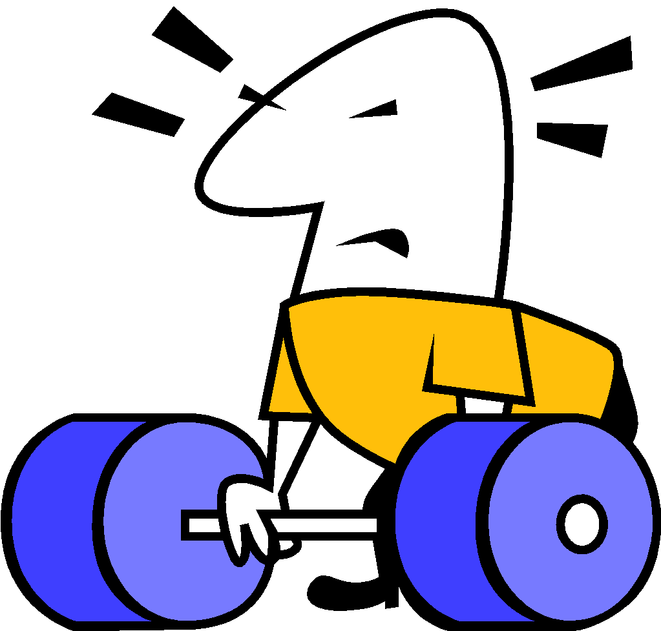
FITT Principle

The FITT Principle (or formula) is a great way of monitoring your exercise program. The acronym FITT outlines the key components of an effective exercise program, and the initials F, I, T, T, stand for:
F = Frequency which refers to how often you exercise
I = Intensity which refers to how hard you exercise
T = Time which refers to how long you exercise for
T = Type which refers to the kind of exercise you undertake

- Disease Prevention /10 marks

Write a report/create a poster/make a PowerPoint on a disease related to general health issues. The report/poster/PowerPoint must include a general description of the causes, symptoms, and effects of the disease, as well as a section on how regular exercise may help with prevention or minimizing symptoms. Below is a list of potential topics:
- Osteoporosis
- Emphysema
- Heart disease
- Asthma
- Obesity
- Diabetes

The report must include the title page and must quote at least one source of information in bibliographic form (usually author, title, publisher and year of publishing). A written report should be between one and two pages long, not including the title page or bibliography sheet. A poster should be on at least 11x17 paper. Your PowerPoint should be a minimum of 10 slides and include a bibliography slide. Please print out a copy of your PowerPoint and attach it to this Course Module book. You may also submit an electronic version via email to your administrator or attach a flash drive to your finished course module book.

/1 Title Page
/1Bibliography
/8 Content (Accurate, informative, includes all required information)

- CPR Awareness /7 marks

Visit the Heart and Stroke Foundation Canada website. Watch the following video:

How to Perform CPR video

Canadian Instruction (3yrs old)
Modern Version CPR 2023

Answer the following questions using the following CPR 2020 Guidelines
(Pages 19-20) following these questions.

- What does C-A-B mean? ____________________________________________________________________________________________________________________________________

- What makes for high-quality chest compressions? ______________________________________________________________________________________________________________________________________________________________________________________________________

- Does the new C-A-B sequence apply to all ages? ____________________________________________________________________________________________________________________________________

- What the differing recommendation is for trained versus untrained rescuers? ________________________________________________________________________________________________________________________________________________________________________________________________________________________________________________________________________

- What is the purpose of chest compressions? ________________________________________________________________________________________________________________________________________________________________________________________________________________________________________________________________________

- What is the recommended pace or rate of chest compressions? ____________________________________________________________________________________________________________________________________

- Where can you get CPR training in your community? You will have to Google search CPR and your community’s name.
____________________________________________________________________________________________________________________________________
____________________________________________________________________________________________________________________________________

2020 Guidelines for CPR

Q: Where can I find the new guidelines?
The new 2020 Guidelines for CPR and ECC can be found at

https://cpr.heartandstroke.ca/s/article/2020-Guidelines?language=en_US

Q: What are the most significant changes in the 2020 Guidelines for CPR & ECC?
The most significant update to the guidelines

Early Initiation of CPR by Lay Rescuers – We recommend that laypersons initiate CPR for presumed cardiac arrest because the risk of harm to the patient is low if
the patient is not in cardiac arrest.

Q: Why did the CPR sequence change from A-B-C to C-A-B?
There are many reasons for this change. First, this change allows rescuers to begin chest compressions right away. As we know, most victims of sudden cardiac arrest (SCA) receive no bystander CPR. One of the reasons for this may be that the A-B-C CPR sequence began with opening the airway, the most difficult and daunting task for the rescuer. This change attempts to decrease the barriers to performing CPR by allowing the rescuer to start with chest compressions. Also, the vast majority of SCAs occur in adults who suffer a witnessed arrest and ventricular fibrillation (VF) or pulseless ventricular tachycardia (VT). In these victims, critical elements of resuscitation are chest compressions and early defibrillation, which can begin earlier if there is no delay to open the airway and provide breaths.
The process of opening the airway (which may involve getting a barrier device or setting up ventilation equipment) takes time and delays the start of CPR. Using the C-A-B sequence lessens this delay.

Q: Why do they recommend early initiation of chest compressions?
New evidence shows that the risk of harm to a victim who received chest compressions when not in cardiac arrest is low. Lay rescuers are not able to determine with accuracy whether a victim has a pulse, and the risk of withholding CPR from a pulseless victim exceeds the harm from unneeded chest compressions.

Q: Does the new CPR sequence apply to all ages?
No. This update only applies to adults. For infants and children with a pulse but absent or inadequate respiratory effort, it is reasonable to give 1 breath every 2 to 3 seconds (20-30 breaths/min)

Q. What are the specific recommendations regarding chest compressions for untrained versus trained rescuers?
There was no recommendation provided for trained versus untrained rescuers. It is recommended that laypersons initiate CPR for presumed cardiac arrest because the risk of harm to the patient is low if the patient is not in cardiac arrest.

The rescuer should continue CPR until EMS arrives and assumes care.

Research now tells us that compression only CPR is easier for a bystander to perform and that survival rates are similar with either compression only CPR or CPR with both compressions and breaths.
Therefore, the new recommendations are:

If a bystander is not trained in CPR, he/she should provide compression only CPR for an adult who suddenly collapses, or follow the directions of the emergency medical system (EMS) dispatcher

In all cases, the rescuer should continue CPR until EMS arrives and assumes care.

4R Assignment

4R Assignment (see page 4)
Only complete this assignment if you have not been able to log activity in at least 5 strands. This option allows you to log activity in 4 strands and to complete this written report on a strand that you did not log hours for. /10

Write a report on an activity that you did not participate in for the course. Your report should include the main objective of the activity, configurations (number of players, playing surface) rules, safety guidelines, risks, etc... The report does not have to be on a game. It could, and should, be about an activity you would like to do but couldn’t for the course, like white water rafting, rock climbing, fly fishing, etc… You should also include information on where this activity can be completed, associated costs, equipment needed etc… Research and include information about an athlete in your chosen activity.

The report must include a title page, and must quote at least one source of information in bibliographic form (usually author, title, publisher and year of publishing)

- PE 10 Assignment /10

The Secrets of Sugar - The Fifth Estate

https://www.youtube.com/watch?v=K3ksKkCOgTw
We’ve heard for years about the dangers of eating too much fat or salt. But there have never been recommended limits for sugar on Canadian food labels, despite emerging research that suggests the sweet stuff may be making more of us fat and sick. In the fifth estate’s season premiere, Gillian Findlay digs into the surprising science — and the reaction from the food industry — to reveal The Secrets of Sugar. Has the sugar industry been hiding an unsavory truth from consumers?
A small but influential group of medical researchers is stirring up the health debate, linking sugar not just to rising obesity rates but also to a host of diseases including cancer, heart disease and Alzheimer’s.
We put a family of four on a healthy diet to try to beat their sugar habit and track the surprising results. We talk to leading scientists – and their critics. And we ask the food industry why those ingredient labels are far from clear when it comes to how much sugar is really on your plate.

Watch this episode and then answer the following questions:

- How much sugar (on average) do we consume in Canada on a daily basis?

2. How many people in North America (estimated) are diabetic or pre-diabetic?

3. What is the cause of diabetes worldwide?

4. What happens to the cancer cells in cancers that correlate with obesity and diabetes?

5. What is the belief now regarding Alzheimer’s and diabetes?

6. Name 2 of the ways that sugar is hidden within the items we consume?

7. What is the ‘Bliss Point?”

- What does the American Heart Association now recommend as a daily average
for sugar intake?

