SPORT & PERFORMANCE PSYCHOLOGY TEXTBOOK CHAPTER
Winning the First Victory
Confidence, Envisioning, and Pre-Performance Control
How performers build certainty, protect it, and express it under pressure
CONFIDENCE MODEL  Understand how certainty is built through evidence, interpretation, and self-regulation. | ROUTINE BRIDGE  Use the C-B-A sequence to move from preparation into automatic execution. | MENTAL REHEARSAL  Design vivid, controlled imagery that prepares both performance and recovery.

Designed as a textbook-style chapter for study, teaching, and practical review.
The first victory is won in the mind before the event begins.

Inside This Chapter
Confidence and envisioning are not soft extras that sit beside real training. They are part of the performance system itself. This chapter explains how performers build the 'first victory' before pressure arrives: they create certainty through evidence, protect it from needless withdrawals, and mentally rehearse both success and recovery so the body can perform with less interference.
Learning objectives
• Define confidence in performance terms and distinguish it from arrogance, mood, and empty positivity.
• Differentiate state confidence, trait confidence, self-efficacy, and robust sport confidence.
• Explain how deposits, withdrawals, and the mental filter shape the confidence account.
• Apply protective tools such as constructive attitude lockdown, the flat tire drill, and the "So What?" review.
• Use the C-B-A routine to bridge preparation and live execution under pressure.
• Design imagery that is vivid, controlled, emotional, and matched to the timing of the actual task.
Chapter roadmap  • What confidence is and why it supports automatic execution  • State confidence, trait confidence, self-efficacy, and robust sport confidence  • The confidence account: deposits, withdrawals, and mental filtering  • Protective thinking, arousal reappraisal, and resilience under setbacks  • The C-B-A pre-performance routine  • Envisioning as multisensory mental rehearsal  • Perspective, controllability, emotion, and real-time timing in imagery  • The Mental Director's Toolkit, multiple-choice review, answer key, and glossary | 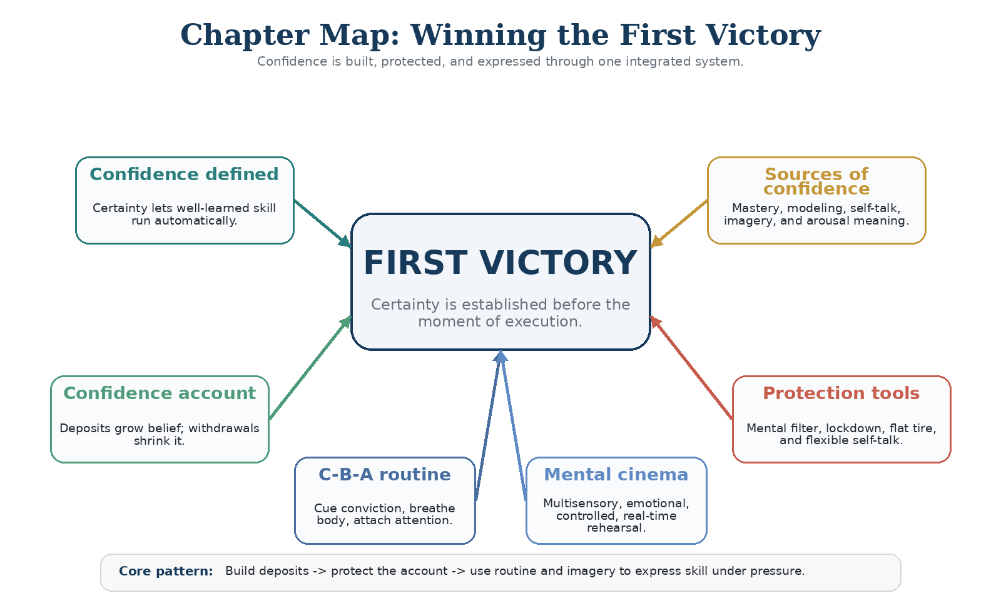

Figure 1. The chapter is built around one system: build certainty, protect it, then express it under pressure.
Study focus
Notice the repeated pattern running through the chapter: evidence builds certainty, interpretation protects it, and routine plus imagery allow that certainty to show up in the live moment.

1. Foundations of Confidence

Confidence is often described vaguely as believing in yourself, but that description is too soft to be useful in performance settings. For performers, confidence is a working sense of certainty about ability that reduces unnecessary conscious interference. When a skill is well learned, execution is best when the performer can perceive, decide, and respond without micromanaging every movement or word. The more pressure rises, the more valuable that certainty becomes.
This is why confidence should not be confused with showmanship, noise, or bravado. A performer can sound certain and still perform tentatively. Likewise, a calm and modest performer may compete with deep conviction. The meaningful question is functional: does confidence free attention and movement, or does doubt pull the performer back into judgment, hesitation, and overcontrol?
Confidence and competence must also be kept distinct. Competence supplies the actual skill base. Confidence determines whether that skill is expressed under pressure. Without competence, confidence becomes fantasy. Without confidence, competence becomes trapped potential. The 'first victory' is won when the performer enters the arena already certain enough to let preparation show up.
Construct | Definition | Why it matters
State confidence | The performer’s momentary belief right now. | Varies with context, recent events, and immediate interpretation.
Trait confidence | A more stable tendency to feel assured across situations. | Influences how often a person enters performance situations expecting success.
Self-efficacy | Task-specific judgment of capability for a particular challenge. | Can be strong in one domain and weak in another; it is highly trainable.
Robust sport confidence | A durable network of positive beliefs that resists environmental and psychological challenge. | Built over time through evidence, self-regulation, and supportive climate.

Table 1. Related confidence constructs describe different levels of stability and specificity.
Common mistake
Treating confidence as a single personality trait leads performers to wait for a feeling instead of building a process. Confidence is situation-specific and trainable.

2. Where Confidence Comes From

Several related constructs help clarify how confidence works. State confidence refers to how certain a performer feels in the moment. Trait confidence refers to a more stable tendency to feel assured across situations. Self-efficacy narrows the lens even further: it is the belief that one can execute a specific task successfully. Robust sport confidence describes a broader, more durable network of positive beliefs that helps a performer withstand challenge, evaluation, and environmental stress.
Bandura’s self-efficacy framework explains why confidence is trainable rather than fixed. The strongest source is mastery experience - past evidence that the performer has actually done the thing or has built the ingredients for doing it. But mastery is not the only source. Modeling, persuasive coaching, imagery, preparation, and the meaning assigned to bodily arousal all shape a performer’s belief about what is possible right now.
Source | Practical deposit | Performance effect
Mastery experiences | Review successful reps, competition highlights, and solved problems. | Most dependable source because it provides direct evidence of capability.
Vicarious experiences | Observe similar others succeeding; study model performances. | Expands belief about what is possible and how it can be done.
Verbal persuasion | Use constructive coaching language and present-tense self-talk. | Works best when specific, credible, and linked to preparation.
Imaginal experiences | Rehearse success, decision sequences, and recovery responses in imagery. | Makes future execution feel more familiar before it occurs.
Physiological and emotional states | Interpret butterflies, racing heart, and activation as readiness. | Meaning matters: the same arousal can be read as threat or fuel.
Preparation and self-regulation | Use routines, plans, and repeated quality practice. | Creates the sense that the performer has earned the right to feel certain.

Table 2. Confidence grows through repeated sources of evidence rather than through a single pep talk.
A constructive self-fulfilling prophecy develops when the performer expects capability and therefore perceives options, persists longer, and makes cleaner task-relevant decisions. A destructive prophecy does the opposite: it narrows attention toward threat, increases hesitation, and makes the performer search for signs that failure is coming.
3. The Confidence Account: Deposits, Withdrawals, and the Mental Filter

A useful way to organize confidence is to treat it like a mental bank account. Every memory, self-statement, and interpretation functions like a transaction. Deposits include remembered success, honest evidence of effort, noticed progress, quality preparation, and vivid mental rehearsal. Withdrawals occur when performers replay criticism, globalize mistakes, or treat temporary setbacks as proof that they are not ready.
The account is managed by a mental filter. This filter decides what gets mentally retained and what gets released or reframed. Strong filters do not deny reality; they keep useful evidence available and convert setbacks into learning. Weak filters allow every bad moment to become a referendum on identity. That is why two performers can live through the same event and leave it with completely different confidence balances.
Daily practices help create reliable deposits. A 'Top Ten' list reminds the performer of meaningful past accomplishments. A daily E-S-P log captures one example of effort, success, and progress so that the account grows even on ordinary days. An after-action review turns experience into usable equity by asking: What happened? So what did it mean? Now what will I do next?
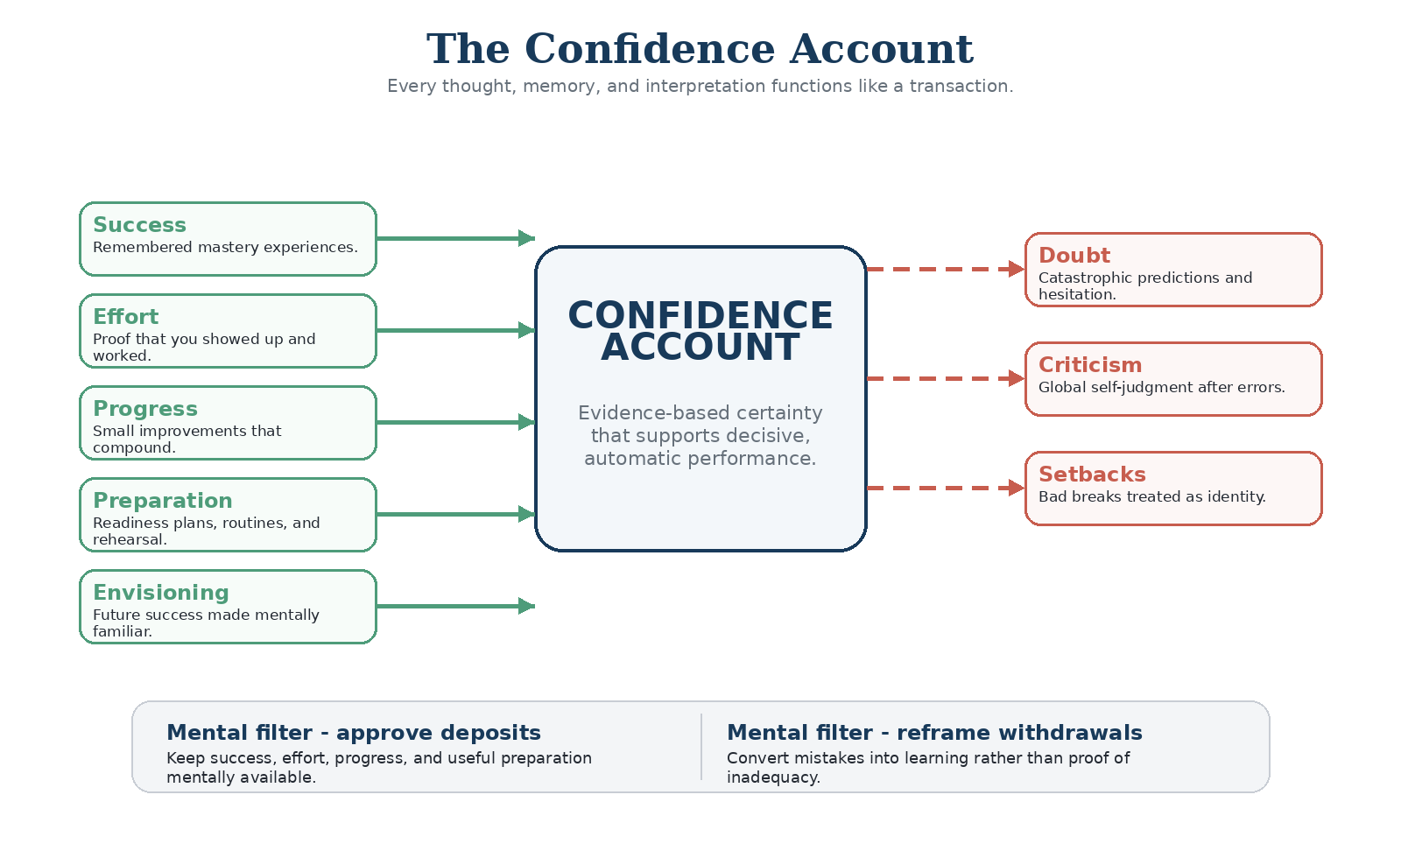
Figure 2. Confidence behaves like an account balance: deposits strengthen usable certainty; withdrawals deplete it.
Top Ten list  Keep a written list of your most meaningful performances, solved problems, or breakthroughs. | Daily E-S-P  Record one example of effort, success, and progress so ordinary days still produce deposits. | What? So what? Now what?  Use objective review to turn each performance into learning and the next plan.
Practice box. Three simple habits that create regular deposits in the confidence account.
4. Protecting Confidence Under Pressure

Confidence becomes fragile when errors are interpreted as global truths. One miss turns into 'I am off today.' One awkward start becomes 'I am not built for this level.' Protective thinking exists to stop that chain reaction. Its job is containment. A mistake should be treated as temporary - it happened once. It should be treated as limited - it belongs to this moment or this subskill, not the whole performance. And it should be treated as nonrepresentative - it is data, not identity.
The same principle explains why performers benefit from rehearsing adversity instead of only rehearsing perfection. The flat tire drill asks the performer to imagine a likely disruption for a brief period, stop the scene, and then spend more time rehearsing the ideal response. This creates a preloaded recovery script. When the disruption actually happens, the performer experiences familiarity instead of surprise and can move quickly toward the next controllable action.
Another part of protection is how bodily activation is interpreted. Racing heart, tight stomach, and jittery hands are often read as proof that something is wrong. But in many performance contexts the same activation can also be understood as mobilized readiness. The body is not always warning of collapse; it may be providing energy. Reframing butterflies as fuel rather than threat protects certainty at the exact moment it is most vulnerable.
Temporary  It happened once. It does not define the whole event. | Limited  It belongs to this area or moment, not everything. | Nonrepresentative  It is not a full statement about who I am as a performer.
Containment rule. Protective thinking keeps one error from becoming a story about the whole self.
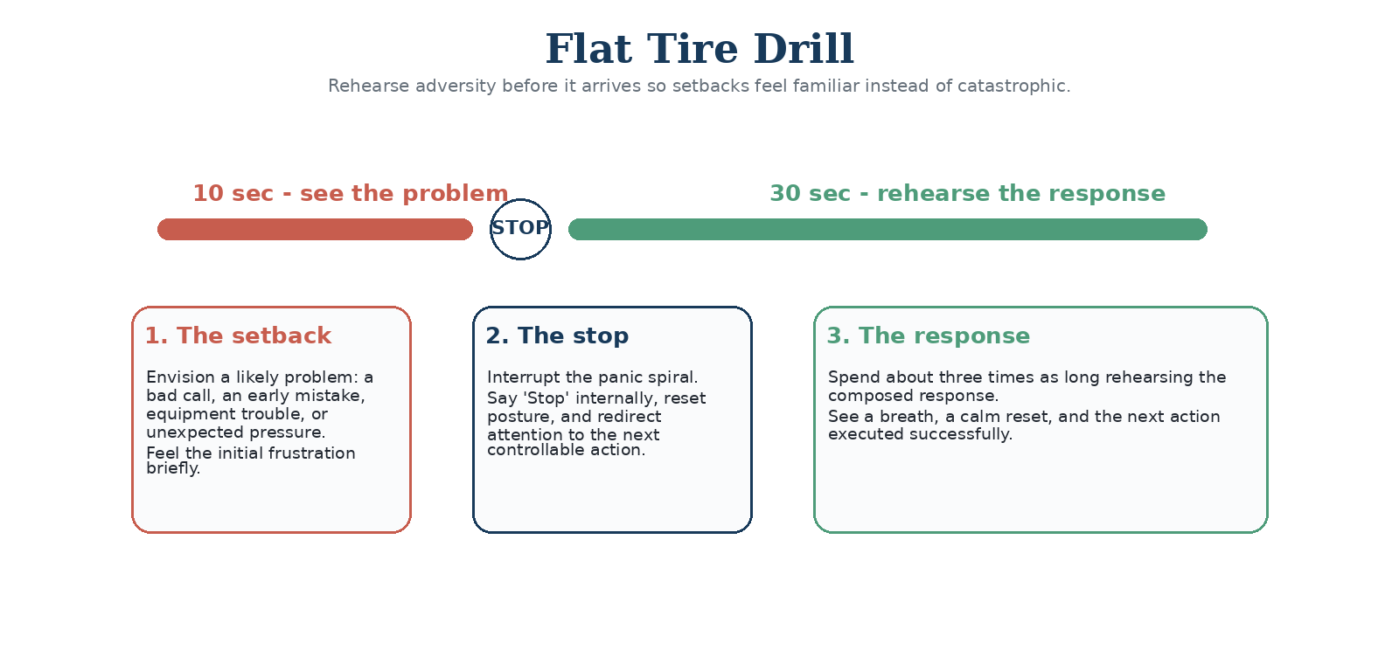
Figure 3. The flat tire drill rehearses likely adversity and, more importantly, the desired recovery response.
Arousal reframe
Butterflies do not automatically mean danger. In many performance settings the same physiology can be interpreted as mobilized readiness. Meaning changes the effect.

5. The Routine Bridge: C-B-A

Even performers who have built strong confidence can struggle to access it in the instant of performance. The gap between preparation and expression often fills with thought traffic: outcomes, judgments, technique corrections, and self-conscious monitoring. A pre-performance routine serves as a bridge from a thinking mind to a performing body. It narrows attention, restores familiarity, and reactivates conviction.
The C-B-A routine is deliberately short. First, cue conviction with a brief, present-tense statement that reminds the performer who they are when prepared and at their best. Second, breathe the body with one or two controlled breaths that interrupt the panic spiral and convert activation into readiness. Third, attach attention to an external target, cue, or task-relevant focal point so that trained action can take over.
The routine works best when it is specific, portable, and repeatable. It should not become a long motivational speech. The cue must be believable, the breath must be practiced, and the attentional target must actually matter for the task. Done well, the routine does not create skill; it clears the runway for skill that already exists.
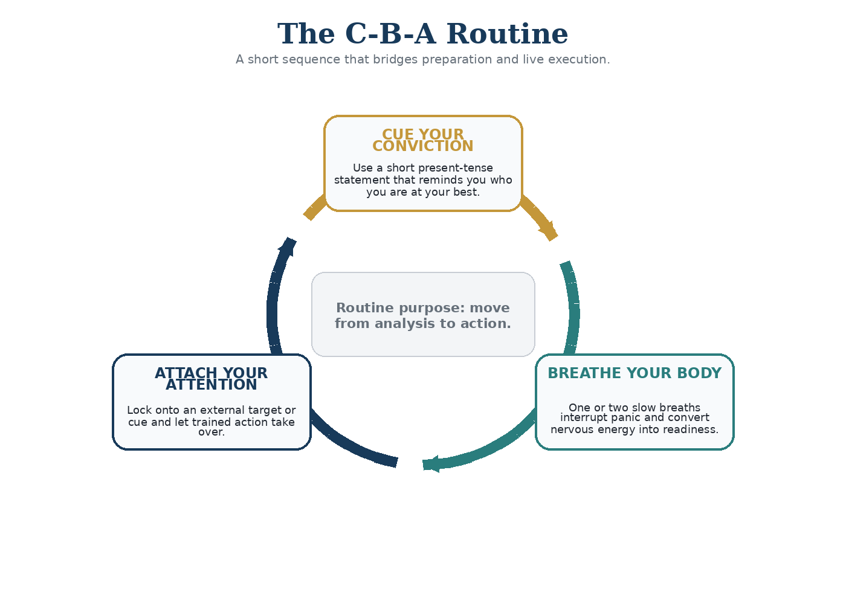
Figure 4. A short routine helps the performer cross from preparation into live execution.
Design rules
Keep the cue brief and believable. Practice the breath before you need it. Choose an attentional target that is external, specific, and relevant to the task.

6. Envisioning: The Mental Cinema

Visualization is a misleading label if it implies only sight. Effective imagery is better understood as envisioning or mental rehearsal: a multisensory simulation of a performance experience. The performer should see the scene, feel the movement, hear the environment, sense the rhythm, and include the emotional tone of successful action. In other words, the image should function more like a virtual performance episode than like a detached picture.
Several theories explain why imagery can help. Psychoneuromuscular accounts argue that imagining action activates movement-related pathways in ways that support skill learning. Bioinformational accounts emphasize that images need both stimulus information and response information - not only what is happening, but how the body is reacting. Symbolic learning accounts propose that imagery acts as a blueprint for sequencing, strategy, and action plans. Across theories, the consistent message is that mental rehearsal works best when it is vivid, embodied, and deliberately structured.
Perspective matters. Internal imagery, or first-person imagery, is typically strongest for timing, kinesthetic feel, and emotion. External imagery, or third-person imagery, is helpful for analyzing form, posture, or overall action shape. Skilled performers use both, but they choose the perspective on purpose. So does control. If a negative image appears, it should not be left to replay uncorrected. The performer cuts the scene, rewinds, and runs the desired version instead.
Timing matters as well. Many performers imagine in slow motion to fix mechanics or fast-forward directly to the win, but the nervous system also needs a blueprint that matches the speed of the actual task. Real-time rehearsal ties mental timing to game timing. Finally, imagery should include emotion. An image without felt energy is weak rehearsal; an image with believable emotion becomes a memory of the future.
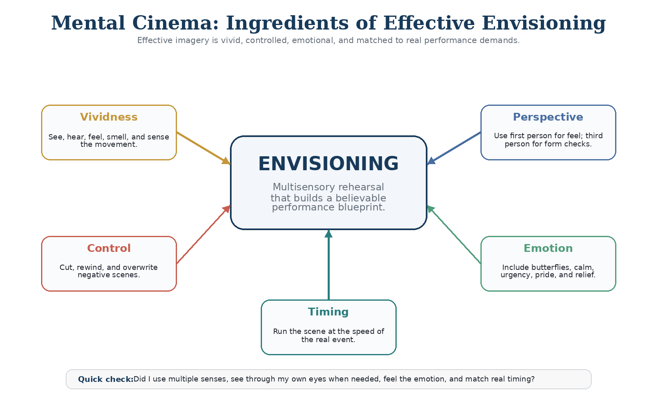
Figure 5. Effective imagery depends on vividness, perspective, control, emotion, and timing.
Perspective | Best use | Practical note
Internal / first person | Strongest for timing, feel, rhythm, kinesthetic cues, and emotional realism. | Use when you want to inhabit the movement and feel the action from inside the body.
External / third person | Useful for form analysis, posture checks, and viewing the whole action pattern. | Use when you need to inspect mechanics, spacing, or tactical shape as an observer.
Skilled use | Switch perspectives deliberately rather than randomly. | Feel the action from inside, then step outside briefly if you need a technical correction.

Table 3. Perspective is chosen for the training goal, not by habit.
Lemon test
If you vividly imagine cutting into a lemon and biting it, your mouth may water. That simple exercise illustrates a core principle of imagery: vivid symbolic experience can trigger genuine physiological response.

7. The Mental Director's Toolkit

A practical imagery system begins with a warm-up. In the prop check drill, the performer imagines a tool of the trade - a racket, ball, instrument, scalpel, or microphone - and mentally feels its weight, texture, and familiar movement. This wakes up the sensory channels. From there, the performer shifts to a GoPro perspective, seeing the action through their own eyes rather than as a spectator from the stands.
The next layer is controllability. The director’s cut drill trains the performer to stop unhelpful scenes, rewind, and overwrite them with the correct execution. Real-time rehearsal then ensures that the action unfolds at the speed and rhythm of the true event. A private, familiar mental starting place can also help by giving the performer a consistent place from which to begin each rehearsal session.
When used consistently, the toolkit does more than improve confidence. It creates a higher-quality relationship between practice and performance. The performer stops waiting to feel perfect and instead learns how to generate certainty, rehearse responses, and recover quickly when pressure disrupts the script.
Drill | Purpose
Prop check | Warm up the imaging system by handling an object mentally: its weight, texture, shape, and familiar movement.
GoPro perspective | Run the scene through your own eyes so the action feels inhabited rather than merely watched.
Director’s cut | If a negative image appears, cut it, rewind to just before the error, and overwrite it with the correct action.
Flat tire drill | See a realistic setback for about ten seconds, stop it, then spend longer rehearsing the composed response.
Real-time rehearsal | Match the speed and rhythm of the real event so the mental blueprint fits the actual task.

Table 4. Five practical drills that turn imagery into deliberate mental practice.
Quality check
Before you end a rehearsal, ask four quick questions: Did I include multiple senses? Did I choose the right perspective? Did I feel believable emotion? Did the scene unfold at real-task timing?

8. Integrating the System

Confidence and envisioning should be treated as one integrated system rather than separate mental skills. Deposits from past performance create evidence. Protective thinking prevents unnecessary withdrawals. Envisioning makes future success and recovery more familiar. Routine bridges preparation and expression. After-action review then feeds the next cycle by turning today’s performance into tomorrow’s deposits.
A simple weekly plan is enough to keep the system alive. Capture daily effort, success, and progress. Rehearse a cue phrase and a short breath-attention reset. Run several brief imagery sessions each week that include both successful execution and a calm response to likely setbacks. After performance, review facts, extract lessons, and plan the next action. The goal is not to feel inspired once; it is to manage certainty as an ongoing discipline.
A compact weekly practice plan
1. Each day: record one item of effort, one success, and one sign of progress.
2. Several times per week: run a short imagery session that includes both ideal execution and a calm response to a likely setback.
3. Before performance: use the C-B-A routine to cue conviction, regulate the body, and narrow attention.
4. After performance: review facts, lessons, and the next action rather than dwelling in vague self-criticism.
Common misunderstandings
Misunderstanding | Correction
Confidence is the same as loudness. | High functioning confidence can be quiet. The real test is whether it frees performance, not whether it sounds impressive.
Positive thinking alone is enough. | Without competence, preparation, and evidence, positivity becomes wishful thinking rather than performance confidence.
Imagery is just seeing pictures. | Effective envisioning is multisensory and embodied. The performer should feel timing, movement, context, and emotion.
Protective thinking means denying mistakes. | The goal is not denial. It is to contain the mistake, extract learning, and prevent one event from becoming identity.
Table 5. Four frequent errors that weaken how performers build and use confidence.
End-of-chapter summary
• Confidence is a trainable sense of certainty that allows well-learned skill to run with minimal conscious interference.
• The strongest confidence draws on evidence: mastery, preparation, imaginal rehearsal, constructive self-talk, and the meaning assigned to arousal.
• The confidence account grows through deposits such as success, effort, and progress, and it is protected by a mental filter that reframes setbacks.
• Protective tools work by containing damage: temporary, limited, nonrepresentative; stop and reset; learn, plan, and move on.
• A pre-performance routine bridges the gap between preparation and live performance by cueing conviction, regulating the body, and narrowing attention.
• Envisioning is deliberate mental rehearsal. It works best when it is vivid, emotionally believable, controlled, and timed like the real event.

Review Quiz: Multiple Choice
Instructions
Choose the best answer for each question. The answer key with brief rationales appears immediately after the quiz.

1. In this chapter, practical confidence is best defined as:
A. a personality trait that some performers are born with
B. a sense of certainty that allows a learned skill to be executed with less conscious interference
C. the absence of all physiological arousal before an event
D. the public display of boldness and intensity
2. Which construct is most task-specific?
A. trait confidence
B. robust sport confidence
C. self-efficacy
D. general optimism
3. According to the confidence account metaphor, which option is a deposit?
A. replaying criticism after practice
B. noticing effort and small progress from the day
C. treating one bad rep as proof you are not ready
D. predicting disaster before competition
4. What is the main job of the mental filter?
A. remove all emotion from performance
B. make every memory feel equally important
C. approve useful deposits and reframe or block withdrawals
D. eliminate the need for practice
5. Constructive attitude lockdown treats an error as:
A. permanent, global, and diagnostic of identity
B. temporary, limited, and nonrepresentative of the whole self
C. proof that confidence was fake
D. something that should never be discussed again
6. The flat tire drill is designed to:
A. focus only on perfect outcomes
B. eliminate the possibility of setbacks
C. rehearse adversity and a composed response before it happens
D. replace physical preparation with mental rehearsal
7. The step 'Attach your attention' in the C-B-A routine means:
A. thinking harder about mechanics while you perform
B. focusing on an external cue or target so trained action can run
C. scanning the crowd to calm yourself down
D. repeating multiple affirmations while the action is unfolding
8. Why can reinterpreting butterflies improve confidence?
A. because arousal disappears when you relabel it
B. because the body stops releasing energy when you breathe
C. because the same activation can be understood as readiness instead of threat
D. because only weak performers feel butterflies
9. Effective imagery differs from ordinary daydreaming because it is:
A. multisensory, controlled, emotional, and intentionally linked to performance
B. always vague so it stays positive
C. useful only after the event, not before it
D. limited to visual detail alone
10. Which imagery perspective is usually strongest for feeling timing and movement from inside the action?
A. external / third person
B. statistical / analytical
C. internal / first person
D. verbal / linguistic
11. If a negative image appears during rehearsal, the recommended response is to:
A. let it run so you get used to failure
B. ignore it and hope it goes away
C. cut it, rewind, and overwrite it with the correct action
D. stop using imagery altogether
12. Why does real-time rehearsal matter?
A. it prevents emotion from entering the scene
B. it helps the mental blueprint match the temporal demands of the real task
C. it makes every skill look faster
D. it works only for team sports
Answer Key
Q | Answer | Why it is correct
1 | B | Confidence is functional certainty that quiets overanalysis and allows learned skill to run more automatically.
2 | C | Self-efficacy is a situation- and task-specific judgment of capability, not a broad personality trait.
3 | B | Effort and progress are deposits because they provide usable evidence that the performer is moving forward.
4 | C | The mental filter determines what is retained as confidence-building evidence and what is reframed as learning instead of damage.
5 | B | Lockdown prevents one error from becoming global identity by containing it to time, area, and meaning.
6 | C | The drill prepares the mind for adversity so the response feels rehearsed rather than improvised under panic.
7 | B | The final step shifts attention outward so the performer stops self-monitoring and lets trained action take over.
8 | C | Activation itself is not automatically bad; interpretation determines whether it becomes threat or fuel.
9 | A | Effective envisioning is deliberate practice, not passive fantasy. It includes senses, emotion, control, and task relevance.
10 | C | First-person imagery usually gives the strongest sense of timing, kinesthetic feel, and emotional realism.
11 | C | Controllability matters. Negative scenes should be corrected rather than rehearsed repeatedly.
12 | B | Timing helps the brain build a blueprint that fits the pace of the real event instead of a distorted one.
Glossary of Essential Terms
C-B-A routine: A brief pre-performance sequence: cue conviction, breathe the body, and attach attention.
Confidence: A sense of certainty about ability that allows a performer to execute with less conscious interference.
Confidence account: The metaphor that treats thoughts, memories, and interpretations as deposits or withdrawals that influence certainty.
Constructive attitude lockdown: A damage-control interpretation that treats errors as temporary, limited, and nonrepresentative.
Controllability: The ability to direct and edit mental images so the desired action, not the feared mistake, is rehearsed.
Daily E-S-P: A brief daily log of effort, success, and progress used to create deposits in confidence.
Envisioning: Deliberate, multisensory mental rehearsal of a desired future performance or response.
Flat tire drill: A resilience drill that rehearses likely setbacks and a composed recovery response.
Imaginal experiences: Imagery-based experiences that shape efficacy beliefs by mentally rehearsing successful action.
Internal perspective: Seeing the action through your own eyes; usually best for feel, timing, and emotion.
Mental filter: The interpretive process that approves confidence-building evidence and blocks or reframes withdrawals.
Psychoneuromuscular theory: The view that imagery activates movement-related pathways in a way that can support skill learning.
Real-time rehearsal: Running imagery at the speed of the actual event so the mental representation matches the task.
Robust sport confidence: A durable set of positive beliefs that protects performance from challenge and pressure.
Self-efficacy: A task-specific belief that one can organize and execute the actions required for success.
State confidence: The performer’s immediate, situation-bound sense of certainty.
Trait confidence: A more stable tendency to feel assured across time and situations.
Vividness: The clarity and sensory richness of mental imagery.
This chapter synthesizes the phase 4 source pack into a single teaching chapter for study and instruction.

