WRITING A PERSONAL RESPONSE to TEXT

The format of a personal response is much the same as any other written response; you state your idea and then you defend the idea with details from the text. Personal responses are worded as follows:

What do these texts suggest to you about…? Support your idea(s) with reference to one or more of the texts presented and to your previous knowledge and/or experience.

In your writing you must
- Use a prose form
- Connect one or more of the texts provided in this examination to your own ideas and impressions

Note that you are given the choice as to how to respond.

The first bullet tells you to choose a prose form. (Prose is anything other than poetry.)

In the table below are a few examples of forms that prose can take:

short essay | editorial | letter | screen play
diary entry | interior monologue | eulogy | speech
reminiscence | short story | interview | anecdote
newspaper article | personal observation | rebuttal | commentary

You are also given the choice as to what perspective to use:

personal | critical | creative

So, when writing a personal response, you need to determine four things before you begin writing:

1. theme of the text (idea, impression)
- supporting details from the text

- prose form the response will take

4. perspective the response will take

Page 2 Personal Response to Text

PERSONAL RESPONSE to TEXTS EXAMPLES

Examine the photograph below. Reflect upon the ideas and impressions suggested by the photograph.

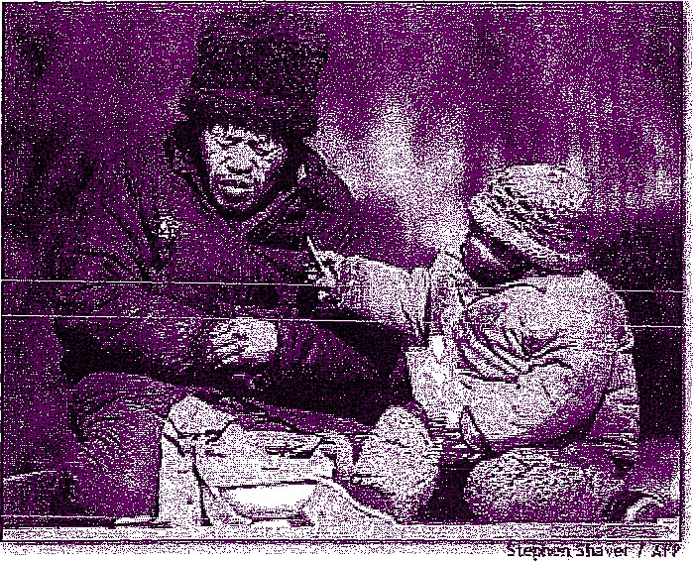

What ideas and impressions does the photograph suggest to you?

- Start with the thesis statement, your answer to the question. Eg. Even at its poorest, humanity
can still find it possible to share what little it has.

- Explain how the details in the visual and the creator’s choices support this idea. Then think of
at least three points that back up your answer.

  - The old man is cold and dirty, which reflects poverty. The little girl is also dirty and has
only crackers to eat. They are poor and have little.
  - The old man is in pain, by his expression. He is huddled into himself as if trying
in vain to gather warmth. The background is blurry and indistinct, accentuating
the isolation of the two. There is no one coming to help them; they are not part
of the big picture.
  - The little girl is offering a cracker, her only food, to the old man. She is holding
the cracker up as a gift, an offering, a hope to bring him comfort. Her facial
expression, although not entirely clear, seems to be one of concern.

3. Now, as you have a thesis statement and the support, which will act as a mini-outline, determine your prose form and perspective, and write your response:



PERSONAL RESPONSE to TEXTS EXAMPLE NUMBER
prose form—ESSAY | perspective—CRITICAL

It seems that even in at its lowest, poorest, coldest, most desolate state, humans can find a way to attempt to comfort one another. This candid photograph reveals a moment between an old man and a child, where the child offers all she can to ease the discomfort of the old man. She has little to offer but the offer itself.

The old man in the photograph is cold and hungry; his face reflects his pain. The man’s jacket seems to have a broken zipper, leaving only the buttons to attempt to shut out the cold. He huddles into himself in a vain attempt to gather warmth. The man is perhaps the girl’s grandfather. As the cold and hunger of poverty can age a person prematurely, the man may even be her father. The little girl is also cold; her soiled clothing and dirty hands indicate she shares the state of poverty with the old man. The
coat and hat, once a bright and cheerful pink have been covered with the dirt and soot of living in the street.

The images in the foreground, the girl and the man, are sharp and distinct. Like the hunger pains and cold winds, the images are sharp. The background abruptly blurs behind them. Like most of the poor in society, they are not part of the ‘big picture’. The back ground is blurred symbolizing a separation from the rest of the scene, the rest of the world. They are isolated in their situation. There is not aid forthcoming, no help advancing from the back ground. The background, like their future is blurry and uncertain.

The little girl is offering a cracker. This is all she has to offer. Her face is not entirely visible but what we can see indicates concern as does her body language. She is holding food up to her fellow man, an offering of all that she has to offer in order to ease his pain. He, most likely, has refused to eat the little food they have in order to feed the child. His sacrifice is another example of humanity in the poorest of circumstances.

He refused to eat the food that would ease his hunger because he wants prevent her hunger. She offers all that she has in the cracker, in attempt to ease his pain. Even in their isolated hunger and cold, the man and the child both offer comfort and aid to one another.

(A. Laidlaw)

Notice how the interpretation is defended with details from the photograph. Conclusions can also be drawn from the details. For example, the relationship between the man and child is not known, but it is surmised they are related. It is also acceptable to draw on personal experiences as one interacts with the text.

 | PERSONAL RESPONSE to TEXTS EXAMPLE NUMBER
prose |  | form—DIARY | ENTRY | perspective—PERSONAL

Dear Diary,

As I was walking through Prince’s Island Park today, I saw a man and his young daughter who moved me to tears. They were off the regular pathway and virtually ignored by the downtown crowd strolling through the park on their lunch breaks.

The two were most certainly homeless - the little girl’s winter coat, once pink, was a dingy grey. The rest of her clothing and that of her father had a similar layer of grey filth. Her father’s jacket was torn and didn’t appear to be protecting him from the elements, as he was shivering against the cold. Both of them had red cheeks, the kind of rosiness that appears after a person has been out in the cold for some time. Between them they had a rather lifeless, and very dirty, canvas knapsack. This knapsack seemed to be a symbol of the father — from his facial expression and body language, he looked as though all hope had long ago deserted him - he appeared deflated and defeated.

His little girl was holding on to a sleeve of soda crackers, trying to entice her father to eat. She had so little to offer, but was doing her best to ease his pain and show her concern. He refused her offering; most likely knowing that was all the food they had at the moment, with no idea as to where and when any more would be found. He refused to eat the food that would have eased his hunger because he wanted to prevent her hunger. She offered all she had in the cracker, in an attempt to ease his pain. Even in their isolated hunger and cold, the man and the child both offered comfort and aid to one another.

This is where my tears came in. Between them, these two had next to nothing, yet
each was willing to sacrifice the little they had for each other. They made me aware of what I was wearing — a coat I’d already had for two years and last season’s boots. Amongst the downtown crowd, I had felt unfashionable, but near these two I felt ashamed and guilty. I spend so much money on clothes, jewellery, my hair… - and my children have stuffed closets and full bellies. We want for nothing, yet when was the last time I put anything into the hamper at the grocery store for the food bank? When was the last time I made a donation to the homeless shelter or the Y? I remember looking at my charitable donations total at tax time and thinking I really needed to be giving more. I give, but it is relatively painless. I need to be giving until it hurts!

I felt ashamed that I have been blessed with so much and have given so little, while these two, who have next to nothing, were willing to share what little they had in order to ease each other’s pain. I also felt ashamed at being moved to tears — as the old song goes “Tears Are Not Enough”. It’s one thing to have wet cheeks in a park at lunch

time, but a totally different thing to actually do something about the situation that moves me to tears! It seems that it is always the poor and the weak who teach the rest of us the true meaning of humanity. All of us are our brothers’ keepers, and I’ve
finally realized how cold and hungry my brothers are.

Notice how this interpretation is also defended with details from the photograph. The difference, however, is in the personal perspective, as to how something might feel after witnessing the scene between father and daughter.

 | PERSONAL RESPONSE to TEXTS EXAMPLE NUMBER
prose |  | INTERIOR MONOLOGUE |  | perspective—CREATIVE

I am so cold. Winter is not even here, yet, and already I am suffering. And my poor Sophie! What a brave little girl she is. Tier cheeks are so red and her little fingers are moving stiffly. I look around at the lunch crowd in this park and remember when I was part of their group. My life has changed so drastically in such a short time.

When Emilie took sick two years ago, at first we were excited by the thought that maybe she was pregnant - she had terrible morning sickness when she carried Sophie. That was not to be, however. She was diagnosed with pancreatic cancer. Devastating! We knew that was almost always fatal, so we took a second mortgage on the house to go to the States in order that Emilie could be treated by the leading doctors in the
field. We were desperate to try anything to save her life - and spend anything in the process.

I miss Emilie so much. And how can I raise Sophie on my own? She needs her mother. And now I feel as though I have so little to offer her — we hardly get enough to eat, and find shelter where we can. Homeless shelters for a man and his small daughter are a bit of a problem.

- It is unbelievable how much misery one person can endure. I feel like Job. Not long after Emilie died, my company down-sized, and I was let go. The severance package covered the cost of her funeral expenses and left little to live on. I could no longer pay the first mortgage, never mind the second one, so I lost the house, along with all its contents.

I don’t even have anyone to turn to. So many of my former co-workers are experiencing difficult financial times, as well. And all of my family are in China. I was sending money back home every month to try to make my parents more comfortable
in their old age. Now they don’t have that, and I feel like I have failed them, too.

Poor Sophie! How she cried when her mama died and then again at the auction sale where her belongings disappeared. How terrible to take a mother away from a child, and then all those things that would give her physical comfort. She doesn’t even have a home anymore - and what a home Emilie had made for us.

Look at my little Sophie. She is trying to share those crackers with me. Those crackers are the only thing between us and starvation. She has such a big heart. She never complains and she must be as hungry as I am. “You eat, little one. Daddy’s not hungry.”

My poor Sophie! You are all I have left in this world, and I for you. Is that enough for both of us? It will have to be

Notice how this interpretation is also defended with details from the photograph, but not to the same degree as the first two. Since this is a creative response, much has been “read” into the photograph, but all is logical for the viewer of the photograph. Everything that has been created logically fits with the scene that has been portrayed.

There are still many more possibilities:

Imagine that you decided to eat your lunch in the park, and you witnessed this scene. Write the journal entry you would pen that night. On what sorts of ideas would you reflect? Your own blessings, perhaps? The wisdom and guidance of your elders that has kept you from a life of poverty?

- As a newspaper editor, you are on a crusade to fight poverty and homelessness in your municipality. Write an editorial inspired by witnessing these two people. What sorts of statements would you make to your reading public? Would you be admonishing? Would you have a call to action of some sort?

- Imagine that you are the small girl in the photo. What kinds of thoughts would be going through your head? How have you interpreted the actions of your father? Your mother? How do you feel about your parents? Are you anxious? Trusting? Etc.

o Perhaps you have had a personal encounter with street people. Relate your own experience.

o ETCI!

Keep in mind that there is more than one acceptable approach to responding to ANY text. There is no right answer; there are logical responses with defensible support.

