# Lowcountry EJ Results

# –

### Table 1. Conservation Reserves by Data Source.

Square miles of conservation land with number of reserves in parentheses. All reported numbers are unfiltered from data source with the exception being multipart polygons clipped to the Lowcountry region. 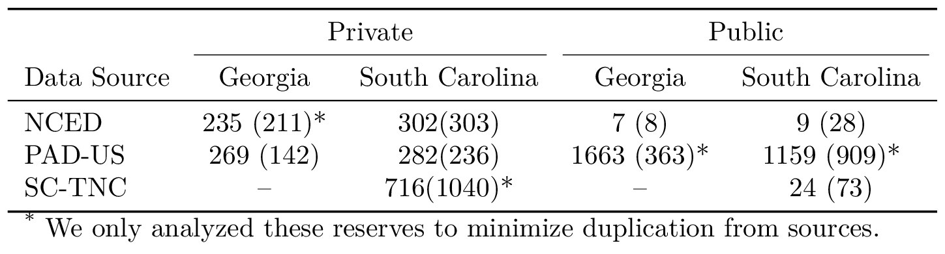

### Table 2. Demographic Comparison by Region.

Area and Beneficiary Population is total for Lowcountry region, but mean for private and public beneficiary zones. Results are for the 10 mile beneficiary zone and 0.2 mile conservation reserve buffer zone pairing. One standard deviation is shown for means. 

### Table 2.1 (URBAN v. RURAL). Demographic Comparison by Region.

Area and Beneficiary Population is total for Lowcountry region, but mean for private and public beneficiary zones. Results are for the 10 mile beneficiary zone and 0.2 mile conservation reserve buffer zone pairing. One standard deviation is shown for means. 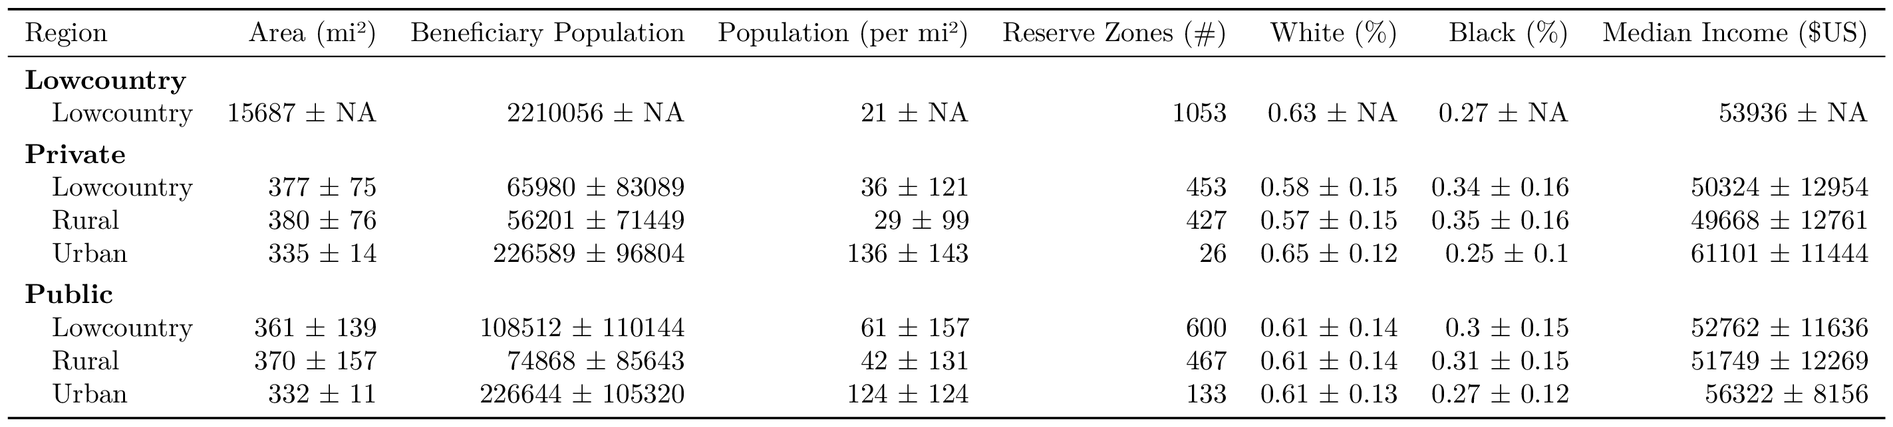

### Table 2.2 (EXPANDED). Demographic Comparison by Region.

Area and Beneficiary Population is total for Lowcountry region, but mean for private and public beneficiary zones. Numbers shown are for the 10 mile beneficiary zone and 0.2 mile conservation reserve buffer zone pairing. One standard deviation is shown for means. 