# Lowcountry EJ Results

# –

### Table 1. Conservation Reserves by Data Source.

Square miles of conservation land with number of reserves in parentheses. All reported numbers are unfiltered from data source with the exception being multipart polygons clipped to the Lowcountry region.

## `summarise()` ungrouping output (override with `.groups` argument)

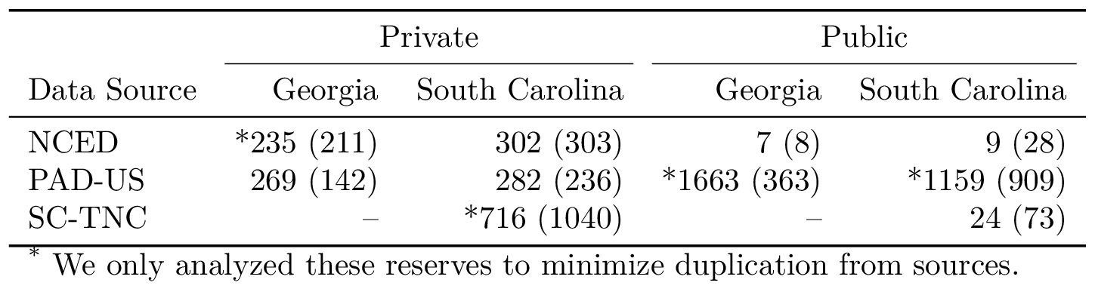

### Table 2. Demographic Comparison by Region.

Results are from the 10 mile beneficiary zone and 0.2 mile conservation reserve buffer zone pairing. Standard error is shown for means of private and public beneficiary zones. 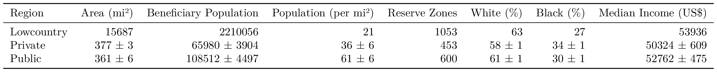

### Table 2.1 (URBAN v. RURAL). Demographic Comparison by Region.

Results are from the 10 mile beneficiary zone and 0.2 mile conservation reserve buffer zone pairing. Standard error is shown for means of private and public beneficiary zones. 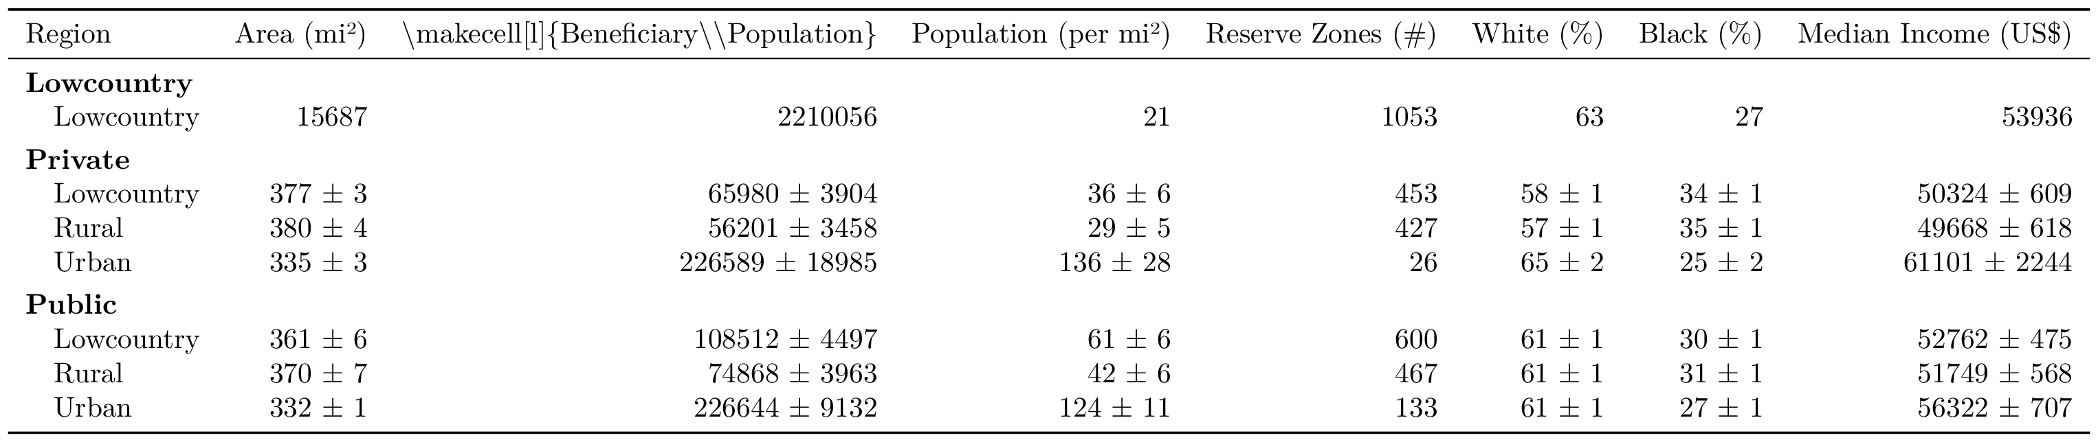

### Table 2.2 (EXPANDED). Demographic Comparison by Region.

Results are from the 10 mile beneficiary zone and 0.2 mile conservation reserve buffer zone pairing. Standard error is shown for means of private and public beneficiary zones. 