Dean Sports App

Wireframe:

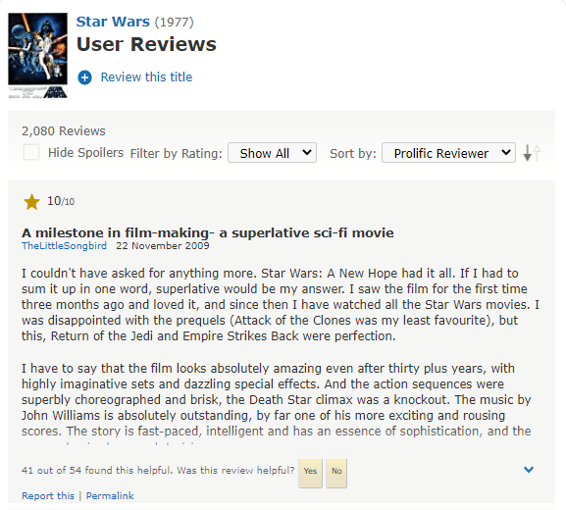

Review

Review

Scores

Matches

Matches

Review

Scores

Matches

Dean Sport Review App

Review

Scores

Matches