**SALESFORCE APP**

To create the sales-force app. Please follow the below steps:

**Step 1:** First of all click on username and then click on “Setup” link as display in below screen shot.

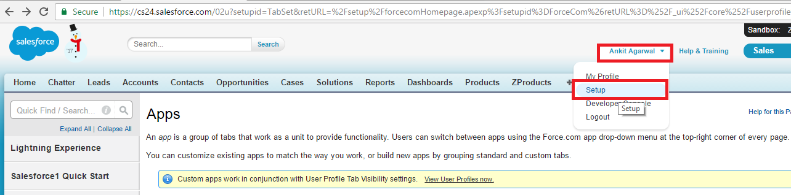

**Step 2:** After that please click on “Manage Apps” link.

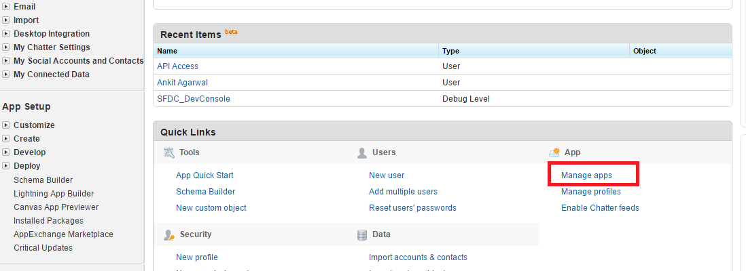

**Step 3:** After that go to “Connected Apps” section and then click on “New” button as display in below screenshot.

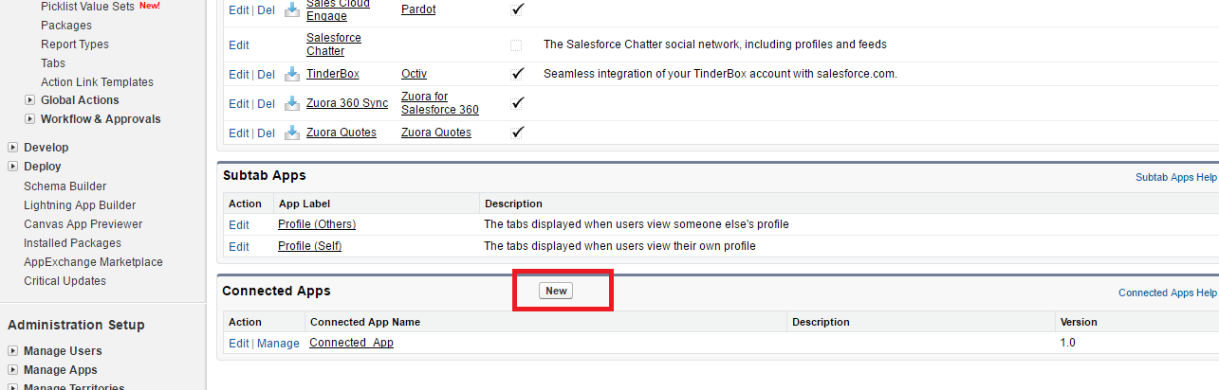

**Step 4:** Now fill the app information and click on save button to save the information.

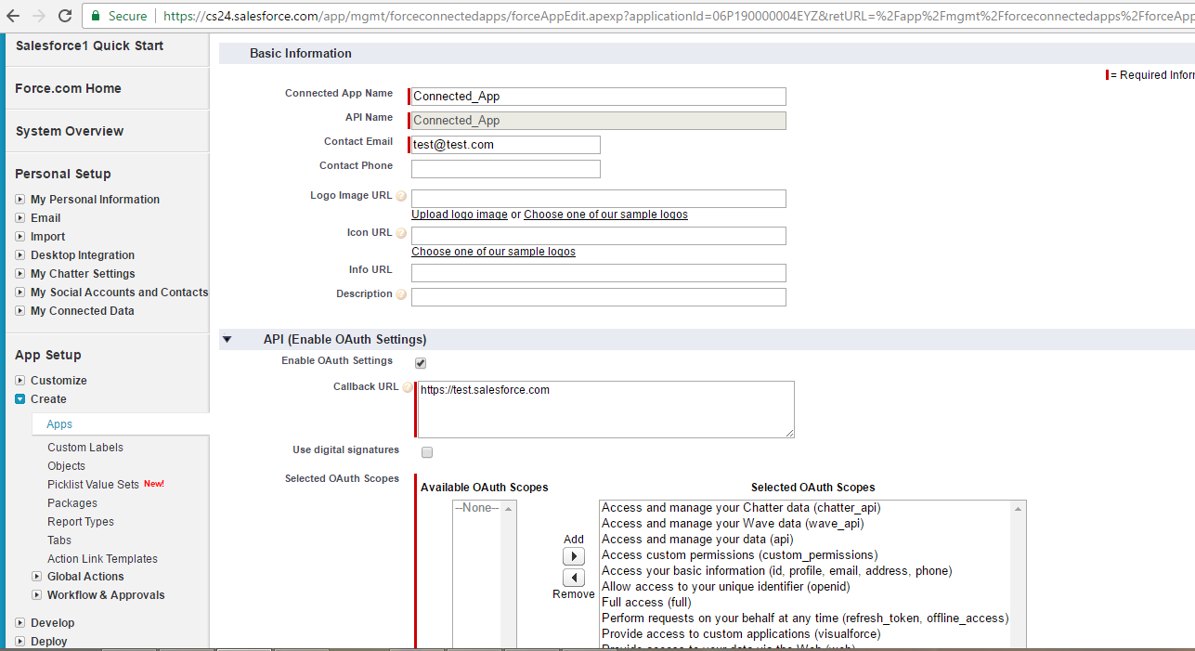

**Step 5:** After that copy the Consumer Key(Client ID) and Consumer Secret(Client Secret) and paste into PHP file.

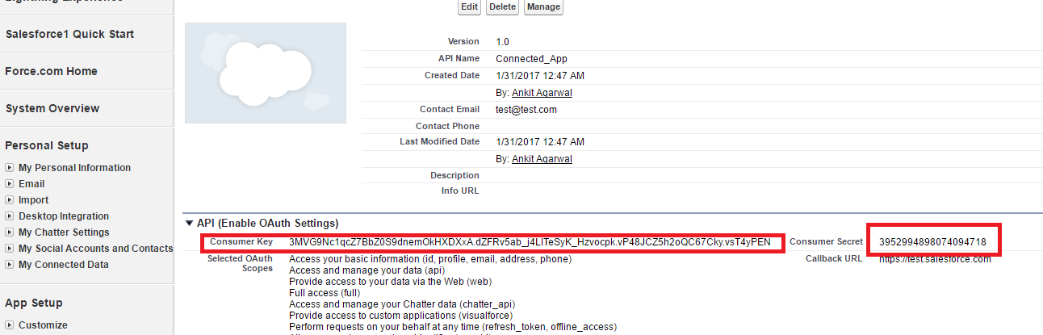

**FRESHDESK APP CHANGES**

Once you have completed the above steps then you need to do the following changes in freshdesk account.

**Step 1:** First of all click on “Admin” tab.

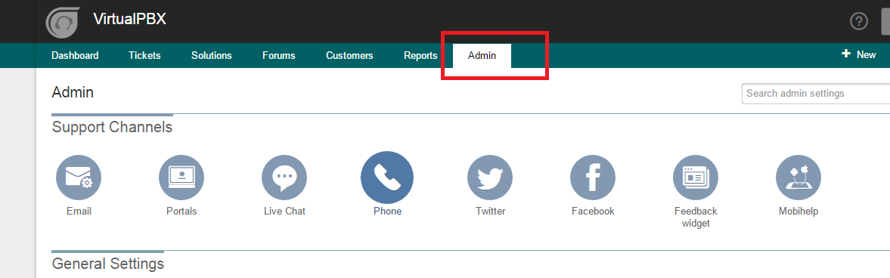

**Step 2:** After that click on “Apps” icon to open the Apps page.

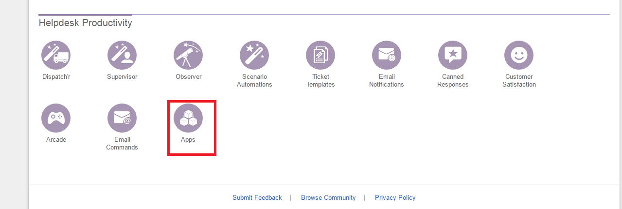

**Step 3:** Now click on “Custom Apps” and then click on “Sample CRM custom app”.

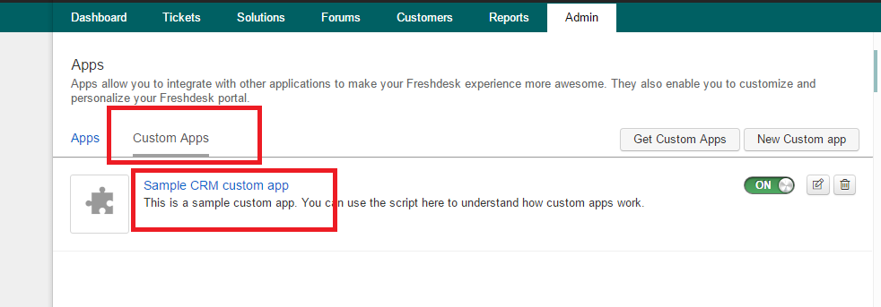

**Step 4:** Now scroll down and change the file browsing URL as display in below screen shot.

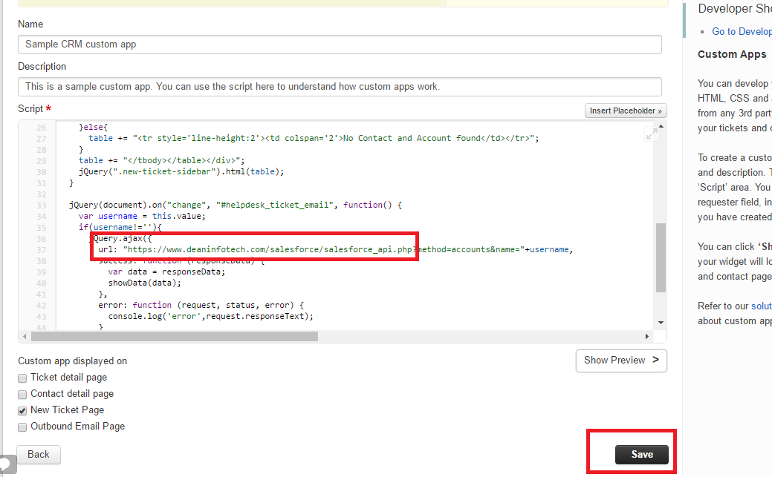

**Step 5:** Now click on “Save” button.