**ME213 Homework set4**

**Problem 1**

The following tabulated data were gathered from a series of Charpy impact tests on a tempered 4340 steel alloy.

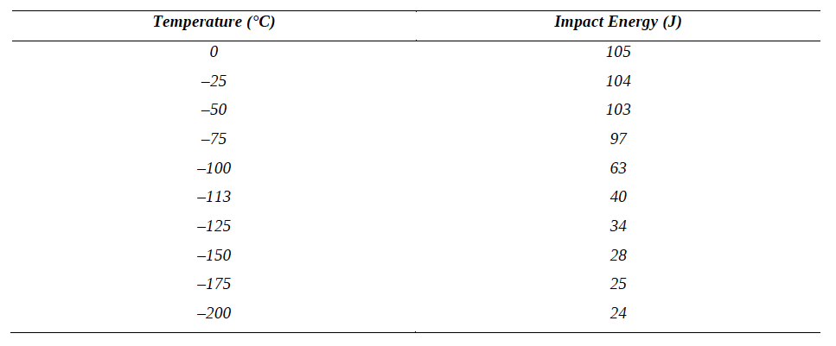

(a) Plot the data as impact energy versus temperature.

(b) Determine a ductile-to-brittle transition temperature as the temperature corresponding to the average of the maximum and minimum impact energies.

*From the plot above, we can calculate that the ductile to brittle transition temperature corresponds to an impact energy of about 65J, giving us a temperature of just above -100°C, perhaps about -98°C.*

(c) Determine a ductile-to-brittle transition temperature as the temperature at which the impact energy is 50 J.

*The temperature at which impact energy is 50 J is about -107°C.*

(d) Give a simple rationalization for the appearance of a ductile-brittle transition in terms of the competition between plastic deformation and fracture.

*As the material stiffens as it gets colder, it also strengthens , pushing to material to its UTS point before plastic deformation can occur. This causes the material to experience brittle fracture before yielding.*

**Problem 2**

The fatigue data for a brass alloy are given as follows

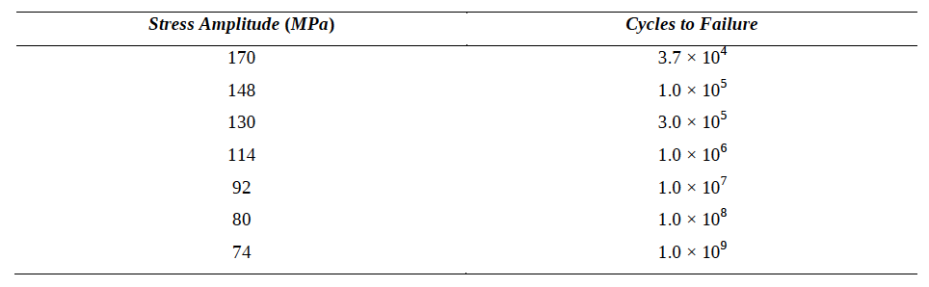

(a) Make an S–N plot (stress amplitude versus logarithm of cycles to failure) using these data.

(b) Determine the fatigue strength at 4x106 cycles.

*For 4x106 cycles, the stress amplitude is about 94 MPa.*

(c) Determine the fatigue life for 120 MPa.

*The fatigue life at a stress amplitude of 120 MPa is about 5x105 cycles.*

**Problem 3**

Use the Pb-Sn diagram below to answer the following questions.

(a) What are the values of the state variables (composition and temperature) at point 1?

*At point 1 both the Pb and Sn are in liquid form and the temperature is 300 °C.*

(b) Mark the points for Pb-60wt% Sn and Pb-20wt% Sn alloys at 250oC. What phases are present in each case?

*See graph for marked points, A for Pb-60wt% Sn and B for Pb-20wt% Sn. At Pb-60wt% Sn, both Pb and Sn are in liquid phase. At Pb-20wt% Sn, the alloy will be in liquid form with nodules of solid Pb-rich phase forming.*

(c) The alloy at point 1 is cooled very slowly to room temperature, maintaining equilibrium. At which temperatures do changes in the number or type of phases occur? What phases are present at points 2 and 3?

*At T ~ 235°C the some of the alloy (Pb-40wt% Sn) begins to solidify into a Pb-rich solid. At point 2, much of the alloy has solidified into this Pb-rich solid. By T~180°C and at point 3, the alloy has completely solidified into a combination of an α-phase Pb-rich solid and some eutectic structure.*

(d) The alloy at point 4 is cooled slowly to room temperature. Identify the following: the initial composition, temperature and phase(s); the temperature at which a phase change occurs, and the final phase(s).

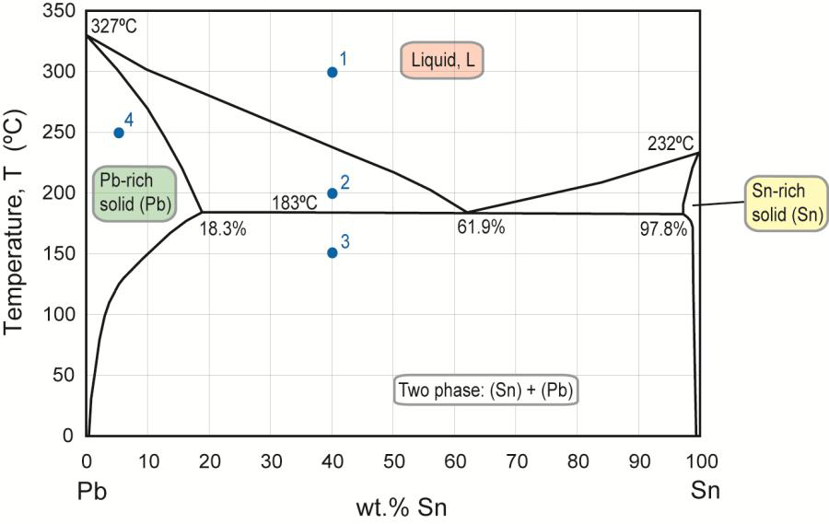

*The initial composition at point 4 is all α-phase Pb-rich solid with about 5wt% of Sn at a temperature of T = 250°C. As the temperature is cooled, the solid allow experiences a phase change at T~125°C and small amounts of Sn-rich β-phase solids precipitate out of the alloy. At temperatures below T=125°C, Pb-rich α-phase and Sn-rich β-phase exist in a solid mixture.*

**Problem 4**

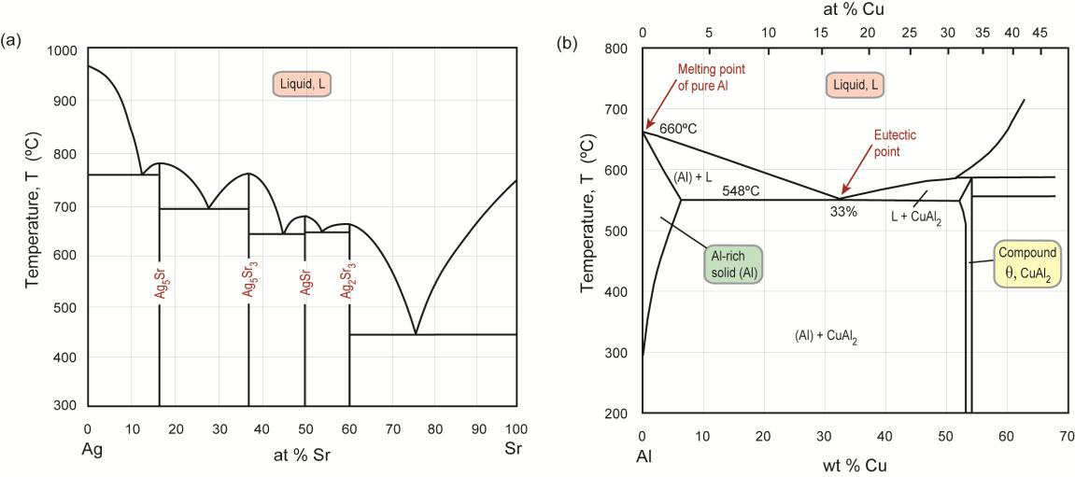

(a) For an Ag-90at% Sr alloy at 600oC:

(i) Identify the phases present, and find their compositions in at%;

*Liquid alloy is present with nodules of Sr-rich phase solidifying in the liquid.*

(ii) The temperature is slowly reduced to 500oC. Will the phase compositions and proportions change? If yes, how?

*As the Ag-90at% Sr alloy cools slowly, the solid phase will slowly become less Sr-rich as Ag solidifies and diffuses into the solid phase. The % od solid phase will grow until T~450°C when the entire allow would be a solid, with mostly a Sr-rich phase and possibly a small portion eutectic phase of Sr-rich solid and Ag2Sr3.*

(b) For an Ag-30at% Sr alloy at 600oC:

(i) Identify the phases present, and find their compositions in at%:

*At T=600°C, the alloy of Ag-30at%Sr is a solid mixture of two phases: Ag5Sr (or Ag-14wt%Sr, Ag-17at%Sr) and Ag5Sr3 (or Ag-33wt%Sr, Ag-38at%Sr)*

(ii) Will the proportions change if the temperature is reduced to 500oC? Why is this?

*Proportions should not change much if at all since the alloy is already in solid solution. Diffusion is possible but will not be fast.*

(c) For an Al-4wt% Cu alloy:

(i) At 550oC, identify the phase(s) present, and find their compositions (in wt%) and proportions by weight

*At T=550°C* and *Al-4wt%Cu, the entire alloy exists as a single phase Al-rich solid. This solid is 96%Al and 4%Cu.*

(ii) Repeat for 250oC.

*At T=250°C, the alloy has both an Al-rich solid phase and the intermetallic compound CuAl2. CuAl2 is Al-54wt%Cu and the Al-rich solid phase is some unknown composition but with less than 4% Cu, probably something like Al-2wt%Cu.*