**ME213 Homework set1**

Name: email: -

**Problem 1**

(a) Potassium iodide (KI) exhibits predominantly ionic bonding. The K+ and I– ions have electron structures that are identical to which two inert gases?

(b) Which of the following electron configurations is for an inert gas? And why?

(1) 1s22s22p63s23p6

(2) 1s22s22p63s2

(3) 1s22s22p63s23p64s1

(4) 1s22s22p63s23p63d24s2

(c) What is the boiling temperature for hydrogen fluoride (HF) and hydrogen chloride (HCl)

(d) Explain why hydrogen fluoride (HF) has a higher boiling temperature than hydrogen chloride (HCl) even though HF has a lower molecular weight.

**Problem 2**

(a) Show the correlation between the unit cell edge length **a** and the atomic radius **R** for a body-centered cubic (bcc) crystal structure.

(b) Show that the atomic packing factor for BCC is 0.68.

(c) Niobium (Nb) has an atomic radius of 0.1430 nm and a density of 8.57 g/cm3. Determine whether it has an FCC or a BCC crystal structure.

**Problem 3**

(a) What is the coordination number for the simple-cubic crystal structure?

(b) Calculate the atomic packing factor for simple cubic.

(c) Identify any element in the periodic table, if there is any, which has a simple cubic (SC) crystal structure.

(d) Compared to other popular crystal structures why is it so rare to have an element with simple cubic structure. Please explain.

**Problem 4**

Determine the Miller indices for the planes shown in the following unit cells.

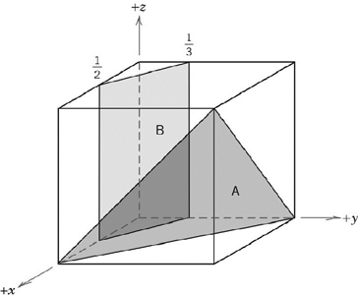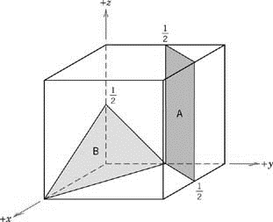

--- end of problem set 1