**ME213 Homework set3**

**Problem 1**

Of those metals listed in Table below, which is the hardest? And why?

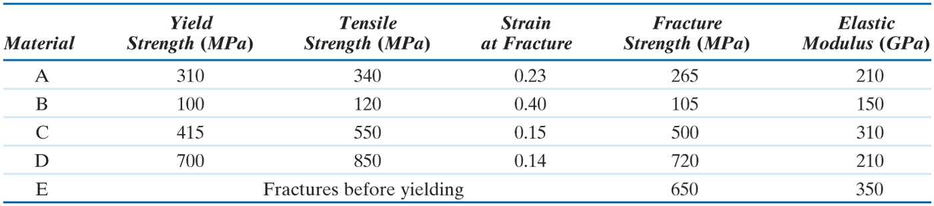

**Problem 2**

(a) Why are the mechanical properties of a material represented by stress and strain rather than load and elongation?

(b) Express the engineering stress and strain in terms of the true stress and true strain.

(c) Show that the engineering stress and strain give a good representation of the mechanical state within the material when the strain is small, but do not represent the mechanical state accurately when the strain is large.

**Problem 3**

(a) Why is it that exceptionally strong materials, such as ceramics and very high strength steels, are almost inevitably brittle?

(b) One of the first researchers to investigate the strength of materials was Gallileo, who measured the ultimate tensile strength of piano wire (very high strength, heavily worked, brittle steel). Among other experiments, he measured the maximum weight a sample of wire could support as a function of the original length of the sample, and found that the apparent strength of long wires was below the strength of short ones. Explain this result.

**Problem 4**

The resistance of a material to fracture is usually measured by determining its 'plane strain fracture toughness', KIC.

(a) Suppose you are designing a structure from a material whose fracture toughness is known, and you also know the maximum size and shape of cracks that cannot be detected by the non-destructive analysis that is used to qualify the structure. How can you use this information to set a safe allowable tensile stress for the structure (assume tensile loading perpendicular to the flaw)?

(b) Structures made of tough, ductile materials are usually designed to the ultimate tensile strength rather than the fracture toughness. Why?

--- end of problem set 3