**ME213 Homework set4**

**Problem 1**

The following tabulated data were gathered from a series of Charpy impact tests on a tempered 4340 steel alloy.

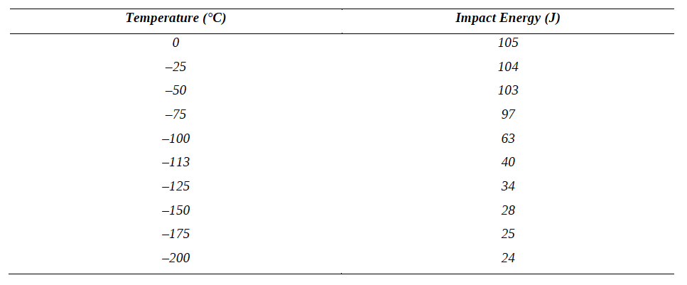

(a) Plot the data as impact energy versus temperature.

(b) Determine a ductile-to-brittle transition temperature as the temperature corresponding to the average of the maximum and minimum impact energies.

(c) Determine a ductile-to-brittle transition temperature as the temperature at which the impact energy is 50 J.

(d) Give a simple rationalization for the appearance of a ductile-brittle transition in terms of the competition between plastic deformation and fracture.

**Problem 2**

The fatigue data for a brass alloy are given as follows

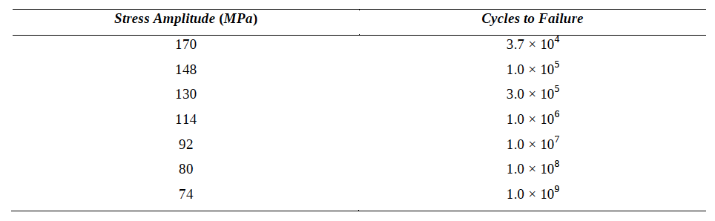

(a) Make an S–N plot (stress amplitude versus logarithm of cycles to failure) using these data.

(b) Determine the fatigue strength at 4x106 cycles.

(c) Determine the fatigue life for 120 MPa.

**Problem 3**

Use the Pb-Sn diagram below to answer the following questions.

(a) What are the values of the state variables (composition and temperature) at point 1?

(b) Mark the points for Pb-60wt% Sn and Pb-20wt% Sn alloys at 250oC. What phases are present in each case?

(c) The alloy at point 1 is cooled very slowly to room temperature, maintaining equilibrium. At which temperatures do changes in the number or type of phases occur? What phases are present at points 2 and 3?

(d) The alloy at point 4 is cooled slowly to room temperature. Identify the following: the initial composition, temperature and phase(s); the temperature at which a phase change occurs, and the final phase(s).

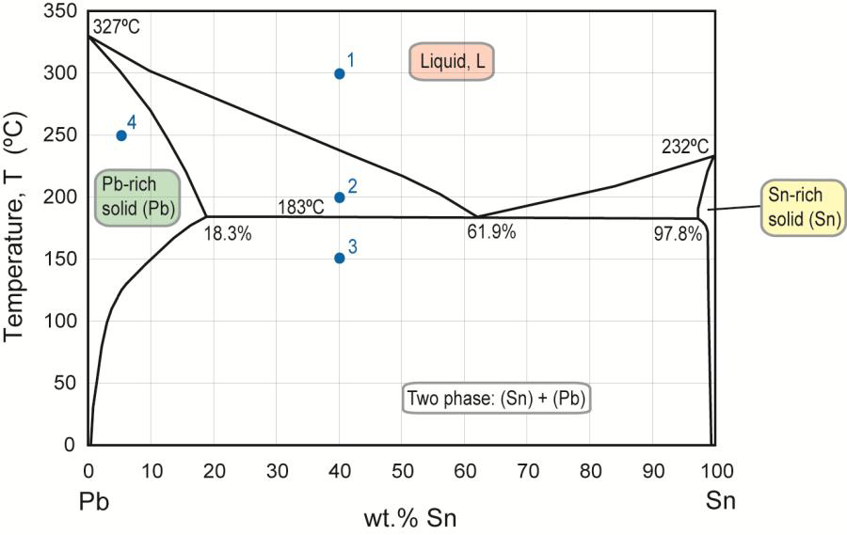

**Problem 4**

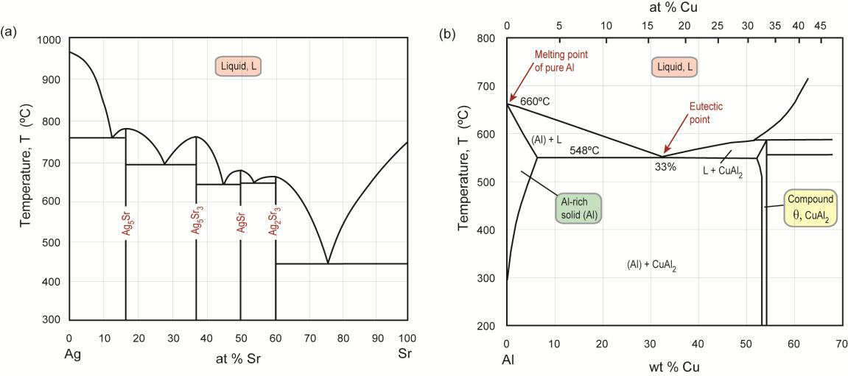

(a) For an Ag-90at% Sr alloy at 600oC:

(i) Identify the phases present, and find their compositions in at%;

(ii) The temperature is slowly reduced to 500oC. Will the phase compositions and proportions change? If yes, how?

(b) For an Ag-30at% Sr alloy at 600oC:

(i) Identify the phases present, and find their compositions in at%;

(ii) Will the proportions change if the temperature is reduced to 500oC? Why is this?

(c) For an Al-4wt% Cu alloy:

(i) At 550oC, identify the phase(s) present, and find their compositions (in wt%) and proportions by weight

(ii) Repeat for 250oC.

--- end of problem set 4