**ME213 Homework set5**

**Problem 1**

The phase diagram for the copper-zinc system is shown in the Figure below. Use the diagram to answer the following questions.

(a) (i) shade the single phase regions; (ii) highlight the eutectoid point and five peritectic points in the copper-zinc system, and write down their compositions and temperatures.

(b) The two common commercial brasses are: *70/30 brass*: WCu = 70%, and *60/40 brass*: WCu = 60%

Locate their constitution points on the diagram at 200oC.

(i) What distinguishes the two alloys?

(ii) What roughly is the melting point of 70/30 brass?

(iii) What are the phases in 60/40 brass at 200oC? Find their compositions and proportions.

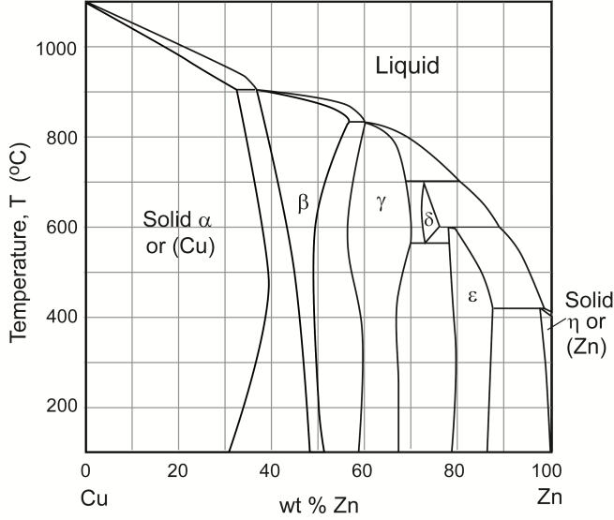

**Problem 2**

A binary system of atoms A and B has a simple eutectic phase diagram (as shown below). Lets assume A is Sn and B is Pb. Please draw the microstructure of the composition X1, X2 and X3 after cooling the liquid to room temperature.

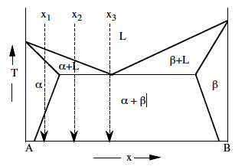



**Problem 3**

A binary system of atoms A and B has a simple eutectic phase diagram (as shown below). The ternary solid solutions are α and β. Let an A-rich sample of the composition indicated by the vertical line be solidified from the melt. It is found that its microstructure depends strongly on how rapidly it is cooled. Slow cooling leads to a polygranular structure of α grains with small β grains dispersed throughout. Fast cooling leads to a dendritic structure of α grains with very fine β precipitates within the dendrites and eutectic constituent in the boundaries between the dendrites. Discuss how these two microstructures might form.

