Fall 2019

**Laboratory 1**

Hardness Testing : Brinell and Rockwell

**Objectives**

- To understand the basic properties of strength and toughness of materials

- To measure the resistance of different materials to deformation (hardness)

- To understand the basic concepts of mechanical stress and strain

**Apparatus and Test specimen**

Hardness test

1. Rockwell Hardness Tester (Rockwell C & Rockwell B)

2. Brinell Hardness Tester

Test Specimens

1. Stainless steel

2. Aluminum

**Lab Report**

Students should hand in a brief laboratory report containing:

1. Data Sheets

2. Data analysis (answers to questions)

3. Conclusions

**Background**

The usefulness of metallic materials in engineering structures primarily depends upon two mechanical properties: high strength and enough ductility to allow the relaxation of stress concentrations through plastic deformation without fracture. In specific cases, though, properties such as dimensional stability, abrasion resistance, corrosion resistance, high impact strength, electrical or thermal conductivity, or other factors can assume primary importance.

At ordinary temperatures, metals and other solids will deform when loaded and small loads the amount of induced deformation will be proportional to the magnitude of the applied load. This strain is elastic in nature, i.e., the material will return to its original shape when the load is removed. But at high loads, permanent changes may occur in the materials. With increasing load, a point will be reached beyond which irreversible deformation called plastic deformation, will occur. Most metals are ductile at room temperatures. That is, they can be deformed plastically prior to fracture. Brittle materials such as glass will fracture, rather than plastically deform, when the elastic limit s exceeded.

Metals are useful because they can be easily fabricated into complicated shapes by plastic deformation, but once metallic components have been incorporated into engineering structures, such as wing spars in aircraft, springs in automobiles, etc., further plastic deformation under normal service loads could be disastrous. Consequently, engineers must base designs upon the elastic properties of the materials they use. These properties are stress (the load divided by the area supporting the load), strain (change in length divided by original length), Young’s modulus, E, (ratio of a stress to strain), and Poisson’s ratio, ν, (the negative value of the ratio of strain in the direction perpendicular to the loading direction to the strain in the loading direction.)

Hardness can be loosely defined as a material’s resistance to deformation. Hardness is one of the easiest mechanical properties of a material to measure, though it is not the most basic property. For this reason, hardness tests are widely used as a rough guide to the strength of materials. These tests are rapid and often ‘non-destructive’ and therefore, represent an important means of quality control. Hardness is not a simple property; it depends on a complex set of other material properties. Different kinds of hardness tests weigh these various properties differently, so an exact definition of hardness necessarily depends on the testing method used. The different kinds of hardness tests are not equivalent and cannot be directly compared. Therefore the information gained from hardness tests on a given materials must be interpreted while considering data obtained from other quantitative measures of mechanical properties, such as the strength. Hardness values from different materials can only be compared when the hardness tests are carried out under identical procedures and conditions.

**Technique**

The following is a brief description of the two hardness testing methods to be used for this experiment.

**Brinell Hardness test**

In this test, the smooth flat specimen surface is indented with a 10mm diameter (D) steel ball under a load of 500Kg for soft metals and 3000 Kg for the rest. The load is maintained for a standard time, usually 30 seconds. The indenter is then removed and the diameter of the permanent impression (d), is measured by a low-power optical microscope. The hardness values are computed from the mean of two diameter measurements at right angles. The Brinell hardness number (BHN) is obtained by dividing the load (F) by the surface area of the indentation, or:



In Brinell hardness measurements the indentation mark is quite large, and may cause damage to finished products, making this a ‘destructive’ evaluation method in most cases.

For the Brinell test a specimen should be flat and securely supported. The specimen must be thick enough so that no bulge appears on the opposite face during penetration by the ball and should preferably be ten times as great in thickness as the depth of the impression. Impressions should not be made within two-and one-half diameters of the specimen edge and should be at least five diameters from other test impressions. The 500Kg load should be applied for a period of at least 30 seconds and the 3000Kg load for at least 15 seconds.

**Rockwell Hardness test**

The Rockwell test is a more rapid and leaves a smaller and less conspicuous indentation on the specimen than does the Brinell test. In the Rockwell test, the hardness value is an arbitrary number that is inversely related to the depth of the indentation, which results from plastic deformation of the material being tested.

The test surface should be flat and free from scale, oxide films, pits and foreign material that may affect the results. A pitted surface may give erratic readings, owning to some indentations being near the edge of a depression. This permits a free flow of metal around the indenting tool and results in a low reading. Oiled surfaces generally give slightly lower readings than dry ones because of the reduced friction under the indenter. The bottom surface should be free from scale, dirt or other foreign material that might crush or flow under the test pressure and so affect the results.

To minimize the effects of surface irregularities, the initial setting (set) of the scale is made after a minor load (10Kg) is applied to preset the indenter into the specimen. The scale reads from 0 to 100 in units of 0.002 mm and graduated in a direction such that the greater the penetration, the lower the reading.

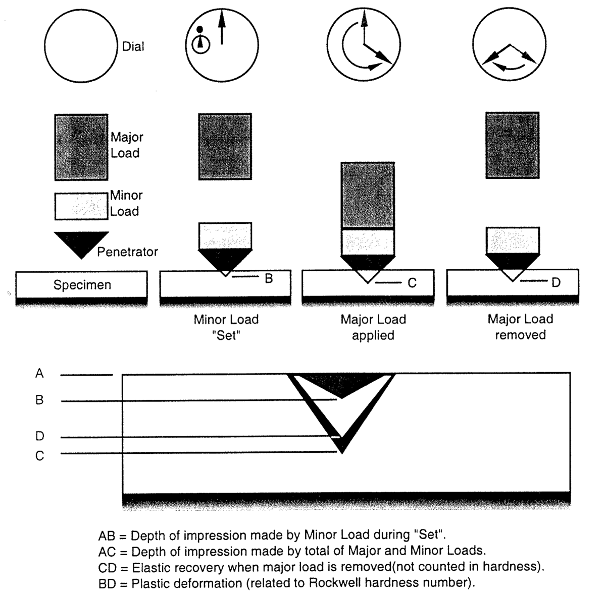

Figure. Schematic of the Rockwell hardness machine.

Note how the hardness is related to the ability of the material to resist indentation.

The load and the design of the penetrator used depend on the kind of material under study. For hard materials a diamond indenter and a 150 Kg major load are ordinarily used (Rockwell C scale). For softer material a 1/6” steel ball penetrator and 100 Kg load are commonly used (Rockwell B scale). A number of other scales are used for specific purposes. For testing surface hardened materials or thin samples a superficial hardness tester uses units of 0.001 mm.

The initial setting (labeled SET) of the dial is a ‘0’ on the black scale, for the diamond indenter, and the ‘30’ on the red scale, for the ball indenter. If the 1/16” ball indenters are used with samples harder than Rockwell B 100 they become flattened and gave incorrect readings; if samples of hardness lower than RB=0 are tested with the 1/16” ball and 100 Kg load, the chuck may contact the sample. The specimen must be carefully supported in the Rockwell test because any unrecovered vertical motion will change the apparent Rockwell hardness by one unit for every 0.002 mm displacement.

**Data Collection**

Specimens of several metals will be tested on Rockwell B, Rockwell C, and Brinell hardness testers. Rockwell hardness tests will be performed on both Aluminum and Stainless Steel. The tests done are conducted on both Rockwell C scale, with 150 kg major load, and Rockwell B scale, with 60 kg major load. When measuring Rockwell hardness, take three readings (for a statistical significant result) at different spots near the corner of the specimen and average the readings. The readings should be at least 1/8” apart so that they do not affect one another due to macroscopic bulk effects caused by the indentation in close proximity of one another.

A Brinell hardness test will then be performed on the same Aluminum specimen on the Brinell hardness testing indenter where the major load is a 3000 kg major load applied by a 10mm steal ball indenter. The diameter of the indent by the machine is then measured using a scope. The diameter is then used to calculate the Brinell Hardness Number (BHN) from the formula given in the introduction to this experiment.

For the third set of measurement, using the Aluminum specimen earlier in which a Brinell indent is made, take a series of three indentation measurements with the first indentation as close to the edge of the Brinell indent as possible using the Rockwell B hardness tester while the subsequent indentation are made with 1 mm spacing between each indentation in a linear row.

**Data Analysis**

In addition to data sheet entries and sample calculations, include your analyses of the following questions.

1. Tabulate the materials tested and their hardness, in order of increasing hardness. You may need to use the hardness conversion table (web or from the given sheet) to convert hardness values between each scale to be able to compare their hardness.

2. In the line scanning measurement from the Aluminum specimen, away and near to the Brinell indentation, compare the three values and explain why the hardness value near the Brinell indentation show a different value than the indentation further away from the Brinell indentation.

3. Why does the value of the following



increase more than the Brinell Hardness number for a given material with an increase of load in the Brinell tests? Would this quantity (load/projected area) be as good a hardness index as the BHN?

4. Identify all the specimen crystal structures and compare the hardness values you measured. Do you see any correlation between the crystal structure and the hardness? Why or Why not?

5. Using conversion charts provided in the lab (or web), convert average Rockwell A numbers to equivalent Brinell numbers. Can you suggest a reason for the poor agreement between converted and measured Brinell numbers in some cases?

6. A hardness test can be used to give a rough estimate of a material’s strength. A tensile test, in which a specimen is strained to failure (to be done in experiment 2) is a much more accurate test of strength. However, hardness tests are often preferred over tensile tests. Give three reasons why this is the case. Which test would you use in engineering design? Which test would you use for quality control?

**Summary**

This experiment provides the student practical experience with two hardness testing methods, and an understanding of the slight differences which do not allow the direct comparison of results from two different hardness tests. Understanding the mechanical properties of different materials and their relationship to the application of these materials as components in engineering strcutures is the most important concept to be learned from this experiment.

**Conclusion**

Please submit the Conclusions as a part of the Lab report, along with the Data sheets and Data Analysis.