Fall 2019

**Laboratory 4**

Fatigue testing

**Objectives**

- To understand the basic properties of strength and toughness of materials

- To determine the stress-cycle (S-N) diagram for a metal

**Reference**

ASTM Standards, specific references related to fatigue tests. Callister, section 8.7 - 8.11

**Background**

Fatigue refers to failure of materials under the action of repeated stresses. Fatigue failure in any metal can occur at stress levels well below the static yield strength of the metal. It is responsible for a large proportion of the failures in which variable or dynamic loads are encountered. In fatigue testing, the behavior of material is studied under repeated loads with specimens subjected to one or combination of the following types of loads: axial, bending (flexural), and torsional. When a bending load is used, as in this test, the stress is determined according to the relationship (flexure formula):



where

S = Elastic unit stress of the outer fiber

M = Bending moment

I = Moment of inertia about the neutral axis

c = Distance of outer fiber from the neutral axis

For a specimen with circular cross-section, the moment of inertia I, and the distance c can be expressed in terms of the diameter d as follows:

 and 

The ratio of I/c is known as section modulus.

The S-N diagram which shows the fatigue behavior is obtained by plotting the maximum stress (stress amplitude) against the number of cycles of loading sustained before failure. Fatigue failures can often be recognized from the appearance of the fracture. Two distinct zones can be identified: (1) A smooth zone near the fatigue crack itself which has been smoothed by the continual rubbing together of the cracked surfaces, and (2) a rough and crystalline-looking zone which is the final fracture. Occasionally the fatigue crack shows roughly concentric rings which correspond to successive positions of the crack. Most fatigue fractures originate as microscopic cracks, causing high concentration of stresses, and gradually spread to the point of fracture. Many of the microcracks originate as a result of slip lines formed from repeated stresses. Other sources that can originate small cracks are imperfections such as surface scratches, notches and inclusions. The effect of stress concentration caused by a change in cross-section can be studied through the use of standard filleted or notched specimens.

**Test Material and apparuatus**

Material : Aluminum alloy

Equipment : Rotating Beam Fatigue Testing Machine. (See Figure 1). The machine includes the following: A motor-driven spindle with adjustable speed between 500 to 10,000; a cycle counter; calibrated beam and weight arrangement which applies an end load to the rotating cantilever beam specimen through the load arm and collects; a cutoff switch with adjusting screw and reset.

**Test process**

Select a stress level below the yield strength of the material and determine the bending moment to be applied. Set Powerstat speed control to zero and move the weight to position "O". Clamp the specimen between the collets. The run-out at the free end should not exceed 0.001 in. and the total run-out should not exceed 0.004 in. Secure the Safety Guard around the load arm. Push down the Cutoff switch reset and adjust the Powerstat speed control to bring the machine up to the desired speed. A Powerstat control setting of 50 will give a speed of about 7000 rpm. Slowly move the weight along the calibrated beam to the desired moment setting and lock in place. Turn the counter quickly to zero without stopping the screw: first, by turning it counterclockwise to make the switch inoperative by the vacillating load arm; then by advancing the screw clockwise one half turn to have it at automatic cutoff position. Secure the safety bar over the end of the load bar. Following the failure of the specimen, record the counter reading which is in hundreds of revolutions or cycles. Repeat for a total of 4 selected stress levels.

**Test Results**

Plot the results of the four tests along with those given on the data sheet on an S-N Diagram which is a plot of S vs. log(N). From the diagram determine the endurance limit (if one is indicated) or the fatigue strength at a service life of  and . The endurance limit or the fatigue limit is the maximum fluctuation stress a material can withstand for an indefinite number of cycles without rupture. Fatigue strength is the stress at which a material fractures by fatigue after a specified number of cycles. Superimpose on the S-N diagram. Examine the fatigue fracture and briefly describe its appearance.

**Lab Report**

Students should hand in a brief laboratory report containing:

1. Introduction
2. Quick Methods (read test process)
3. Results/Data Sheets (any sample calculations)
4. Data analysis (answer to questions)
5. Conclusion

*include original lab instructions

**Data Analysis and questions**

For one of the test specimens, plot stress vs. time for one complete cycle of loading showing maximum tensile and compressive stresses.

1. Does the fatigue fracture show any evidence of elongation (plastic deformation)? Compare its appearance with that of the fracture of a tensile specimen.

2. From the S-N curve, determine the load that corresponds to a fatigue life of 100,000 cycles. Using a factor of safety of 1.2, what is the maximum stress you can apply on this material if it is to survive 100,000 cycles?

3. List the major factors, which will influence the fatigue strength of a material.

4. The specimen used in this test is not ground (i.e., not smooth). If the specimen is ground before testing, would you expect similar S-N curve? Explain.

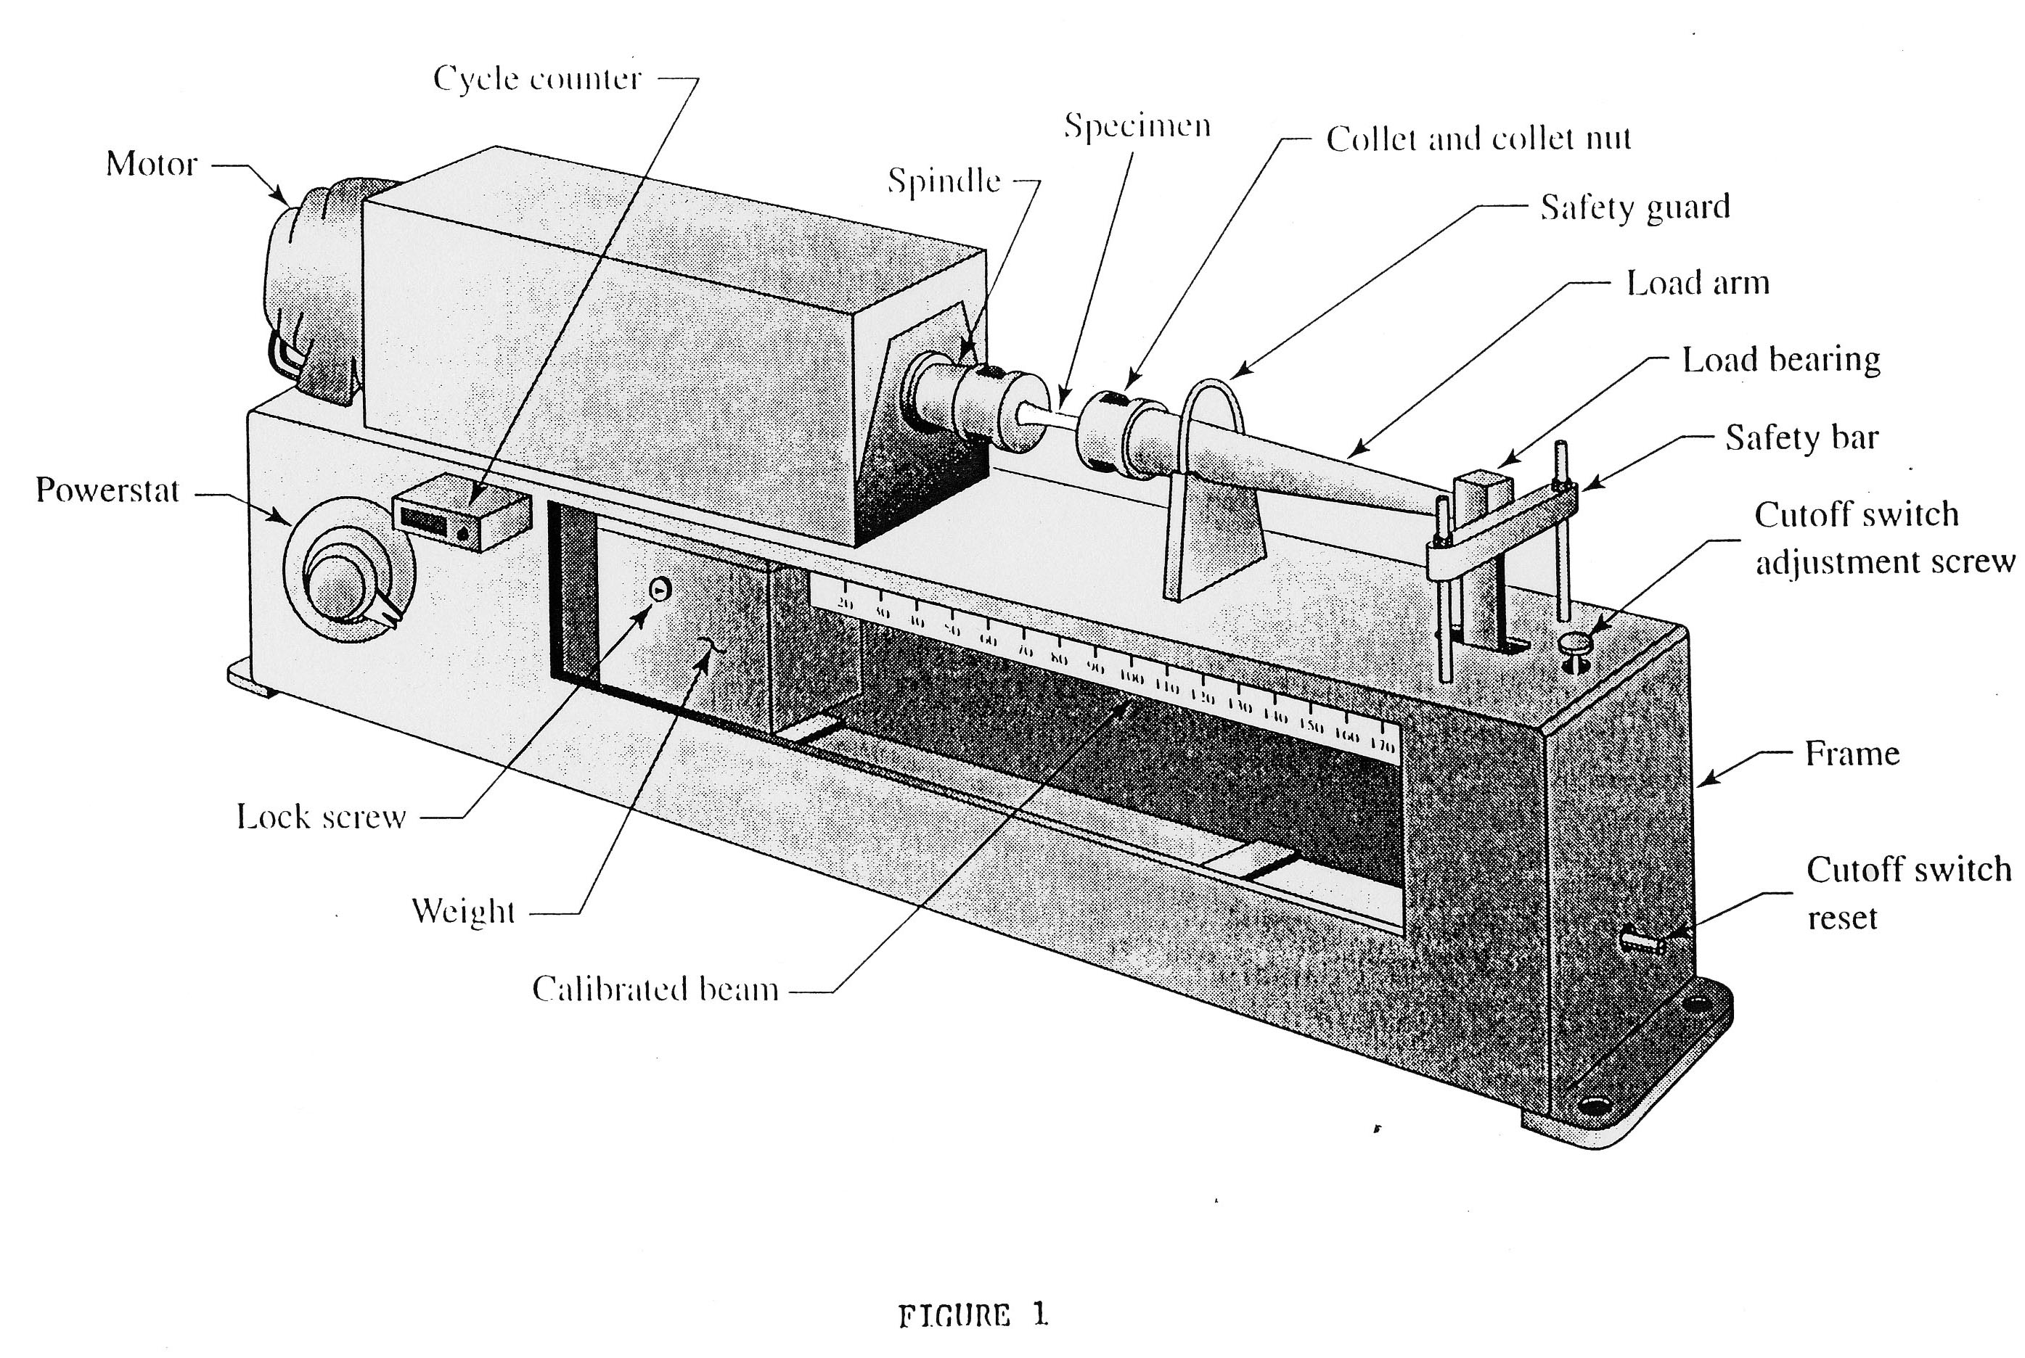

Course_____________ Term______________ Section_______ Instructor__________________

DATA SHEET - FATIGUE TEST

Material_____________________ Specimen_________20_____________

Machine_____________________ Machine Speed_________________

Mean Stress__________________ Bending Moment________________

Material_____________________ Specimen_________21_____________

Machine_____________________ Machine Speed_________________

Mean Stress__________________ Bending Moment________________

Material_____________________ Specimen__________22____________

Machine_____________________ Machine Speed_________________

Mean Stress__________________ Bending Moment________________

Material_____________________ Specimen__________23____________

Machine_____________________ Machine Speed_________________

Mean Stress__________________ Bending Moment________________

|  |  |  |  |  |  |  |
| --- | --- | --- | --- | --- | --- | --- |
| Specimen  Number | Bending  Moment  (in-lb) | Stress  Amplitude  (psi) | RPM | Start  Date/Time | Number  of Cycles | Diameter of specimen (inch) |
| 1 | 40 |  | 5000 |  | 9200 | 0.188 |
| 2 | 30 |  | 5000 |  | 46200 | 0.187 |
| 3 | 55 |  | 4000 |  | 5600 | 0.190 |
| 4 | 60 |  | 5000 |  | 1300 | 0.186 |
| 5 | 28 |  | 4000 |  | 74800 | 0.187 |
| 6 | 50 |  | 4000 |  | 5000 | 0.185 |
| 7 | 20 |  | 4000 |  | 127200 | 0.185 |
| 8 | 25 |  | 5000 |  | 104800 | 0.18 |
| 9 | 17 |  | 5000 |  | 338600 | 0.18 |
| 10 | 35 |  | 5000 |  | 17400 | 0.18 |
| 11 | 28 |  | 5000 |  | 87800 | 0.189 |
| 12 | 24 |  | 5000 |  | 182400 | 0.189 |
| 13 | 10 |  | 5000 |  | 25584000 (run out) | 0.189 |
| 14 | 27 |  | 5000 |  | 55000 | 0.182 |
| 15 | 22 |  | 5000 |  | 278500 | 0.189 |
| 16 | 19 |  | 5000 |  | 445900 | 0.192 |
| 17 | 30 |  | 5000 |  | 44700 | 0.184 |
| 18 | 20 |  | 5000 |  | 390700 | 0.186 |
| 19 | 25 |  | 5000 |  | 61100 | 0.184 |
| 20 |  |  |  |  |  |  |
| 21 |  |  |  |  |  |  |
| 22 |  |  |  |  |  |  |
| 23 |  |  |  |  |  |  |
| 24 |  |  |  |  |  |  |
| 25 |  |  |  |  |  |  |
| 26 |  |  |  |  |  |  |