SOLO STRATEGIST

Alphabet
The Compounding Intelligence Engine
────────────────────────────────────────
A Deep-Dive Case Study on AI-Era Infrastructure Value
February 16th 2026 | NASDAQ: GOOGL
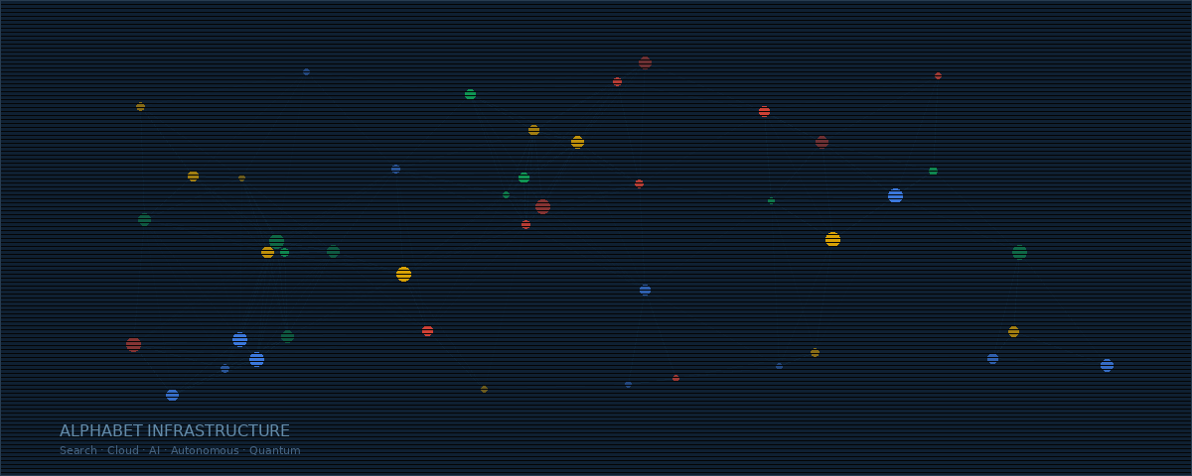
Alphabet is not merely the world’s dominant search company. It is a vertically integrated intelligence utility, operating across the full spectrum of computational infrastructure: from the physical layer of data centres and custom silicon, through the platform layer of cloud services and AI models, to the application layer of autonomous mobility and quantum research. At approximately $306 per share and a market capitalisation of $3.7 trillion, the equity presents a compelling case for long-term allocators prepared to look past near-term capital expenditure concerns.
I. THE INVESTMENT THESIS: TEMPORARY NOISE, PERMANENT VALUE
In the days following Alphabet’s Q4 2025 earnings release on 4 February 2026, shares fell approximately 6% despite the company delivering record results across every major metric. The catalyst for the sell-off was a single data point: projected 2026 capital expenditure of $175–$185 billion, nearly double the $91.5 billion spent in 2025, and significantly above consensus expectations of ~$120 billion. This pattern is now familiar to students of hyperscaler capital cycles.
Bearish Concerns and Our Rebuttal
Concern 1: CapEx is unsustainable and will destroy free cash flow.
Alphabet generated $73.3 billion in free cash flow for the full year 2025 and $164.7 billion in operating cash flow. The company ended Q4 with $126.8 billion in cash and marketable securities. Furthermore, Alphabet raised $24.8 billion via senior unsecured notes in November 2025 and a further $20 billion in February 2026, demonstrating the bond market’s confidence in its creditworthiness. This is a company that can comfortably fund its ambitions without diluting shareholders.
Concern 2: Antitrust rulings will dismantle the ecosystem.
In September 2025, Judge Amit Mehta rejected the DOJ’s most severe proposed remedies, including the forced divestiture of Chrome and Android. The ruling imposed behavioural remedies, primarily banning exclusive default search contracts and requiring limited data sharing with competitors. Multiple legal commentators described it as a “best-case scenario” for Alphabet. Whilst the DOJ has filed an appeal, the structural integrity of Alphabet’s ecosystem remains intact. A separate ad-tech antitrust case is pending, but the search ruling sets a precedent of judicial restraint towards structural breakup.
Concern 3: AI search will cannibalise advertising revenue.
The evidence suggests precisely the opposite. Google Search revenue accelerated to 17% year-on-year growth in Q4 2025, reaching $63.1 billion, whilst AI Overviews now serve 2 billion monthly users. CEO Sundar Pichai noted that “Search saw more usage than ever before, with AI continuing to drive an expansionary moment.” The company is actively monetising AI Mode through Direct Offers and ads below AI responses, creating new inventory rather than cannibalising existing inventory.
II. QUANTITATIVE ANALYSIS: RECORD-BREAKING FUNDAMENTALS
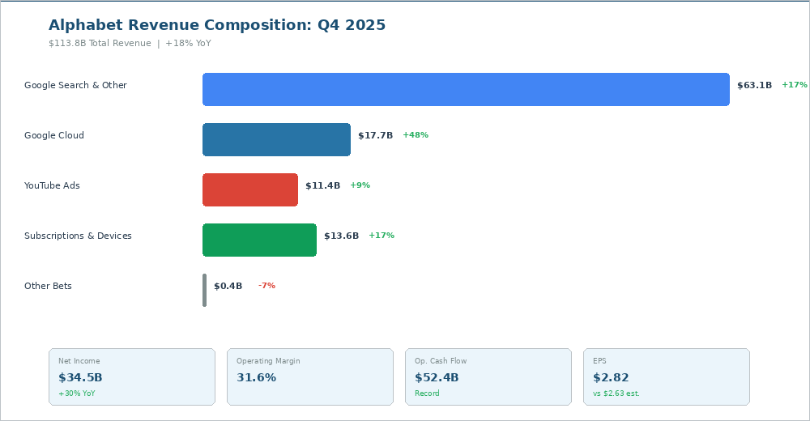
Figure 1: Alphabet Q4 2025 Revenue Composition and Key Financial Metrics
Revenue Trajectory
Alphabet’s consolidated revenue reached $113.8 billion in Q4 2025, an 18% increase year-on-year and an acceleration from 16% in Q3. For the full year, revenue crossed $400 billion for the first time, reaching $402.8 billion. Every major segment contributed: Google Search grew 17%, Google Cloud surged 48%, YouTube’s combined advertising and subscription revenue exceeded $60 billion annually, and consumer paid subscriptions surpassed 325 million across Google One, YouTube Premium, and related services.
Profitability and Capital Efficiency
Net income for Q4 reached $34.5 billion, up 30% year-on-year, with diluted EPS of $2.82 against consensus estimates of $2.63. Operating margin held steady at 31.6%, with Google Services achieving an impressive 41.9% operating margin, up from 39.0% a year prior. Crucially, Gemini serving unit costs fell 78% over 2025 through model optimisations and efficiency improvements, demonstrating that AI costs are declining on a per-unit basis even as absolute spending increases.

Metric | Q4 2025 | Q4 2024 | YoY Change
Total Revenue | $113.8B | $96.5B | +18%
Net Income | $34.5B | $26.5B | +30%
EPS (Diluted) | $2.82 | $2.15 | +31%
Operating Margin | 31.6% | 32.1% | -0.5pp
Operating Cash Flow | $52.4B | $36.2B | +45%
Google Cloud Revenue | $17.7B | $12.0B | +48%
III. GOOGLE CLOUD: THE AI INFRASTRUCTURE LANDLORD
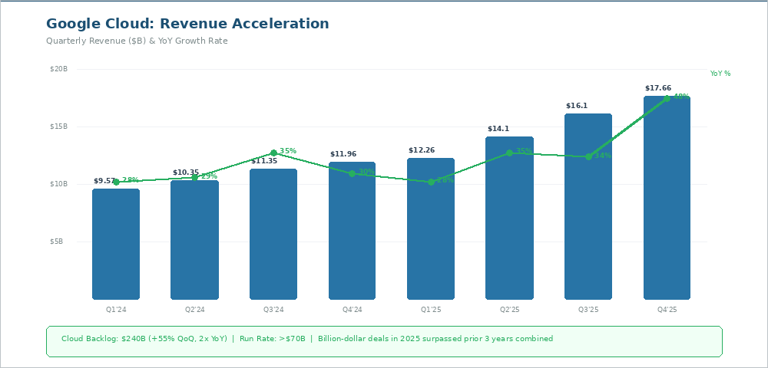
Figure 2: Google Cloud Quarterly Revenue and Growth Rate Acceleration
Google Cloud represents perhaps the most compelling growth story within Alphabet. Revenue surged 48% to $17.7 billion in Q4, materially above consensus expectations of $16.2 billion. The segment now operates at an annual run rate exceeding $70 billion. More importantly, the backlog tells the forward story: $240 billion at year-end, having grown 55% sequentially and more than doubled year-on-year.
The qualitative indicators are equally striking. The number of deals exceeding $1 billion in 2025 surpassed the previous three years combined. New customer acquisition velocity doubled between Q1 and Q4. Existing customers are outpacing their initial commitments by over 30%. Nearly 75% of Google Cloud customers now utilise vertically optimised AI services, and these AI-engaged customers consume 1.8 times as many products as non-AI customers, creating powerful cross-selling dynamics.
In a landmark validation of its cloud credentials, Google Cloud secured a multi-million dollar contract with the NATO Communication and Information Agency (NCIA), placing it alongside AWS and Azure as a trusted platform for sovereign and defence workloads.
IV. GEMINI: FRONTIER INTELLIGENCE AT SCALE
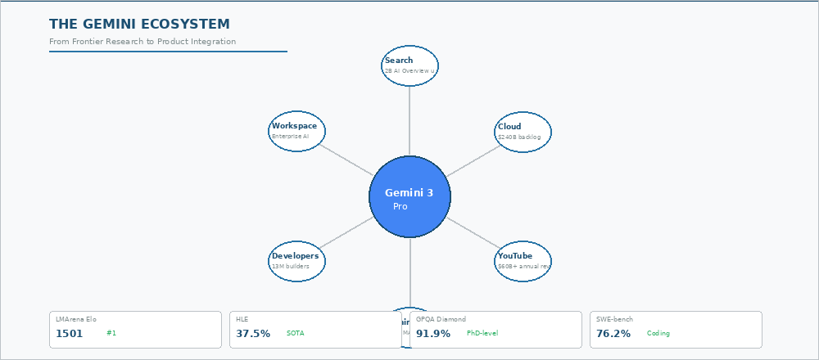
Figure 3: The Gemini 3 Ecosystem and Benchmark Performance
The launch of Gemini 3 in November 2025 marked a watershed moment for Alphabet’s AI ambitions. The model immediately topped the LMArena leaderboard with an unprecedented 1,501 Elo score, the first model to break the 1,500 barrier. On Humanity’s Last Exam, a benchmark designed to test PhD-level expertise, Gemini 3 Pro scored 37.5% without tools, surpassing GPT-5 Pro’s previous high of 31.6%. The Deep Think reasoning mode pushed this further to 41.0%.
In mathematics, Gemini 3 Pro achieved a perfect 100% on AIME 2025 with code execution, and 95% without. On GPQA Diamond, it reached 91.9%. Perhaps most impressively, ARC-AGI-2 scores leapt from 4.9% (Gemini 2.5 Pro) to 31.1%, with Deep Think reaching 45.1%, an order-of-magnitude improvement that suggests genuinely novel reasoning capabilities rather than mere pattern matching.
Critically, Gemini is not merely a research achievement; it is deeply embedded in commercial products. The Gemini App now exceeds 750 million monthly active users. Over 13 million developers build with Gemini models. The API processes over 10 billion tokens per minute. Gemini 3 Flash, released in December 2025, matches Pro-grade reasoning at a fraction of the cost, and is now the default model across the Gemini App and AI Mode in Search.
The competitive moat here is financial as much as technical. Alphabet can subsidise Gemini’s adoption through its $82 billion quarterly advertising revenue, pricing aggressively to win market share in ways that standalone AI companies simply cannot sustain.
V. WAYMO: FROM MOONSHOT TO COMMERCIAL REALITY
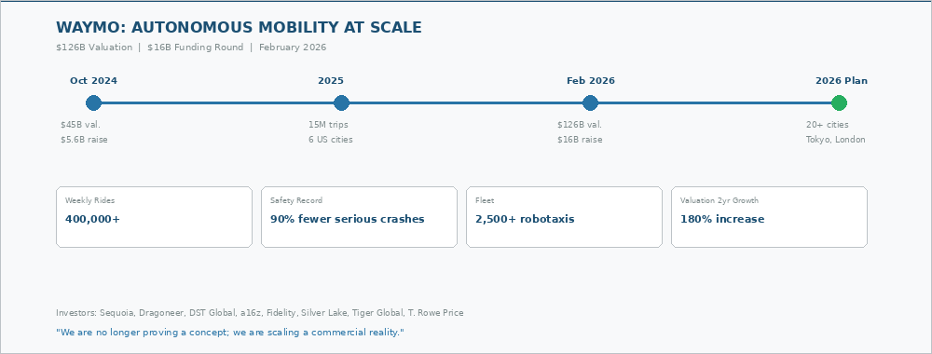
Figure 4: Waymo’s Trajectory from R&D to Global Autonomous Mobility
In February 2026, Waymo raised $16 billion at a post-money valuation of $126 billion, nearly tripling its $45 billion valuation from October 2024. The funding round, led by Dragoneer, DST Global, and Sequoia Capital, reads as a who’s who of institutional tech investing: firms that do not write $16 billion cheques without extensive due diligence.
The operational metrics underpin the valuation. Waymo now delivers over 400,000 paid rides weekly across six US cities, having completed 15 million trips in 2025 alone. Its safety record, with 90% fewer serious crashes than human drivers across 127 million autonomous miles, provides the regulatory confidence necessary for expansion. The 2026 roadmap is ambitious: deployment across 20+ new cities, including New York, Dallas, Denver, Washington D.C., and critically, London and Tokyo, marking Waymo’s first international operations.
For Alphabet’s equity valuation, Waymo’s $126 billion standalone value is material. It represents approximately 3.4% of Alphabet’s market capitalisation, yet is buried within the loss-making “Other Bets” segment that many analysts effectively assign zero value. This is a classic case of sum-of-the-parts mispricing.
VI. QUANTUM COMPUTING: WILLOW AND THE LONG FRONTIER
Google Quantum AI’s Willow processor, a 105-qubit superconducting chip, achieved the first below-threshold quantum error correction in December 2024, cracking a challenge the field had pursued for nearly 30 years. In October 2025, Google announced the “Quantum Echoes” algorithm, the first verifiable quantum advantage on hardware, running 13,000 times faster than the world’s most powerful supercomputer on a scientifically meaningful task. The result was published in Nature.
We maintain intellectual honesty here: commercially meaningful quantum computing remains years, perhaps a decade, away. Current demonstrations are scientifically impressive but limited in practical scope. However, the strategic value lies in option convexity. If quantum computing delivers on even a fraction of its theoretical promise in materials science, drug discovery, or cryptography, Alphabet’s decade-long head start and dedicated fabrication facility in Santa Barbara represent an asymmetric upside that the market assigns no premium to. Google has opened Willow access to UK researchers via the National Quantum Computing Centre, a move that accelerates practical applications whilst strengthening Alphabet’s position at the frontier.
VII. RISK ASSESSMENT
Value Trap Check
Verdict: Definitively not a value trap.
• Revenue growing at 18% on a $400 billion base
• Operating margins above 31%, with Google Services at 42%
• Free cash flow of $73.3 billion annually
• Google Cloud accelerating, not decelerating
Hype Check
Unlike pure-play AI companies trading on narrative, Alphabet’s AI thesis is already generating measurable revenue. Google Cloud’s 48% growth is driven by paying enterprise customers, not speculative future demand. The 78% reduction in Gemini serving costs over 2025 demonstrates improving unit economics, not cost escalation.
Antitrust Risk Assessment
The September 2025 search ruling was materially more favourable than bears anticipated. Chrome and Android remain intact. The DOJ’s appeal introduces uncertainty, but the judicial precedent of behavioural over structural remedies provides a reasonable base case. The ad-tech case remains a monitoring point, though potential remedies to the advertising stack carry less existential risk to the core business than a Chrome or Android divestiture would have.
VIII. DISCOUNTED CASH FLOW ANALYSIS: INTRINSIC VALUE DERIVATION
We construct a ten-year two-stage DCF model to derive Alphabet’s intrinsic value. Our approach discounts projected unlevered free cash flows to the firm and applies a terminal value based on a perpetuity growth model. We deliberately lean towards conservative assumptions in early years and allow the compounding effect of Alphabet’s structural advantages to drive the valuation outcome.
Key Assumptions
Weighted Average Cost of Capital (WACC): 8.5%
We apply a WACC of 8.5%, moderately above the consensus estimate of 7.45% (per Alpha Spread) to introduce conservatism. This reflects a cost of equity of approximately 8.6% (risk-free rate of 4.3%, equity risk premium of 4.8%, beta of 0.9) and a negligible cost of debt given Alphabet’s minimal leverage (debt-to-capital ratio below 1%).
Revenue Growth Assumptions
We model a two-phase trajectory. Phase 1 (2026–2030) captures the AI infrastructure build-out and Cloud’s hypergrowth, with consolidated revenue CAGR of 14%. Phase 2 (2031–2035) models maturation as CapEx intensity normalises, with CAGR decelerating to 10%. These assumptions are supported by Alphabet’s 14-year historical revenue CAGR of 18% and the consensus projected 3-year CAGR of 13%.
Margin Trajectory
We project operating margins expanding from 31.6% (FY2025) to 37% by 2030 and 40% by 2035, driven by three structural forces: Google Cloud’s margin expansion from 23.7% towards AWS-like levels of 35%+, declining Gemini serving costs (78% reduction achieved in 2025 alone), and CapEx intensity normalising as the AI infrastructure build-out matures. Free cash flow margins expand from approximately 18% (FY2025, depressed by peak CapEx) to 28% by 2030 as capital spending moderates.
Terminal Growth Rate: 3.5%
We apply a terminal growth rate of 3.5%, above the standard 2.5–3.0% range, reflecting Alphabet’s unique positioning at the intersection of AI, cloud infrastructure, and autonomous mobility, each of which represents secular growth tailwinds that should persist well beyond the explicit forecast horizon.
Shares Outstanding: ~12.2 billion
We assume modest ongoing share buybacks, reducing the diluted share count from approximately 12.2 billion to 11.5 billion by 2035, consistent with Alphabet’s historical capital return programme.
Projected Free Cash Flow to Firm

Year | Revenue ($B) | Op. Margin | FCF Margin | FCFF ($B)
2025A | $402.8 | 31.6% | 18.2% | $73.3
2026E | $462 | 29.0% | 12.0% | $55.4
2027E | $527 | 31.5% | 18.0% | $94.9
2028E | $601 | 33.5% | 22.0% | $132.2
2029E | $680 | 35.5% | 25.0% | $170.0
2030E | $766 | 37.0% | 28.0% | $214.5
2031E | $843 | 37.5% | 29.0% | $244.5
2032E | $927 | 38.0% | 30.0% | $278.1
2033E | $1,020 | 39.0% | 31.0% | $316.2
2034E | $1,112 | 39.5% | 31.5% | $350.3
2035E | $1,201 | 40.0% | 32.0% | $384.3

Note: 2026E FCF margin is deliberately compressed to 12% to reflect the peak CapEx year ($175–$185B guidance). This is the “worst year” in the model and is precisely the trough that creates the current buying opportunity.
Valuation Output
Discounting the projected free cash flows at our 8.5% WACC and applying a terminal value using the Gordon Growth Model:

Component | Value
PV of Explicit Period FCFs (2026–2035) | $1,209B
Terminal Value (at 3.5% perpetuity growth) | $7,949B
PV of Terminal Value | $3,466B
Enterprise Value | $4,675B
Less: Net Debt (Debt $46.5B – Cash $126.8B) | +$80.3B
Equity Value | $4,755B
Diluted Shares Outstanding | ~12.2B
Intrinsic Value Per Share | $390

At the current share price of approximately $306, this implies a Margin of Safety of approximately 22% and a potential upside of 27% to our base-case intrinsic value.
Sensitivity Analysis: WACC vs. Terminal Growth Rate
The DCF output is sensitive to the discount rate and terminal growth assumptions. The matrix below presents intrinsic value per share across a range of scenarios:

WACC → / TGR ↓ | 7.5% | 8.0% | 8.5% | 9.0% | 9.5%
2.5% | $398 | $362 | $332 | $306 | $284
3.0% | $432 | $390 | $355 | $326 | $301
3.5% (Base) | $474 | $424 | $390 | $349 | $320
4.0% | $528 | $466 | $415 | $376 | $343
4.5% | $600 | $521 | $458 | $408 | $368

The shaded diagonal (7.5% WACC / 2.5% TGR through 9.5% WACC / 4.5% TGR) represents roughly equivalent risk-return profiles. Our base case of 8.5% / 3.5% sits in the centre. Even in a bear scenario (9.5% WACC, 2.5% TGR), intrinsic value of $284 implies only ~7% downside from the current price, demonstrating the asymmetric risk-reward profile.
Sum-of-the-Parts Cross-Check
As a validation of the DCF, we construct a segment-level sum-of-the-parts (SOTP) analysis:

Segment | Metric | Multiple | Implied Value
Google Services | $382B rev (FY25) | 5.5x Revenue | $2,101B
Google Cloud | $70B+ run rate | 15x Revenue | $1,050B
Waymo | External valuation | 1.0x | $126B
Other Bets / Quantum | Option value | Nominal | $30B
Less: Net Cash |  |  | +$80B
Total Equity Value |  |  | $3,387B
Per Share (conservative) |  |  | $278
Per Share (w/ Cloud at 20x) |  |  | $407

The SOTP range of $278–$407 brackets and corroborates our DCF base case of $390. The variance is driven almost entirely by the multiple assigned to Google Cloud; as Cloud margins converge towards AWS levels and the $240 billion backlog converts, the upper end of this range becomes increasingly defensible.
IX. PRICE TARGETS, ENTRY POINTS & POSITION SIZING
The Solo Strategist Price Targets

Scenario | 12-Month Target | Intrinsic Value | Implied Return
Bear Case | $285 | $330 | -7% from current
Base Case | $370 | $390 | +21% from current
Bull Case | $430 | $470 | +41% from current

Bear Case ($285 / 12-month): Assumes antitrust appeal introduces new structural risk, Cloud growth decelerates to 25–30%, and AI monetisation stalls. Even here, the core advertising business alone supports a floor valuation near $280 on a 20x forward earnings multiple.
Base Case ($370 / 12-month): Cloud continues at 35%+ growth, Gemini monetisation gains traction, CapEx guidance for 2027 moderates (signalling the inflection point), and Waymo expansion proceeds on schedule. This aligns with the median Wall Street analyst target of $370 and our DCF-derived value of $390.
Bull Case ($430 / 12-month): Cloud accelerates further on AI demand, Gemini captures significant share from OpenAI, Waymo announces an IPO timeline or additional external funding at $150B+ valuation, and the ad-tech antitrust case resolves favourably. The highest analyst target on Wall Street stands at $443, corroborating this scenario.
Optimal Entry Points
For the disciplined value allocator, we identify three tiers of entry based on our DCF-derived margin of safety:

Entry Tier | Price Range | Margin of Safety | Action
Tier 1: Accumulate | $290–$310 | 20–26% | Begin building core position
Tier 2: Strong Buy | $260–$290 | 26–33% | Aggressive accumulation
Tier 3: Exceptional | Under $260 | >33% | Maximum conviction

Current Assessment (February 2026): At ~$306, Alphabet sits squarely in Tier 1 territory. The stock offers a 22% margin of safety to our base-case intrinsic value of $390 and trades at approximately 28.5x trailing earnings, below its 5-year average P/E of ~33x and significantly below peak multiples of 40x+. For context, the consensus 12-month target of $370 implies 21% upside, whilst the highest analyst target of $443 implies 45%.
The most likely catalyst for a Tier 2 or Tier 3 entry would be a further market overreaction to quarterly CapEx disclosures, an adverse antitrust headline, or a broader technology sector rotation. Each of these would represent noise, not signal, and should be treated as buying opportunities by the long-term allocator.
Catalysts for Re-Rating:
• Q1/Q2 2026 earnings confirming Cloud revenue acceleration above 40%
• Any moderation in forward CapEx guidance, signalling the inflection point
• Waymo IPO speculation or further external funding at higher valuations
• Gemini 3 market share gains validated by third-party data
• Resolution of antitrust appeals with structural integrity preserved
SUMMARY VERDICT & STRATEGIC VIEW
Alphabet represents a High-Conviction Structural Position. The market’s fixation on near-term CapEx guidance has created a valuation anomaly in a company that dominates search, is winning the cloud infrastructure race, fields arguably the world’s most capable AI model family, and owns the only commercially operational robotaxi fleet at global scale.

Key Data Point | Current
Market Capitalisation | $3.7 Trillion
Current Price | ~$306
DCF Intrinsic Value (Base) | $390 per share
Margin of Safety | 22%
12-Month Target (Base) | $370
12-Month Target (Bull) | $430
Optimal Entry (Strong Buy) | $260–$290
Waymo Standalone Valuation | $126B
“Alphabet is not spending into the void. It is converting capital expenditure into the infrastructure of intelligence, and the market is still pricing the bricks whilst ignoring the building.”
THE SOLO STRATEGIST TACTICAL VIEW
At ~$306, Alphabet offers a 22% margin of safety to intrinsic value. Any pullback below $290 represents a Strong Buy. Periods of CapEx-driven sentiment weakness are accumulation opportunities for the disciplined, long-term allocator.


Disclaimer: This analysis is for informational purposes only and does not constitute investment advice.
Interested in a complementary analysis of defensive portfolio positions? Let us know if you would like a similar deep-dive on countercyclical assets to balance this growth-heavy position.

