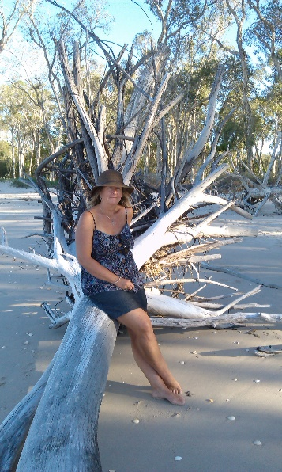Lisa Gordon

Ballina NSW 2478 | 0448968377 |

Email: lisagordonart@gmail.com

Statement

I am an emerging artist. I am a painter and drawer working in various mediums. Primarily my paintings are in oil or gouache and my drawings are typically graphite and charcoal. I also make my own natural washes from tea, coffee and onion skins.

My work is often figurative with a strong focus on the portrait, although I am just as happy drawing on images from nature.

What makes us unique as humans is our ability to contemplate. My themes will generally explore the human condition and the relationship of our internal world to the physical world. I want to visually explore my curiosity and the observation of ourselves and the world around us.

Education

Diploma Visual Arts (Achieved at Distinction level)

2015 TAFE North Coast Institute

*Studied under*:

Hobie Porter

Nicole Voevodin-Cash

Exhibitions

*Solo Exhibitions*

2016 *Art on the Beach* Greenmount QLD

2016 Unik. Kirra QLD

*Group Exhibitions*

2018 Finalist

*Gallery 7* Byron Bay NSW

2016 Finalist

*Brisbane Art Prize* Fortitude Valley Brisbane QLD

2016 Finalist

*Lethbridge 10 000 Small Scale Art Awards* Paddington Brisbane QLD

2016 Bentley Art Prize

2016 Ocean Shores Art Expo

2015 *Border Art Prize* Gold Coast Art Centre Surfers Paradise

2015 *Noel Chettle Memorial Art Prize Fund*

Collections

*Public Collections*

Headspace. Carmarco Building. Wharf St Tweed Heads NSW

*Private Collections*

Works held in the Gold Coast QLD, Northern Rivers Area NSW, Central Coast NSW and Canberra ACT.