**VIX analysis on SPX Index**

***Langyu Gu***

***16/05/2017***

VIX is known as the “fear Index” in the investment field. Investors seek protection by purchasing options which is measured by VIX index. The purpose of the report is to carry out an analysis on VIX and find out if VIX has predictability for forward returns on SPX Index.

The analysis is split into the following five parts:

* Level of VIX Index
* Level of VIX Index with momentum
* VIX and Valuation
* VIX one-day spike
* VIX futures term structure

Each part will discuss the respective items in order to reveal the explanatory power on SPX Index. The behaviour of VIX index will also be discussed throughout the report.

**A High level summary:**

**Level of VIX:** does not provide useful predictability of SPX’s forward return.

**Level of VIX with momentum:** is an improved model of the above. The VIX level of [22,28] along with an uptrending VIX indicates an average of -3.5% of forward 12 months return.

**VIX and Valuation:** we have constructed the factor score, which is a blended score of the VIX and valuation factors. The current score has reached the highest level that has never seen before. The second high score has appeared in 1999.

**VIX one-day spike:**  is only a short-lived phenomenon and does not provide predictability of long-term crisis. However, it can be used as a short-term mean-reversion signal to buy on SPX.

**VIX futures term structure:** has medium-term projection on market uncertainty. Although the trading strategy built on SPX index using VIX futures term structure performs poorly, the signal applies on VIX futures trading has significant outperformance with after-cost Sharpe Ratio of 1.4.

**Level of VIX Index**

At the first instance, people question if Level VIX could provide any insight on bear knocking down bull. I have pulled out the forward 6 months and 12 months returns of SPX respectively with respect to VIX Level. The pure VIX level does not provide much useful information as all levels show positive forward returns but we know that there are several crises happened in the analysed historical data since 1990.



**Chart 1**

However, under the comparison to average forward 6 months and 12 months returns, the level between [16, 27] show weaker forward returns than the averages. The levels are highlighted in pink in the above table.

**Level of VIX with momentum**

On top of the VIX level, we take a step further to add momentum onto the VIX level in order to determine uptrend/ downtrend on VIX. Subsequently, we examine the forward returns with respect to both directions of trend and the level of VIX.

The trend is defined by short term exponential moving average (ST_EMA) crossing long term exponential moving average (LT_EMA). Uptrend is defined when ST_EMA crossing above LT_EMA and downtrend is defined when ST_EMA crossing below LT_EMA. Based on our “big data tuning engine”, we define the optimal short-term and long-term EMA parameters are 21 and 250 Days.

The below tables are split into uptrend and downtrend tables.

**Two key takeaways from the tables:**

* When VIX is trending upward and trading at the level of [22, 28], SPX has negative forward 12 months returns at -3.5%. We often see that VIX spikes to much higher level when it is trading at the range.
* When VIX is trending downward and trading above 26, SPX on average has significantly higher return with average 12 months forward returns of 21.4%. High VIX levels often follow a sharp decline in the market. Meanwhile, VIX is trending downward means that fear in the market starts fading away. It makes sense that when these two signals appear together, SPX is expected to deliver excessive high returns.





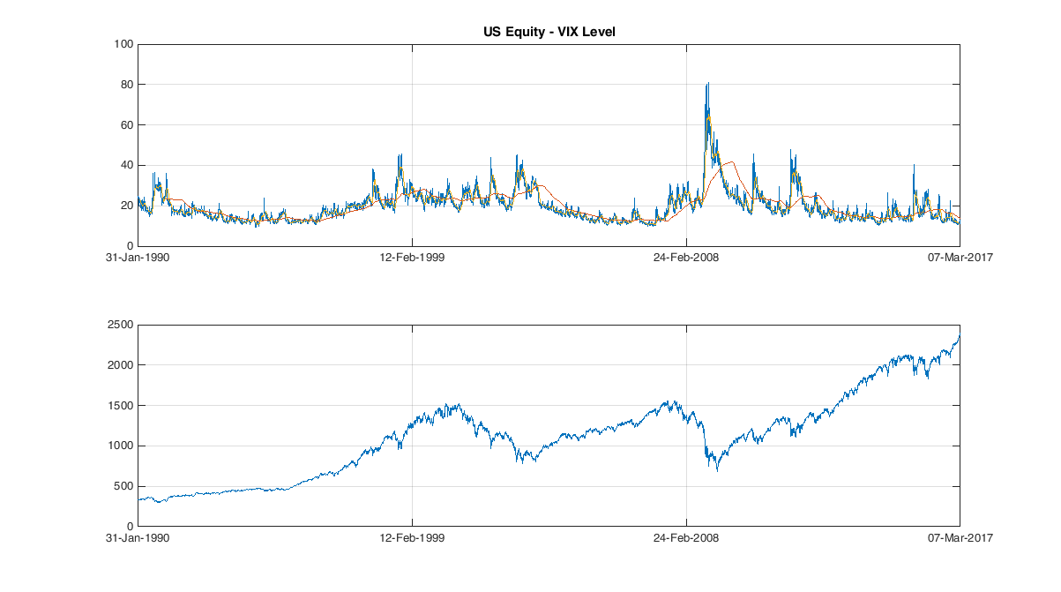

**VIX and Valuation**

A combination views on VIX and valuation is an interesting topic to explore. Recall that current VIX is at 11 the historical low level and the current PE level is at 22, which is the highest level since 2009. Looking back to the past two bear markets, 1999 tech bubble and 2008 financial crisis, we find some similarities of current situation with the two crises. From valuation perspective, the current market PE is being stretched and it is mainly contributed by technology stocks. It is similar to 1999, although the PE has not yet reached the extreme level of 30 as we have seen in 1999. It is because a certain part of Information technology sector is considered as value stocks rather than grow stocks in 1999. But VIX was at 19-20 level in 1999. From volatility perspective, the current VIX has reached the historical low level. Such low level was only observed in pre-2008 financial crisis period. However, the valuation was not expensive at the time. Therefore, the current market can be seen as the “combination” of 1999 and 2008 crisis. Its combined factor of volatility and valuation has reached an unprecedented level, as we will illustrate below.

We constructed the combined factor by combining the z-scores on PE ratio and price index and inverse z-scores on VIX index. As you can see in the below chart, the current factor score has reached the highest level in 20 years, as shown at the blue dotted line in the below chart. The second highest level appears in 1999. Its forward 6 months, 12 months and 36 months returns are 3.0%, -3.1% and -37.8% respectively.

We took a step further to see whether the factor is able to predict a downtrend in a shorter term. We calculated the MACD signal as the factor score minus its 40-days moving average in order to detect the speed of changes on the factor score. For the purpose of better illustration, we built the “trading model” which is based on the signal and examine the quality by revealing its performance. In order to avoid long-only bias in US market, we looked at the performance of the long-short and short only portfolios. Both of portfolios have delivered positive returns. Especially the trade signals for short-only portfolio are only generated in 2001, 2008 and the most recent one in 2016.

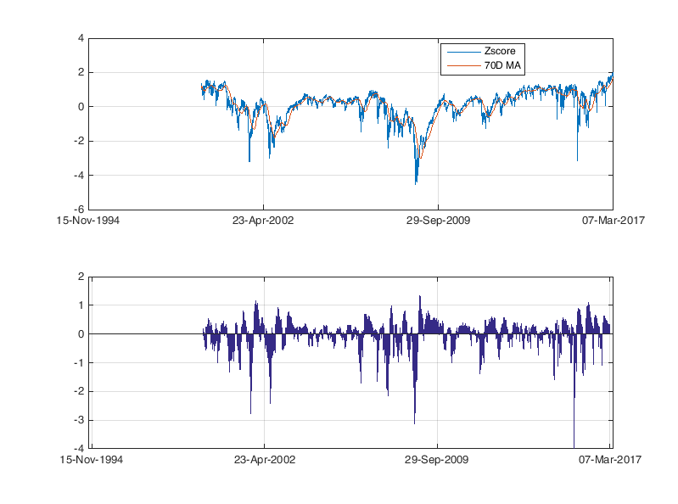

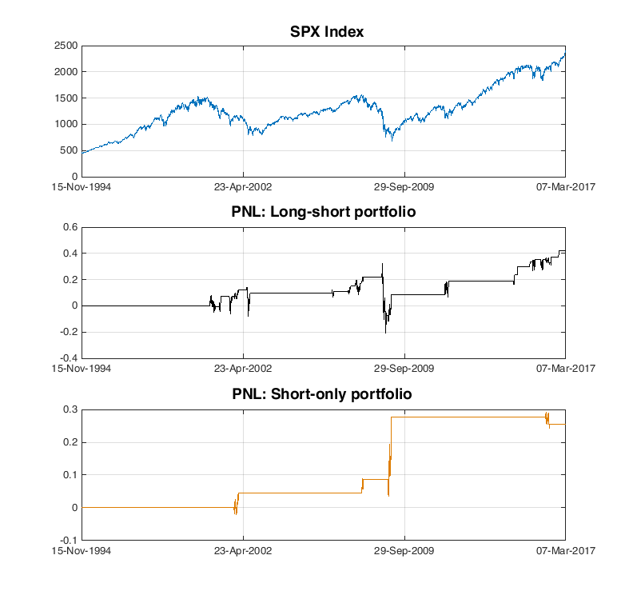

**VIX one-day Spike**

We often see the VIX spikes when black swan events happen. On the remarkable “Brexit day” 23/06/16, VIX increased by 50% from 17.3 to 25.8. The move came in the conjunction with 3.4% decline in SPX index. The question we would like to ask is that would the VIX spike, whether it is caused by black swan events like Brexit or it comes out of nowhere, able to predict the “big cliff” in the market ahead.

We collated the largest one-day VIX spike in the recent three decades of VIX history. We observed that there is a significant increase in number of days that VIX spikes more than 15% during the years of 2007 and 2008. In the same period, SPX Index dropped by as much as 45%. However, in contrast, it was not the case in 2001 “doc com bubble”. There was only one day spike over 15%. Additionally in the other end of spectrum, Year 2011 is observed with the highest number of one-day spike in the history along with fear from European Debt crisis, but the market managed to walk out of the year unscratched. The similar phenomena happened in 2014 with concern on China’s hard landing.

Conclusively, we have seen that VIX spike is often a short-lived phenomenon. It does not provide the predictability for medium term or long term crisis. I think what happened in 2007 and 2008 is just a coincidence. However, the spike does provide us an opportunity to long SPX index in the short-term to capture the inefficiency of the market. It perfectly proves the statement “When people in fear, you should be in greed”.

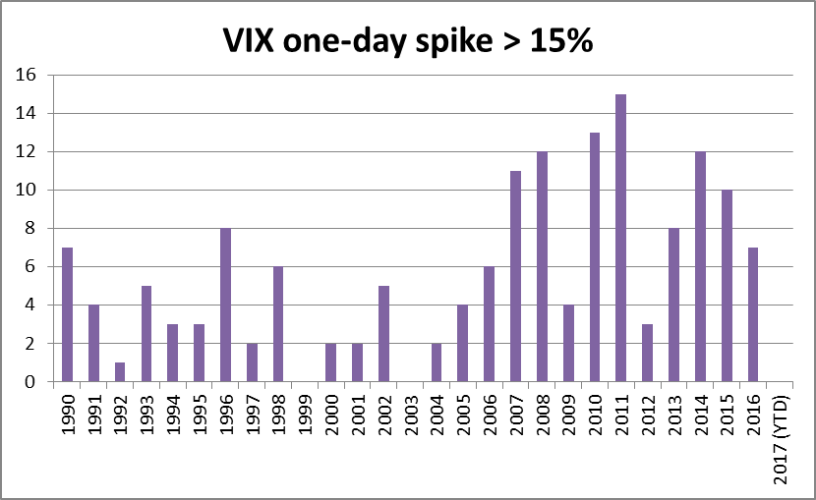

**VIX futures term structure**

We look at the VIX futures term structure and see if it could provide any insight on SPX index. VIX Index is calculated from the projection of VIX futures. VIX futures is only available for trading from 2004. In the most of its lifetime, VIX futures term structure is in Contango, which means that the nearest futures contract has lower price than the second nearest contract. When uncertainty in market rises, investors seek short-term protection by buying short-term expiry contract, so the price of nearer contract will subsequently swing higher than the farther contract and change its term structure to Backwardation. We observed that the term structure remains in Backwardation during most of periods in late 2007 and early 2008.

Given the short history of VIX futures, there is no significance to conclude any result based on the term structure. However, one interesting point to mention is that in late 2007 and early 2008, when VIX was trading at sub-30 level and simultaneously the futures term structure has turned into Backwardation, it has showed a significant decline in SPX index. It coincides with what we observed in section “VIX level with momentum”.

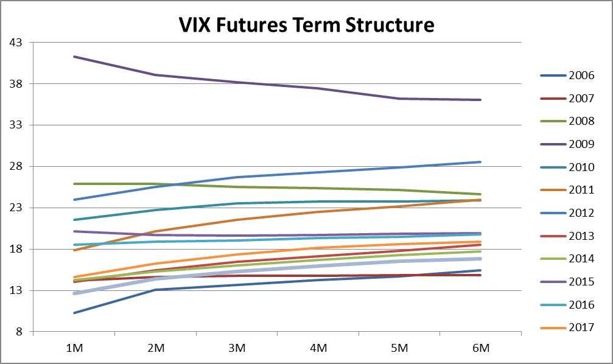

**VIX Futures trading strategy based on the term structure**

We have also built a few strategies on SPX futures based on the signal from VIX Futures term structure. The results unfortunately are poor and fail to outperform the long-only strategy. However, when the signal applies on VIX futures, it shows very encouraging performance. The logic of trading strategy is shown as following:

* Calculate the term spread between the nearest contract and the second nearest contract
* Only trade when absolute value of spread is larger than 1
* Generate signals based on the term spread and capped the extreme signals value
* Calculate number of contracts to long/short based on signals
* Short 2nd nearest contract when signal is negative; Long 2nd nearest contract when signal is positive

Please note that given VIX futures were not so liquid during its early years of life, we applied wider bid-ask spread to transaction cost in order to compensate the liquidity issue.

The below table shows the statistics of the trading strategy. The back test result shows that the strategy has a stunning after-cost annualised rate of return of 47%, with volatility of 33%, which is equivalent to Sharpe ratio (Return/Volatility) of 1.41. The strategy has accumulated ~40,000% of return since 2004.



