HubLab website project brief
Nov 5, 2026 · @Dean
We need a multi-page marketing website for HubLab, Australia's regulatory intelligence layer, designed and built from an approved design system, approved copy and a working homepage build we will send you. The site is for a CFO in private wealth, government, technology or enterprise, and it has one job: show that HubLab puts definitive AI into regulated work, with a record that stands up, and get that reader to start a conversation.

The brief in one paragraph
HubLab puts definitive AI into the regulated work of Australian enterprise and government: AI that encodes the rule itself, gives the same answer every time, and traces every decision to the clause that made it. A person signs off every finding. The engine is Labrynth, built in the United States and proven in government there, exclusive to HubLab in Australia. The first product live is CERTAiNTY, the first insurance-backed payroll assurance in Australia. The design, the words and the animations are already decided. Your work is to turn them into a polished, fast, accessible site on every page, at every screen size, in a dark and a light theme.

Scope and deliverables
You design and build seven top-level pages plus four sector pages, two legal pages and an insights template, desktop and mobile, in a dark and a light theme, then hand the site over in HubLab's name.
Deliverable | What we expect
Page designs | Every page in the site map below, at desktop (1440) and phone (390) widths, in both themes
Build | A working site on [platform to confirm: Webflow, Framer or WordPress], editable by HubLab without code
Components | Header, footer, buttons, eyebrow, gold rule, card, record band, sector panel, status list, theme toggle, dropdown menu, contact form, built once and reused
Animations | The five animations described under Design system, in CSS or the platform's native interactions, no video or GIF
Insights | A CMS collection for briefings and articles, with a list page and an article template
Contact form | Name, organisation, role, email, a short message; sends to enquiries@hublab.com.au; spam protection
Search and sharing | Page titles and descriptions, Open Graph images, the JSON-LD organisation block we supply, favicon, sitemap.xml, robots.txt
Accessibility | WCAG 2.2 AA: contrast as specified, visible focus, keyboard-operable menu and toggle, 44px touch targets, reduced-motion support
Handover | Admin access, all source files, a one-page guide to editing pages and adding an insight, and a 30-minute walkthrough call
Out of scope: writing new copy beyond the approved language, logo or brand changes, stock photography, and naming or showing any customer. If something you need is missing, ask rather than invent it.

Audience
The primary reader is a CFO who signs off regulated outcomes and now carries personal exposure for them; every page should feel like a well-edited briefing for that person, not a product pitch. They skim first, look for proof, and decide in under a minute whether to keep reading.
Reader | What they need to see | The line we use for them
CFO (primary) | Exposure, proof, a record they can stand behind | CERTAiNTY certifies every pay run before it locks, and insurance stands behind the result.
Board director | Defensibility to a regulator | Same input, same answer, every time, with the clause that made it. That is a record a regulator can follow.
Government (secretary, agency CFO) | Scale of rules, consistency of decisions | The rules are written. Someone has to read them, every cycle. We read them the way your specialists do, at scale.
CIO | No disruption, data stays onshore | We sit above the systems you run. No rip and replace. Hosted in Australia, segregated per customer.
The four sectors are private wealth and financial services, government, technology and platforms, and enterprise. The tone throughout is restrained, specific and evidence first: short sentences, real numbers, no hype.

Site map and page content
The site has seven top-level pages in this order: Home, How it works, Sectors, CERTAiNTY, About us, Insights, Contact. The homepage build we send you shows the order, the components and the copy for most of these; the other pages expand the matching homepage section.
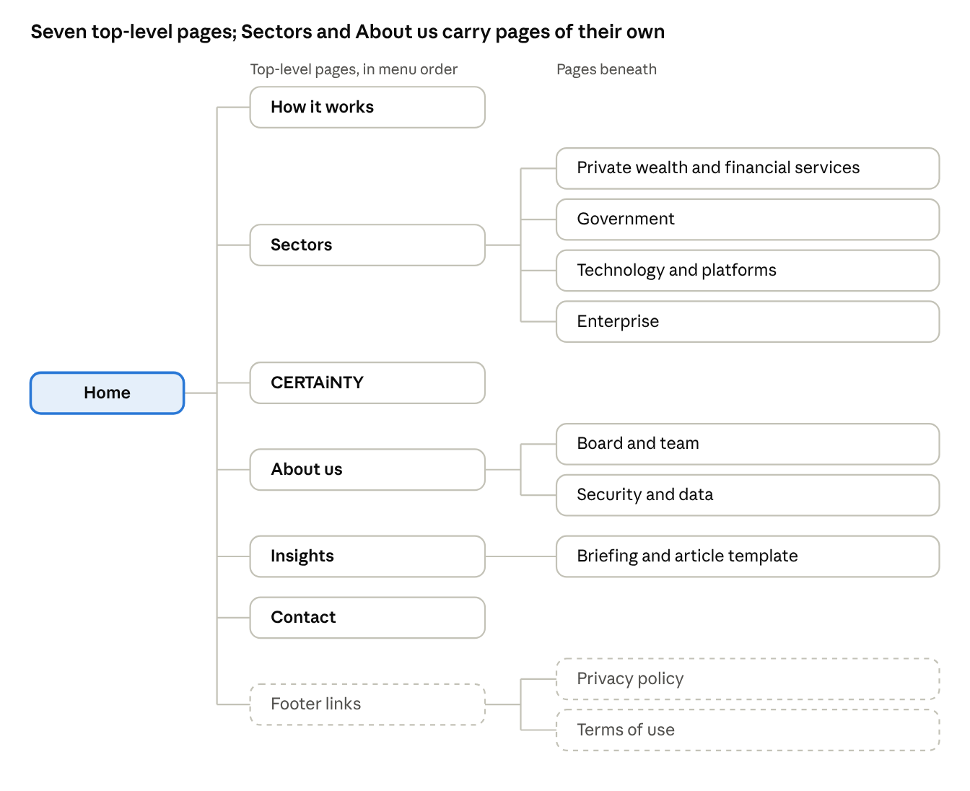
site map · 7 pages, 4 sector pages, 2 about pages, footer links
Home links to every top-level page; the four sector pages and the two about pages sit one level down, and the legal pages live in the footer.
Page | Its job | Sections, in order | Primary action
Home | State the gap and the answer, show proof, route each reader | Lockup and tagline; headline with the "what arrived, what it means" flow animation beside it; Local team. Global engine. (orbit animation); scrolling ticker of what the engine reads; the gap, probabilistic versus definitive AI; record band (80,000+); discovery, build, licence (proof cards); every cycle (loop animation); sectors; CERTAiNTY; your systems, data and people; insights; contact | Start a conversation
How it works | Explain the engine, the layer and the person who signs | Three parties, one accountable; rule to record flow; definitive versus probabilistic AI; discovery, build, licence in detail; data and security | Start a conversation
Sectors (4 pages) | One page per sector, written for that CFO | Sector headline; the obligations we read; what a record looks like there; relevant proof; the line for that reader | Start a conversation
CERTAiNTY | The first product live, as proof of the engine | What it is; how a pay run is certified before it locks; insurance backing; proof numbers; link to the CERTAiNTY site | Ask about CERTAiNTY
About us | Who stands behind the record | One accountable party; Labrynth and Hubify; board and team bios; security and data handling | Start a conversation
Insights | Regulatory change briefings and articles | List page, article template, newest first | Read a briefing
Contact | Start a conversation | The first conversation is about the problem, not a proposal; form; email address; Melbourne | Send
The footer on every page carries: HubLab Pty Ltd · ABN 11 682 982 592 · Camberwell VIC 3124, enquiries@hublab.com.au, and links to the privacy policy and terms of use. Privacy contact: privacy@hublab.com.au.

Design system
Use the HubLab design system exactly as supplied: navy and white grounds, gold as a line colour only, Archivo for headlines and Source Serif 4 for reading, square corners, no shadows. Where this brief and the homepage build disagree, the build wins; ask us if unsure.

Colour
Token | Hex | Use
Navy | #0A1628 | Dark theme ground; headline ink in the light theme
White | #FFFFFF | Light theme ground
Cream | #F5F3ED | Raised panels in the light theme; headline ink in the dark theme
Raised navy | #101E34 | Raised panels in the dark theme
Gold | #D4AF37 | 2px rules, link underlines, focus ring, the one primary button fill. Never text, never a background field
Slate | #5A6B86 | Graphic elements only (rings, arcs, the logo bars). Never text
Text on navy | #F5F3ED, #C3C9D2, #AEB6C2, #8F98A6 | Headlines, body, muted, labels
Text on white | #0A1628, #1F2937, #3A4250, #6B7280 | Headlines, body, muted, labels (label grey at 13px and up only)
Hairline | #22324B on navy, #E5E7EB on white | 1px structure lines

Type
Style | Font | Size and leading | Notes
Display | Archivo 600 | 44 to 88px, 1.02 | Width 104%, tracking -0.02em
H1 | Archivo 600 | 34 to 52px, 1.02 | Width 104%, tracking -0.015em
H2 | Archivo 600 | 26 to 34px, 1.15 | Width 104%
H3 and card titles | Archivo 600 | 24px and 26px, 1.15 | Width 102%
Lead | Source Serif 4 | 20px, 1.55 | Max 34em
Body | Source Serif 4 | 17px, 1.6 | Max 62 characters a line
Label and eyebrow | Archivo 500 | 13px, tracking 0.02em | Sentence case, never all caps
Figures | Archivo 600 | up to 96px | Lining figures
Both fonts are on Google Fonts; load Archivo with its width axis.

Layout and components
- Left-aligned, max content width 1200px, side padding 64px (20px on phones), sections 96 to 120px apart vertically, columns 64px apart.
- Corner radius 0 everywhere; the only rounded shape is the favicon badge.
- Emphasis is a 2px gold rule: 88px long under headlines, 48px short above list items and card titles. Structure is a 1px hairline. No shadows, no gradients.
- One break band per page: the record band, which is cream on navy in the dark theme and navy on white in the light theme.
- Buttons: primary is gold fill with navy label; secondary is a 1px gold outline. Labels are verbs in sentence case.

Header and theme toggle
- Fixed bar across the top: the HubLab lockup on the left, the menu centred, the Dark and Light toggle and "Start a conversation" on the right. One row, one height; it hides when the reader scrolls down and returns when they scroll up.
- How it works and Sectors open dropdowns on hover, focus or click; Escape closes them. The current section is underlined in gold.
- Below 1180px the menu collapses behind a Menu button.
- The toggle is two text buttons, Dark and Light, with the active one outlined in gold. First visit follows the reader's device setting; the choice is remembered and applied before the page paints, so there is no flash of the wrong theme. Colours change with a 200ms ease.

Animations
All motion is quiet: linear loops or a 200ms ease, no bounce, no parallax, and every animation settles on its final frame when the reader has reduced motion turned on.
Animation | Where | What it shows
Hero flow | Home hero, right of the headline | A rule change lights up, a gold marker carries it into HubLab, three steps light in turn, "A person signs off" lights, then the record (clause, signature, trail)
Orbit | Local team. Global engine. | Labrynth at the core; HubLab highlighted on the middle ring in gold; the reader's systems on the outer ring, each sending a marker in and back
Proof cards | Discovery, build, licence | Obligations fill row by row with a counter; 188 days shrinks to 8; a checklist ticks to "Pay run certified before it locks"
Loop | Every cycle | A marker circles read, map, decide, sign off, with the record at the centre
Ticker and count-ups | Under the hero; record band | Two rows scrolling what the engine reads and where; 80,000+, 4,000+ and 120+ counting up once

Logo
Use the supplied lockup (three bars plus the HubLab wordmark) as a unit: the white-on-navy file on dark grounds, the navy file on light grounds, the bars-only badge for the favicon. Never redraw the mark or set the name as plain text in its place.

Approved language
Every word on the site comes from the approved copy we send you, copied exactly; if a page needs a sentence that is not there, leave a marked placeholder and ask. These rules apply to every heading, button, alt text and meta description.

Names, spelled exactly
Write | Never write
HubLab, Australia's regulatory intelligence layer | Hublab, Hub Lab, RegTech company, AI consultancy, platform, operating layer
Labrynth (the engine; a founding partner, not a vendor) | Labyrinth, joint venture, JV, vendor, supplier
CERTAiNTY (capital C-E-R-T-A, lowercase i, capital N-T-Y) | Certainty, CERTAINTY, certainty. The legal entity Certainty AI Pty Ltd stays as written
Hubify (ASX: HFY), strategic investor and operational partner | Parent, owner, delivery partner
A national facilities services group; a state government | Any customer name or logo

Lines to use exactly as written
- Australia's regulatory intelligence layer
- From rules to action. In weeks, not months.
- The system tells you what arrived. It cannot tell you what it means.
- Same input, same answer, every time. Every decision traced to the rule that made it.
- One accountable party.
- Not a roadmap. A record.
- Local team. Global engine.
- Checked. Proven. Protected. (CERTAiNTY only)
- The rules are written. Someone has to read them, every cycle. (hero line, awaiting final sign-off)

Proof numbers, the only ones allowed
Number | Say exactly
80,000+ shifts, 4,000+ employees | validated in live production for a national facilities services group
120+ Modern Awards | ingested
188 days to 8 | planning permits in Lancaster, California, on the same engine
January 2025 | deliberate underpayment a criminal offence; personal exposure for directors

Style
- Sentence case everywhere, including headings, eyebrows and buttons. No all-caps labels.
- No em dashes or en dashes; hyphens only in compound words. No exclamation marks, no emoji, no italics for emphasis.
- No superlatives: never revolutionary, seamless, cutting-edge, AI-powered, first in the world, guaranteed compliance.
- Australian spelling. Address the reader as "you"; HubLab speaks as "we".
- Say "definitive AI", never "generative", for what HubLab does. Say "discovery, build, licence" and "measured result", never "pilot" or "proof of concept".

People for the About us page
Four bios are ready to use as written; four are still being written, so design the team grid to hold eight people and leave those cards as marked placeholders. Use the names and titles exactly as below; headshots will follow.
Name | Title | Bio
Charbel Nader | Chairman | Investment banker with more than three decades in corporate finance, M&A and strategic advisory. Chartered Accountant, Fellow of the Tax Institute of Australia. Non-Executive Director of Hubify Limited (ASX: HFY). A core architect of the HubLab commercial model from the outset.
Pat LaManna | Director | [Bio to come]
Stuart Lacey | Board advisor | Founder and CEO of Labrynth. Forbes author, TEDx speaker, YPO member. 13 companies founded, 5 exits, 13 patents.
Mark Dinnison | Chief Executive Officer | CEO of HubLab since incorporation. Identified the regulatory-interpretation gap and secured the Labrynth partnership, negotiating the exclusive Australian rights. Two decades across infrastructure investment, energy and technology, starting at Morrison & Co, with senior commercial roles at Lumo Energy and Vix Technology.
Joe Lamanna | Chief Operating Officer | [Bio to come]
Dean O'Reilly | Partner, AI and Technology Strategy | More than ten years in technology at AWS and Snowflake. Dean brings technical depth, executive strategy and operating rhythm, connecting the business problems customers have with the technical solutions that solve them, with a focus on return on investment. [Draft, final wording to come]
Dylan Docherty | [Title to come] | [Bio to come]
Jim Christo | [Title to come] | [Bio to come]
The board sits above the team on the page: Chairman, Director, Board advisor, then the team led by the CEO.

What we are handing over
You will receive six things with this brief; the homepage build is the single best reference for look, motion and behaviour, so start there.
Item | What it is | How you get it
Homepage build | Working homepage in HTML and CSS: every component, both themes, the header, all five animations, the approved copy | Shared link; the page source is yours to copy from
Design canvas | The five animations on their own, five earlier homepage directions, and the combined mock | Shared link
HubLab design system | Tokens, type scale, components and usage rules | Shared link
Logo files | HubLab lockup in navy and white-on-navy, and the bars-only badge, as PNG | Sent as files
Approved copy | The external press release and FAQ, the language register above, and the bios above | Sent as a document
CERTAiNTY | A separate brand (paper and coral) with its own site; link to it, do not restyle it in HubLab colours | Link to follow
The JSON-LD organisation block for the site head is in the head of the homepage build; use it as supplied.

Open items, timeline and how we work
Nine items are still open on our side; build with the current wording and leave these swappable, and we will confirm each before launch.
- ☐ Hero line "The rules are written. Someone has to read them, every cycle." final sign-off
- ☐ Primary button wording: "Start a conversation" (current) or "Book a briefing"
- ☐ Status of NDIS integrity (shown as live) and private wealth mandate compliance (shown as in build)
- ☐ Light theme ground: white is the decision; the design system's cream token will be updated to match
- ☐ Final logo files supplied
- ☐ Bios and titles for Pat LaManna, Joe Lamanna, Dylan Docherty and Jim Christo; final wording for Dean O'Reilly
- ☐ Headshots for the board and team
- ☐ First two insights briefings
- ☐ Customer logos: none until written approval is on file; design the proof area to work without them

Timeline
- Kick-off call and questions answered: [date]
- Homepage and one inner page designed, both themes, desktop and phone: [date]
- All pages designed and approved: [date]
- Build complete on staging, animations and toggle working: [date]
- Review, accessibility and content check, fixes: [date]
- Launch with the media release: [launch date]

Budget and working together
- Budget: [your quote, fixed price], paid against milestones 2, 4 and 6.
- Two rounds of revisions per milestone are included.
- One point of contact: Dean O'Reilly, dean.oreilly@hublab.com.au. Questions in writing; we answer within one business day, Melbourne time.
- Everything you make (designs, code, accounts, fonts licences, domains) is set up in HubLab's name and handed over in full at the end; HubLab Pty Ltd owns all work product.
- Treat everything in this brief and the linked files as confidential until launch.

