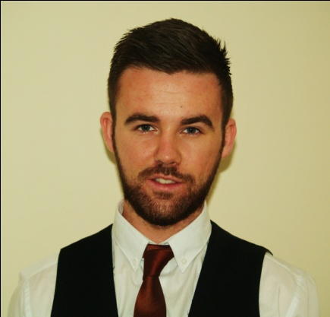**Dean O’Reilly**

**Contact Details**

**Address :** Apt.27, Annally Close, Ongar, Dublin 15

**Contact Telephone Number:** +353 85 8171358

**Email Address:** de[an.oreilly2@mydit.ie](mailto:oreilly2@mydit.ie)

**Linkedin :** ie.linkedin.com/in/oreillydean

**Career Objective**

Seeking a challenging and intriguing placement where I can utilize my skills and understanding of

technologies I have already worked with, while also attaining understanding and experience

with new technologies.

**Education**

**Dublin Institute of Technology - 2013-2017**

* **BSc (Hons) in Computer Science (Infrastructure)**

- The BSc in Computer Science (Infrastructure) has allowed me to gain extensive knowledge of many technologies and operating systems and a range of programming languages. Along with the technical skills I have obtained, I have also built up many non technical skills such as team work, problem solving, debugging and administration skills.

- The course also allows students to gain knowledge of the development and design techniques needed in order to achieve a platform which proves successful and user friendly.

**Technical Skills**

|  |  |  |
| --- | --- | --- |
| Languages | Operating Systems | Other Technologies |
| * C * C++ * Python * HTML * SQL * Assembly Language * PHP | * Linux * Ubuntu * Unix * Windows | * MySQL * CCNA * Networking * Oracle Databases * SQL server * Bash * Raspberry Pi |

**Module Names and Grades**

**Year 1 Year 2**

• Building a PC – 69 % • Legal & Professional Issues- 60%

• Communication and personal Development – 64% • Microprocessors- 61%

• Information Technology and Fundamentals – 71% • Networking 2 (Routing)-64%

• Introduction to Algorithms – 40% • Operating Systems & Systems Admin-58%

• Introduction to Operating Systems – 46 % • System Infrastructure & Archit.-63%

• Mathematics 1-52% • Databases 1 – 70%

• Networking Fundamentals- 63 % •  Human Computer Interaction – 67%

• Program Design – 64 % • Mathematics 2 – 55%

• Programming C – 65% • Networking (Switching)-59%

• Programming with Persistent Data- 60% • Object Oriented Programming (python) – 62%

• Team Computing (Robotics) – 40% • Internet app & web development - 73%

**WPAPPLIED – June 2014**

**-Delivered by Ballsbridge College of Further Education**

- The WPAPPLIED course allowed me to gain all the knowledge I needed in order for me to correctly design and set up a functional website through Wordpress.

- It also provided knowledge of business ideas how to run a functional business online and processes of maintaining such a business

**St. Joseph’s Secondary School, Rochfortbridge, Co. Westmeath – 2006-2011**

**-Leaving Cert**

Irish (O)(C1), English(O)(B3), Mathematics(O)(C1), Geography(H)(C1), Biology(H)(B3), Business(H)(B2), Home Economics(H)(B2)

**Employment**

**Janurary 2014- Present**

*CastleKnock Hotel and Country Club, Dublin*

• General tasks include, bar tendering, waiting tables and making coffees

 • Additional tasks involve setting up Function rooms for events and conferences, training new staff in barista and cocktail skills.

• In Castleknock hotel, team work is essential as the hotel is a very large complex with many different departments relying on each other. Communication is therefore very important in order to ensure all guests enjoy their stay.

**June 2014 – Website developer**

Natalierossiter.com

• Designing and helping Natalie come up with ideas on how to populate her site

• Designing and developing the webpage along with setting up Hosting and domain naming

**June 2013- August 2013**

The Shed, Northbridge, Perth, Western Australia

**Bar Tender**

• While I was working with The Shed, I was main job was bar tendering.

• The team at The Shed was large and it was essential to communicate with all personnel in the team i.e. Security

• Ensure that Responsible Service of Alcohol Law’s where followed at all times when operating.

**Referees**

**Stephen O’Sullivan Patricia O’Byrne**

Assistant Food and Beverage *Manager-* Chairperson DT211 *Castleknock hotel and country club* Computer Science (infrastructure)

Ph+ 353(01) 6406300 patricia.obyrne@dit.i