PACTR Testing

**First Digital**

Bradley Deans, Mitchel Cook

[bradley.deans@firsttech.digital](mailto:bradley.deans@firsttech.digital)

<mitchel.cook@firsttech.digital>

Contents

Summary 2

Test 1: Basic Trial 2

Test 2: Full Trial & Submission (Researcher) 2

Test 2: Setting Review Status (Admin) 2

Test 3: Trial Comments & Reason for Change 2

Test 1: Basic Trial 3

Test 2: Full Trial, Submission, Review Status 4

Test 3: Comments & Reason for Change 5

Observations 6

Test 1 6

RegisterTrial.aspx (Researcher) 6

ManageTrials_v2 (Researcher) 6

Test 2 6

RegisterTrial.aspx (Researcher) 6

ManageTrials_v2 (Researcher) 6

ManageTrials_v2: Before Changes (Admin) 6

RegisterTrial.aspx (Admin) 7

ManageTrials_v2: After Changes (Admin) 7

Test 3 7

ManageTrials_v2: Before Changes (Admin) 7

RegisterTrial.aspx (Admin) 7

ManageTrials_v2: After Changes (Admin) 7

RegisterTrial.aspx (Admin) 8

# Summary

The following document outlines the guidelines that were followed to test the Trial feature for PACTR. Testing included multiple tests to assess the process of creating a new trial from start to finish. Each test varies depending on the certain options that have been selected or altered throughout the life cycle of a trial.

## Test 1: Basic Trial

* Login as Researcher.
* Fill out required fields for only the Trial Details.
* Save trial.
* View Manage Trials list.

## Test 2: Full Trial & Submission (Researcher)

* Login as Researcher.
* Fill out required fields for, Trial Details, Study Design, Interventions (2 added – as required), Eligibility Criteria, Outcomes, Recruitment Centre (1 added), Ethics Approval (PDF attached), Funding Sources (1 added), Sponsors, Contact People (3 added – as required), Reporting.
* Select `**No**` for, Secondary IDs, Collaborators, and Results received under Reporting.
* Save and submit trial for review.

## Test 2: Setting Review Status (Admin)

* Login as Admin.
* Assign trial to self.
* Open trial and set the review status to Approved.
* Fill out all required fields (trial status, comment, and site)
* Save trial.

## Test 3: Trial Comments & Reason for Change

* Login as Admin.
* Edit trial.
* Update fields in Trial Details.
* Add Comments.
* Set Trial Review Status to ‘**In Review’**.

# Test 1: Basic Trial

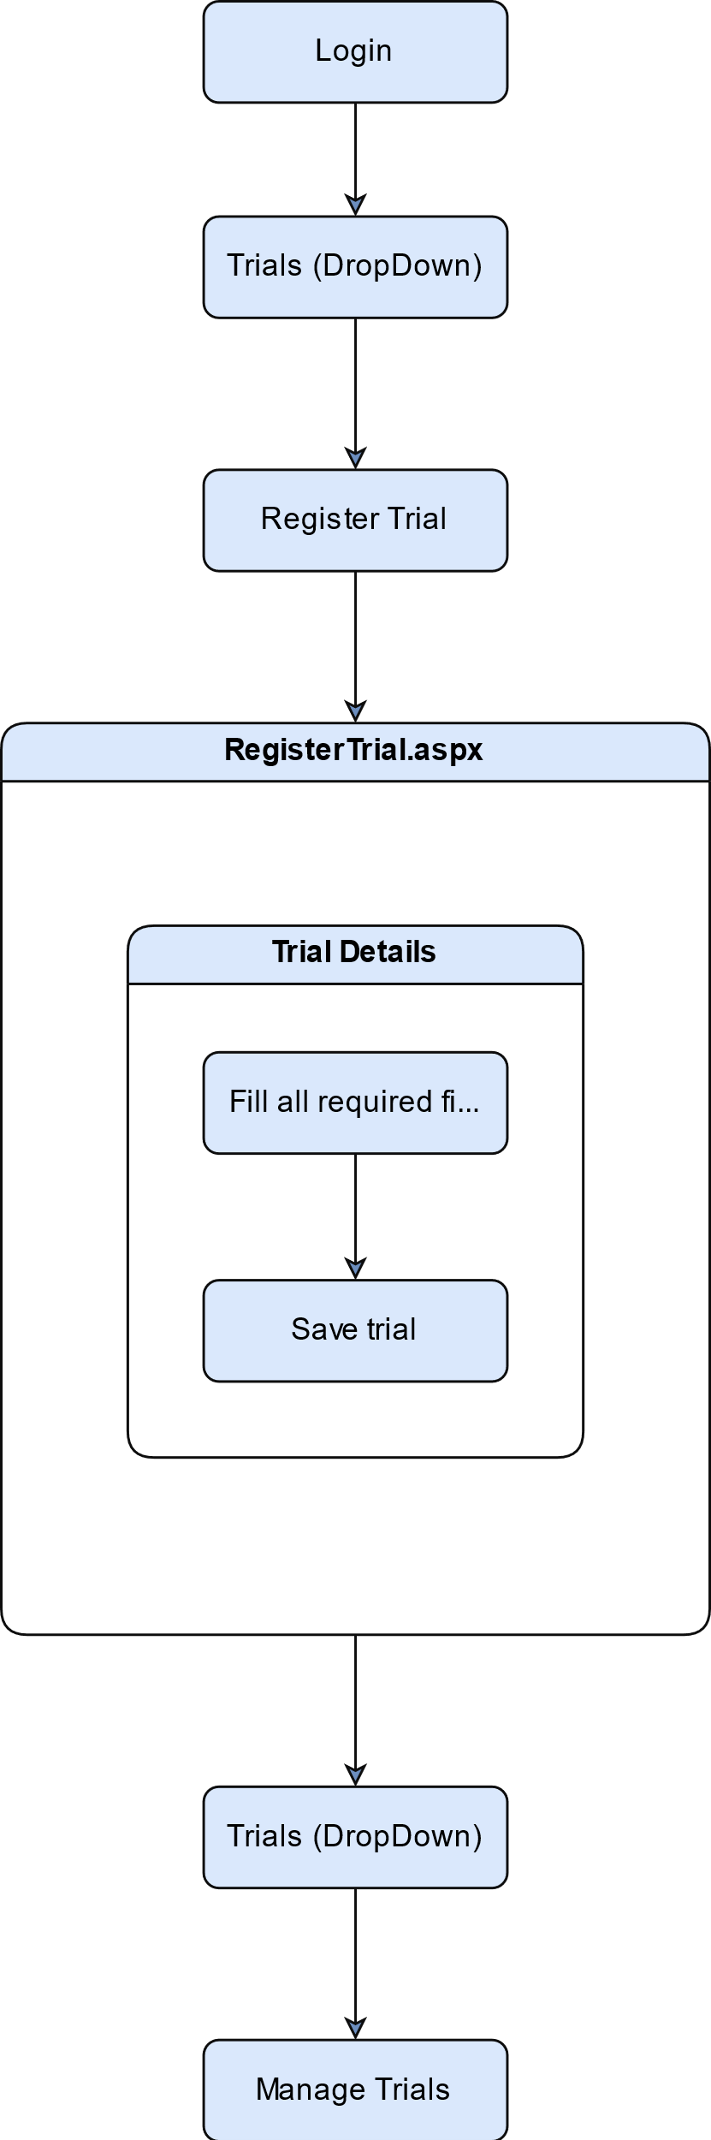

# Test 2: Full Trial, Submission, Review Status

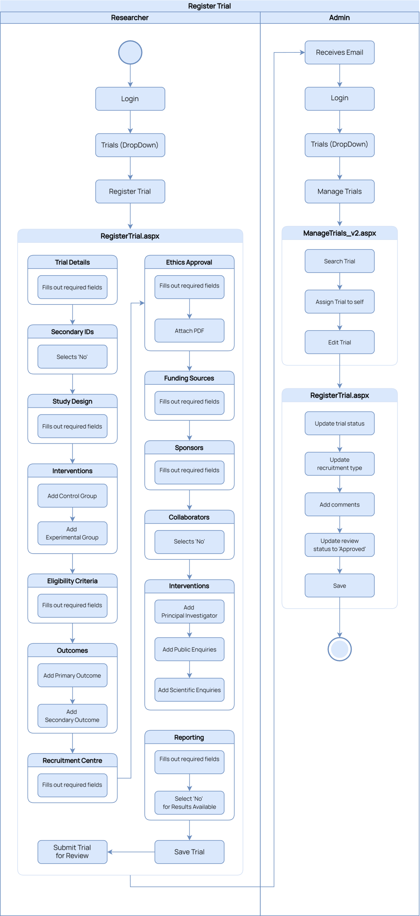

# Test 3: Comments & Reason for Change

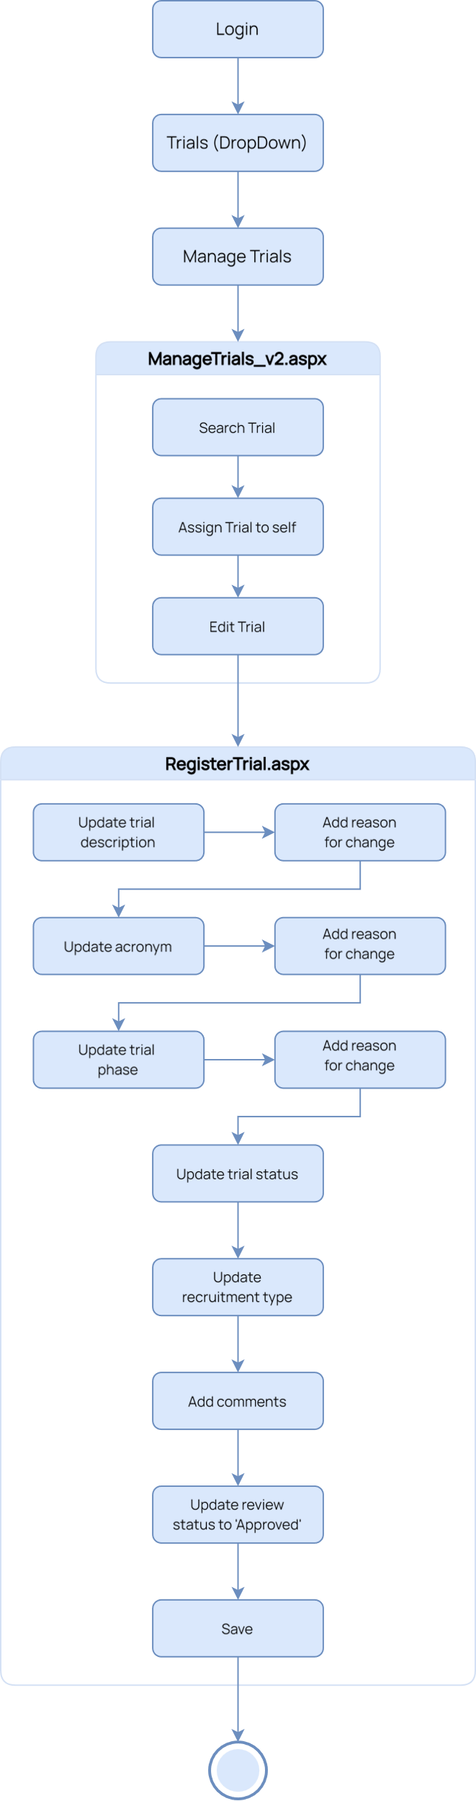

# Observations

## Test 1

### RegisterTrial.aspx (Researcher)

* Button for Submit Trial for Review is visible.
* Button is not duplicated.

### ManageTrials_v2 (Researcher)

* Trial review status is not assigned.
* Action status assigned to draft.
* Edit button is visible.
* Trial can be edited.
* Viewer button is hidden.

## Test 2

### RegisterTrial.aspx (Researcher)

* Button for Submit Trial for Review is visible.
* Button is not duplicated.

### ManageTrials_v2 (Researcher)

* Trial review status is not assigned.
* Action status assigned to draft.
* View button is visible.
* Trial cannot be edited.
* Viewer button is hidden.

### ManageTrials_v2: Before Changes (Admin)

* Admin for trial is unassigned.
* Trial review status is not assigned.
* Action status assigned to draft.
* View button is visible while trial has no admin assigned.
* While an admin is not assigned to a trial, the trial cannot be edited.
* While an admin is assigned to a trial, the trial can be edited.
* Viewer button is hidden.

### RegisterTrial.aspx (Admin)

* Review status dropdown is set to default (not assigned).
* Button for Submit Trial for Review is hidden.
* Button is not duplicated.

### ManageTrials_v2: After Changes (Admin)

* Admin for trial is assigned.
* Trial review status is set to Approved.
* Edit button is visible.
* Trial can be edited.
* Viewer button is hidden.

## Test 3

### ManageTrials_v2: Before Changes (Admin)

* Admin for trial is unassigned.
* Trial review status is not assigned.
* Action status assigned to draft.
* View button is visible while trial has no admin assigned.
* While an admin is not assigned to a trial, the trial cannot be edited.
* While an admin is assigned to a trial, the trial can be edited.
* Viewer button is hidden.

### RegisterTrial.aspx (Admin)

* Review status dropdown is set to default (not assigned).
* Button for Submit Trial for Review is hidden.
* Button is not duplicated.

### ManageTrials_v2: After Changes (Admin)

* Admin for trial is assigned.
* Trial review status is set to Approved.
* Edit button is visible.
* Trial can be edited.
* Viewer button is hidden.

### RegisterTrial.aspx (Admin)

* Comments added previously remain.
* Updates and Reason for Change added previously remain.
* Review status dropdown is set to Approved.
* Button for Submit Trial for Review is hidden.
* Button is not duplicated.