Title:
Author: Dean Keithly
Mentor: Robert Sivilli
Date: 6/4/2019

Abstract:

Week1:
Obtain access to UDL.
Filled out AFRL connect stuffs.
Wrote a script to extract TLE from a TLE text file.
Requested access to Seradata, EXO, and L3 data for Sensors and Obs
Opened my grab_JPL_horizons script which queries JPL Horizons for major body data from NAIF
Initial project though: We could use the visual magnitude brightness of single observations or multiple observations (light curves) of optical measurements combined with the observation phase angle (angle between observer and sun) along with assumptions of spacecraft solar panel absorptive and emissive properties as well as attitude to back out minimum and maximum expected spacecraft size***. Size here could mean bus size, solar panel size. We might be able to derive a spacecraft power consumption (or consumption bounds) based on the solar array sizes. This can be used to classify the type of spacecraft. If spacecraft attitude is able to be extracted, we could know* what the spacecraft is doing. Robert went off on a brief side tangent about Seradata which contains information about insured spacecraft ~we could determine if a spacecraft is properly insured (?whatever that means?)~.

Read the article: Astrophotometrical Observation of Artificial Satellites and Study of the Technical Status of Parental Bodies of Space Debris at Geostationary Ring
http://articles.adsabs.harvard.edu/cgi-bin/nph-iarticle_query?2005ESASP.587..159K&defaultprint=YES&filetype=.pdf

APPLCATION/CUSTOMER:
Ground radio and optical observations (light curves) can be used to characterize the spin rate of space debris. The spin rate of different debris can be used to correlate debris origin (aka which spacecraft it came from) as shown in “Investigations of the evolution of optical characteristics and dynamics of proper rotation of uncontrolled geostationary artificial satellites” (Papushev 2009). The spin rate is based on a Fast Fourier Transform of the light curve signal with both short and long period peaks indicative of the spin rate. A previous study “Astrophotometrical Observation of Artificial Satellites and Study of the Technical Status of Parental Bodies of Space Debris at Geostationary Ring” (Karavaev et. al. 2005) showed a similar periodogram study of space debris. Spin rate information associated with debris used to classify what originating spacecraft debris belongs to can be used to determine the “at fault” party in future collision events for insurance purposes.

APPLICATION/CUSTOMER:
There was some discussion at a meeting about how UDL could be used to determine whether a “high priority object” (something that we want to keep our eyes on) has made a maneuver by checking (at a future ground station the spacecraft should pass over) whether the spacecraft is where it is expected to be.

Observed objects can be classified into:
1. Operating Spacecraft
a. Our known mission objective spacecraft
b. Unknown mission objective spacecraft (i.e. China, Russia, India, etc...)
2. Non-operational Spacecraft (derilect, failed missions,
3. Debris

TODO:
- Upgrade grab JPL Horizons to get the positions of the planetary bodies at specific moment(s) in time.
  - What moments in time?
  - What format is time in?
  - NEED UDL DATA to determine time data format
- Q: Do I need to know altitude of ground stations making observations?
- Q: Where can I find a comprehensive listing of all ground stations?
  - https://www.fcc.gov/reports-research/developers

Cool Figure Sidethoughts:
- What if I had a connected graph like that circle from that presentation by that guy at Cornell showing connections between ground stations and spacecraft orbits.
- Mathy figure showing the Earth inertial center relative to the sun, ground station relative to earth inertial center, spacecraft relative to ground station, and spacecraft relative to sun.

About Two Line Element Sets
The reference frame of a TLE is the Earth-Centered Inertial (ECI) coordinates produced by the SGP4/SDP4 oribtal model with true equator, mean equinox of epoch (TEME).
This open source python package https://pypi.org/project/sgp4/ extracts all relevant TLE information from a TLE.

DATA ACCESS REQUESTS:
Include Robert.Sivilli.1@us.af.mil
Template for data access request:
I am a DoD contractor seeking access to data available to the AFRL in support of an AFRL contract. Requesting access through August 23rd, 2019.

Request submitted for:
Seradata – heard back, waiting on an OK from Brent Miller (with ATA Corp). Tried calling ATA Corp headquarters in ABQ to get in contact with Brent to no avail
EXO Elsets
EXO Obs
EXO Sensors
L3 Space and Sensors: Obs
L3 Space and Sensors: Sensors
Numerica- all
LeoLabs-all

Defining Vectors and Frames for an Observation
Figure 1.
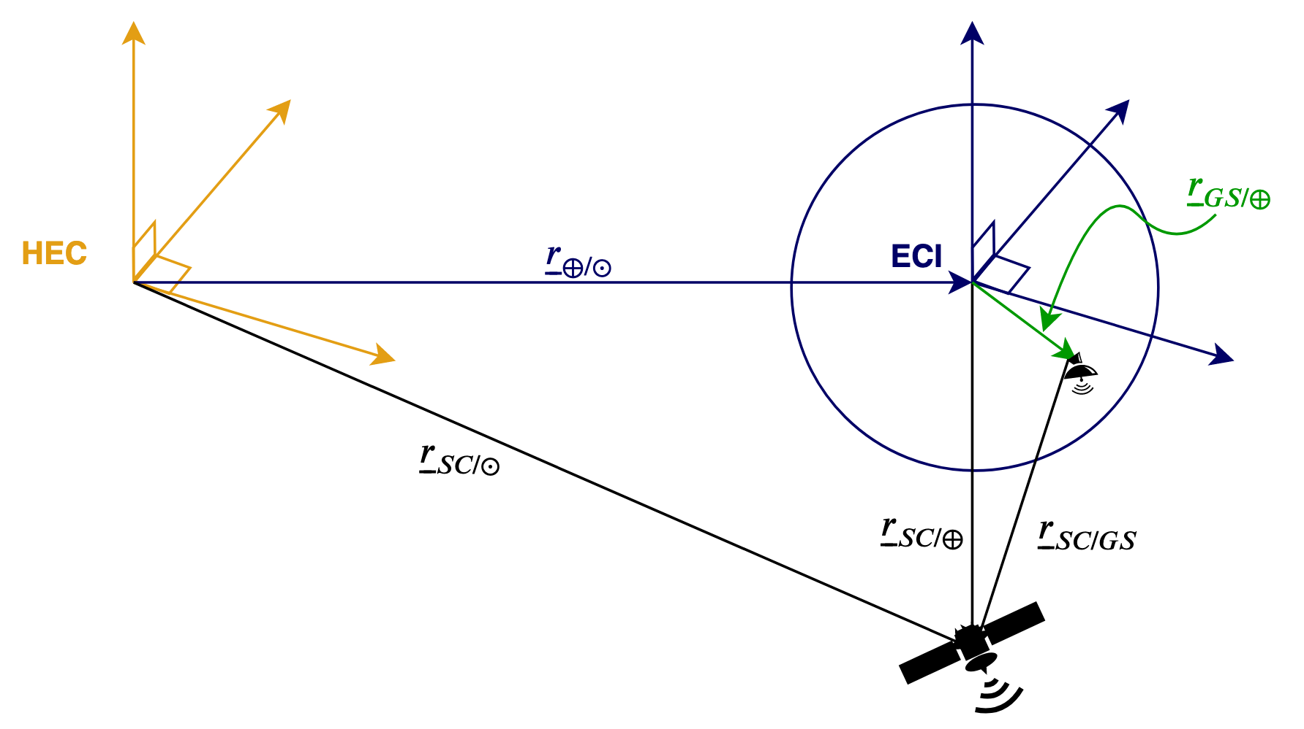
The Heliocentric Ecliptic Coordinate Frame (HEC) originates from the solar system barycenter and is the origin for all NAIF and JPL Horizons derivative data in this document.

is the position of the spacecraft relative to the Earth Centered Inertial Frame (ECI) and is derived from the Spacecraft’s (SC) Two Line Element (TLE) which is valid for ~1 week from generation date.
is the position of the Ground Station (GS) relative to the ECI which comes from UDL data.
is the position of the SC relative to the GS which comes from the UDL data.
is the position of the ECI relative to the HEC and is derived from the JPL Horizons and NAIF database. We treat the HEC as the sun’s center to simplify calculations.
is the position of the SC relative to the HEC.

Since I am uncertain whether the UDL observations contain phase angle data, I can calculate the sun-SC-GS phase angle ф here using
.

