Homework 2
Dean Keithly

Problem 1:
The code included in github (RBTree) is capable of inserting and deleting nodes of a Red-Black Tree and is covered by unittesting to 99%.
The time to insert a new node into the Red-Black Tree is O(log n).

Problem 2:
We will first encode this problem as a numeric array with -1 and +1 for simple summation.

We will calculate the sum of the values of the binary array provided as we increment through the array. If we discover the first occurrence of the number, we will save the value to a firstList along with the firstIndex. These contain the first occurrence of each value in the list. If we discover a value that has been previously discovered, then we will add that value to the lastList and lastIndex list. If these values are discovered multiple times, then we overwrite the occurrence index.

Why do we take this approach and why does it work. Well, whenever the sum across a sequence is 0, we know the two points must have the same sum. It is trivial to increment through the list calculating the sum and find the intersection points between the two lists.

This algorithm should operate in O(n) time since we iterate over the list only 1 time. The absolute maximum time is O(n^2) but this is probabilistically impossible. The lower asymptotic complexity is O(n) with a an average complexity near t here.
Additional iterations occur when searching the lastList and firstList for duplicate occurance, which must occur at every step. These are modest and do not scale with n. They have some binomial probability of increasing in size beyond 5 of less than something like 1/32 (0.5)^5. The additional loops through the firstList and lastList would take something like 0.5*5. Of course this would modestly grow as n grows but not linearly.

NEED TO REDO PROBLEM 2 WITH HASH TABLES. IT WORKS, IT JUST ISN’T AS EFFICIENT

Problem 3
The unordered array uO is of form [lb1,…,ub1,i,lb2,…,ub2]
We know lb1 and ub2.
We first determine whether key to search for is >= lb1 or <= ub2 (determines search start direction).
We then pick the string bisector round(n/2) to determine the middle index of the array to start the search.
If key < uO[n/2] and greater than lb1, bisect left and continue with new lb and ub
If key < uO[n/2] and less than ub2, bisect…...
If key > uO[n/2]……

The function used for this problem is findElement.py. This function iteratively calls itself using the upper bound index, lower bound index, and picking some middle index. Because the array is continuously bisected, it should reach a solution in O(log n) time. There is some multiplication factor of 5 on this due to the large scale of the if else statements to handle the possible ub, lb, and partition values.

Problem 4
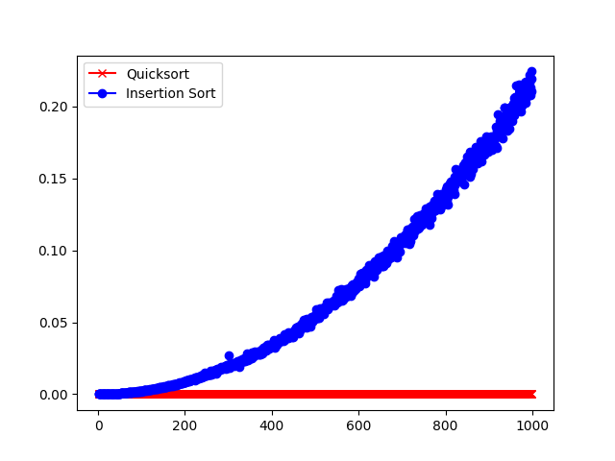
I have a homebrew implementation of the insertion sorting algorithm, but the performance appears to be very slow comparative to the stock numpy quicksort. The y axis is time in seconds to sort completion. The x axis is the number of items in the list. You can see insertion sort is n^2 and quicksort is much less.

If we look at the time performance of insertion sort algorithms at the following link:
https://vinayakgarg.wordpress.com/2011/10/25/time-comparison-of-quick-sort-insertion-sort-and-bubble-sort/
We can see that insertion sort should work far more effectively but my algorithm appears to be very similar if not identical to the one they tested.

In a very zoomed in view, it appears the two methods separate in complexity when k~=8.

I HAVE NOT UPDATED THIS TO INCLUDE THE HOMBREW QUICKSORT ALGORITHM IN ITS ENTIRETY.

Problem 5
To use the Bellman-Ford algorithm, we must assume the weighted directed graph G = (V,E) with source s and weight function w: E→All Real. The algorithm progressively decreases estimate v.d on the weight of a shortest path from the source s to each vertex v for all V until it achieves the actual shortest-path weight.

I define a simple directed graph V={0,1,2,3,4} with the following Edges. The table reads left to right as vertice 0 has an edge to vertice 1 as indicated by the 1 in the box. Since the table reads from left to right, it indicates vertice 1 has no edge to vertice 0.

 |  | To Next Node
 |  | 0 | 1 | 2 | 3 | 4
From Current Node | 0 | 0 | 1 | 1 | 0 | 0
From Current Node | 1 | 0 | 0 | 1 | 0 | 0
From Current Node | 2 | 0 | 0 | 0 | 1 | 0
From Current Node | 3 | 0 | 1 | 0 | 0 | 1
From Current Node | 4 | 1 | 0 | 0 | 0 | 0

 |  | To Next Node
 |  | 0 | 1 | 2 | 3 | 4
From Current Node | 0 | 0 | 1 | 1 | 0 | 0
From Current Node | 1 | 0 | 0 | -1 | 0 | 0
From Current Node | 2 | 0 | 0 | 0 | -1 | 0
From Current Node | 3 | 0 | -1 | 0 | 0 | 1
From Current Node | 4 | 1 | 0 | 0 | 0 | 0

The bellman_ford function iterates over all vertices and along all edges of those vertices evaluating whether a shorter route exists between two nodes. We then modify the lists containing vertices that have been looked at and yet to be looked at.

We then iterate through all edges and evaluate whether any node to node distance plus edges is negative. This would indicate a negative cycle exists.

This can functionally be observed by the execution of runBF.py where two asserts would signal if the algorithm did not run properly.

Complexity: The major nested for loops iterate over V vertices and E edges making worst case complexity O(V*E)

The following for loop would make complexity O(V*E + E)

