1. **Most Viewed Video**
   * Title: "Would You Fly To Paris For A Baguette?"
   * Views: 1,104,624,530 views
2. **Top 5 Videos with the Highest Like-to-View Ratio**
   * Exility And Some Other Stuff - Update Vid: 22.42%
   * Make This Video The Most Liked Video On Youtube: 20.10%
   * WHERE IS MY COOKIE?????: 10.83%
   * Exility vs Dr.Pineapplez - Misleading Contest!: 9.37%
   * If This Video Gets One Million Views.....: 9.21%
3. **Average View Count Variation Over Different Days of the Week**
   * Saturday: 20,835,304,915
   * Thursday: 8,062,453,055
   * Tuesday: 4,774,781,680
   * Friday: 4,438,553,286
   * Wednesday: 2,748,512,256
   * Sunday: 1,031,934,499
   * Monday: 810,446,529
4. **Relationship Between Video Duration and Engagement**
   * Duration vs View Count: r = -0.0234
   * Duration vs Like Count: r = -0.0230
   * There is a weak negative correlation between the duration of a video and its view count or engagement.
5. **Distribution of Video Durations**
   * Most videos are around the 3-minute mark.
6. **Average Number of Videos Published by MrBeast in a Week**
   * MrBeast publishes around 1 video per week.
7. **Correlation between Years and View Count**
   * There is a positive correlation of 0.754 between the years and the view count, suggesting that view count tends to increase over the years.

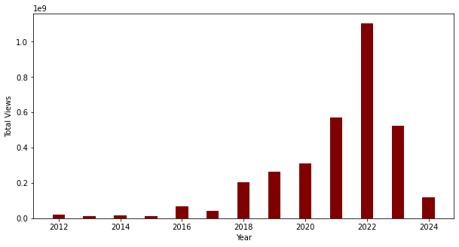

1. **Distribution of Video Durations (Excluding Videos Longer than 90 Minutes)**
   * Most videos are around the 3-minute mark.

