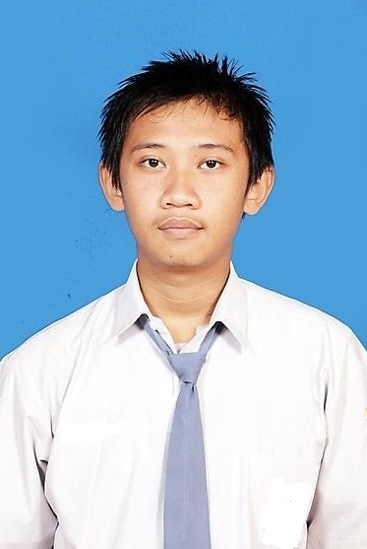

Dean Zaka Hidayat

deanzaka.h@gmail.com

+62 857 70796993

Jl. Belimbing No. 34, RT/RW 02/08, Deket Kulon, Deket, Lamongan

PERSONAL INFORMATION

If you're looking for a young, talented, and fresh worker on your Research and Development on embedded system, my eager mind, new idea, and passion on working on new things will prove invaluable. My experience of working on various project on my robotics team, competition and event project, and some project I did in my course itself, make learning and troubleshooting come as second nature for me, meaning fewer and less frequent issues for your Research and Development Project.

Personal Skills:

- PCB Designing, Simulation, Production, and Troubleshooting

8 bit Microcontroller Programming, Android Programming, and Basic Computer Vision
- Ability to work as a team

EXPERIENCE HISTORY

--------------------------------------------2014 – NOW-------------------------------------------

Head of Research and Development Department – University of Indonesia Robotics Team – uiroboticsteam.net – Depok

Head of Embedded Division – Exercise FTUI – exerciseftui.blogspot.com – Depok

Head of Curriculum Department – Technique Informal School FTUI – tis-ftui.blogspot.com – Depok

Hardware Engineer (2 month of internship) – PT Konekthing Benda Pintar – www.konekthing.com – Depok

Key Achievements:

- Fan and Heater Failure Detector (PT Konekthing Benda Pintar)
- Android IOIO and Android Computer Vision application on Soccer Robot (University of Indonesia Robotics Team Research Project)
- Automatic LED Lighting on Ladder (Commercial Project)

Key Skills Gained:

- Basic computer vision on android
- Basic android use as a hardware controller
- Leadership and human resources management

--------------------------------------------2012 – 2013--------------------------------------------

Team Leader of Soccer Robot Team – University of Indonesia Robotics Team – uiroboticsteam.net – Depok

Key Achievements:

- 3rd Position at Regional Competition of Robot Soccer (Jakarta, Banten, and West Java Region)
- 3rd Position at Program Kreatifitas Mahasiswa: Bidang Karsa Cipta BEM FT University of Indonesia

Key Skills:

- Bioloid (Humanoid Robot) Kinematics and Programming
- Basic Computer Vision with CMUCAM 4

--------------------------------------------2011 – 2012--------------------------------------------

Team Leader of N.U.B.I Line Follower Team – University of Indonesia Robotics Team – uiroboticsteam.net – Depok

Automatic Robot Programmer of Gatot Kaca Team on International Robotics Challenge in India – University of Indonesia Robotics Team – uiroboticsteam.net – Depok

Programmer of Juragan Jammer on Lomba Cipta Elektronika Nasional in Sepuluh Nopember Institute of Technology – University of Indonesia Robotics Team – uiroboticsteam.net – Depok

Key Achievements:

- 1st Position on Makara Line Follower Robot Competition University of Indonesia
- Participant on International Robotics Challenge in India
- Finalist on Lomba Cipta Elektronika Nasional in Sepuluh Nopember Institute of Technology
- Talking Trashcan (Lifebuoy “Kampung Wisata” Project)

Key Skills Gained:

- PCB Designing, Simulation, Production, and Troubleshooting

8 bit Microcontroller Programming

EDUCATION

--------------------------------------------2011 – NOW-------------------------------------------

Computer Engineering – University of Indonesia - Depok

Key Achievements:

- Water Level Controller with Hand Gesture Panel (Microcontroller Class Project)
- Smart Home Room with Android Controller System (Software Engneering Class Project)
- Security Camera Moving Object Detection with Image Aqcuisition Motion Detector (Image Processing Class Project)

-----------------------------------------------------------------------------------------------------------------------------------------

2006 - 2009 : SMA Negeri 2 Lamongan
2003 - 2006 : SMP Negeri 1 Lamongan
1997 - 2003 : SD Deket Kulon III

PERSONAL INTERESTS

I’m currently interested in concept of internet of things, combined with embedded system we can even make anything around us to be nodes for wireless sensors networks, adding the actuators to bring the mobility of the sensors we can even make the concept of cloud robotics. I do have interest in computer vision too, as vision is the most applicable sensors that can be implemented in various things.

REFERENCES

References are available on request.

