**SHUTTLECOCK TRAJECTORY DETECTION IN THREE DIMENSIONAL SPACE USING KALMAN FILTER BASED CAMSHIFT AND EPIPOLAR GEOMETRY**

Dean Zaka Hidayat

Departemen Teknik Elektro Fakultas Teknik Universitas Indonesia

Depok, Indonesia

dean.zaka@ui.ac.id

*Abstract*— One of the most important thing in a badminton sport science research is the data of shuttlecock movements that shows its trajectory and velocity. There are several techniques that can be used to get this, one of them is using image processing techniques, such as videography or optoelectronic techniques. The advantage of using camera to detect motion of an object is the cost is quite low when compared to laser and radar as well as easy to get the tools needed. The problems encountered in building this system is in the real world the shuttlecock move in three-dimensional space, while the camera only captures a two-dimensional image. Because of that, the epipolar geometry stereo vision algorithm method is used. This method is optimized with Kalman filter based camshift algorithm. This method was chosen because of its flexibility in the determination of the object so that the object can be regarded as one point or reconstructed as same points as seen from the perspective of different cameras. The result of the test shows that the system can detect an average of 83.33 percent shuttlecock trajectory with an average detection persentages in the trajectory 85.54 percent.

Keywords—epipolar geometry, camshift, Kalman filter, background substraction, shuttle cock

# Introduction

Research in the field of sport science are now starting to grow rapidly. Sport is no longer just be a separate branch, but also became a subject of great interest to researchers around the world. Its studies include how the human body works when you exercise, how exercise can improve health, and research that supports development in various sports such as soccer ball aerodynamics research on soccer.

One of the most often sports that becomes the subject of research in the world of sport science is badminton. Ranging from the type of racket, shuttle cock type, until the movement of the shuttle cock itself are very interesting topic for research.

One of the most important things in a research in the field of badminton is the shuttle cock movement data that describes the trajectory and speed of the shuttle cock. The data is quite difficult to obtain due to the unique shape of the shuttlecock that cause any modification to the shuttlecock will affect the movement of the shuttle cock trajectory so that the data is no longer valid. There are several techniques that can be used to do this, like laser technology, radar, or by using image processing techniques, such as videography or optoelectronic engineering. Laser technology that can be used for example is LIDAR (Light Radar), which the laser is fired in all directions to find out the position of objects. The same thing was done by the ordinary radar system for detecting objects. As for image processing, using tools such as cameras and computers with good computing capability.

The advantages of using a camera to detect movement of an object, among others, is the cost is quite low when compared to laser and radar as well as easy to get the tools needed. Although, the computation required more severe than with laser or radar, but its use can be more effective with a choice of a wide variety of algorithms that can be applied to various cases.

Moving object detection algorithm in which in this case is a shuttlecock is very important in building a data retrieval system of shuttlecock trajectory. The problems encountered in building this system is in the real world shuttlecock move in three-dimensional space, while the camera only captures two-dimensional images. Because of that, it needs sensing system that can get the position of objects in three-dimensional space. The system can be made by applying the concept of stereo vision.

In stereo vision there are several methods that can be used. This system using epipolar geometry stereo vision method. This method was chosen due to its flexibility in the determination of the object so that the object can be considered as a single point or reconstructed as the same points as seen from the perspective of different cameras.

# Dasar Teori

## Object Detection using Computer Stereo Vision Epipolar Geometri

Two images taken from different perspectives are connected by something called the epipolar geometry. Relations between the two images could be described as follows, when taken arbitrary point x of the first image, if the point is a projection of a 3D point X of the picture, then the projection of x' is on a line that is determined by the position x is called the epipolar line. [2] From that, the epipolar geometry can be written as



where F is a 3x3 matrix called the fundamental matrix.

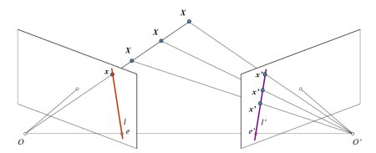

1. The basic arrangement of two cameras to take pictures

Figure 1 shows the basic settings of the camera to take two pictures from the different perspectives of the same scene. If we only use the left camera, we could not find a 3D point in accordance with point x in the image because every point on the path OX projected to the same point in the image area. But, consider the results of the right camera images too. Now, another point on the line OX projected to different points (x ') in the field next door. So with these two images, we can triangulate a true 3D point. This is the concept of epipolar geometry.

All epiline definitely pass its epipole. So to find the location of epipole, we can find many epilines and find the crossover point.

So to get the depth of the picture, we have to focus on finding epipole and epipolar line. But to find epipolar line and its epipole, we need two other things, the fundamental matrix (F) and essential matrix (E). Essential matrix contains information about translation and rotation, which describes the location of a second camera relative to the first camera in global coordinates.

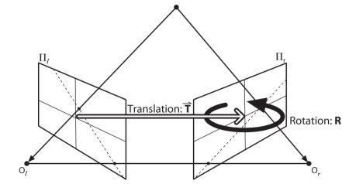

1. Transalation and rotation of the camera 2 to camera 1

However, in reality, we will do measurements performed in pixel coordinates. Fundamental matrix contains the same information as the essential matrix coupled with the intrinsic information from both cameras so that we can deal with both cameras in pixel coordinates. Simply put, the fundamental matrix F, connecting a point on a line in the image to other images. It can be calculated through the points corresponding to each of the two images. [3]

## Detection of Objects in Two Dimensional Image

At epipolar geometry stereo vision, one of the most important things is the ability of the system to get the features that can be corresponded to each other. This means that the algorithm to detect objects in a two-dimensional image in each camera should read the same features at the same point. For the reconstruction of three-dimensional images in full, this process will be a process that is heavy enough for the processor because the processor must process features found in each point to be able to reconstruct the depth of the image.

However, the design of this system, the system is made so it does not need to process each point corresponding features. In this system, the object is regarded as one point of perspective views from two different pictures in order to locate the position of objects in three-dimensional space.

The object to be detected by this system, the shuttlecock, is an object that is quite difficult to detect because the color of the object is white and it has a fairly rapid movement. Therefore, this system will be designed to take advantage of some algorithms to obtain the position of the shuttlecock in a two-dimensional plane in each camera. There are two important things that can be utilized in the detection of objects shuttle cock, the object is a moving object and the background can be assumed not to move. Thus, the algorithm can be seen in Figure 3, as follows:

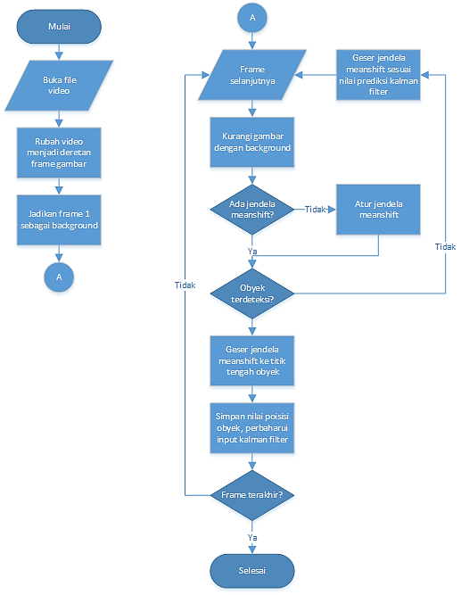

1. Detection algorithm diagram on a two-dimensional plane

As can be seen above, shuttle cock object detection algorithms can be divided into several stages. Begins by taking a background image. Background image is an image in which the object is not found in the images and the background image of the object will not move. It is important to for the later stage. The second stage is the stage of taking pictures with an object in it. From here we enter the third stage, early stage detection of moving objects. The simplest scheme for detecting moving objects in a sequence of images is to use a fixed background image to reduce further the objects move. Images are then obtained can then be analyzed to obtain the object. It is called the background subtraction method [4]

However, background subtraction is not enough, we need a method to separate the object to be detected, in this case the shuttlecock with its surrounding environment. This needs to be done because no matter what the environment is set to distinguish background with an object, interference will still occur.

Because of that, this system using camshift algorithms (continuously adaptive meanshift). This algorithm chosen for its ability to define, update, and renew object detection window size, position, and shape of the window. This allows the system to ignore the noises that are beyond the detection window.

Input from camshift is in form of histogram algorithm that describes a value. In this system, the input used is the value of Hue in HSV (Hue, Saturation, Value) image. HSV color space chosen for being able to express colors more accurately.

The system will perform the extraction component of H in the picture, then this component will be divided into m division with each value corresponds to a value of sub-characteristics. With this, the entire target area can be characterized by this value. On each sub-features, kernel-based density distribution function was used to calculate the probability distribution. Then, the characteristics of the probability of all u can be written as follows:



where x0 is the midpoint of the search window, xi is the i-th position of the pixel, k (‖x‖2) is the kernel function, h is the radius of the window, b and δ function determines whether the pixel at the point xi accordance with the characteristic value of all u.

Camshift algorithm is a result of the use of meanshift algorithms on a continuous image sequence in which the results of the previous frame is used as the initial value of the search window on the next frame [6]. If this iteration continues, then moving object detection can be performed. The steps are as follows:

1. Set the image as the search area
2. Initialize the search window size and position
3. Calculate the probability distribution of color in the search window
4. Run meanshift to get the position and size of the new window
5. In the next frame, the initiation of position and size of the search window by step 4. Go to step 3.

To complete the algorithm used Camshift Kalman filter algorithm. Kalman filter algorithm here is the algorithm used to predict the most likely location of the object at the current frame based on the results of the search object in the previous frame, the algorithm then find the search objects in the area around the site. When the target is found in the search area, continue to the next frame. Kalman filter is the key to prediction and updates the value [6]. Figure 4 shows a diagram of the Kalman filter.

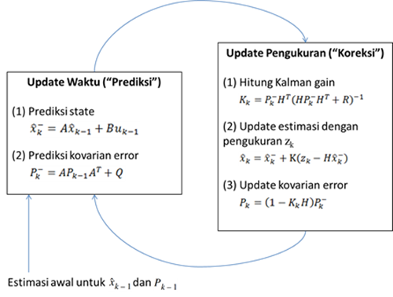

1. Kalman Filter Diagram

# Research Method

In this section we will discuss the design of the system associated with the system to be built to detect the movement of the shuttle cock. Based Software Development Life Cycle (SLDC), after determining the theme and problem definition and objectives, then the next step in making the shuttle cock detection system is planning. The planning phase includes system requirements, design, and implementation. System testing and analysis will not be discussed in this chapter. In documenting each stage of SLDC, Unified Modeling Language (UML) is used as the standard method. With UML, the design of hardware and workflow can be represented in diagrams which have their respective functions.

## System Requirement

Listed below are the results of the collection requirement obtained through the study of literature:

* Two cameras are positioned outside the pitch at two different ends where each camera can capture the entire field in the Field of View her.
* Two cameras are directed toward the background as much as possible to have different colors used to shuttle cock
* Two cameras take images simultaneously and record it in the form of video files

## System Modelling

This system requires a model to get the position of an object in three-dimensional space. Figure 5 is a modeling is made for this system.

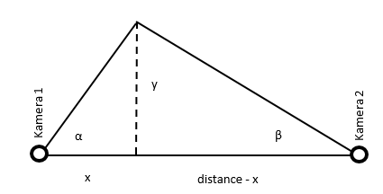

1. System Modelling in x and y plane

The models can be derived into the following equation:





As for the z plane can be modelled as in figure 6 as follows:

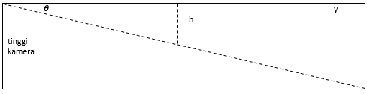

1. System Modelling in z plane

The models can be derived into the following equation:





## Software Design

Position detection system of shuttle cock made in this study is designed to provide accurate results from the position of the shuttlecock, trajectory and speed. This system will be controlled by a PC. As for the input image to be used on the system will be obtained from two PlayStation Eye camera placed at both ends of the field and capture the entire area of movement of the shuttlecock. Figure 7 shows a block diagram of the whole system:

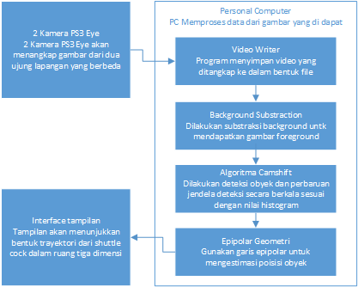

1. System Block Diagram

# Experiment and Analysis

## Camera Setup and Calibration

One of the most important things in this system is essential matrix values of the two cameras used. Essential matrix contains information about translation and rotation, which describes the location of the second camera relative to the first camera in global coordinates.

The camera used in this system does not have the ability to measure the degree of tilt of the camera, so that the angle of the camera position must be set manually by the user. Therefore, it required a camera position calibration method that can be used to adjust the camera position. This can be done by reversing the process used by this system, in which the normal use of the system using an object on a pixel position to be able to determine the position of objects in three-dimensional space, then we can also specify the position of the object on the pixels to the position of an object on three-dimensional space that we already know. As for the stages are as follows:

1. Determine the position of an object in the real world that is parallel to the horizon of the camera.
2. Find the angles of camera one and camera two to determine the coordinates of the object to the camera distance.
3. Adjust the offset angle obtained by the camera.
4. Convert the value of the angle in degrees to be the value of the pixels on the camera
5. Point the camera so that the detected object has a pixel value corresponding to the calculation

## The Effect of Object Posistion on Accuration Analysis

Before performing testing on a moving object, conducted testing on a static object. This is done to determine the value of the error that occurred in the positions of certain objects. Testing is done by putting an object on a pole with a height equal to the pillar camera and began taking pictures at certain positions. From the test results, it can be analyzed by determining the influence of the position of the object with an accuracy on the x-axis and y-axis of the real world. The result can be seen through the charts below:

1. Graph on y = 180
2. Graph on y = 240
3. Graph on y = 300
4. Graph on y = 360
5. Graph on y = 420

From the graphs above can be analyzed that the influence of an object laying on the x-axis in the real world has little effect on the estimates of the system to the position of the object on the z axis (height of the object). While on the y-axis, when the object is placed at a distance below 300 cm, the highest error occurs at the midpoint of graph, this happens as a result of the object has not passed the midpoint of the pixels so that most errors occurred in the estimation in the middle. When the object is farther than 300 cm on the y axis, more error occurs when the object is in the far right or far left detection area, this is because the camera only captures the two objects at the edges so that in case of error is quite large. Interesting things happen at the reading system in the x-axis, as though laying objects and symmetrical camera but apparently reading systems have a greater error when an object is detected is on the right. This is because the backlight differences between camera one and camera two.

Furthermore, for the analysis of the effect of an object laying on the y axis in the real world, can be seen in the following charts:

1. Graph on x = 240
2. Graph on x = 300
3. Graph on x = 360

It can be seen from the graphs above, the error value always increases with the increase in the position of objects on the y-axis. This, occurring mainly on the value of the x-axis and z-axis. This is because the further away the object from the camera, the pixels are read from the object also becomes smaller, so the error of the reading increases.

## Object Movement Direction Effect on Detection Result

After testing at static objects, the system is ready to detect the moving object. In this section conducted an analysis of the influence of the direction of motion of the object to the detection results. The parameter used is the percentage trajectory obtained by the system as well as the percentage ratio of the object detected by the object predictable trajectory obtained. Display detection system can be seen in the following figure:

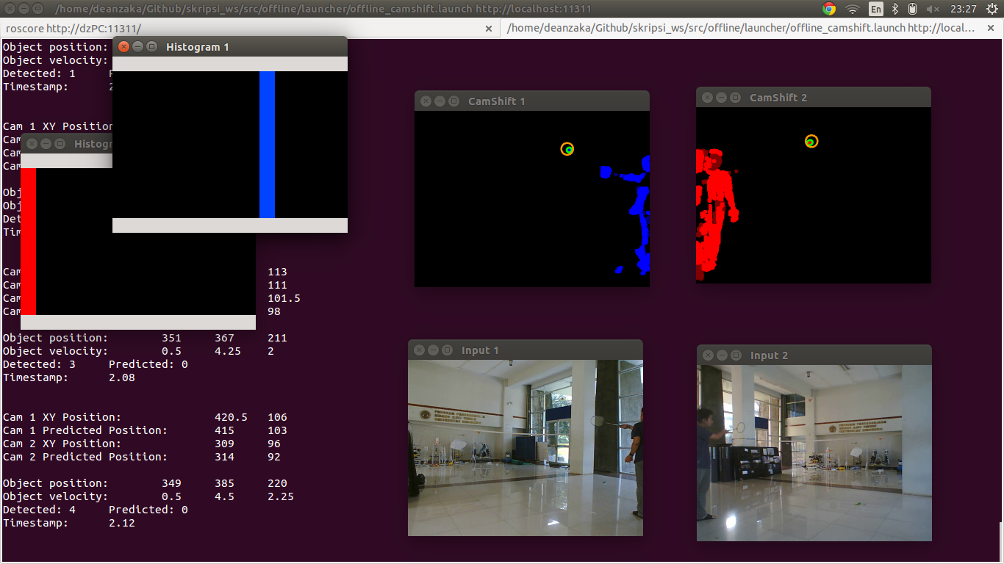

1. Dispay System

Percentage trajectory is obtained by comparing the time since the object was first detected to the time since the object was first hit to object landed on the ground. This experiment using a red the shuttlecock, this is done to distinguish the color of the background to the object. Results from these tests can be seen in the following table:

1. Direction Closing In Test

|  |  |  |  |  |  |  |  |
| --- | --- | --- | --- | --- | --- | --- | --- |
| No | Detected Trajectory from First Hit until Landed | | | | Detected Object in Trajectory | | |
| First Hit (second) | First Detected (second) | Landed (second) | Persentage | Detected | Predicted | Persentage |
| 1 | 3,4 | 4 | 4,88 | 59,46 | 20 | 2 | 90,91 |
| 2 | 5,92 | 6,24 | 7,2 | 68,42 | 24 | 0 | 100,00 |
| 3 | 1,36 | 1,84 | 2,88 | 60,00 | 25 | 2 | 92,59 |
| 4 | 3 | 3,64 | 4,6 | 74,36 | 25 | 0 | 96,77 |
| 5 | 1,72 | 2,12 | 3,28 | 75,68 | 30 | 1 | 100,00 |
| 6 | 4,2 | 4,56 | 5,68 | 70,59 | 28 | 0 | 96,15 |
| 7 | 1,16 | 1,56 | 2,52 | 84,62 | 25 | 1 | 100,00 |
| 8 | 3,4 | 3,64 | 4,96 | 82,50 | 33 | 0 | 97,06 |
| 9 | 1,4 | 1,68 | 3,00 | 81,69 | 33 | 1 | 89,29 |
| 10 | 3,74 | 4 | 5,16 | 75,00 | 25 | 3 | 92,86 |
| 11 | 1,12 | 1,48 | 2,56 | 80,00 | 26 | 2 | 96,97 |
| 12 | 4,56 | 4,88 | 6,16 | 65,63 | 32 | 1 | 91,30 |
| 13 | 2,12 | 2,56 | 3,40 | 76,32 | 21 | 2 | 100,00 |
| 14 | 4,16 | 4,52 | 5,68 | 76,32 | 30 | 0 | 96,55 |
| 15 | 1,4 | 1,76 | 2,92 | 76,32 | 28 | 1 | 96,67 |
| 16 | 3,72 | 4,08 | 5,24 | 76,67 | 29 | 1 | 100,00 |
| 17 | 1,2 | 1,48 | 2,40 | 77,78 | 23 | 0 | 96,43 |
| 18 | 3,4 | 3,72 | 4,84 | 69,70 | 27 | 1 | 95,83 |
| 19 | 1,32 | 1,72 | 2,64 | 69,44 | 23 | 1 | 100,00 |
| 20 | 3,48 | 3,92 | 4,92 | 69,44 | 26 | 0 | 100,00 |
| Average | | | | 73,50 | Average | | 96,47 |

1. Direction Away Test

|  |  |  |  |  |  |  |  |
| --- | --- | --- | --- | --- | --- | --- | --- |
| No | Detected Trajectory from First Hit until Landed | | | | Detected Object in Trajectory | | |
| First Hit (second) | First Detected (second) | Landed (second) | Persentage | Detected | Predicted | Persentage |
| 1 | 1,76 | 1,96 | 3,2 | 86,11 | 29 | 3 | 90,63 |
| 2 | 5,48 | 5,68 | 7,2 | 88,37 | 38 | 1 | 97,44 |
| 3 | 1,76 | 2,04 | 3,44 | 83,33 | 31 | 5 | 86,11 |
| 4 | 4,36 | 4,64 | 6,04 | 83,33 | 33 | 2 | 94,29 |
| 5 | 2 | 2,2 | 3,56 | 87,18 | 30 | 6 | 83,33 |
| 6 | 4,49 | 4,6 | 6,08 | 93,08 | 34 | 4 | 89,47 |
| 7 | 2,32 | 2,6 | 3,96 | 82,93 | 27 | 8 | 77,14 |
| 8 | 4,92 | 5,24 | 6,60 | 80,95 | 31 | 6 | 83,78 |
| 9 | 1,28 | 1,52 | 2,76 | 83,78 | 24 | 8 | 75,00 |
| 10 | 3,72 | 4,16 | 5,32 | 72,50 | 27 | 3 | 90,00 |
| 11 | 1,24 | 1,52 | 2,60 | 79,41 | 25 | 6 | 80,65 |
| 12 | 3,76 | 4 | 5,16 | 82,86 | 28 | 2 | 93,33 |
| 13 | 1,32 | 1,56 | 2,68 | 82,35 | 27 | 5 | 84,38 |
| 14 | 7,52 | 7,72 | 9,04 | 86,84 | 26 | 8 | 76,47 |
| 15 | 2,56 | 2,88 | 4,28 | 81,40 | 31 | 5 | 86,11 |
| 16 | 5,08 | 5,4 | 6,36 | 75,00 | 26 | 3 | 89,66 |
| 17 | 2,44 | 2,64 | 3,80 | 85,29 | 25 | 4 | 86,21 |
| 18 | 4,56 | 4,8 | 6,04 | 83,78 | 24 | 7 | 77,42 |
| 19 | 1,16 | 1,48 | 2,84 | 80,95 | 34 | 4 | 89,47 |
| 20 | 3,8 | 4 | 5,36 | 87,18 | 28 | 7 | 80,00 |
| Average | | | | 83,33 | Average | | 85,54 |

As can be seen in the table above, the object is detected approaching the camera has detected a shorter trajectory than the object away from the camera, this is because the starting point of the trajectory starts away from the camera so it is difficult to read by the system. However, it can be seen that the percentage reading at the objects of the trajectory can be greater when the object approached the camera, this means that the object is approaching the camera does not have a lot of missing detection while on the move. This is because most of the trajectory of the object is detected close to the camera, while at the object away from the camera, most of the trajectory is read to be away from the camera. The results of the simulated readings in the system rviz of ROS can be seen in figure 17 below:

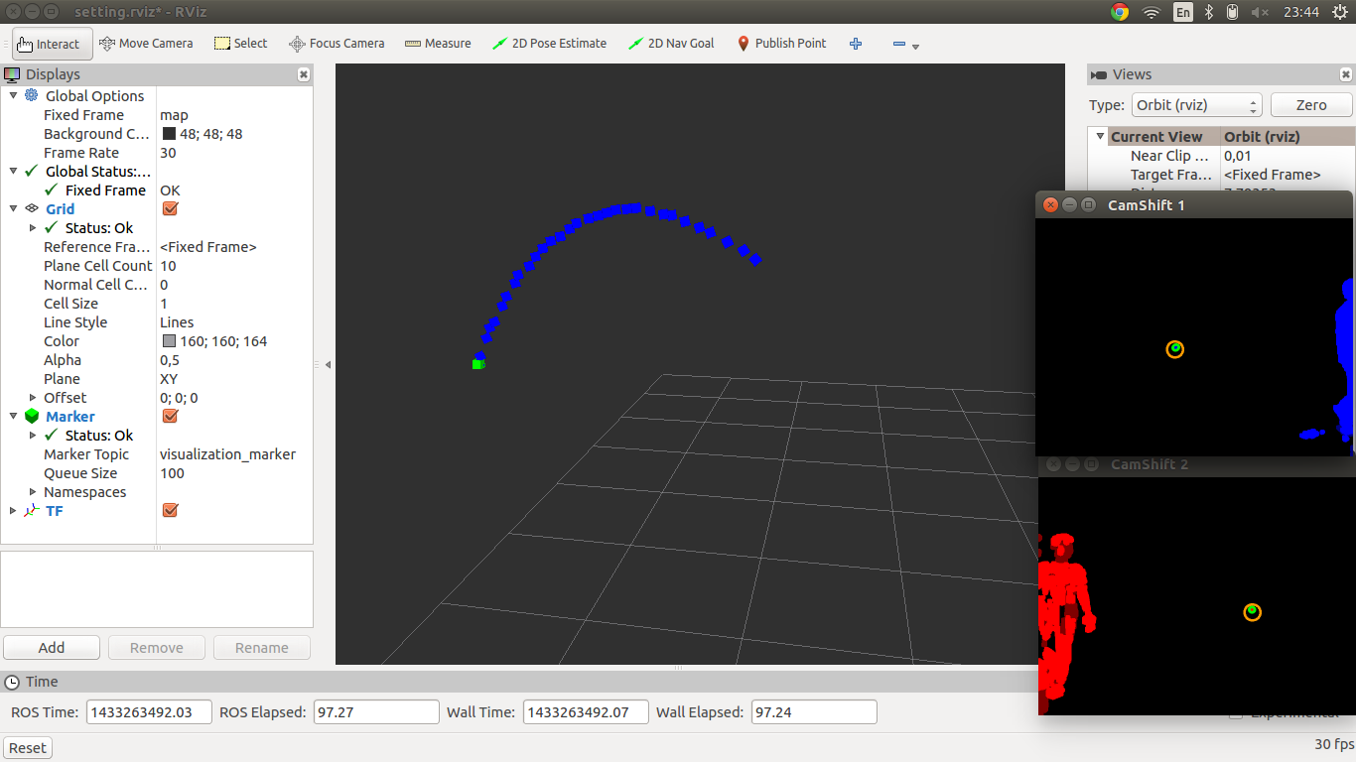

1. rviz simulation display with ROS

As we mentioned in an earlier experiment, shuttle cock used in the experiment shuttle cock is red, it is intended to distinguish the color of the object with the background color. In this experiment, the system tried to use the shuttle cock that has the same color as the background. The result can be seen in the following table:

1. Object Color Similar to Background Test

|  |  |  |  |  |  |  |  |
| --- | --- | --- | --- | --- | --- | --- | --- |
| No | Detected Trajectory from First Hit until Landed | | | | Detected Object in Trajectory | | |
| First Hit (second) | First Detected (second) | Landed (second) | Persentage | Detected | Predicted | Persentage |
| 1 | 0,44 | 1,28 | 2 | 46,15 | 17 | 2 | 89,47 |
| 2 | 2,76 | 4,2 | 4,36 | 10,00 | 8 | 2 | 80,00 |
| 3 | 1 | 1,88 | 2,28 | 31,25 | 11 | 0 | 100,00 |
| 4 | 4,2 | 5,28 | 5,92 | 37,21 | 16 | 1 | 94,12 |
| 5 | 0,72 | 1,92 | 2,16 | 16,67 | 6 | 1 | 85,71 |
| 6 | 2,6 | 3,52 | 3,92 | 30,30 | 9 | 2 | 81,82 |
| 7 | 0,64 | 1,8 | 2,28 | 29,27 | 12 | 1 | 92,31 |
| 8 | 2,3 | 3,56 | 4,08 | 29,21 | 12 | 2 | 85,71 |
| 9 | 1,32 | 2,16 | 2,48 | 27,59 | 8 | 0 | 100,00 |
| 10 | 3,48 | 4,8 | 4,96 | 10,81 | 3 | 1 | 75,00 |
| 11 | 1,8 | 2,84 | 3,20 | 25,71 | 9 | 1 | 90,00 |
| 12 | 4 | 5,28 | 5,52 | 15,79 | 7 | 0 | 100,00 |
| 13 | 2 | 2,92 | 3,56 | 41,03 | 14 | 3 | 82,35 |
| 14 | 4,24 | 5,68 | 5,92 | 14,29 | 7 | 0 | 100,00 |
| 15 | 1,4 | 2,68 | 2,96 | 17,95 | 8 | 0 | 100,00 |
| 16 | 3,88 | 5,08 | 5,32 | 16,67 | 7 | 0 | 100,00 |
| 17 | 0,76 | 2,16 | 2,40 | 14,63 | 7 | 0 | 100,00 |
| 18 | 3,2 | 4,28 | 4,60 | 22,86 | 9 | 0 | 100,00 |
| 19 | 1,88 | 2,88 | 3,28 | 28,57 | 11 | 0 | 100,00 |
| 20 | 3,92 | 4,96 | 5,48 | 33,33 | 13 | 1 | 92,86 |
|  | Average | | | 24,96 | Average | | 92,47 |

It can be seen in the table above percentages trajectory legible down dramatically compared to trials using red-colored objects. However, the object is not completely disappear from the system. Shuttle cock still can be read at the end of the trajectory. This is because the position of the shuttle cock is approaching the camera so that the captured pixel color began to read the difference. Also, it can be seen in the percentage of detected objects in readable trajectory is above 90%, it indicates that the trajectory is detected, the system readings of the object is good enough although the object has similar color with the background.

## Lighting Effect on Detection Analysis

In the analysis of the effect of light on the readings, the system tried to use normal lighting at night. As a result, there is a noise that cuukup much so that the system cannot distinguish where the object where dots caused by noise. This means, the lighting environment has a huge impact on this system. The results of the experiment can be seen in the figure below:

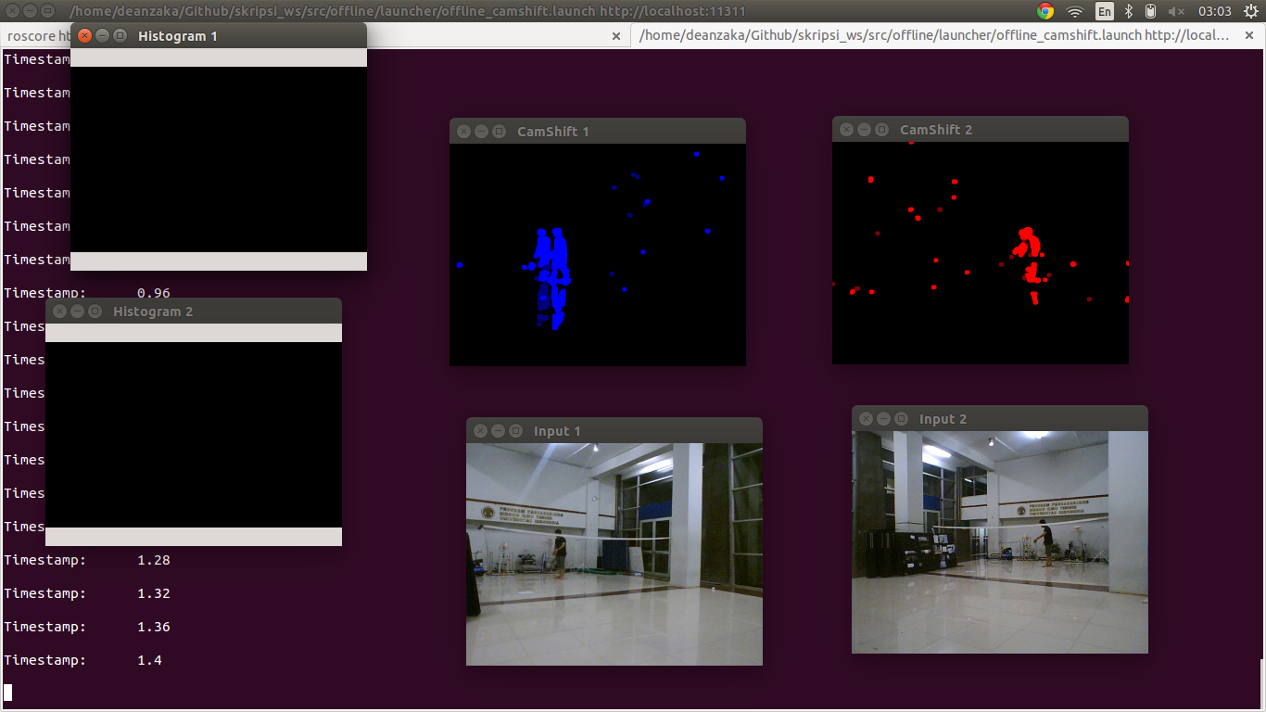

1. Test Result in Unconditioned Lighting

# Conclusions

1. System test results on static objects show the system can detect the position of objects in three-dimensional space using epipolar geometry. However, it is still seen an increase in the value of the object position error increases with increasing distance of the object to the camera, this is because the camera angle calibration factors are done manually so that does not really fit with the calculation ..
2. The test results demonstrate the system on a moving object system can detect an average of 83.33% trajectory shuttle cock with an average detection percentages in the trajectory 85.54%. As well as the detection system can still continue despite the loss of the object in the middle of the trajectory, it can be concluded based camshift Kalman filter algorithm is a good algorithm in the detection trajectory shuttle cock.
3. After a change of direction of the shuttle cock toward the camera, the trajectory is detected down to an average of 73.5% but the percentage increased to 96.47% detection. These results are consistent with the results of testing on static objects where the objects closer to the camera will have an accuracy of readings higher position.
4. After a change of color of objects that resemble the background image in the capture. Trajectory detected down to an average of 24.96%. This shows the difference in color with the background image object is very influential on the results obtained system.
5. After experiments with minimal lighting at night, the results show that the system can not distinguish objects with dots generated by noise, so the system is totally unusable. This shows that the lighting of the room has a very significant influence on the system

##### References

1. A. Kaehler dan G. Bradsky, Learning OpenCV, O'Reilly, 2013.
2. W. Li dan B. Li, “Map Estimation of Epipolar Geometry by EM Algorithm,” dalam IEEE International Conference on Image Processing, San Antonio, 2007.
3. G. Bradsky, “OpenCV 3.0.0-dev documentation,” [Online]. Available: http://docs.opencv.org/trunk/doc/py_tutorials/py_calib3d/py_epipolar_geometry/py_epipolar_geometry.html. [Diakses 18 Desember 2014].
4. H. Sekkati, R. Laganiere, A. Mitiche dan R. Youmaran, “Robust background subtraction using geodesic active contours in ICA subspace for video surveillance application,” dalam Ninth Conference on Computer and Robot Vision, Toronto, 2012.
5. “OpenCV 3.0.0-dev documentation,” [Online]. Available: http://docs.opencv.org/trunk/doc/py_tutorials/py_video/py_bg_subtraction/py_bg_subtraction.html. [Diakses 18 Desember 2014].
6. S. Huang dan J. Hong, “Moving Object Tracking System Based On Camshift,” dalam International Conference on Consumer Electronics, Communications and Networks (CECNet), Xianning, 2011.
7. “ROS,” [Online]. Available: http://www.ros.org/. [Diakses 29 05 2015].
8. “ PLAYSTATIONEye Brings Next-Generation Communication to PLAYSTATION3,” Sony Computer Entertainment, 26 April 2007. [Online]. Available: http://www.us.playstation.com/News/PressReleases/396. [Diakses 18 Desember 2014].