A-4 Skeleton and a Plan

Name: Jingyi Ouyang

ID: A53108909

Name: Weihan Jiang

ID: A92089193

Name: Derrick Lieu

ID: A12075300

**Development Plan**

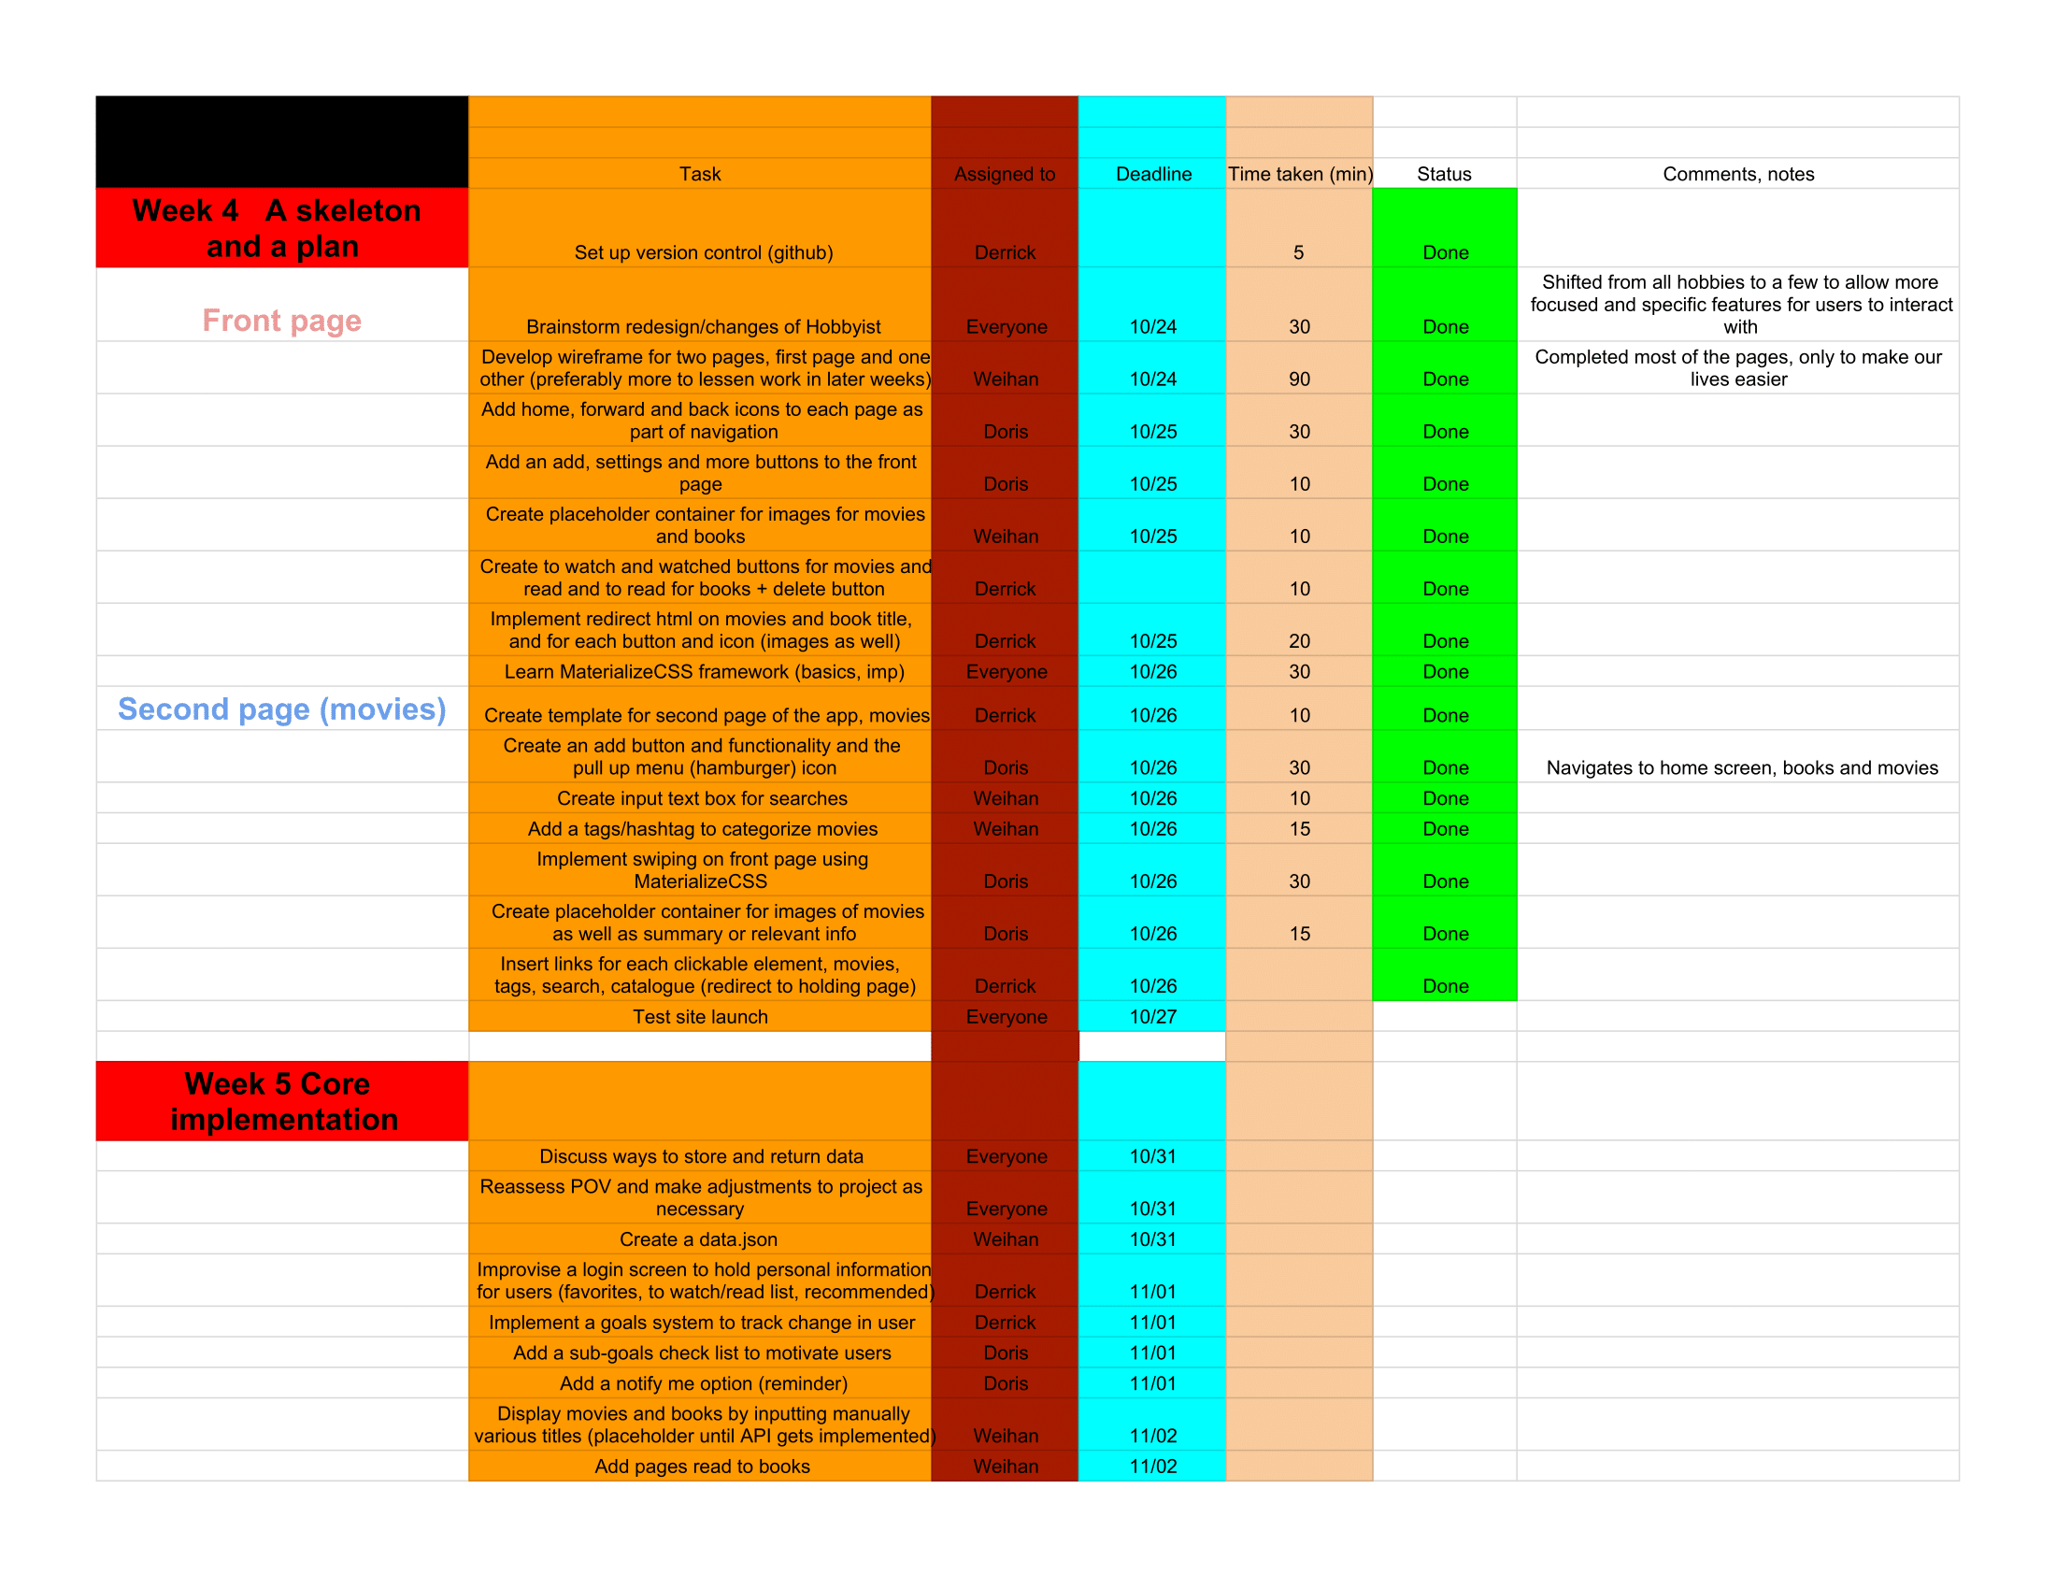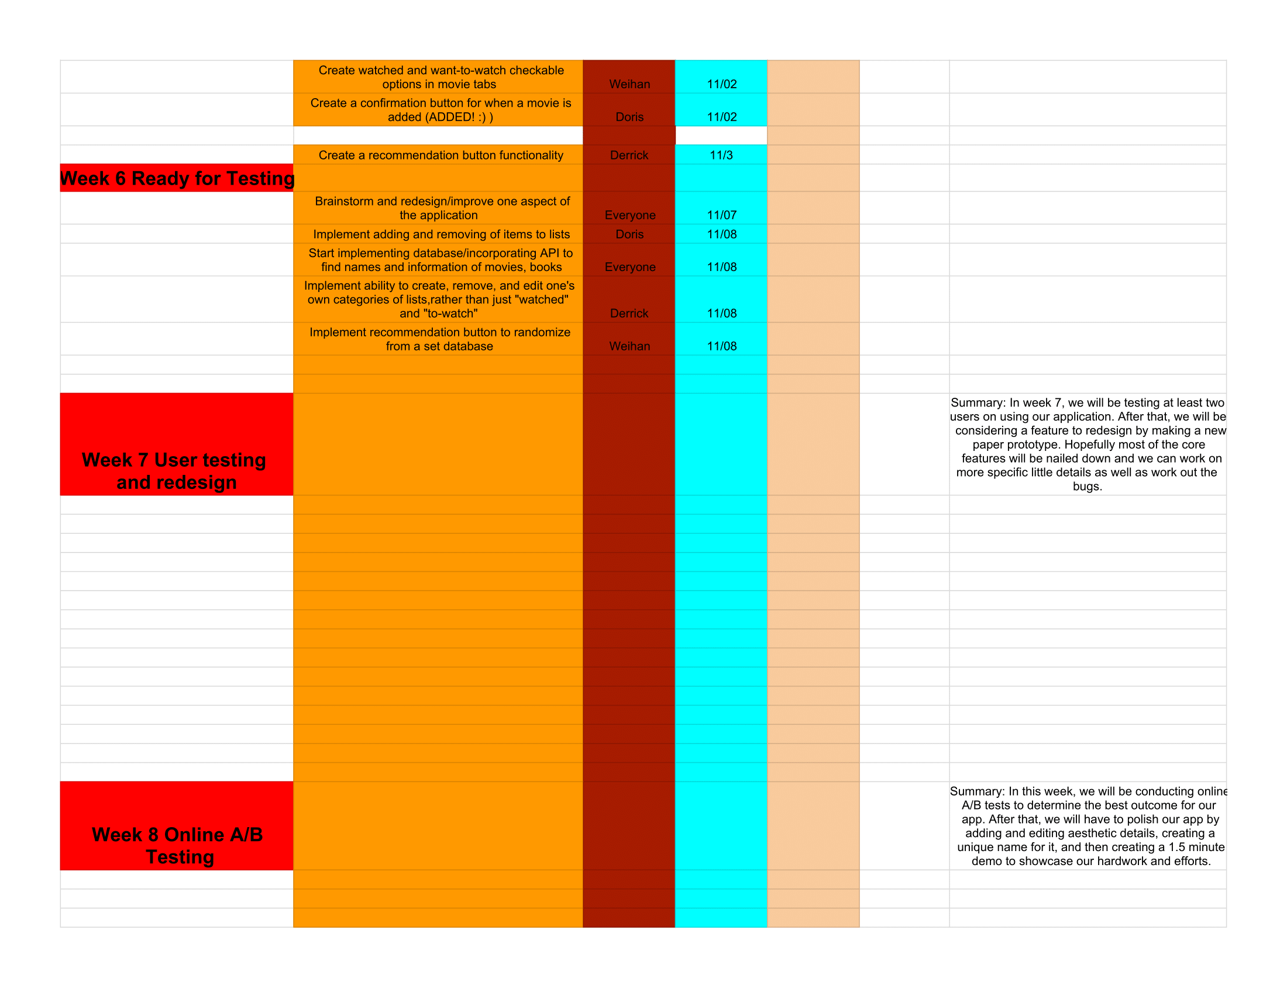

**Wireframe**

https://invis.io/Y293W81Z9

**Skeleton and two pages**

<https://phob.herokuapp.com/index.html>

**Summary**

Our user in this case is anyone who wants to catalogue or chronicle movies and books they have seen or read, are currently watching or reading, or want to watch or read in the future. Any person who watches movies or read books can also use this application. In this case, we are using the history of users’ movie and reading list as a means to view the various nuances in their tastes. Similarly, we are allowing users to recommend movies and books which will be input into the database which will be used to recommend other users a random movie from that database. This will allow an indirect interaction and molding of user interests in these forms of entertainment. They will be able to visualize these interactions with each other by understanding another user’s taste in books or movies.