A7 - User Testing and Redesign

Name: Jingyi Ouyang

ID: A53108909

Name: Weihan Jiang

ID: A92089193

Name: Derrick Lieu

ID: A12075300

**In-Person Testing**

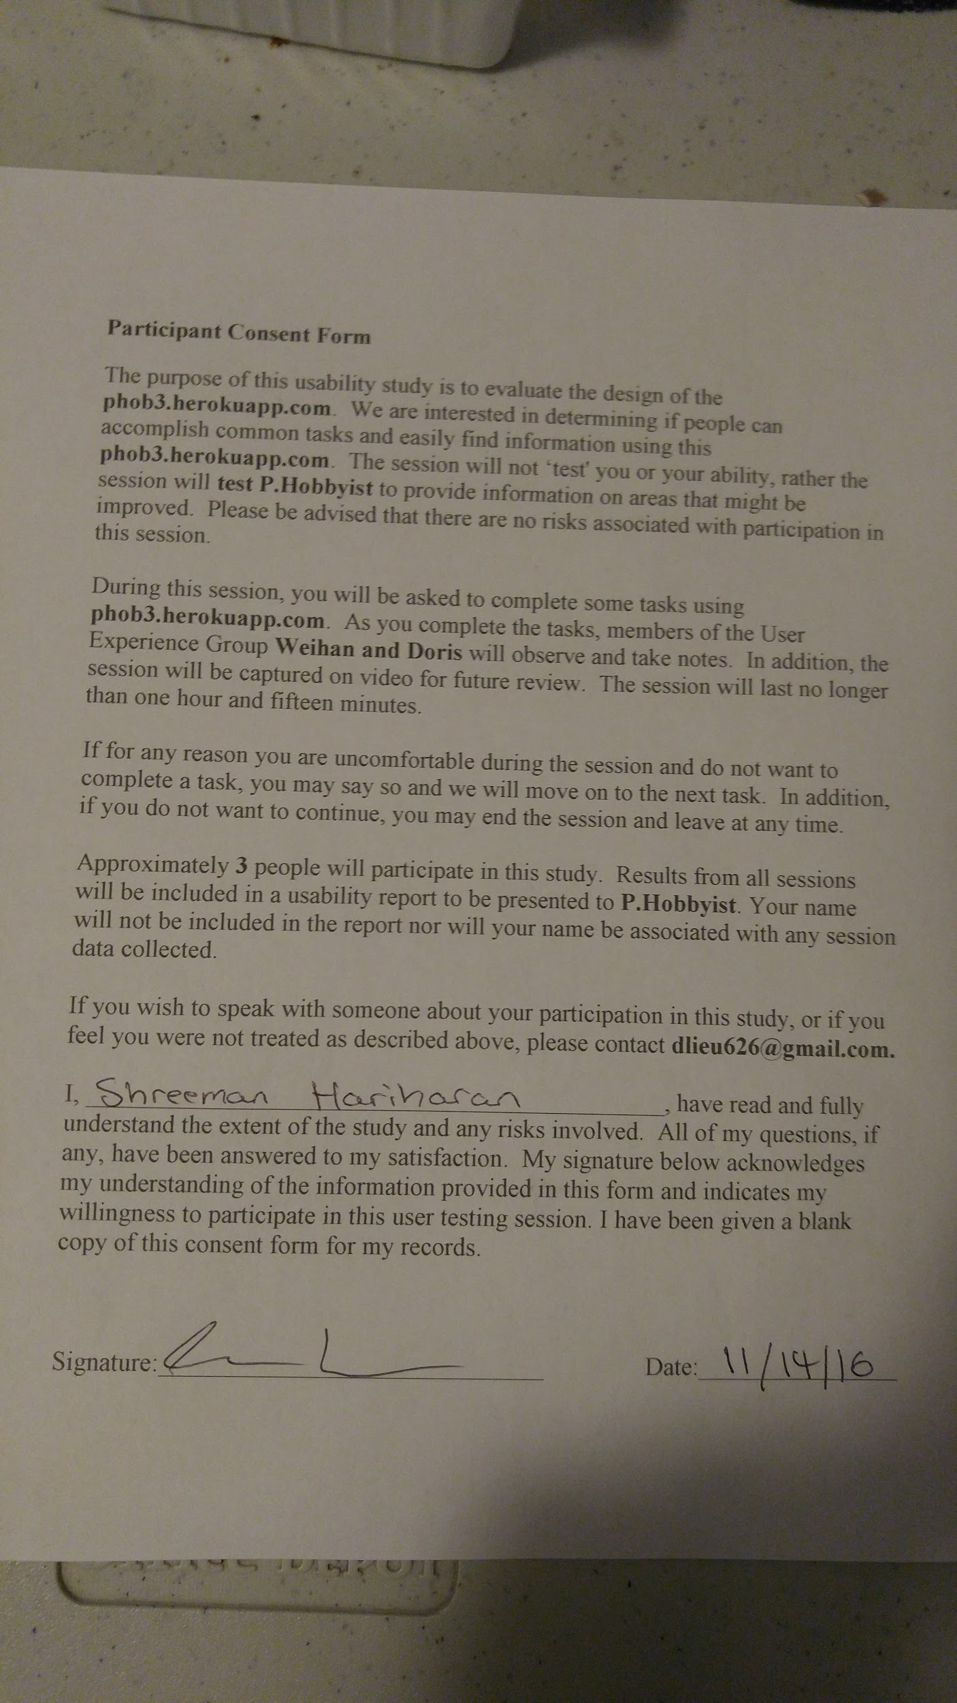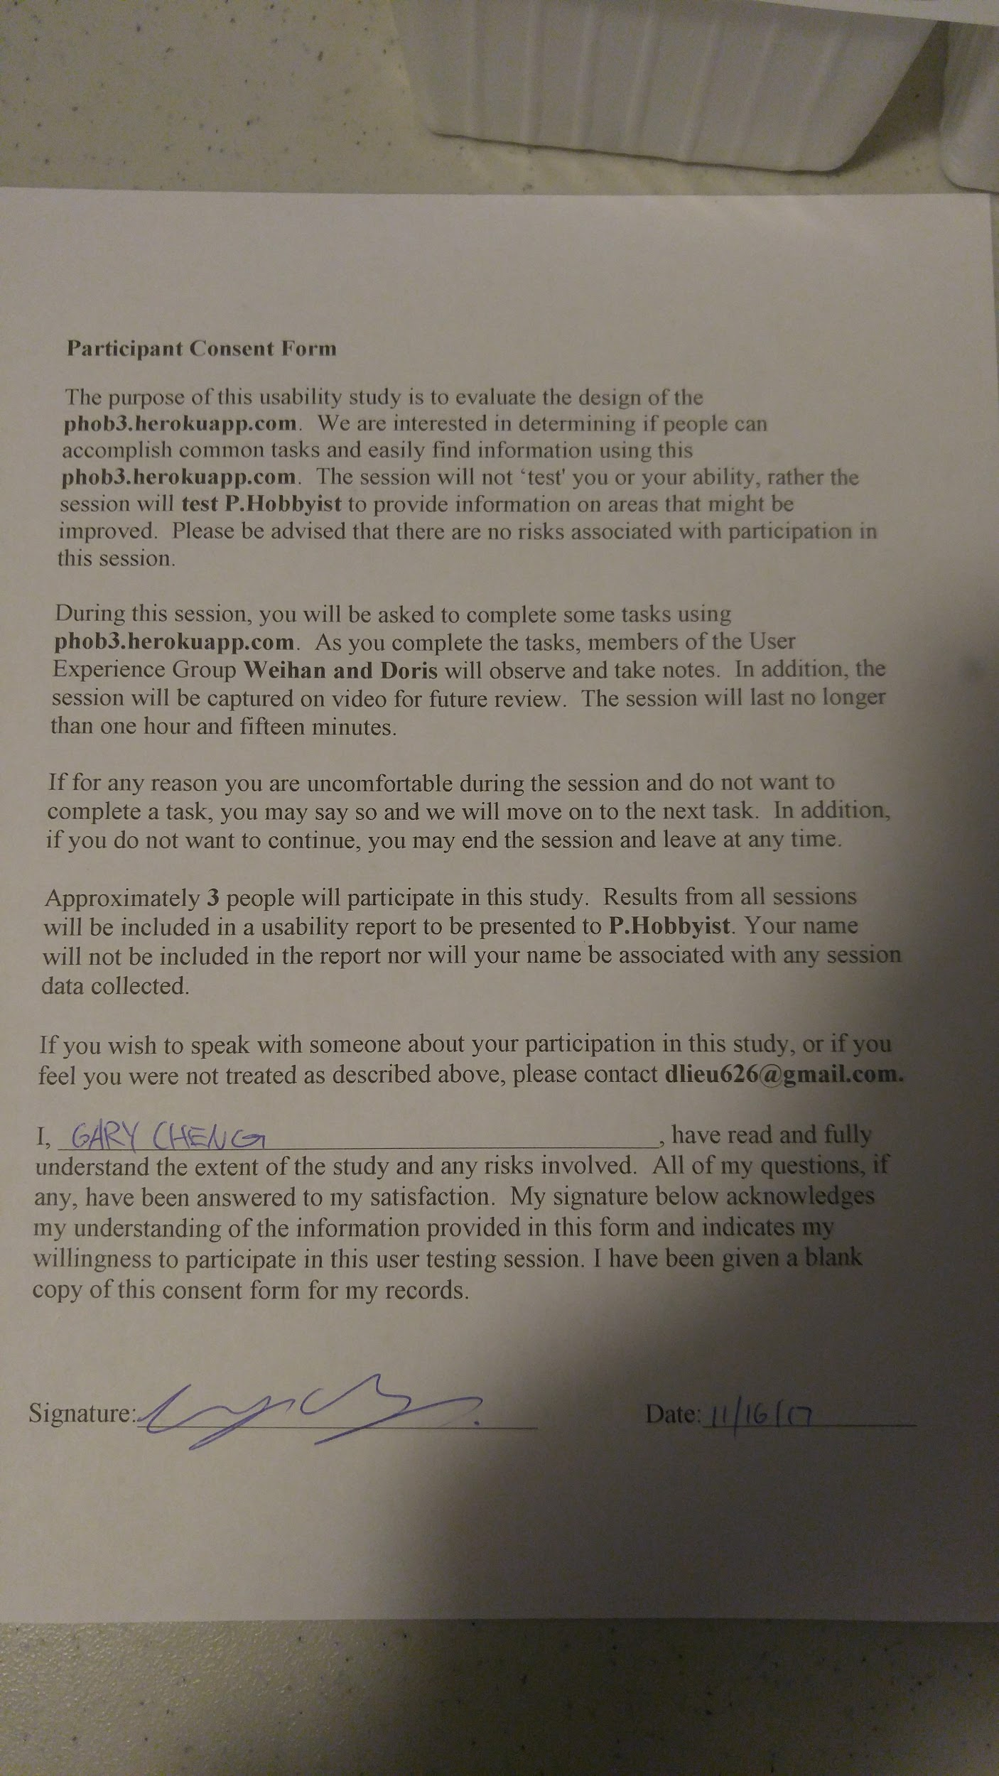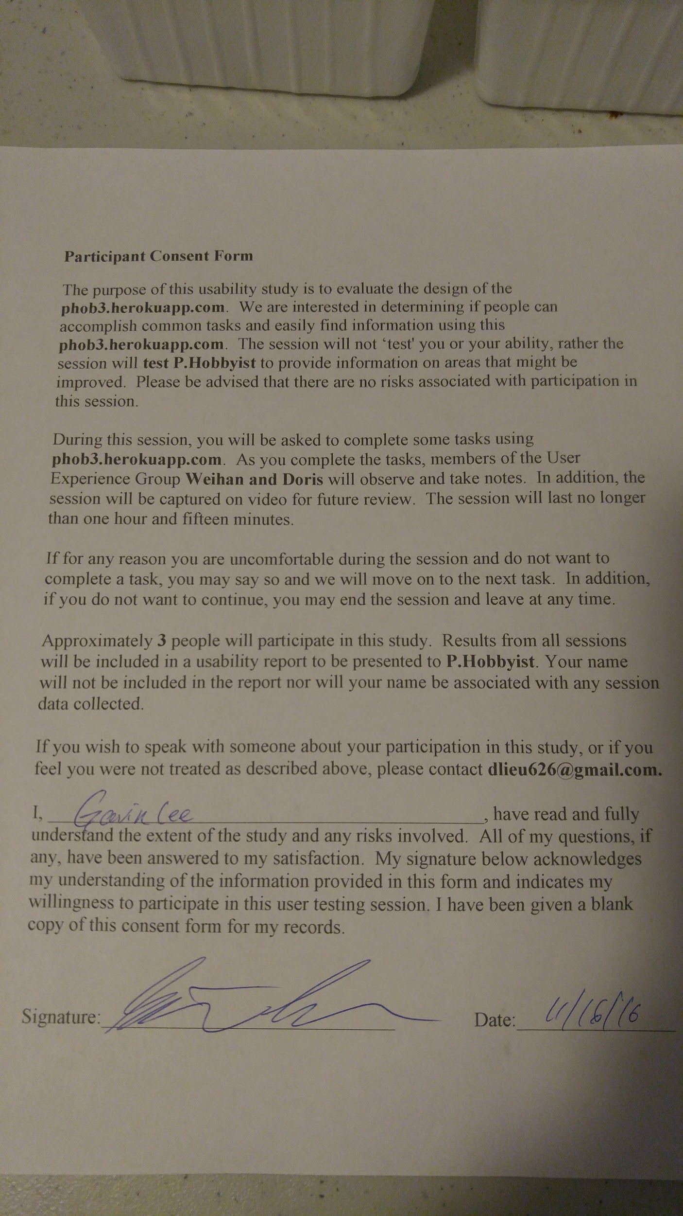

**Usability Script**

* Have users login with username: Doris and password: wow
* Have users type a movie in the search bar (might we suggest Doctor Strange?)
* Swipe left and right across the Recommended container and interact with the element there
* Interact with the recent functionality by swiping through the wheel and letting them decide what to do next
* Press the global navigational button to navigate between home and the movies screen
* Navigate to the movies screen and press a movie of their choice
* Press watched on the movie details and return to the movie homepage
* Enter the History page to see the current state of the movie
* Let the user play with the filters
* Return to front page and allow users to play with the app as they please, noticing the recent function as they interacted with previous movie elements

While the user is using the application, we will ask the tester to ask questions to the user such as how does the navigation menu feel at the bottom right when navigating throughout the application? Or what trouble are you having with the thought process behind using the application?

#### **Things to keep an eye out for:**

1. What does the user first look at and try to interact with?
2. How often and how long does the user become hesitant in pressing a button or interacting with certain elements?
3. How important is the back button? How often is it used?
4. What is the feature that users are interacting with the most? What do they care about?
5. Are there any extraneous steps or info while navigating this app?

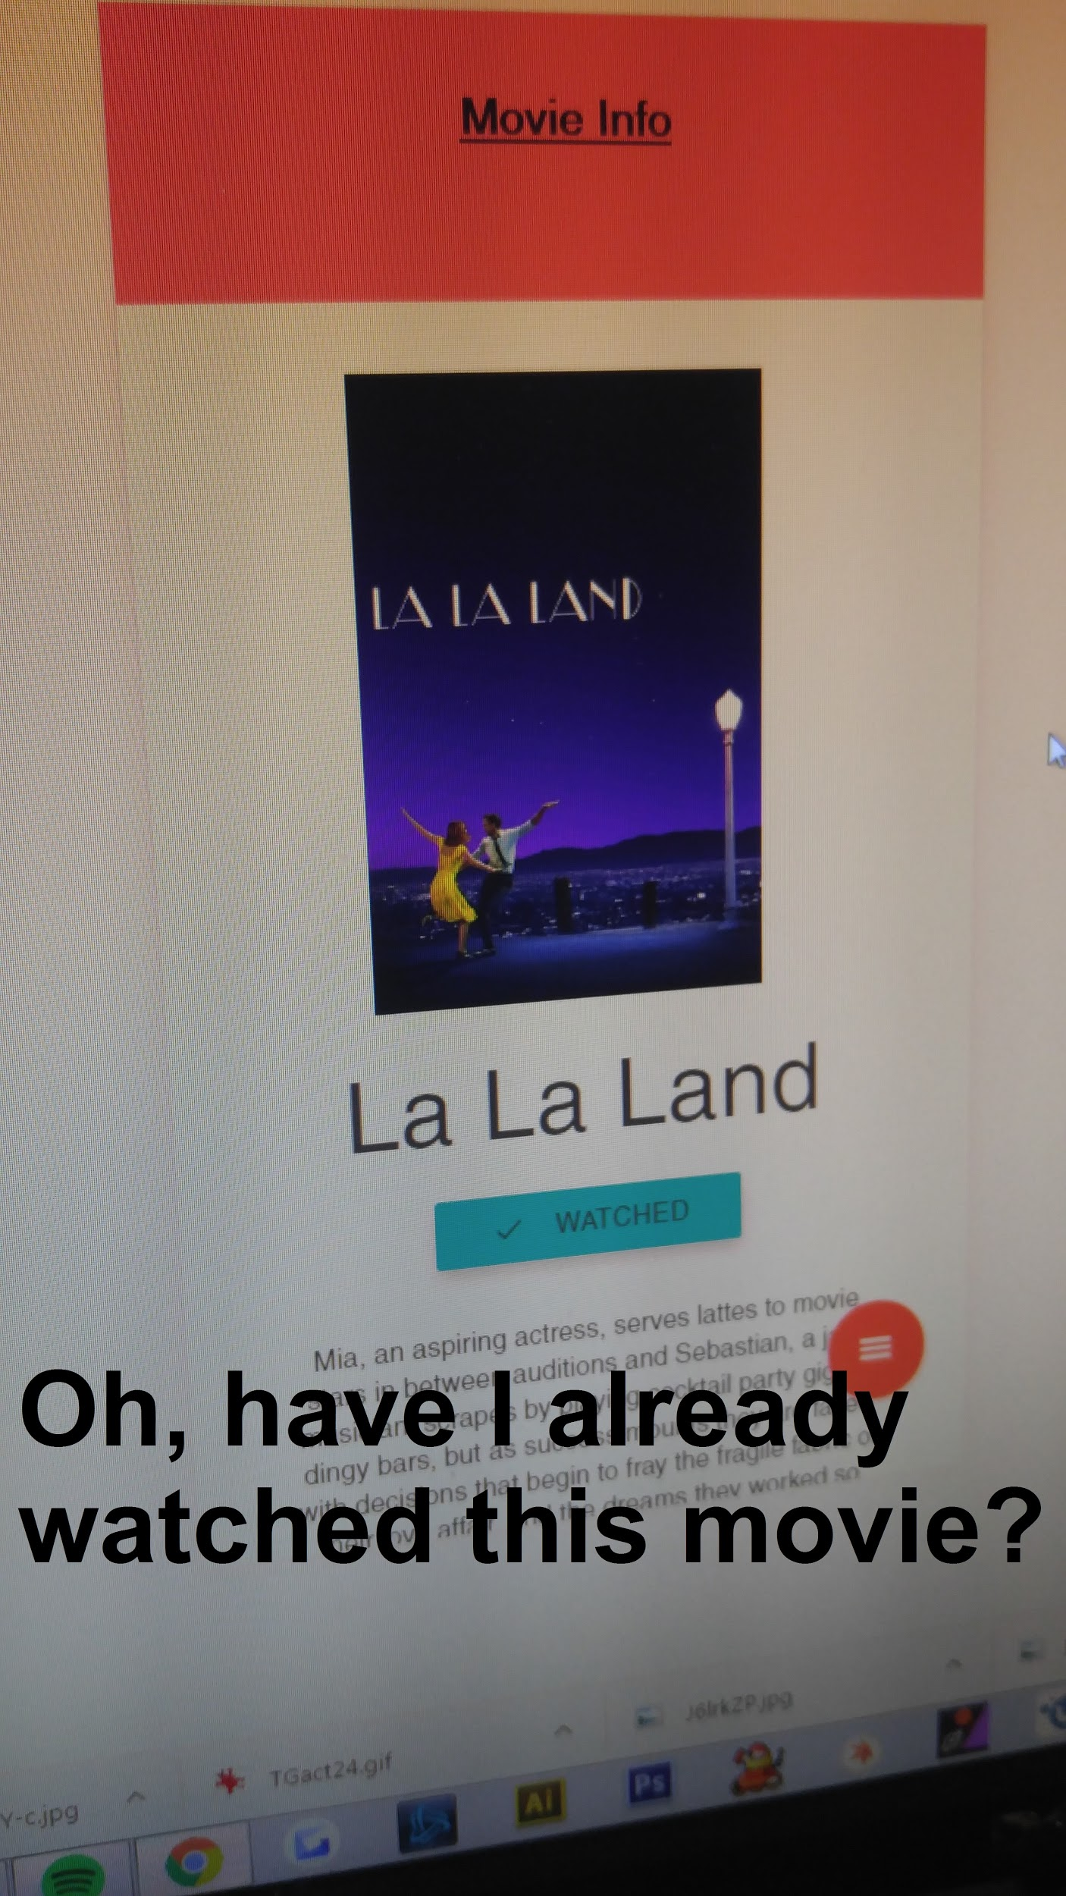

**Test #1**: The user was confused with the wording and display of the word “Watched” when the page first loaded. He couldn’t tell if the movie was already “watched” or if it was available for the user to press to change it to “watched.”

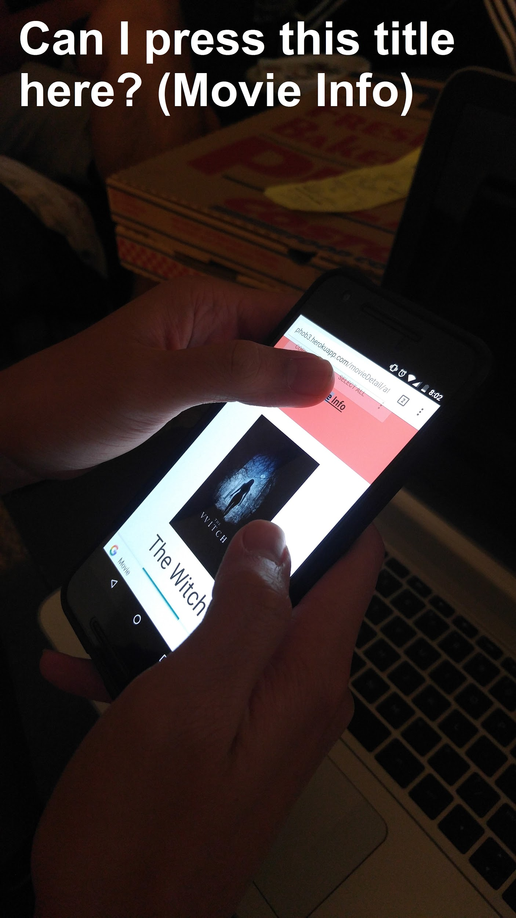

**Test #2:** The user here thought the title Movie Info was clickable and could return to the movies page. He also pointed out some elements were not centered correctly.

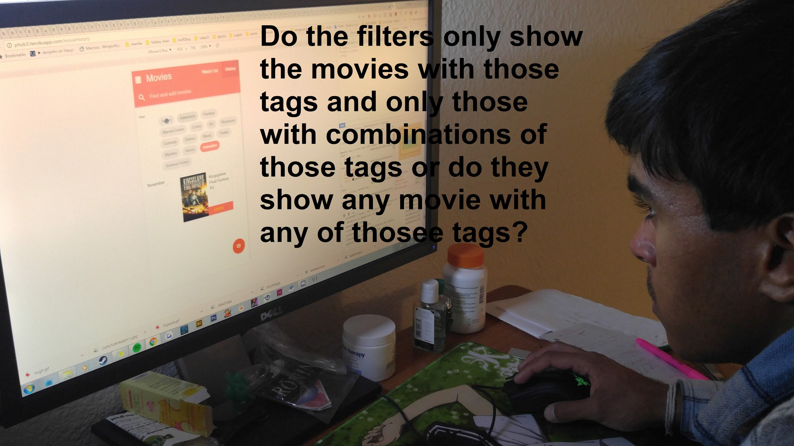

**Test #3:** The last user was confused with how the filter system worked. He had thought the filter worked by **only** allowing movies with those tags to show up.

**List of changes**

**Top priority changes (* means implemented in this iteration, -- means will be started this iteration but completed in the next iteration)**

* Remove books from movieHistory.handlebars, this was an oversight on our part and is a high priority yet low effort to achieve **(*)**
* Change “watched” in movieDetail to “Seen this movie?” if not seen and to “Added to History!” when user clicks on it. This will clarify the problem of users being confused with the notion “Watched?” versus “Watched” being the difference of a movie that hasn’t been seen and one that has been. It also interacts with the user since it tells them that it was moved to another category as opposed to “watched” just signifying a change in wording or class. **(*)**
* Use better wording if possible, gets confusing which ruins user flow and interaction. Words like “Watchlist” and “History” are confusing at first and may cause users to hesitate to use this app **(--)**
* Recommend on front page (next to The Witch) → Recommended and bold it to make it stand out so users are more inclined to look at that portion of the page **(*)**
* Implement the recent function to show any recent activity that a user has engaged in. Though not a top priority, it would be a nice feature to include in this app. For example, if a user clicks on Doctor Strange but then returns to the index without doing anything, Doctor Strange should show up in the recent timeline just in case they wanted to have a quick access to it again. It is also possible to Wizard of Oz this feature! **(*)**
* Fix recommendation to give actual random movies from JSON as well as fix “Just give me a movie” in movies.handlebars. **(--)**

**Further discussion with teammates**

* Move the search bar to the bottom since it is a phone application and users will find it difficult to press it all the way at the top? **(--)**
* Upscale the application interface. Text and images and other interface were small when user was testing the prototype. The application looked small on certain phones, mostly older ones like iPhone 5’s but scales well with the newer models of androids. **(--)**
* Add a description or disclaimer on above or near the filter on the movies page to let users know that the filter includes ALL movies with ANY of the tags to prevent further confusion when they first use it and are uncertain as to how it works. **(--)**

**If time permits**

* Implement search in both movies and movieHistory. While the main importance of the search is for users to quickly find a movie they are looking for on the front page, it would be nice to also be able to search on either movies or the movieHistory pages if there are more than say, 10 movies, on that page. **(--)**

**Redesign urls**

1. [**http://phob3.herokuapp.com/index2**](http://phob3.herokuapp.com/index2) **-** Add “history” button in the homepage. Instead of going to movie page to find users’ history list, users can directly go to their history page by clicking “history” button in the homepage.
2. [**http://phob3.herokuapp.com/**](http://phob3.herokuapp.com/index2) **-** This homepage is the primary one that does not have the Your History button on the front. Users will have to navigate to the movies homepage to switch between their Watchlist and History tabs.

**Development plan**

## **Description of Online Test**

*Test #1: Without history button on the front page or With history button on the front page*

*One user noted that he was confused that there was even a history tab in this application since it was not on display in the front page. He knew that there was a “Watchlist” since it was shown on the front page, but he did not know that there was a history until after he clicked “Watchlist” which showed the History tab in the top right corner right next to Watchlist. After a length discussion of whether or not we should include History as a button on the front page, we decided to use this opportunity for the A/B testing. Things to consider for this experiment would be, would users be more likely to click “Watchlist” and then use that to click “History?” How many times would they use the “History” tab in the version without it on the front? For the version with “History” on the front, how often would the user click on “History?” So, in short, version A of our app will not include a “Your History” button next to the “Your Watchlist” while the version B will include the “Your History” button next to the watchlist. Hopefully this analytics test will help us determine the importance of the “History” button on the front page and give us a better image of how users plan to use this app and interact with it. We want a better idea of how often people check their history and whether or not it should be a important enough feature to put on the front page such that the user frequently uses it to check the list of movies they’ve seen.*