A8 - A/B Testing and Finalize

Name: Jingyi Ouyang

ID: A53108909

Name: Weihan Jiang

ID: A92089193

Name: Derrick Lieu

ID: A12075300

**ScreenShot of A/B Test**

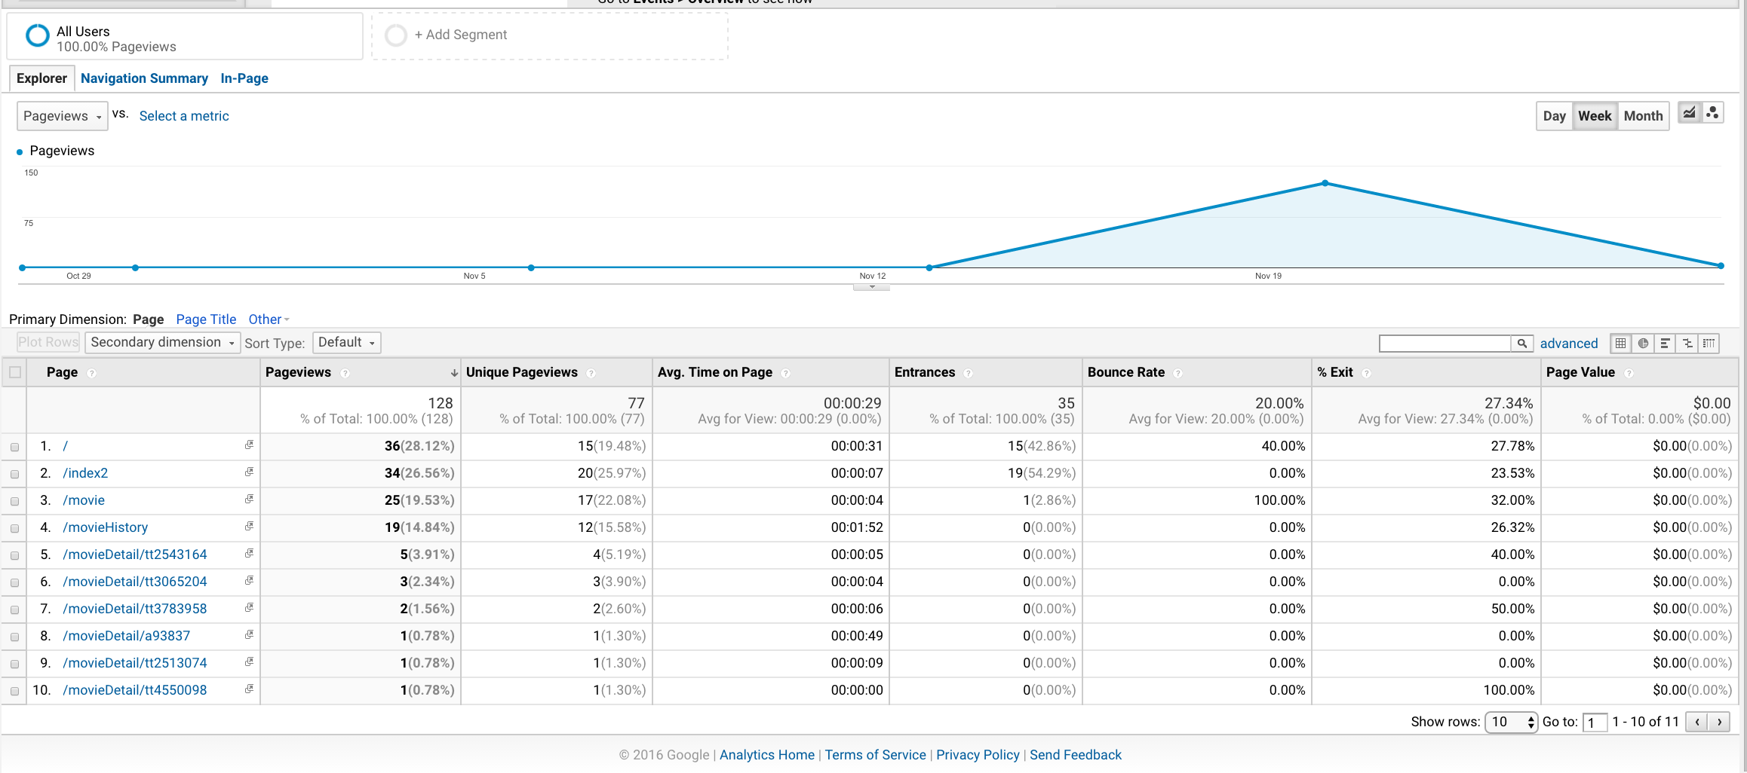

page “/” and page “/index2” are the pages for A/B test. 15 users viewed the page”/” and 20 viewed the page “/index2”.

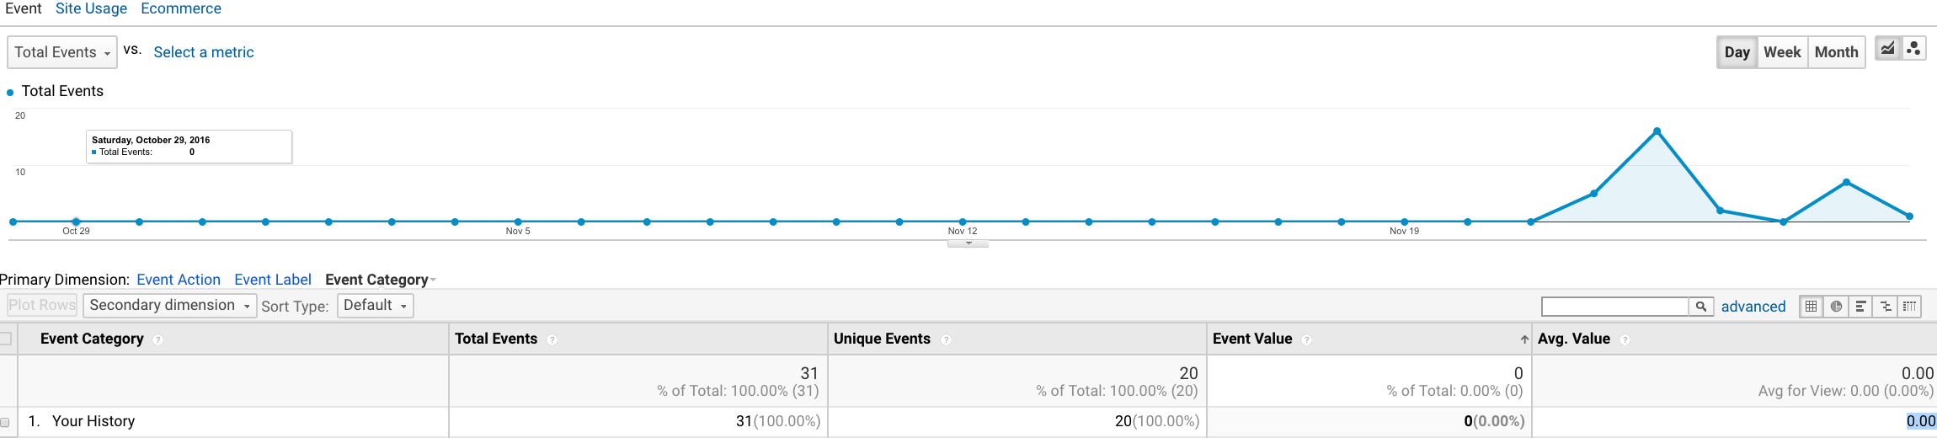

This is the data of event occurrence. 20 users clicked “Your History” button which is in the page “/index2”.

All the data above are used for analysis below.

**Analyze A/B Test Data**

**1. Null Hypothesis**

The “Your History” button will lead to no significant change in the number of people to go to the history page versus the original “Sign Up” button.

**2. Calculation**

|  |  |  |
| --- | --- | --- |
| Observed in experiment | Does the homepage have “Your History” button? | |
| No | Yes |
| Users went to history page | 12 | 20 |
| Users did not go to history page | 3 | 0 |

|  |  |  |  |
| --- | --- | --- | --- |
| Observed in experiment | Does the homepage have “Your History” button? | |  |
| No | Yes | Totals |
| Users went to history page | 12 | 20 | 32 |
| Users did not go to history page | 3 | 0 | 3 |
| Total users | 15 | 20 | 35 |

|  |  |  |  |
| --- | --- | --- | --- |
| Expected if null hypothesis is true | Does the homepage have “Your History” button? | |  |
| No | Yes | Totals |
| Users went to history page | (32/35)*15 = **13.7** | (32/35)*20 = **18.3** | 32 |
| Users did not go to history page | (3/35)*15 = **1.3** | (0/35)*20 = **0** | 3 |
| Total users | 15 | 20 | 35 |

To calculate the chi-squared value, called χ 2 , sum up all pairs of: (observed - expected)2 / expected

|  |  |  |
| --- | --- | --- |
| Observed in experiment | Does the homepage have “Your History” button? | |
| No | Yes |
| Users went to history page | 12 | 20 |
| Users did not go to history page | 3 | 0 |

|  |  |  |
| --- | --- | --- |
| Expected if null hypothesis is true | Does the homepage have “Your History” button? | |
| No | Yes |
| Users went to history page | 13.7 | 18.3 |
| Users did not go to history page | 1.3 | 0 |

(12-13.7)^2/13.7 + (3-1.3)^2/1.3 + (20-18.3)^2/18.3 + 0 = **2.59**

For 2x2 table, **df = 1**;

Now we have chi-squared value = 2.59 and degrees of freedom df=1.

According to “Chi-Square Probability” table, we can get p ≈ 0.10.

Though the result of p indicates that null hypothesis we made is true, we still can not make a solid conclusion that “Your History” button won’t lead to significant change. First, the number of total users participating in the experiment is not large(only 35 in total) enough. Second, according to the data, we know that all the users clicked “Your History” button when they are in the homepage with “Your History” button, which indicates that “Your History” is so obvious that all users will notice and try to click. To make the result of p more reliable, we need more users to participate in the experiment for further testing.

**List of revisions**

In in-person experiment, users came up with the problem that the homepage only has “Your watchlist” button but does not have “Your History” button. Then we did the AB test of this problem. But according to the result of AB test, there is no significant change between homepage with “Your History” button and homepage without “Your History” button. Based on in-person experiment and AB test, we restarted to think about the features on the homepage.

Actually, the main features we want users to use are “recommend a movie” and “just give me a movie”. But “Your watchlist” button, “Your History” button and “Recent” part showing many movie covers in the same page distracted users from the main features. So **the first revision is to reallocate these features to make the homepage simple and intuitive.** We create two pages that can be toggled between each other by swiping. The first page is only for features of “recommend” and “just give me a movie”, while the other page lists all the movies user recently searched. In this way, users can focus on one or two features in one page.

**The second revision is to add tags to the movies.** Users can get more information about the genres of a certain movie.

**The third revision is to add back button on each movie detail page.** Users always have an access to the previous page they viewed.

**Brand Yourself:**

App name: Hobbyist

**URL of Final App**

<http://hobbyists.herokuapp.com/>

**URL of Final Presentation Video**

<https://youtu.be/2e8Abomp5K4>