### 人事管理系统详细说明

一、引言

人事管理系统是针对企业内部人事管理设计，分角色实现对公司部门及各部门员

工的增、删、改、查以及对员工考勤的管理。

1.1编写目的:

在系统需求分析的基础上，对需求分析中产生的功能模块进行过程描述，设计功

能模块的内部细节，包括算法和详细数据结构，为编写源代码提供必要的说明，并作

为测试和维护的参考文档。

详细设计说明书$的预期用户为所有与此项目相关的决策人员、开发人员和测试人

1.2项目背景:

项目名称:人事管理系统

项目介绍:

人事管理是一套先进的管理模式， 其实施要取得成功，必须有必需的技术和工具

支持，公司人事管理软件(CPM)是实施人事部门人员管理职工必不可少的一套技术

和工具集成支持平台。CPM管理系统基于通讯、计算机等信息技术，能实现企业对职

工、部门的良好管理，能够协助管理者更好地完成管理的两项基本任务:管理和了解

职工状况。

1.3定义

CPM:CompanyPersonnelManagement,公司人事 管理系统的缩写

命名规则

①窗体：功能模块名

②控件：功能

1. 数据库设计
2. 数据库表设计

|  |  |  |
| --- | --- | --- |
| 序号 | 关系名称 | 表描述 |
| 1 | 部门表 | 存储公司的部门名称 |
| 2 | 管理员表 | 存储管理员信息 |
| 3 | 员工表 | 存储员工的信息 |
| 4 | 考勤表 | 存储考勤信息 |
| 5 | 密码表 | 存储密码的信息 |

1. 逻辑结构设计

|  |  |  |
| --- | --- | --- |
| 序号 | 关系名称 | 关系的属性 |
| 1 | 部门表 | 部门号、部门名、职位 |
| 2 | 管理员 | 工号、姓名、性别、职位、薪资、电话 |
| 3 | 员工 | 工号、姓名、性别、职位、薪资、电话 |
| 4 | 考勤 | 工、签到、签退 |
| 5 | 密码 | 工号、密码 |

1. 物理结构设计

①部门表

|  |  |  |  |  |
| --- | --- | --- | --- | --- |
| 字段 | 说明 | 类型 | 可空 | 备注 |
| sno | 部门号 | Int | NO | 主键 |
| sname | 部门名称 | Varchar | NO |  |
| Position | 职位 | Varchar | NO |  |

②管理员表

|  |  |  |  |  |
| --- | --- | --- | --- | --- |
| 字段 | 说明 | 类型 | 可空 | 备注 |
| jno | 工号 | Int | NO | 主键 |
| nane | 姓名 | Varchar | NO |  |
| sex | 性别 | Varchar | NO |  |
| Position | 职位 | Varchar | NO |  |
| salary | 薪资 | int | NO |  |
| tel | 电话 | Varchar | NO |  |

③员工表

|  |  |  |  |  |
| --- | --- | --- | --- | --- |
| 字段 | 说明 | 类型 | 可空 | 备注 |
| jno | 工号 | Int | NO | 主键 |
| nane | 姓名 | Varchar | NO |  |
| sex | 性别 | Varchar | NO |  |
| Position | 职位 | Varchar | NO |  |
| salary | 薪资 | int | NO |  |
| tel | 电话 | Varchar | NO |  |

④密码表

|  |  |  |  |  |
| --- | --- | --- | --- | --- |
| 字段 | 说明 | 类型 | 可空 | 备注 |
| jno | 工号 | Int | NO | 主键 |
| password | 密码 | Varchar | NO |  |

⑤考勤表

|  |  |  |  |  |
| --- | --- | --- | --- | --- |
| 字段 | 说明 | 类型 | 可空 | 备注 |
| jno | 工号 | Int | NO | 主键 |
| checkin | 签到 | datetime |  |  |
| checkout | 签退 | datetime |  |  |

1. 数据表代码记录

员工表

create table employee(

jno int primary key,

name varchar(20),

sex varchar(10),

position varchar(20),

salary int,

foreign key(position) references section(position)

);

考勤表

create table worktime(

jno int primary key,

checkin_time datetime,

checkout_datetime

);

部门表

create table section(

sno int primary key,

sname varchar(20),

position varchar(20)

);

管理员表

create table manager(

jno int primary key,

name varchar(20),

sex varchar(6),

position varchar(12),

salary int,

tel varchar(20),

foreign key(position) references section(position)

);

密码表

create table password(

jno int primary key,

password varchar(20) not null

);

1. 数据库ER图

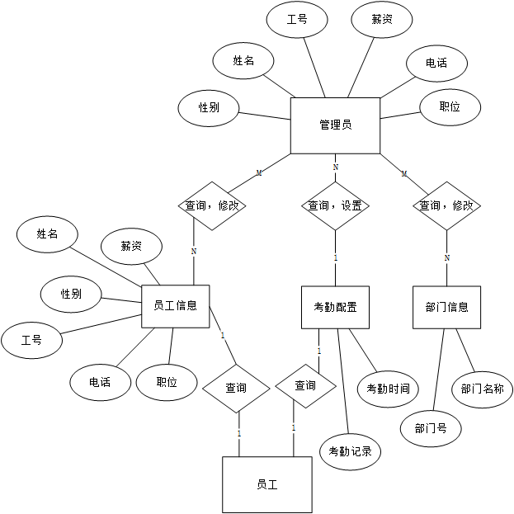

1. 软件结构
2. 顶层结构

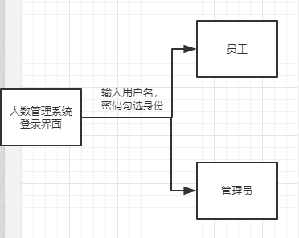

1. 管理员界面结构

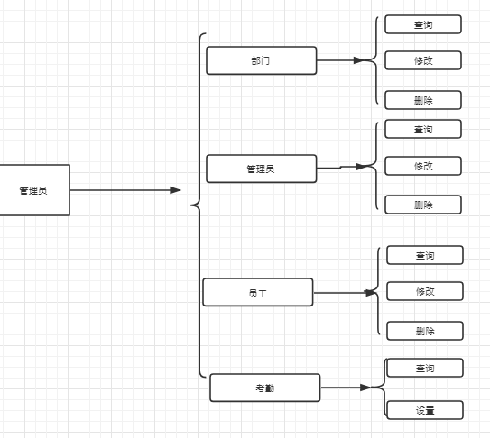

1. 员工界面结构

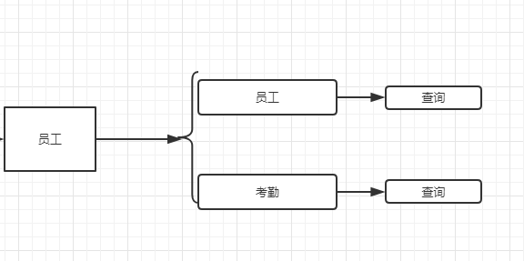

1. 程序模块设计
2. 登录模块
3. 流程图

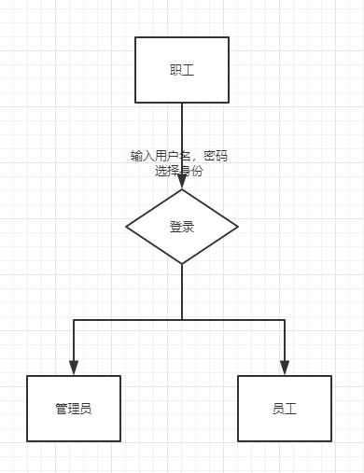

◆职工输入用户名、密码井选择登录身份，根据选择的身份做不同的操作

◎若选择的是“职工”，系统将查询数据库中的用户表Users的记录，用户名密码核对正确

正确后加载职工主界面:。

若选择的是 “管理员”，系统将查询数据库中的管理员表Adms的记录，用户名密码核对正确后加载管理员主界面:

若用户名、密码核对不正确，弹出提示消息框:“输入有误或未勾选身份!”。

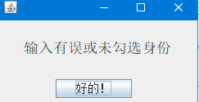

1. 界面设计

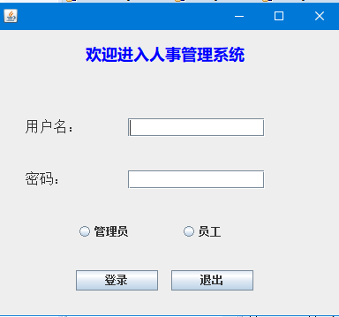

1. 代码:

用户名文本框名称:user_name

密码文本框名称:pass_word

管理员单选按钮：r1

员工单选按钮：r2

登录按钮名称:btn_ login

退出按钮名称:btn_exit

public class aa extends JFrame {

private JPanel contentPane;

private JTextField user_name;

private JPasswordField pass_word;

public JRadioButton r1;

public JRadioButton r2;

/**

* Launch the application.

*/

public static void main(String[] args) {

EventQueue.invokeLater(new Runnable() {

public void run() {

try {

aa frame = new aa();

frame.setVisible(true);

} catch (Exception e) {

e.printStackTrace();

}

}

});

}

/**

* Create the frame.

*/

public boolean login(int jobNumber,String passWord) {

Connection conn=null;

Statement st=null;

ResultSet rs=null;

try {

//1、装载驱动

Class.forName("com.mysql.jdbc.Driver");

} catch (ClassNotFoundException e) {

e.printStackTrace();

}

try {

//2、链接数据库，使用com.mysql.jdbc.Connection包会出错

List<User> list=new ArrayList<User>();

conn=DriverManager.getConnection("jdbc:mysql://localhost:3306/personalSystem?useSSL=false","root","");

//3、创建连接语句

st=conn.createStatement();

//4、执行ＳＱＬ语句获得结果集

rs=st.executeQuery("select * from password where jno = "+jobNumber +" and password = '"+ passWord+"'");

//5、循环获得数据库字段生成对象

if(rs.next()) {

return true;

}

} catch (SQLException e) {

e.printStackTrace();

}finally {

//关闭结果集

try {

if(rs!=null) {

rs.close();

}

} catch (SQLException e) {

e.printStackTrace();

}

//关闭连接语句

try {

if(st!=null) {

st.close();

}

} catch (SQLException e) {

e.printStackTrace();

}

//关闭数据库连接

try {

if(conn!=null) {

conn.close();

}

} catch (SQLException e) {

e.printStackTrace();

}

}

return false;

}

public aa() {

setDefaultCloseOperation(JFrame.EXIT_ON_CLOSE);

setBounds(100, 100, 405, 362);

contentPane = new JPanel();

contentPane.setBorder(new EmptyBorder(5, 5, 5, 5));

setContentPane(contentPane);

contentPane.setLayout(null);

JLabel label = new JLabel("\u6B22\u8FCE\u8FDB\u5165\u4EBA\u4E8B\u7BA1\u7406\u7CFB\u7EDF");

label.setForeground(Color.BLUE);

label.setHorizontalAlignment(SwingConstants.CENTER);

label.setFont(new Font("微软雅黑", Font.BOLD, 18));

label.setBounds(10, 10, 363, 34);

contentPane.add(label);

JLabel Label_username = new JLabel("\u7528\u6237\u540D\uFF1A");

Label_username.setFont(new Font("宋体", Font.PLAIN, 16));

Label_username.setBounds(33, 92, 77, 34);

contentPane.add(Label_username);

JLabel label_password = new JLabel("\u5BC6\u7801\uFF1A");

label_password.setFont(new Font("宋体", Font.PLAIN, 16));

label_password.setBounds(33, 151, 77, 35);

contentPane.add(label_password);

user_name = new JTextField(); //用户名

user_name.setBounds(149, 100, 155, 21);

contentPane.add(user_name);

user_name.setColumns(10);

pass_word = new JPasswordField(); //密码

pass_word.setBounds(149, 159, 155, 21);

contentPane.add(pass_word);

r1 = new JRadioButton("\u7BA1\u7406\u5458"); //管理员选项

r1.setBounds(90, 217, 103, 23);

contentPane.add(r1);

r2 = new JRadioButton("\u5458\u5DE5"); //员工选项

r2.setBounds(208, 217, 83, 23);

contentPane.add(r2);

ButtonGroup group =new ButtonGroup();

group.add(r1);

group.add(r2);

JButton btn_login = new JButton("\u767B\u5F55"); //登录

btn_login.addMouseListener(new MouseAdapter() {

@Override

public void mouseClicked(MouseEvent e) {

功能选择 frame = new 功能选择();

功能选择1 frame1 = new 功能选择1();

登陆提示 frame2 = new 登陆提示();

String p1 =new String(pass_word.getPassword());

try {

aa a1 =new aa();

if(a1.login(Integer.parseInt(user_name.getText()),p1)&&r2.isSelected()) { //员工

frame1.setVisible(true);

}

else if(a1.login(Integer.parseInt(user_name.getText()),p1)&&r1.isSelected()) {

frame.setVisible(true);

}

else

{

frame2.setVisible(true);

}

} catch (Exception e1) {

// TODO Auto-generated catch block

e1.printStackTrace();

frame2.setVisible(true);

}

// if(user_name.getText().equals("12345") && p1.equals("12345")&&r1.isSelected()) {

// frame.setVisible(true);

//

// }

// else if(user_name.getText().equals("12345") && p1.equals("12345")&&r2.isSelected()) {

// frame1.setVisible(true);

// }

// else

// {

// 登陆提示 frame2 = new 登陆提示();

// frame2.setVisible(true);

// }

}

});

btn_login.setBounds(90, 272, 93, 23);

contentPane.add(btn_login);

JButton btn_exit = new JButton("\u9000\u51FA"); //退出

btn_exit.addMouseListener(new MouseAdapter() {

@Override

public void mouseClicked(MouseEvent e) {

System.exit(0);

}

});

btn_exit.setBounds(198, 272, 93, 23);

contentPane.add(btn_exit);

}

}

1. 管理员功能选择模块
2. 流程图

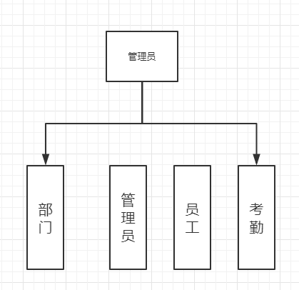

管理员根据要操作的内容进行点击，跳转到下一个页面

1. 界面设计

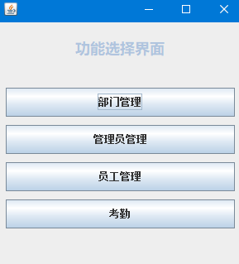

1. 代码

部门管理文本框名称:btn_bumen

管理员按钮名称:btn_guanli

员工管理按钮名称：btn_yuangong

考勤按钮名称：btn_kaoqin  
  
public class 操作提示 extends JFrame {  
  
private JPanel contentPane;  
  
/**  
 * Launch the application.  
 */  
public static void main(String[] args) {  
EventQueue.invokeLater(new Runnable() {  
public void run() {  
try {  
操作提示 frame = new 操作提示();  
frame.setVisible(true);  
} catch (Exception e) {  
e.printStackTrace();  
}  
}  
});  
}  
  
/**  
 * Create the frame.  
 */  
public 操作提示() {  
setDefaultCloseOperation(JFrame.EXIT_ON_CLOSE);  
setBounds(100, 100, 234, 195);  
contentPane = new JPanel();  
contentPane.setBorder(new EmptyBorder(5, 5, 5, 5));  
setContentPane(contentPane);  
contentPane.setLayout(null);  
  
JLabel label = new JLabel("\u64CD\u4F5C\u6210\u529F");  
label.setHorizontalAlignment(SwingConstants.CENTER);  
label.setFont(new Font("宋体", Font.PLAIN, 18));  
label.setBounds(10, 40, 208, 15);  
contentPane.add(label);  
  
JButton button = new JButton("\u7EE7\u7EED");  
button.addMouseListener(new MouseAdapter() {  
@Override  
public void mouseClicked(MouseEvent e) {  
dispose();  
}  
  
});  
button.setFont(new Font("宋体", Font.PLAIN, 14));  
button.setBounds(67, 94, 93, 23);  
contentPane.add(button);  
}  
  
}

1. 员工选择功能模块
2. 流程图

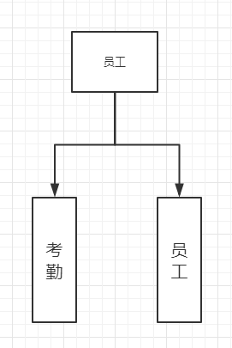

员工登录后可有两项操作，查询考勤以及对员工基本信息的增删改查

1. 界面设计

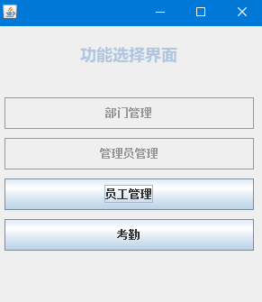

1. 代码

员工管理按钮名称：btn_yuangong

考勤按钮名称：btn_kaoqin

public class 操作提示1 extends JFrame {  
  
private JPanel contentPane;  
  
/**  
 * Launch the application.  
 */  
public static void main(String[] args) {  
EventQueue.invokeLater(new Runnable() {  
public void run() {  
try {  
操作提示1 frame = new 操作提示1();  
frame.setVisible(true);  
} catch (Exception e) {  
e.printStackTrace();  
}  
}  
});  
}  
  
/**  
 * Create the frame.  
 */  
public 操作提示1() {  
setDefaultCloseOperation(JFrame.EXIT_ON_CLOSE);  
setBounds(100, 100, 269, 165);  
contentPane = new JPanel();  
contentPane.setBorder(new EmptyBorder(5, 5, 5, 5));  
setContentPane(contentPane);  
contentPane.setLayout(null);  
  
JLabel label = new JLabel("\u5931\u8D25\uFF01\u8BF7\u91CD\u8BD5\uFF01");  
label.setHorizontalAlignment(SwingConstants.CENTER);  
label.setFont(new Font("宋体", Font.PLAIN, 18));  
label.setBounds(10, 35, 233, 15);  
contentPane.add(label);  
  
JButton button = new JButton("\u91CD\u8BD5");  
button.addMouseListener(new MouseAdapter() {  
@Override  
public void mouseClicked(MouseEvent e) {  
dispose();  
}  
});  
button.setFont(new Font("宋体", Font.PLAIN, 14));  
button.setBounds(79, 93, 93, 23);  
contentPane.add(button);  
}  
  
}

1. 管理员模块
2. 流程图

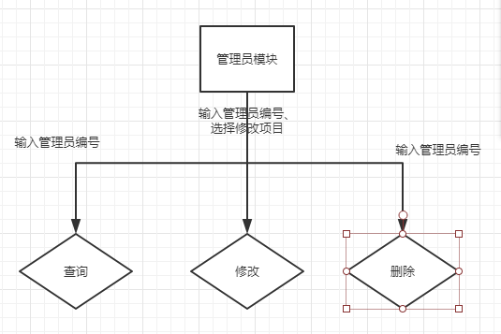

管理员可输入管理员编号进行对管理员信息的查询，查询成功将显示在页面上

可输入管理员编号 以及输入新的内容对管理人员的更替

可输入管理员编号对管理员进行删除

操作成功则提示如图

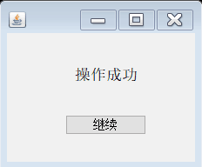

失败弹出提示

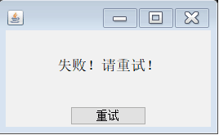

1. 界面设计

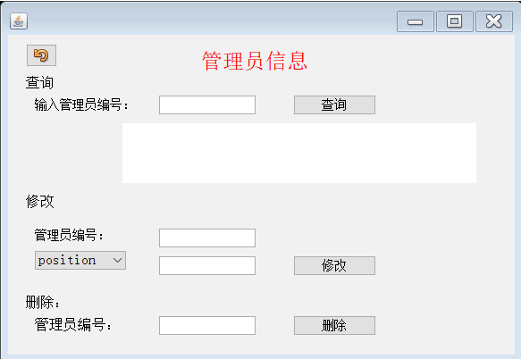

1. 代码

员工管理按钮名称：btn_yuangong

考勤按钮名称：btn_kaoqin

public class 管理员 extends JFrame {

private JPanel contentPane;

private JTextField condition1;

private JTextField textField_1;

private JTextField condition2;

private JTextField condition3;

private JTextArea print;

/**

* Launch the application.

*/

public static void main(String[] args) {

EventQueue.invokeLater(new Runnable() {

public void run() {

try {

管理员 frame = new 管理员();

frame.setVisible(true);

} catch (Exception e) {

e.printStackTrace();

}

}

});

}

/**

* Create the frame.

*/

public String select(int jno) {

Connection connection = null;

Statement stmt = null;

String str ="";

try {

//1.加载驱动

Class.forName("com.mysql.jdbc.Driver");

//2.获取连接

connection = DriverManager.getConnection("jdbc:mysql://localhost/personalSystem?useSSL=false", "root", "");

//3.创建语句对象

stmt = connection.createStatement();

//4.执行

String sql = "select * from manager where jno="+jno;

ResultSet rs = stmt.executeQuery(sql);

while (rs.next()) {

Integer col1 = rs.getInt("jno");

String col2 = rs.getString("name");

String col3 = rs.getString("sex");

String col4 = rs.getString("position");

Integer col5 = rs.getInt("salary");

String col6 = rs.getString("tel");

str = "工号：" + col1 + " 姓名：" + col2 + " 性别：" + col3 + " 职位：" + col4 +"\n"+ " 工资：" + col5 + " 电话：" + col6;

}

} catch (ClassNotFoundException e) {

e.printStackTrace();

} catch (SQLException e) {

e.printStackTrace();

} finally {

//5.关闭资源

try {

if (stmt != null) {

stmt.close();

}

if (connection != null) {

connection.close();

}

} catch (SQLException e) {

e.printStackTrace();

}

}

return str;

}

public void update(int jno,String position){

Scanner scan = new Scanner(System.in);

Connection connection = null;

PreparedStatement stmt = null;

try {

//1.加载驱动

Class.forName("com.mysql.jdbc.Driver");

//2.获取连接

connection = DriverManager.getConnection("jdbc:mysql://localhost/personalSystem?useSSL=false", "root", "");

//4.执行

String sql1 = "update manager set position=? where jno="+jno;

stmt = connection.prepareStatement(sql1);

stmt.setObject(1,position);

stmt.executeUpdate();

} catch (ClassNotFoundException e) {

e.printStackTrace();

} catch (SQLException e) {

e.printStackTrace();

} finally {

//5.关闭资源

try {

if (stmt != null) {

stmt.close();

}

if (connection != null) {

connection.close();

}

} catch (SQLException e) {

e.printStackTrace();

}

}

}

public void delete(int jno){

Scanner scan = new Scanner(System.in);

Connection connection = null;

PreparedStatement stmt = null;

try {

//1.加载驱动

Class.forName("com.mysql.jdbc.Driver");

//2.获取连接

connection = DriverManager.getConnection("jdbc:mysql://localhost/personalSystem?useSSL=false", "root", "");

//4.执行

String sql = "delete from manager where jno="+jno;

stmt = connection.prepareStatement(sql);

stmt.execute();

} catch (ClassNotFoundException e) {

e.printStackTrace();

} catch (SQLException e) {

e.printStackTrace();

} finally {

//5.关闭资源

try {

if (stmt != null) {

stmt.close();

}

if (connection != null) {

connection.close();

}

} catch (SQLException e) {

e.printStackTrace();

}

}

}

public 管理员() {

setDefaultCloseOperation(JFrame.EXIT_ON_CLOSE);

setBounds(100, 100, 585, 405);

contentPane = new JPanel();

contentPane.setBorder(new EmptyBorder(5, 5, 5, 5));

setContentPane(contentPane);

contentPane.setLayout(null);

JLabel label = new JLabel("\u7BA1\u7406\u5458\u4FE1\u606F");

label.setForeground(Color.RED);

label.setHorizontalAlignment(SwingConstants.CENTER);

label.setFont(new Font("宋体", Font.PLAIN, 24));

label.setBounds(10, 10, 533, 39);

contentPane.add(label);

JLabel lblNewLabel = new JLabel("\u67E5\u8BE2");

lblNewLabel.setFont(new Font("宋体", Font.PLAIN, 16));

lblNewLabel.setBounds(20, 46, 54, 15);

contentPane.add(lblNewLabel);

JLabel lblNewLabel_1 = new JLabel("\u8F93\u5165\u7BA1\u7406\u5458\u7F16\u53F7\uFF1A");

lblNewLabel_1.setFont(new Font("宋体", Font.PLAIN, 14));

lblNewLabel_1.setBounds(30, 71, 129, 15);

contentPane.add(lblNewLabel_1);

condition1 = new JTextField();

condition1.setBounds(169, 68, 108, 21);

contentPane.add(condition1);

condition1.setColumns(10);

JButton btn_select = new JButton("\u67E5\u8BE2");

btn_select.addMouseListener(new MouseAdapter() {

@Override

public void mouseClicked(MouseEvent e) { //查询

if(Integer.parseInt(condition1.getText())<=205&&Integer.parseInt(condition1.getText())>=201) {

管理员 c =new 管理员();

String s = c.select(Integer.parseInt(condition1.getText()));

print.append(s+"\n");

}

else {

操作提示 c =new 操作提示();

c.setVisible(true);

}

}

});

btn_select.setFont(new Font("宋体", Font.PLAIN, 14));

btn_select.setBounds(319, 67, 93, 23);

contentPane.add(btn_select);

JLabel lblNewLabel_2 = new JLabel("\u4FEE\u6539");

lblNewLabel_2.setFont(new Font("宋体", Font.PLAIN, 16));

lblNewLabel_2.setBounds(20, 179, 54, 15);

contentPane.add(lblNewLabel_2);

textField_1 = new JTextField();

textField_1.setBounds(169, 248, 108, 21);

contentPane.add(textField_1);

textField_1.setColumns(10);

JButton btn_updata = new JButton("\u4FEE\u6539");

btn_updata.addMouseListener(new MouseAdapter() {

@Override

public void mouseClicked(MouseEvent e) { //修改

if(Integer.parseInt(condition2.getText())<=205&&Integer.parseInt(condition2.getText())>=201) {

管理员 c3 =new 管理员();

c3.update(Integer.parseInt(condition2.getText()),textField_1.getText());

操作提示 c1 =new 操作提示();

c1.setVisible(true);

}

else {

操作提示1 c11 =new 操作提示1();

c11.setVisible(true);

}

}

});

btn_updata.setFont(new Font("宋体", Font.PLAIN, 14));

btn_updata.setBounds(319, 247, 93, 23);

contentPane.add(btn_updata);

JLabel lbll = new JLabel("\u5220\u9664\uFF1A");

lbll.setFont(new Font("宋体", Font.PLAIN, 16));

lbll.setBounds(20, 292, 54, 15);

contentPane.add(lbll);

JLabel label_1 = new JLabel("");

label_1.setBounds(20, 217, 54, 15);

contentPane.add(label_1);

JLabel label_2 = new JLabel("\u7BA1\u7406\u5458\u7F16\u53F7\uFF1A");

label_2.setFont(new Font("宋体", Font.PLAIN, 14));

label_2.setBounds(30, 217, 102, 15);

contentPane.add(label_2);

condition2 = new JTextField();

condition2.setBounds(169, 217, 108, 21);

contentPane.add(condition2);

condition2.setColumns(10);

JLabel label_3 = new JLabel("\u7BA1\u7406\u5458\u7F16\u53F7\uFF1A");

label_3.setFont(new Font("宋体", Font.PLAIN, 16));

label_3.setBounds(30, 317, 108, 15);

contentPane.add(label_3);

condition3 = new JTextField();

condition3.setBounds(169, 315, 108, 21);

contentPane.add(condition3);

condition3.setColumns(10);

JButton btn_delete = new JButton("\u5220\u9664");

btn_delete.addMouseListener(new MouseAdapter() {

@Override

public void mouseClicked(MouseEvent e) { //删除

if(Integer.parseInt(condition3.getText())<=205&&Integer.parseInt(condition3.getText())>=201) {

管理员 c4 =new 管理员();

c4.delete(Integer.parseInt(condition3.getText()));

操作提示 c2 =new 操作提示();

c2.setVisible(true);

}

else {

操作提示1 c12 =new 操作提示1();

c12.setVisible(true);

}

}

});

btn_delete.setFont(new Font("宋体", Font.PLAIN, 14));

btn_delete.setBounds(319, 314, 93, 23);

contentPane.add(btn_delete);

JComboBox comboBox = new JComboBox();

comboBox.setModel(new DefaultComboBoxModel(new String[] {"position", "salary", "tel"}));

comboBox.setBounds(30, 242, 102, 21);

contentPane.add(comboBox);

JButton btnNewButton_3 = new JButton("");

btnNewButton_3.addMouseListener(new MouseAdapter() {

@Override

public void mouseClicked(MouseEvent e) {//返回

dispose();

}

});

btnNewButton_3.setIcon(new ImageIcon(管理员.class.getResource("/com/sun/javafx/scene/web/skin/Undo_16x16_JFX.png")));

btnNewButton_3.setBounds(20, 10, 35, 26);

contentPane.add(btnNewButton_3);

print = new JTextArea();

print.setBounds(128, 99, 396, 67);

contentPane.add(print);

}

}

1. 员工模块
2. 流程图

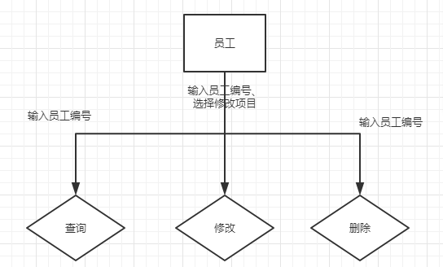

管理员可输入员工编号进行对员工信息的查询，查询成功将显示在页面上

可输入员工编号 以及选择新的条目对指定内容进行修改

可输入员工编号对管理员进行删除

操作成功则提示如图



失败弹出提示



1. 界面设计

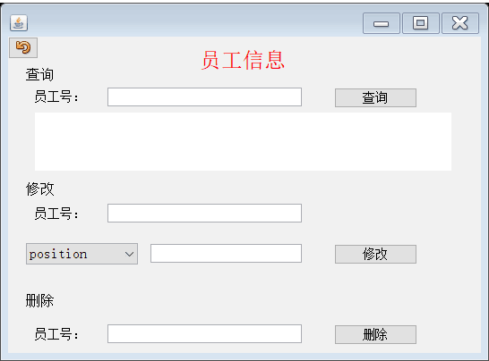

1. 代码

public class 员工 extends JFrame {

private JPanel contentPane;

private JTextField condition1;

private JTextField condition2;

private JTextField condition3;

private JTextField condition4;

private JTextArea print;

private JComboBox comboBox;

/**

* Launch the application.

*/

public static void main(String[] args) {

EventQueue.invokeLater(new Runnable() {

public void run() {

try {

员工 frame = new 员工();

frame.setVisible(true);

} catch (Exception e) {

e.printStackTrace();

}

}

});

}

/**

* Create the frame.

*/

public String select(int jno) {

Connection connection = null;

Statement stmt = null;

String str ="";

try {

//1.加载驱动

Class.forName("com.mysql.jdbc.Driver");

//2.获取连接

connection = DriverManager.getConnection("jdbc:mysql://localhost/personalSystem?useSSL=false", "root", "");

//3.创建语句对象

stmt = connection.createStatement();

//4.执行

String sql = "select * from employee where jno="+jno;

ResultSet rs = stmt.executeQuery(sql);

while (rs.next()) {

Integer col1 = rs.getInt("jno");

String col2 = rs.getString("name");

String col3 = rs.getString("sex");

String col4 = rs.getString("position");

Integer col5 = rs.getInt("salary");

String col6 = rs.getString("tel");

str = "工号：" + col1 + " 姓名：" + col2 + " 性别：" + col3 + " 职位：" + col4 + " 工资：" + col5 + " 电话：" + col6;

}

} catch (ClassNotFoundException e) {

e.printStackTrace();

} catch (SQLException e) {

e.printStackTrace();

} finally {

//5.关闭资源

try {

if (stmt != null) {

stmt.close();

}

if (connection != null) {

connection.close();

}

} catch (SQLException e) {

e.printStackTrace();

}

}

return str;

}

public void update(int jno,String position){

Scanner scan = new Scanner(System.in);

Connection connection = null;

PreparedStatement stmt = null;

try {

//1.加载驱动

Class.forName("com.mysql.jdbc.Driver");

//2.获取连接

connection = DriverManager.getConnection("jdbc:mysql://localhost/personalSystem?useSSL=false", "root", "");

//4.执行

String sql1 = "update employee set position=? where jno="+jno;

stmt = connection.prepareStatement(sql1);

stmt.setString(1,position);

stmt.executeUpdate();

} catch (ClassNotFoundException e) {

e.printStackTrace();

} catch (SQLException e) {

e.printStackTrace();

} finally {

//5.关闭资源

try {

if (stmt != null) {

stmt.close();

}

if (connection != null) {

connection.close();

}

} catch (SQLException e) {

e.printStackTrace();

}

}

}

public void update2(int jno,int salary){

Scanner scan = new Scanner(System.in);

Connection connection = null;

PreparedStatement stmt = null;

try {

//1.加载驱动

Class.forName("com.mysql.jdbc.Driver");

//2.获取连接

connection = DriverManager.getConnection("jdbc:mysql://localhost/personalSystem?useSSL=false", "root", "");

//4.执行

String sql1 = "update employee set salary=? where jno="+jno;

stmt = connection.prepareStatement(sql1);

stmt.setInt(1,salary);

stmt.executeUpdate();

} catch (ClassNotFoundException e) {

e.printStackTrace();

} catch (SQLException e) {

e.printStackTrace();

} finally {

//5.关闭资源

try {

if (stmt != null) {

stmt.close();

}

if (connection != null) {

connection.close();

}

} catch (SQLException e) {

e.printStackTrace();

}

}

}

public void update3(int jno,String tel){

Scanner scan = new Scanner(System.in);

Connection connection = null;

PreparedStatement stmt = null;

try {

//1.加载驱动

Class.forName("com.mysql.jdbc.Driver");

//2.获取连接

connection = DriverManager.getConnection("jdbc:mysql://localhost/personalSystem?useSSL=false", "root", "");

//4.执行

String sql1 = "update employee set tel=? where jno="+jno;

stmt = connection.prepareStatement(sql1);

stmt.setString(1,tel);

stmt.executeUpdate();

} catch (ClassNotFoundException e) {

e.printStackTrace();

} catch (SQLException e) {

e.printStackTrace();

} finally {

//5.关闭资源

try {

if (stmt != null) {

stmt.close();

}

if (connection != null) {

connection.close();

}

} catch (SQLException e) {

e.printStackTrace();

}

}

}

public void delete(int jno){

Scanner scan = new Scanner(System.in);

Connection connection = null;

PreparedStatement stmt = null;

try {

//1.加载驱动

Class.forName("com.mysql.jdbc.Driver");

//2.获取连接

connection = DriverManager.getConnection("jdbc:mysql://localhost/personalSystem?useSSL=false", "root", "");

//4.执行

String sql = "delete from employee where jno="+jno;

stmt = connection.prepareStatement(sql);

stmt.execute();

} catch (ClassNotFoundException e) {

e.printStackTrace();

} catch (SQLException e) {

e.printStackTrace();

} finally {

//5.关闭资源

try {

if (stmt != null) {

stmt.close();

}

if (connection != null) {

connection.close();

}

} catch (SQLException e) {

e.printStackTrace();

}

}

}

public 员工() {

setDefaultCloseOperation(JFrame.EXIT_ON_CLOSE);

setBounds(100, 100, 546, 401);

contentPane = new JPanel();

contentPane.setBorder(new EmptyBorder(5, 5, 5, 5));

setContentPane(contentPane);

contentPane.setLayout(null);

JLabel label = new JLabel("\u5458\u5DE5\u4FE1\u606F");

label.setHorizontalAlignment(SwingConstants.CENTER);

label.setForeground(Color.RED);

label.setFont(new Font("宋体", Font.PLAIN, 24));

label.setBounds(10, 10, 504, 33);

contentPane.add(label);

JLabel label_1 = new JLabel("\u67E5\u8BE2");

label_1.setFont(new Font("宋体", Font.PLAIN, 16));

label_1.setBounds(20, 35, 54, 15);

contentPane.add(label_1);

JLabel label_2 = new JLabel("\u5458\u5DE5\u53F7\uFF1A");

label_2.setFont(new Font("宋体", Font.PLAIN, 14));

label_2.setBounds(30, 60, 71, 15);

contentPane.add(label_2);

condition1 = new JTextField();

condition1.setText("");

condition1.setBounds(111, 57, 217, 21);

contentPane.add(condition1);

condition1.setColumns(10);

JButton btn_select = new JButton("\u67E5\u8BE2");

btn_select.addMouseListener(new MouseAdapter() {

@Override

public void mouseClicked(MouseEvent e) { //查询一个

if(Integer.parseInt(condition1.getText())<=105&&Integer.parseInt(condition1.getText())>=101 ){

员工 b =new 员工();

String s = b.select(Integer.parseInt(condition1.getText()));

print.append(s+"\n");

}

else {

操作提示 c =new 操作提示();

c.setVisible(true);

}

}

});

btn_select.setFont(new Font("宋体", Font.PLAIN, 14));

btn_select.setBounds(364, 57, 93, 23);

contentPane.add(btn_select);

JLabel label_3 = new JLabel("\u4FEE\u6539");

label_3.setFont(new Font("宋体", Font.PLAIN, 16));

label_3.setBounds(20, 163, 54, 15);

contentPane.add(label_3);

JLabel label_4 = new JLabel("\u5458\u5DE5\u53F7\uFF1A");

label_4.setFont(new Font("宋体", Font.PLAIN, 14));

label_4.setBounds(30, 191, 71, 15);

contentPane.add(label_4);

condition2 = new JTextField();

condition2.setBounds(111, 187, 217, 21);

contentPane.add(condition2);

condition2.setColumns(10);

condition3 = new JTextField();

condition3.setBounds(159, 232, 169, 21);

contentPane.add(condition3);

condition3.setColumns(10);

JButton btn_updata = new JButton("\u4FEE\u6539");

btn_updata.addMouseListener(new MouseAdapter() {

@Override

public void mouseClicked(MouseEvent e) { //修改

if(Integer.parseInt(condition2.getText())<=105&&Integer.parseInt(condition2.getText())>=100&&comboBox.getSelectedItem().equals("position")) {

员工 b1 =new 员工();

b1.update(Integer.parseInt(condition2.getText()),condition3.getText());

操作提示 c1 =new 操作提示();

c1.setVisible(true);

}

else if(Integer.parseInt(condition2.getText())<=105&&Integer.parseInt(condition2.getText())>=100&&comboBox.getSelectedItem().equals("tel")) {

员工 b3 =new 员工();

b3.update3(Integer.parseInt(condition2.getText()),condition3.getText());

操作提示 c1 =new 操作提示();

c1.setVisible(true);

}

else if(Integer.parseInt(condition2.getText())<=105&&Integer.parseInt(condition2.getText())>=100&&comboBox.getSelectedItem().equals("salary")) {

员工 b2 =new 员工();

b2.update2(Integer.parseInt(condition2.getText()),Integer.parseInt(condition3.getText()));

操作提示 c1 =new 操作提示();

c1.setVisible(true);

}

else {

操作提示1 c11 =new 操作提示1();

c11.setVisible(true);

}

}

});

btn_updata.setFont(new Font("宋体", Font.PLAIN, 14));

btn_updata.setBounds(364, 232, 93, 23);

contentPane.add(btn_updata);

JLabel label_5 = new JLabel("\u5220\u9664");

label_5.setFont(new Font("宋体", Font.PLAIN, 16));

label_5.setBounds(20, 288, 54, 15);

contentPane.add(label_5);

JLabel label_6 = new JLabel("\u5458\u5DE5\u53F7\uFF1A");

label_6.setFont(new Font("宋体", Font.PLAIN, 14));

label_6.setBounds(30, 326, 71, 15);

contentPane.add(label_6);

condition4 = new JTextField();

condition4.setBounds(111, 322, 217, 21);

contentPane.add(condition4);

condition4.setColumns(10);

JButton btn_delete = new JButton("\u5220\u9664");

btn_delete.addMouseListener(new MouseAdapter() {

@Override

public void mouseClicked(MouseEvent e) { //删除

if(Integer.parseInt(condition4.getText())<=105&&Integer.parseInt(condition4.getText())>=100) {

员工 b2 =new 员工();

b2.delete(Integer.parseInt(condition4.getText()));

操作提示 c2 =new 操作提示();

c2.setVisible(true);

}

else {

操作提示1 c12 =new 操作提示1();

c12.setVisible(true);

}

}

});

btn_delete.setFont(new Font("宋体", Font.PLAIN, 14));

btn_delete.setBounds(364, 322, 93, 23);

contentPane.add(btn_delete);

JButton btn_return = new JButton("");

btn_return.addMouseListener(new MouseAdapter() {

@Override

public void mouseClicked(MouseEvent e) {//返回

dispose(); }

});

btn_return.setIcon(new ImageIcon(员工.class.getResource("/com/sun/javafx/scene/web/skin/Undo_16x16_JFX.png")));

btn_return.setBounds(0, 0, 34, 25);

contentPane.add(btn_return);

print = new JTextArea();

print.setBounds(30, 85, 465, 65);

contentPane.add(print);

comboBox = new JComboBox();

comboBox.setModel(new DefaultComboBoxModel(new String[] {"position", "salary", "tel"}));

comboBox.setBounds(20, 231, 125, 24);

contentPane.add(comboBox);

}

}

1. 考勤模块
2. 流程图

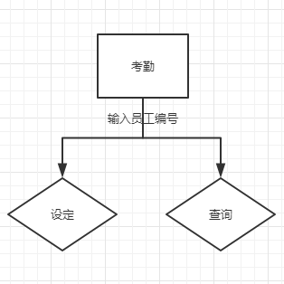

1. 界面设计

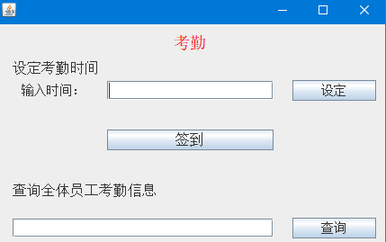

1. 代码

public class 考勤 extends JFrame {

private JPanel contentPane;

private JTextArea print;

private JTextField textField;

private JTextField textField_1;

/**

* Launch the application.

*/

public static void main(String[] args) {

EventQueue.invokeLater(new Runnable() {

public void run() {

try {

考勤 frame = new 考勤();

frame.setVisible(true);

} catch (Exception e) {

e.printStackTrace();

}

}

});

}

/**

* Create the frame.

*/

public void insert(int jno){

Scanner scan = new Scanner(System.in);

Connection connection = null;

PreparedStatement stmt = null;

try {

//1.加载驱动

Class.forName("com.mysql.jdbc.Driver");

//2.获取连接

connection = DriverManager.getConnection("jdbc:mysql://localhost/personalSystem?useSSL=false", "root", "");

//4.执行

String sql = "insert into worktime values(?,?,?)";

stmt = connection.prepareStatement(sql);

stmt.setInt(1,jno);

stmt.setString(2,"2019-1-3 8:00:00");

stmt.setString(3,"2019-1-3 18:00:00");

stmt.execute();

} catch (ClassNotFoundException e) {

e.printStackTrace();

} catch (SQLException e) {

e.printStackTrace();

} finally {

//5.关闭资源

try {

if (stmt != null) {

stmt.close();

}

if (connection != null) {

connection.close();

}

} catch (SQLException e) {

e.printStackTrace();

}

}

}

public String select(int jno){

Connection connection = null;

Statement stmt = null;

String str="";

try {

//1.加载驱动

Class.forName("com.mysql.jdbc.Driver");

//2.获取连接

connection = DriverManager.getConnection("jdbc:mysql://localhost/personalSystem?useSSL=false", "root", "");

//3.创建语句对象

stmt = connection.createStatement();

//4.执行

String sql = "select * from worktime where jno="+jno;

ResultSet rs = stmt.executeQuery(sql);

while(rs.next()){

Integer col1 = rs.getInt("jno");

String col2 = rs.getString("signin_time");

String col3 = rs.getString("signout_time");

str = "工号：" + col1 + " 签到时间：" + col2 +"\n"+ " 签退时间：" + col3;

}

} catch (ClassNotFoundException e) {

e.printStackTrace();

} catch (SQLException e) {

e.printStackTrace();

} finally {

//5.关闭资源

try {

if (stmt != null) {

stmt.close();

}

if (connection != null) {

connection.close();

}

} catch (SQLException e) {

e.printStackTrace();

}

}

return str;

}

public 考勤() {

setDefaultCloseOperation(JFrame.EXIT_ON_CLOSE);

setBounds(100, 100, 450, 361);

contentPane = new JPanel();

contentPane.setBorder(new EmptyBorder(5, 5, 5, 5));

setContentPane(contentPane);

contentPane.setLayout(null);

JButton button_1 = new JButton("");

button_1.addMouseListener(new MouseAdapter() {

@Override

public void mouseClicked(MouseEvent e) {//返回

dispose();

}

});

button_1.setIcon(new ImageIcon(考勤.class.getResource("/com/sun/javafx/scene/web/skin/Undo_16x16_JFX.png")));

button_1.setBounds(10, 0, 36, 31);

contentPane.add(button_1);

JLabel label = new JLabel("\u8003\u52E4");

label.setHorizontalAlignment(SwingConstants.CENTER);

label.setForeground(Color.RED);

label.setFont(new Font("宋体", Font.PLAIN, 24));

label.setBounds(10, 10, 414, 31);

contentPane.add(label);

JLabel label_1 = new JLabel("\u8BB0\u5F55\u8003\u52E4\u65F6\u95F4");

label_1.setFont(new Font("宋体", Font.PLAIN, 16));

label_1.setBounds(20, 41, 112, 15);

contentPane.add(label_1);

JLabel label_2 = new JLabel("\u8F93\u5165\u65F6\u95F4\uFF1A");

label_2.setFont(new Font("宋体", Font.PLAIN, 16));

label_2.setBounds(30, 69, 162, 15);

contentPane.add(label_2);

JButton btn_set = new JButton("\u8BBE\u5B9A");

btn_set.addMouseListener(new MouseAdapter() {

@Override

public void mouseClicked(MouseEvent e) { //设定时间

if(Integer.parseInt(textField.getText())<=105&&Integer.parseInt(textField.getText())>=100) {

考勤 b1 =new 考勤();

b1.insert(Integer.parseInt(textField.getText()));

操作提示 c1 =new 操作提示();

c1.setVisible(true);

}

else {

操作提示1 c11 =new 操作提示1();

c11.setVisible(true);

}

}

});

btn_set.setFont(new Font("宋体", Font.PLAIN, 14));

btn_set.setBounds(331, 66, 93, 23);

contentPane.add(btn_set);

JLabel label_3 = new JLabel("\u67E5\u8BE2\u5458\u5DE5\u8003\u52E4\u4FE1\u606F");

label_3.setFont(new Font("宋体", Font.PLAIN, 16));

label_3.setBounds(10, 125, 171, 15);

contentPane.add(label_3);

JButton btn_select = new JButton("\u67E5\u8BE2");

btn_select.addMouseListener(new MouseAdapter() {

@Override

public void mouseClicked(MouseEvent e) { //查询textField_1

if(Integer.parseInt(textField_1.getText())<=105&&Integer.parseInt(textField_1.getText())>=100 ){

考勤 b =new 考勤();

String s = b.select(Integer.parseInt(textField_1.getText()));

print.append(s+"\n");

}

else {

操作提示 c =new 操作提示();

c.setVisible(true);

}

}

});

btn_select.setFont(new Font("宋体", Font.PLAIN, 14));

btn_select.setBounds(331, 122, 93, 23);

contentPane.add(btn_select);

print = new JTextArea();

print.setFont(new Font("宋体", Font.PLAIN, 13));

print.setBounds(20, 163, 394, 119);

contentPane.add(print);

textField = new JTextField();

textField.setBounds(137, 65, 171, 24);

contentPane.add(textField);

textField.setColumns(10);

textField_1 = new JTextField();

textField_1.setBounds(164, 121, 144, 24);

contentPane.add(textField_1);

textField_1.setColumns(10);

}

}

1. 部门模块
2. 流程图

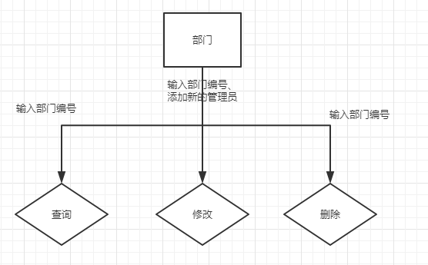

1. 界面设计

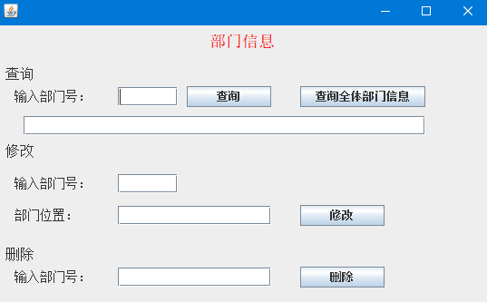

1. 代码

public class 部门 extends JFrame {

private JPanel contentPane;

private JTextField condition1;

private JTextField textField_1;

private JTextField condition3;

private JTextField condition2;

private JTextArea print;

/**

* Launch the application.

*/

public static void main(String[] args) {

EventQueue.invokeLater(new Runnable() {

public void run() {

try {

部门 frame = new 部门();

frame.setVisible(true);

} catch (Exception e) {

e.printStackTrace();

}

}

});

}

/**

* Create the frame.

*/

public String select(String sno) {

Connection connection = null;

Statement stmt = null;

String str ="";

try {

//1.加载驱动

Class.forName("com.mysql.jdbc.Driver");

//2.获取连接

connection = DriverManager.getConnection("jdbc:mysql://localhost/personalSystem?useSSL=false", "root", "");

//3.创建语句对象

stmt = connection.createStatement();

//4.执行

String sql = "select * from section where sno="+sno;

ResultSet rs = stmt.executeQuery(sql);

while (rs.next()) {

Integer col1 = rs.getInt("sno");

String col2 = rs.getString("sname");

String col3 = rs.getString("smanager");

str = "部门号\t" + col1 + " 部门名\t" + col2 + " 经理\t" + col3;

}

} catch (ClassNotFoundException e) {

e.printStackTrace();

} catch (SQLException e) {

e.printStackTrace();

} finally {

//5.关闭资源

try {

if (stmt != null) {

stmt.close();

}

if (connection != null) {

connection.close();

}

} catch (SQLException e) {

e.printStackTrace();

}

}

return str;

}

public void update(String smanager,int sno){

Scanner scan = new Scanner(System.in);

Connection connection = null;

PreparedStatement stmt = null;

try {

//1.加载驱动

Class.forName("com.mysql.jdbc.Driver");

//2.获取连接

connection = DriverManager.getConnection("jdbc:mysql://localhost/personalSystem?useSSL=false", "root", "");

//4.执行

String sql1 = "update section set smanager=? where sno="+sno;

stmt = connection.prepareStatement(sql1);

stmt.setObject(1,smanager);

stmt.executeUpdate();

} catch (ClassNotFoundException e) {

e.printStackTrace();

} catch (SQLException e) {

e.printStackTrace();

} finally {

//5.关闭资源

try {

if (stmt != null) {

stmt.close();

}

if (connection != null) {

connection.close();

}

} catch (SQLException e) {

e.printStackTrace();

}

}

}

public void delete(int sno){

Scanner scan = new Scanner(System.in);

Connection connection = null;

PreparedStatement stmt = null;

try {

//1.加载驱动

Class.forName("com.mysql.jdbc.Driver");

//2.获取连接

connection = DriverManager.getConnection("jdbc:mysql://localhost/personalSystem?useSSL=false", "root", "");

//4.执行

String sql = "delete from section where sno="+sno;

stmt = connection.prepareStatement(sql);

stmt.execute();

} catch (ClassNotFoundException e) {

e.printStackTrace();

} catch (SQLException e) {

e.printStackTrace();

} finally {

//5.关闭资源

try {

if (stmt != null) {

stmt.close();

}

if (connection != null) {

connection.close();

}

} catch (SQLException e) {

e.printStackTrace();

}

}

}

public 部门() {

setDefaultCloseOperation(JFrame.EXIT_ON_CLOSE);

setBounds(100, 100, 637, 441);

contentPane = new JPanel();

contentPane.setBorder(new EmptyBorder(5, 5, 5, 5));

setContentPane(contentPane);

contentPane.setLayout(null);

JLabel label = new JLabel("\u90E8\u95E8\u4FE1\u606F");

label.setForeground(Color.RED);

label.setHorizontalAlignment(SwingConstants.CENTER);

label.setFont(new Font("宋体", Font.PLAIN, 24));

label.setBounds(10, 10, 595, 45);

contentPane.add(label);

JLabel label_1 = new JLabel("\u67E5\u8BE2");

label_1.setFont(new Font("宋体", Font.PLAIN, 16));

label_1.setBounds(10, 46, 54, 15);

contentPane.add(label_1);

JLabel label_2 = new JLabel("\u8F93\u5165\u90E8\u95E8\u53F7\uFF1A");

label_2.setFont(new Font("宋体", Font.PLAIN, 14));

label_2.setBounds(20, 71, 104, 15);

contentPane.add(label_2);

condition1 = new JTextField();

condition1.setBounds(134, 68, 66, 21);

contentPane.add(condition1);

condition1.setColumns(10);

JButton btn_select = new JButton("\u67E5\u8BE2");

btn_select.addMouseListener(new MouseAdapter() {

@Override

public void mouseClicked(MouseEvent e) { // 查询一个

if(Integer.parseInt(condition1.getText())<=5 ){

部门 b =new 部门();

String s = b.select(condition1.getText());

print.append(s+"\n");

}

else {

操作提示 c =new 操作提示();

c.setVisible(true);

}

}

});

btn_select.setBounds(210, 67, 93, 23);

contentPane.add(btn_select);

JLabel label_3 = new JLabel("\u4FEE\u6539");

label_3.setFont(new Font("宋体", Font.PLAIN, 16));

label_3.setBounds(10, 244, 54, 15);

contentPane.add(label_3);

JLabel label_4 = new JLabel("新的管理人");

label_4.setFont(new Font("宋体", Font.PLAIN, 14));

label_4.setBounds(20, 305, 83, 15);

contentPane.add(label_4);

textField_1 = new JTextField();

textField_1.setBounds(134, 302, 169, 21);

contentPane.add(textField_1);

textField_1.setColumns(10);

JButton btn_updata = new JButton("\u4FEE\u6539");

btn_updata.addMouseListener(new MouseAdapter() {

@Override

public void mouseClicked(MouseEvent e) { //修改

if(Integer.parseInt(condition2.getText())<=5 ) {

部门 b1 =new 部门();

b1.update(textField_1.getText(),Integer.parseInt(condition2.getText()));

操作提示 c1 =new 操作提示();

c1.setVisible(true);

}

else {

操作提示1 c11 =new 操作提示1();

c11.setVisible(true);

}

}

});

btn_updata.setBounds(335, 304, 93, 23);

contentPane.add(btn_updata);

JLabel label_5 = new JLabel("\u5220\u9664");

label_5.setFont(new Font("宋体", Font.PLAIN, 16));

label_5.setBounds(10, 333, 54, 15);

contentPane.add(label_5);

JLabel lblNewLabel = new JLabel("\u8F93\u5165\u90E8\u95E8\u53F7\uFF1A");

lblNewLabel.setFont(new Font("宋体", Font.PLAIN, 14));

lblNewLabel.setBounds(20, 358, 104, 15);

contentPane.add(lblNewLabel);

condition3 = new JTextField();

condition3.setBounds(134, 355, 169, 21);

contentPane.add(condition3);

condition3.setColumns(10);

JButton btn_delete = new JButton("\u5220\u9664");

btn_delete.addMouseListener(new MouseAdapter() {

@Override

public void mouseClicked(MouseEvent e) { //删除

if(Integer.parseInt(condition3.getText())<=5) {

部门 b2 =new 部门();

b2.delete(Integer.parseInt(condition3.getText()));

操作提示 c2 =new 操作提示();

c2.setVisible(true);

}

else {

操作提示1 c12 =new 操作提示1();

c12.setVisible(true);

}

}

});

btn_delete.setBounds(335, 354, 93, 23);

contentPane.add(btn_delete);

JLabel label_6 = new JLabel("\u8F93\u5165\u90E8\u95E8\u53F7\uFF1A");

label_6.setFont(new Font("宋体", Font.PLAIN, 14));

label_6.setBounds(20, 274, 104, 15);

contentPane.add(label_6);

condition2 = new JTextField();

condition2.setText("");

condition2.setBounds(134, 271, 66, 21);

contentPane.add(condition2);

condition2.setColumns(10);

JButton button_3 = new JButton("");

button_3.addMouseListener(new MouseAdapter() {

@Override

public void mouseClicked(MouseEvent e) {//返回

dispose();

}

});

button_3.setIcon(new ImageIcon(部门.class.getResource("/com/sun/javafx/scene/web/skin/Undo_16x16_JFX.png")));

button_3.setBounds(20, 8, 34, 28);

contentPane.add(button_3);

print = new JTextArea();

print.setEnabled(false);

print.setBounds(99, 96, 434, 154);

contentPane.add(print);

}

}

1. 员工的员工模块
2. 流程图

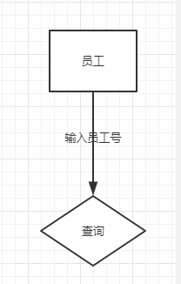

1. 界面设计

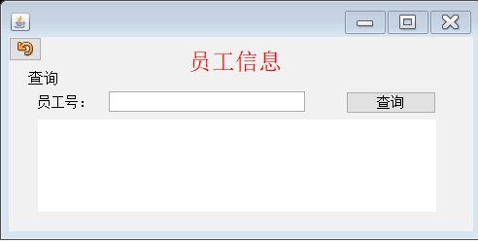

1. 代码

public class 员工1 extends JFrame {

private JPanel contentPane;

private JTextField condition1;

private JTextArea print;

/**

* Launch the application.

*/

public static void main(String[] args) {

EventQueue.invokeLater(new Runnable() {

public void run() {

try {

员工1 frame = new 员工1();

frame.setVisible(true);

} catch (Exception e) {

e.printStackTrace();

}

}

});

}

/**

* Create the frame.

*/

public String select(int jno) {

Connection connection = null;

Statement stmt = null;

String str ="";

try {

//1.加载驱动

Class.forName("com.mysql.jdbc.Driver");

//2.获取连接

connection = DriverManager.getConnection("jdbc:mysql://localhost/personalSystem?useSSL=false", "root", "");

//3.创建语句对象

stmt = connection.createStatement();

//4.执行

String sql = "select * from employee where jno="+jno;

ResultSet rs = stmt.executeQuery(sql);

while (rs.next()) {

Integer col1 = rs.getInt("jno");

String col2 = rs.getString("name");

String col3 = rs.getString("sex");

String col4 = rs.getString("position");

Integer col5 = rs.getInt("salary");

String col6 = rs.getString("tel");

str = "工号：" + col1 + " 姓名：" + col2 + " 性别：" + col3 + " 职位：" + col4 + " 工资：" + col5 + " 电话：" + col6;

}

} catch (ClassNotFoundException e) {

e.printStackTrace();

} catch (SQLException e) {

e.printStackTrace();

} finally {

//5.关闭资源

try {

if (stmt != null) {

stmt.close();

}

if (connection != null) {

connection.close();

}

} catch (SQLException e) {

e.printStackTrace();

}

}

return str;

}

public 员工1() {

setDefaultCloseOperation(JFrame.EXIT_ON_CLOSE);

setBounds(100, 100, 496, 247);

contentPane = new JPanel();

contentPane.setBorder(new EmptyBorder(5, 5, 5, 5));

setContentPane(contentPane);

contentPane.setLayout(null);

JLabel label = new JLabel("\u5458\u5DE5\u4FE1\u606F");

label.setHorizontalAlignment(SwingConstants.CENTER);

label.setForeground(Color.RED);

label.setFont(new Font("宋体", Font.PLAIN, 24));

label.setBounds(10, 0, 447, 50);

contentPane.add(label);

JLabel label_1 = new JLabel("\u67E5\u8BE2");

label_1.setFont(new Font("宋体", Font.PLAIN, 16));

label_1.setBounds(20, 35, 54, 15);

contentPane.add(label_1);

JLabel label_2 = new JLabel("\u5458\u5DE5\u53F7\uFF1A");

label_2.setFont(new Font("宋体", Font.PLAIN, 14));

label_2.setBounds(30, 60, 71, 15);

contentPane.add(label_2);

condition1 = new JTextField();

condition1.setText("");

condition1.setBounds(103, 56, 202, 21);

contentPane.add(condition1);

condition1.setColumns(10);

JButton btn_select = new JButton("\u67E5\u8BE2");

btn_select.addMouseListener(new MouseAdapter() {

@Override

public void mouseClicked(MouseEvent e) { //查询一个

if(Integer.parseInt(condition1.getText())<=105&&Integer.parseInt(condition1.getText())>=101 ){

员工 b =new 员工();

String s = b.select(Integer.parseInt(condition1.getText()));

print.append(s+"\n");

}

else {

操作提示 c =new 操作提示();

c.setVisible(true);

}

}

});

btn_select.setFont(new Font("宋体", Font.PLAIN, 14));

btn_select.setBounds(347, 56, 93, 23);

contentPane.add(btn_select);

JButton btn_return = new JButton("");

btn_return.addMouseListener(new MouseAdapter() {

@Override

public void mouseClicked(MouseEvent e) {//返回

dispose(); }

});

btn_return.setIcon(new ImageIcon(员工.class.getResource("/com/sun/javafx/scene/web/skin/Undo_16x16_JFX.png")));

btn_return.setBounds(0, 0, 34, 25);

contentPane.add(btn_return);

print = new JTextArea();

print.setBounds(30, 85, 410, 95);

contentPane.add(print);

}

}

1. 员工的考勤模块
2. 流程图

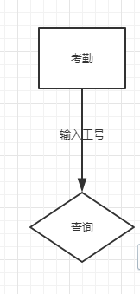

1. 界面设计

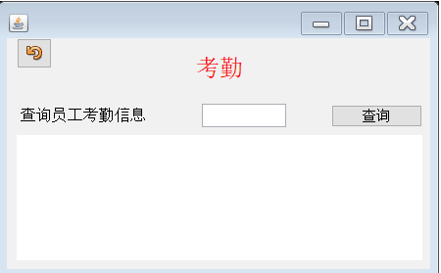

1. 代码

public class 考勤1 extends JFrame {

private JPanel contentPane;

private JTextArea print;

private JTextField textField;

/**

* Launch the application.

*/

public static void main(String[] args) {

EventQueue.invokeLater(new Runnable() {

public void run() {

try {

考勤1 frame = new 考勤1();

frame.setVisible(true);

} catch (Exception e) {

e.printStackTrace();

}

}

});

}

/**

* Create the frame.

*/

public String select(int jno){

Connection connection = null;

Statement stmt = null;

String str="";

try {

//1.加载驱动

Class.forName("com.mysql.jdbc.Driver");

//2.获取连接

connection = DriverManager.getConnection("jdbc:mysql://localhost/personalSystem?useSSL=false", "root", "");

//3.创建语句对象

stmt = connection.createStatement();

//4.执行

String sql = "select * from worktime where jno="+jno;

ResultSet rs = stmt.executeQuery(sql);

while(rs.next()){

Integer col1 = rs.getInt("jno");

String col2 = rs.getString("signin_time");

String col3 = rs.getString("signout_time");

str = "工号：" + col1 + " 签到时间：" + col2 +"\n"+ " 签退时间：" + col3;

}

} catch (ClassNotFoundException e) {

e.printStackTrace();

} catch (SQLException e) {

e.printStackTrace();

} finally {

//5.关闭资源

try {

if (stmt != null) {

stmt.close();

}

if (connection != null) {

connection.close();

}

} catch (SQLException e) {

e.printStackTrace();

}

}

return str;

}

public 考勤1() {

setDefaultCloseOperation(JFrame.EXIT_ON_CLOSE);

setBounds(100, 100, 450, 283);

contentPane = new JPanel();

contentPane.setBorder(new EmptyBorder(5, 5, 5, 5));

setContentPane(contentPane);

contentPane.setLayout(null);

JButton button_1 = new JButton("");

button_1.addMouseListener(new MouseAdapter() {

@Override

public void mouseClicked(MouseEvent e) {//返回

dispose();

}

});

button_1.setIcon(new ImageIcon(考勤.class.getResource("/com/sun/javafx/scene/web/skin/Undo_16x16_JFX.png")));

button_1.setBounds(10, 0, 36, 31);

contentPane.add(button_1);

JLabel label = new JLabel("\u8003\u52E4");

label.setHorizontalAlignment(SwingConstants.CENTER);

label.setForeground(Color.RED);

label.setFont(new Font("宋体", Font.PLAIN, 24));

label.setBounds(10, 10, 414, 40);

contentPane.add(label);

JLabel label_3 = new JLabel("\u67E5\u8BE2\u5458\u5DE5\u8003\u52E4\u4FE1\u606F");

label_3.setFont(new Font("宋体", Font.PLAIN, 16));

label_3.setBounds(14, 71, 171, 15);

contentPane.add(label_3);

JButton btn_select = new JButton("\u67E5\u8BE2");

btn_select.addMouseListener(new MouseAdapter() {

@Override

public void mouseClicked(MouseEvent e) { //查询全体

if(Integer.parseInt(textField.getText())<=105&&Integer.parseInt(textField.getText())>=100 ){

考勤 b =new 考勤();

String s = b.select(Integer.parseInt(textField.getText()));

print.append(s+"\n");

}

else {

操作提示 c =new 操作提示();

c.setVisible(true);

}

}

});

btn_select.setFont(new Font("宋体", Font.PLAIN, 14));

btn_select.setBounds(331, 68, 93, 23);

contentPane.add(btn_select);

print = new JTextArea();

print.setFont(new Font("宋体", Font.PLAIN, 13));

print.setBounds(10, 99, 414, 128);

contentPane.add(print);

textField = new JTextField();

textField.setText("");

textField.setBounds(199, 67, 86, 24);

contentPane.add(textField);

textField.setColumns(10);

}

}