一、目录结构

A Tour of OFBiz
by Si Chen
This tutorial will walk you through OFBiz and one of its applications to help you understand the structure of OFBiz.
First, go into your OFBiz directory and take a look inside:
[sichen@localhost ofbiz_5010]$ ls -l
total 88
drwxrwxr-x 15 sichen sichen 4096 May 20 07:54 applications
drwxrwxr-x 8 sichen sichen 4096 May 20 07:59 base
-rw-rw-r-- 1 sichen sichen 10173 May 20 07:58 build.xml
drwxrwxr-x 4 sichen sichen 4096 May 20 07:59 data
drwxrwxr-x 24 sichen sichen 4096 May 20 07:58 framework
drwxrwxr-x 3 sichen sichen 4096 May 20 07:52 hot-deploy
-rwxrwxr-x 1 sichen sichen 309 May 20 07:58 ij.ofbiz
drwxrwxr-x 2 sichen sichen 4096 May 20 08:08 logs
-rw-rw-r-- 1 sichen sichen 21167 May 20 08:07 ofbiz.jar
-rw-rw-r-- 1 sichen sichen 2869 May 20 07:58 rc.ofbiz
drwxrwxr-x 6 sichen sichen 4096 May 20 07:55 specialized
-rw-rw-r-- 1 sichen sichen 265 May 20 07:58 startofbiz.bat
-rwxrw-r-- 1 sichen sichen 790 May 20 07:58 startofbiz.sh
-rwxrw-r-- 1 sichen sichen 325 May 20 07:58 stopofbiz.sh
drwxrwxr-x 12 sichen sichen 4096 May 20 07:52 website
Things to note here:
- OFBiz is built around a components-based architecture, which means each application is inside a component. This allows outside or custom applications to be added easily.
- The applications/ directory holds the applications components, such as order manager and ecommerce store.
- The framework/ directory holds the components for the OFBiz framework, such as the entity engine, and service engine.
- specialized/ contains some other applications which are not part of the OFBiz core.
- hot-deploy/ is another directory where components can be dropped in and automatically loaded.
- base/ contains code for starting up and configuring ofbiz.
- logs/ contains log files. On Unix/Linux, ofbiz runs as a background process, and all console output is in logs/console.log
- website/ is the contents of ofbiz.org.
Now let's go inside framework/ and take a look:
[sichen@localhost ofbiz_5010]$ cd framework/
[sichen@localhost framework]$ ls -l
total 88
drwxrwxr-x 7 sichen sichen 4096 May 20 08:00 appserver
drwxrwxr-x 8 sichen sichen 4096 May 20 07:59 catalina
drwxrwxr-x 12 sichen sichen 4096 May 20 08:00 common
-rw-rw-r-- 1 sichen sichen 2988 May 20 07:58 component-load.xml
drwxrwxr-x 6 sichen sichen 4096 May 20 07:59 datafile
drwxrwxr-x 10 sichen sichen 4096 May 20 07:59 entity
drwxrwxr-x 9 sichen sichen 4096 May 20 07:59 entityext
drwxrwxr-x 12 sichen sichen 4096 May 20 07:55 example
drwxrwxr-x 6 sichen sichen 4096 May 20 08:00 guiapp
drwxrwxr-x 4 sichen sichen 4096 May 20 07:56 images
drwxrwxr-x 6 sichen sichen 4096 May 20 07:59 jetty
drwxrwxr-x 7 sichen sichen 4096 May 20 07:59 jotm
drwxrwxr-x 6 sichen sichen 4096 May 20 07:59 minerva
drwxrwxr-x 7 sichen sichen 4096 May 20 08:00 minilang
drwxrwxr-x 9 sichen sichen 4096 May 20 07:59 security
drwxrwxr-x 11 sichen sichen 4096 May 20 07:59 service
drwxrwxr-x 12 sichen sichen 4096 May 20 08:00 shark
drwxrwxr-x 10 sichen sichen 4096 May 20 08:00 tests
drwxrwxr-x 9 sichen sichen 4096 May 20 08:00 webapp
drwxrwxr-x 9 sichen sichen 4096 May 20 08:00 webtools
drwxrwxr-x 6 sichen sichen 4096 May 20 08:00 widget
drwxrwxr-x 9 sichen sichen 4096 May 20 08:00 workflow
These are the components of the OFBiz framework, which is used to develop the OFBiz applications. component-load.xml controls which of the components in the current directory are loaded.
Now go back and take a look at the applications themselves:
[sichen@localhost framework]$ cd ..
[sichen@localhost ofbiz_5010]$ cd applications/
[sichen@localhost applications]$ ls -l
total 52
drwxrwxr-x 13 sichen sichen 4096 May 20 08:00 accounting
-rw-rw-r-- 1 sichen sichen 2425 May 20 07:54 component-load.xml
drwxrwxr-x 15 sichen sichen 4096 May 20 08:00 content
drwxrwxr-x 11 sichen sichen 4096 May 20 08:00 ecommerce
drwxrwxr-x 5 sichen sichen 4096 May 20 07:53 humanres
drwxrwxr-x 12 sichen sichen 4096 May 20 08:00 manufacturing
drwxrwxr-x 12 sichen sichen 4096 May 20 08:00 marketing
drwxrwxr-x 13 sichen sichen 4096 May 20 08:00 order
drwxrwxr-x 12 sichen sichen 4096 May 20 08:00 party
drwxrwxr-x 12 sichen sichen 4096 May 20 08:00 pos
drwxrwxr-x 12 sichen sichen 4096 May 20 08:00 product
drwxrwxr-x 10 sichen sichen 4096 May 20 08:00 securityext
drwxrwxr-x 12 sichen sichen 4096 May 20 08:00 workeffort
These are the OFBiz applications themselves. Each application is self-contained with its own data model definitions, business logic, and presentation (web or Swing) tier, although applications may reuse each others' business logic and thus depend on each other.
Now let's go inside an application and see what it looks like:
[sichen@localhost applications]$ cd product/
[sichen@localhost product]$ ls -l
total 52
drwxrwxr-x 4 sichen sichen 4096 May 20 08:08 build
-rw-rw-r-- 1 sichen sichen 6413 May 20 07:53 build.xml
drwxrwxr-x 3 sichen sichen 4096 May 20 07:53 config
drwxrwxr-x 3 sichen sichen 4096 May 20 07:53 data
drwxrwxr-x 3 sichen sichen 4096 May 20 07:53 entitydef
-rw-rw-r-- 1 sichen sichen 4202 May 20 07:53 ofbiz-component.xml
drwxrwxr-x 4 sichen sichen 4096 May 20 07:53 script
drwxrwxr-x 3 sichen sichen 4096 May 20 07:53 servicedef
drwxrwxr-x 4 sichen sichen 4096 May 20 07:53 src
drwxrwxr-x 5 sichen sichen 4096 May 20 07:53 webapp
drwxrwxr-x 5 sichen sichen 4096 May 20 07:53 widget
Here is what you are seeing:
- build/ is where the compiled Java code and any libraries for this application go.
- build.xml tells ant how to build this application. It is like a Makefile.
- config/ is for configuration data, such as internationalization (i18n) UI labels in various languages.
- data/ is where the seed and demo data, in XML format, are located.
- entitydef/ is where the data model definitions of this application are.
- script/ is where scripts for business logic are. Scripts can be written in beanshell, OFBiz minilang, Jython, etc.
- servicedef/ is where the services, which are small, granular pieces of business logic (similar to functions or methods), are defined.
- src/ is where Java classes for implementing business logic are.
- webapp/ is where the web interface, or front end, applications are. An OFBiz application can have more than one webapp.
- ofbiz-component.xml defines this application by specifying where its data model, business logic, seed data, and web applications are located.
A look inside the entitydef/ and servicedef/ directories will show the XML files used to define the data model and business logic, respectively:
[si@localhost product]$ ls -l entitydef/
total 264
-rw-rw-r-- 1 si si 3094 May 27 08:00 eecas.xml
-rw-rw-r-- 1 si si 16862 May 27 08:00 entitygroup.xml
-rw-rw-r-- 1 si si 62923 May 27 08:00 entitymodel_shipment.xml
-rw-rw-r-- 1 si si 171582 May 27 08:00 entitymodel.xml
[si@localhost product]$ ls -l servicedef/
total 252
-rw-rw-r-- 1 si si 1836 May 27 08:00 groups_shipment.xml
-rw-rw-r-- 1 si si 5217 May 27 08:00 secas_shipment.xml
-rw-rw-r-- 1 si si 3897 May 27 08:00 secas.xml
-rw-rw-r-- 1 si si 42967 May 27 08:00 services_facility.xml
-rw-rw-r-- 1 si si 15516 May 27 08:00 services_feature.xml
-rw-rw-r-- 1 si si 9261 May 27 08:00 services_maint.xml
-rw-rw-r-- 1 si si 9411 May 27 08:00 services_picklist.xml
-rw-rw-r-- 1 si si 19216 May 27 08:00 services_pricepromo.xml
-rw-rw-r-- 1 si si 3374 May 27 08:00 services_shipment_ups.xml
-rw-rw-r-- 1 si si 5844 May 27 08:00 services_shipment_usps.xml
-rw-rw-r-- 1 si si 29717 May 27 08:00 services_shipment.xml
-rw-rw-r-- 1 si si 16205 May 27 08:00 services_store.xml
-rw-rw-r-- 1 si si 9817 May 27 08:00 services_view.xml
-rw-rw-r-- 1 si si 56540 May 27 08:00 services.xml
The webapp/ directory holds the web front end applications. A look inside shows that this application actually has two web applications, catalog and facility:
[si@localhost product]$ ls -l webapp/
total 8
drwxrwxr-x 18 si si 4096 May 27 08:00 catalog
drwxrwxr-x 13 si si 4096 May 27 08:00 facility
catalog/ is the OFBiz Catalog Manager, used to manage product information. facility/ is the OFBiz Facility Manager, used to manage warehouses and inventory.
In most dynamic web pages, there are some page elements, such as page headers, navigation bars, or shopping cart contents, that are repeated on many pages. When a visitor requests the page, the page will usually do some preprocessing, such as retrieving data from a database, and then present it to the user on a display page. In PHP, this is usually done by a SQL query first and then HTML code which presents the results of the query.
With OFBiz, pages are divided into smaller pieces which are re-combined to create the final product. Thus, many pages can share common elements such as page headers, sidebars, and navigation bars. This is called the "decorator pattern." There is a further separation of the activities of a page into "actions," such as getting data from a database, and "presentation," the display of that data to the visitor.
The "actions" in OFBiz are written in beanshell scripts, while the "presentation" is written in Freemarker template pages. Beanshell (.bsh) is a scripted version of Java, while Freemarker (.ftl) is a templating language that is used in OFBiz to create HTML or XSL:FO pages.
So here are the contents immediately inside a web application. The sub-directories hold the pieces of Freemarker pages:
[si@localhost product]$ ls -l webapp/catalog/
total 80
drwxrwxr-x 3 si si 4096 May 27 08:00 catalog
drwxrwxr-x 3 si si 4096 May 27 08:00 category
-rw-rw-r-- 1 si si 1866 May 27 08:00 ChooseTopCategory.ftl
drwxrwxr-x 3 si si 4096 May 27 08:00 config
drwxrwxr-x 3 si si 4096 May 27 08:00 error
-rw-rw-r-- 1 si si 1552 May 27 08:00 FastLoadCache.ftl
drwxrwxr-x 3 si si 4096 May 27 08:00 feature
drwxrwxr-x 3 si si 4096 May 27 08:00 find
drwxrwxr-x 3 si si 4096 May 27 08:00 includes
-rw-rw-r-- 1 si si 44 May 27 08:00 index.jsp
drwxrwxr-x 3 si si 4096 May 27 08:00 lookup
-rw-rw-r-- 1 si si 4575 May 27 08:00 main.ftl
drwxrwxr-x 3 si si 4096 May 27 08:00 price
drwxrwxr-x 3 si si 4096 May 27 08:00 product
drwxrwxr-x 3 si si 4096 May 27 08:00 promo
drwxrwxr-x 3 si si 4096 May 27 08:00 reviews
drwxrwxr-x 3 si si 4096 May 27 08:00 store
drwxrwxr-x 3 si si 4096 May 27 08:00 thesaurus
drwxrwxr-x 4 si si 4096 May 27 12:21 WEB-INF
Most of the web application's page sections are put into different directories depending on their function. The includes/ directory holds many of the pieces of a web application. The WEB-INF directory is a "private" directory for files which should not be viewed directly by visitors. It holds files for controlling the flow logic and actions of this web application:
[si@localhost product]$ ls -l webapp/catalog/WEB-INF/
total 132
drwxrwxr-x 13 si si 4096 May 27 08:00 actions
-rw-rw-r-- 1 si si 117202 May 27 08:00 controller.xml
-rw-rw-r-- 1 si si 4442 May 27 08:00 web.xml
- controller.xml is a very important file that directs the flow of the web application. It maps URI requests from the visitor's browser to events, services, and pages.
- web.xml contains supplemental information for the web application.
- actions/ directory has beanshell scripts that are used to process and gather data for the pages.
The beanshell scripts in the WEB-INF/actions/ directory often mirror the Freemarker pages in the other directories. For example:
[si@localhost product]$ ls -l webapp/catalog/product/
total 240
-rw-rw-r-- 1 si si 6886 May 27 08:00 ApplyFeaturesFromCategory.ftl
-rw-rw-r-- 1 si si 2099 May 27 08:00 CreateVirtualWithVariantsForm.ftl
-rw-rw-r-- 1 si si 16552 May 27 08:00 EditProductAssoc.ftl
-rw-rw-r-- 1 si si 3813 May 27 08:00 EditProductAttributes.ftl
-rw-rw-r-- 1 si si 1407 May 27 08:00 EditProductContentContent.ftl
-rw-rw-r-- 1 si si 14132 May 27 08:00 EditProductContent.ftl
-rw-rw-r-- 1 si si 6126 May 27 08:00 EditProductDupForm.ftl
-rw-rw-r-- 1 si si 4519 May 27 08:00 EditProductFacilities.ftl
-rw-rw-r-- 1 si si 5273 May 27 08:00 EditProductFacilityLocations.ftl
-rw-rw-r-- 1 si si 13625 May 27 08:00 EditProductFeatures.ftl
-rw-rw-r-- 1 si si 5008 May 27 08:00 EditProductGlAccounts.ftl
-rw-rw-r-- 1 si si 4200 May 27 08:00 EditProductGoodIdentifications.ftl
-rw-rw-r-- 1 si si 13207 May 27 08:00 EditProductInventoryItems.ftl
-rw-rw-r-- 1 si si 6358 May 27 08:00 EditProductKeyword.ftl
-rw-rw-r-- 1 si si 23480 May 27 08:00 EditProductQuickAdmin.ftl
-rw-rw-r-- 1 si si 60917 May 27 08:00 ProductForms.xml
-rw-rw-r-- 1 si si 5721 May 27 08:00 ProductTabBar.ftl
-rw-rw-r-- 1 si si 6380 May 27 08:00 QuickAddVariants.ftl
[si@localhost product]$ ls -l webapp/catalog/WEB-INF/actions/product/
total 72
-rw-rw-r-- 1 si si 5862 May 27 08:00 ApplyFeaturesFromCategory.bsh
-rw-rw-r-- 1 si si 2489 May 27 08:00 ApplyFeaturesFromGroup.bsh
-rw-rw-r-- 1 si si 3548 May 27 08:00 EditProductAssoc.bsh
-rw-rw-r-- 1 si si 7490 May 27 08:00 EditProductContent.bsh
-rw-rw-r-- 1 si si 6920 May 27 08:00 EditProductContentContent.bsh
-rw-rw-r-- 1 si si 2574 May 27 08:00 EditProductFeatures.bsh
-rw-rw-r-- 1 si si 11386 May 27 12:27 EditProductInventoryItems.bsh
-rw-rw-r-- 1 si si 17166 May 27 08:00 EditProductQuickAdmin.bsh
-rw-rw-r-- 1 si si 1890 May 27 08:00 QuickAddVariants.bsh
There is not a one-to-one correspondence because the same beanshell script in actions/ can be reused for multiple pages, and also because some pages are pieced together from multiple Freemarker templates but require only one beanshell script.
Finally, there is one more component of an OFBiz application: the widgets/ directory:
[si@localhost product]$ ls -l widget/
total 8
drwxrwxr-x 3 si si 4096 May 27 08:00 catalog
drwxrwxr-x 3 si si 4096 May 27 08:00 facility
As you can see, this mirrors the contents of webapp/ from above. This is not an accident. The widgets/ directory holds "widgets" for rendering user interface screens. OFBiz allows user interface designs to be created as "generic screens" rather than just web pages, so they could be reused eventually for some other platform. The widgets/ directory's contents mirror those of the webapp/, so there are widgets for the catalog/ webapp and the facility/ webapp.
Now let's take a look at what's in a widgets directory:
[si@localhost product]$ ls -l widget/catalog/
total 176
-rwxrwxr-x 1 si si 11824 May 27 08:00 CatalogScreens.xml
-rwxrwxr-x 1 si si 19862 May 27 08:00 CategoryScreens.xml
-rw-rw-r-- 1 si si 9986 May 27 08:00 CommonScreens.xml
-rwxrwxr-x 1 si si 11122 May 27 08:00 ConfigScreens.xml
-rw-rw-r-- 1 si si 10961 May 27 08:00 FeatureScreens.xml
-rwxrwxr-x 1 si si 5937 May 27 08:00 FindScreens.xml
-rw-rw-r-- 1 si si 6695 May 27 08:00 LookupScreens.xml
-rwxrwxr-x 1 si si 4440 May 27 08:00 PriceScreens.xml
-rw-rw-r-- 1 si si 39740 May 27 08:00 ProductScreens.xml
-rwxrwxr-x 1 si si 14900 May 27 08:00 PromoScreens.xml
-rwxrwxr-x 1 si si 3682 May 27 08:00 ReviewScreens.xml
-rwxrwxr-x 1 si si 19802 May 27 08:00 StoreScreens.xml
-rwxrwxr-x 1 si si 3588 May 27 08:00 ThesaurusScreens.xml
What you see are XML definitions for various screens here. The screens tell OFBiz how to create a screen: what pieces of common navigation elements, Freemarker page sections, and actions are required to create a particular page.
Now you've seen how an OFBiz application is put together. Future tutorials will show you how to develop one from scratch and customize an existing one.

二、Entities and Services - Data Models and Business Logic in OFBiz
This tutorial will provide a more detailed overview of how data models and business logic is defined in Open For Business. It will show how to use beanshell with OFBiz.

Throughout this tutorial, click on any image to enlarge it.

Data Modeling with Entities
The data model of an application is a model of the physical "things" in the application, their properties, and their relationships. Typically, data models are implementetd either with SQL or objects or a combination of both.
OFBiz provides us with an "entity engine" which allows data models to be implemented at a higher level of abstraction. The data model is defined in an XML file, and OFBiz provides us with a set of generic APIs for working with the actual data: finding, creating, updating, and removing them. The entity engine thus allows us to:
- work with the data at a higher level, rather than in lower level SQL or Java code.
- achieve complete independence from the underlying database. OFBiz will work with a large number of commercial or open source databases.
- reduce the amount of maintenance when applications need to be changed, by centralizing definitions and working with more generic concepts.
- avoid the overhead of object-relational persistence with a simple set of APIs.
The basic unit of the data model is an "entity," which is a discrete "thing" modeled in the data model. Here is an example of how an entity for information about a person is defined: 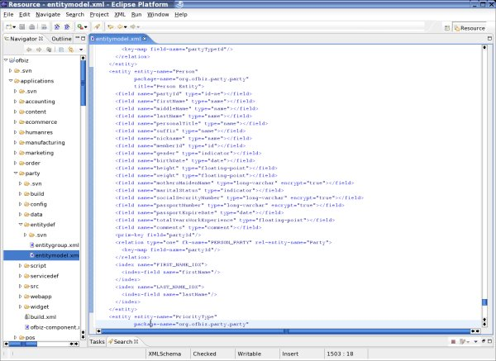
The entity is analogous to a SQL table or Java object, with various fields for specific attributes of a person. The definition, is however, at a more abstract level. The OFBiz entity engine will start with this definition and create the database tables, check the tables against the definitions over time, and modify tables if needed.
The types of the fields are defined in generic types, rather than specific SQL or Java types. OFBiz will then translate these fields to SQL types when working with the database and to Java types when working in Java. The exact translation is determined in a fieldtype file in the framework/entity/fieldtype/ directory: You can see the fieldtype definitions for all the different databases on the left and the actual field mappings for MySQL and Microsoft SQL Server on the right. Notice how different some of the SQL types can be.
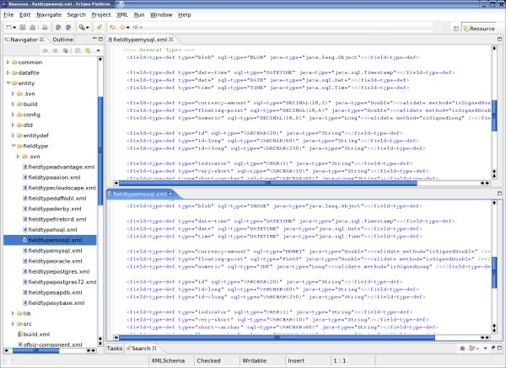
The other important part of defining data models in OFBiz is creating relationships between entities. The entity engine lets you create explicit relationships between entities based on their keys:
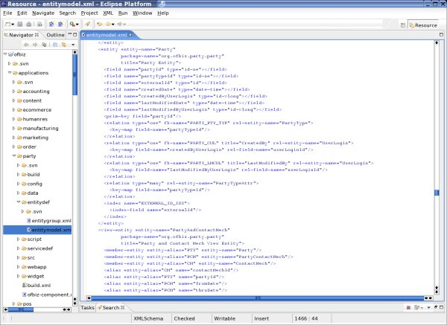
Relationships can be one-to-one or one-to-many and can (but does not have to) involve referential integrity checks. Using these relationships allows you to go from one entity to another in your application without having to remember exactly which key was involved at all times. Should the keys used in a relationship change, it also avoids the need to make modifications throughout your application.
(Note: OFBiz can generate the foreign-key names automatically for you, but it is good practice to specify them yourself to avoid accidental key collisions, etc.)
In the OFBiz webtools application, you can take a look at all the entities available:
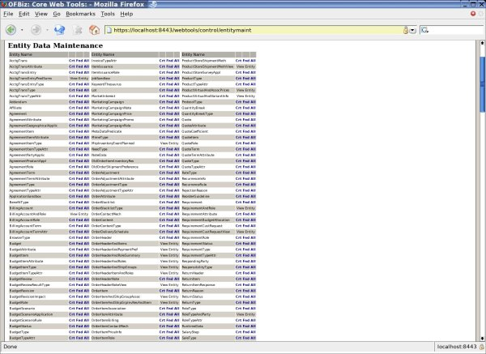

A Word about Beanshell
beanshell is a dynamic scripting language with Java syntax, and it is used extensively in OFBiz for view layer presentation data gathering. It can also be used for debugging, testing, and prototyping. In fact, entire services can be prototyped in beanshell and then used "as is" with the service engine or transformed to Java code when done.
When you start OFBiz, you may have noticed these lines on your console:
Httpd started on port: 9989
Sessiond started on port: 9990
23092 (main) [ BeanShellContainer.java:109:INFO ] Started BeanShell telnet service on 9989, 9990
23093 (main) [ BeanShellContainer.java:110:INFO ] NOTICE: BeanShell service ports are not secure. Please protect the ports
They tell you that OFBiz has opened a beanshell container on port 9990. (WARNING: protect or close this port on production systems.) You can telnet into this port and have full access to your OFBiz server, allowing you to test code and monitor events. I have a bshcontainer.bsh which, once placed in your ofbiz/ directory, can be called up with:
source("bshcontainer.bsh");
It will give you a delegator object for accessing the entity engine, a dispatcher for running services, and an admin UserLogin entity for services which require authentication.
I prefer to telnet into beanshell from Xemacs on Linux, which allows me to edit my beanshell commands. Unfortunately, I don't know of a good Windows telnet client. (If you do, please let me know.)

Working with Entities
Now let's work with our entities. Telnet into beanshell and (after some preliminary experiments) use the delegator object to access the Person entity. delegator is a GenericDelegator object with a set of methods for finding, creating, updating, and removing data. The delegator accepts parameters in the form of key-value pairs and translates them into actual SQL statements such as SELECT and INSERT. It will also observe the correct SQL syntax for the particular database you are using. Here is an example:
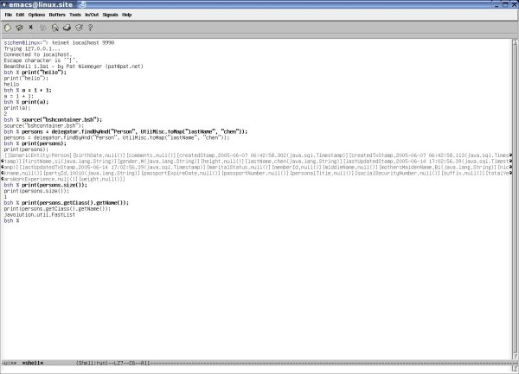
Above we had just found all Persons with a last name of "chen", and the delegator returned a List of just one. Now let's take a look at a particular person record:
bsh % me = persons.get(0);
bsh % print(me.getClass().getName());
org.ofbiz.entity.GenericValue
Each entity is an object of the GenericValue class, which itself is a sub-class of GenericEntity. GenericEntity provides us with methods to get and set values to fields, while GenericValue gives us methods for traversing through the data model with defined relationships.
Here is an example of how to get values from fields:
bsh % print(me.getString("firstName") + " " + me.get("lastName"));
print(me.getString("firstName") + " " + me.get("lastName"));
si chen
and for setting values to fields:
bsh % me.set("memberId", "11111");
me.set("memberId", "11111");
and storing the entity:
bsh % me.store();
Now let's retrieve it again and see if our change was effecive:
bsh % me2 = delegator.findByPrimaryKeyCache("Person", UtilMisc.toMap("partyId", "10010"));
bsh % print(me2.get("firstName") + " " + me2.get("lastName") + " " + me2.get("memberId"));
si chen 11111
Notice the different find method here--I was able to use the primary key field to get to the entity directly. The entity engine also caches values for you, so I used a cached find method this time.
You can also traverse from one entity to another. For example, there is a one-to-one relationship from Person to Party, so you can get the Party for a Person like so: bsh % print(me2.getRelatedOne("Party"));
[GenericEntity:Party][createdByUserLogin,null()][createdDate,2005-06-07 06:42:57.919(java.sql.Timestamp)]
[createdStamp,2005-06-07 06:42:58.113(java.sql.Timestamp)][createdTxStamp,2005-06-07 06:42:58.113(java.sql.Timestamp)]
[externalId,null()][lastModifiedByUserLogin,null()][lastModifiedDate,2005-06-07 06:42:57.919(java.sql.Timestamp)]
[lastUpdatedStamp,2005-06-07 06:42:58.113(java.sql.Timestamp)][lastUpdatedTxStamp,2005-06-07 06:42:58.113(java.sql.Timestamp)]
[partyId,10010(java.lang.String)][partyTypeId,PERSON(java.lang.String)]
Any Party can have many UserLogins, so you can go a step further to get the UserLogins for a Person through Party: bsh % print(me2.getRelatedOne("Party").getRelated("UserLogin")); print(me2.getRelatedOne("Party").getRelated("UserLogin"));
[[GenericEntity:UserLogin][createdStamp,2005-06-07 06:42:58.343(java.sql.Timestamp)]
[createdTxStamp,2005-06-07 06:42:58.113(java.sql.Timestamp)][currentPassword,(java.lang.String)]
[disabledDateTime,null()][enabled,null()][hasLoggedOut,null()]
[isSystem,null()][lastCurrencyUom,null()][lastLocale,null()][lastUpdatedStamp,2005-06-07 06:42:58.343(java.sql.Timestamp)]
[lastUpdatedTxStamp,2005-06-07 06:42:58.113(java.sql.Timestamp)][partyId,10010(java.lang.String)][passwordHint,null()]
[successiveFailedLogins,null()][userLoginId,sichen0607@graciousstyle.com(java.lang.String)]]
Finally, an unusually complicated one for getting the shipping address of a person:
bsh % print(me2.getRelatedOne("Party").getRelatedByAnd("PartyContactMechPurpose", UtilMisc.toMap("contactMechPurposeTypeId", "SHIPPING_LOCATION")).get(0).getRelatedOne("ContactMech").getRelatedOne("PostalAddress"));
[GenericEntity:PostalAddress][address1,11986 Foxboro Dr(java.lang.String)][address2,null()][attnName,null()]
[city,Los Angeles(java.lang.String)][contactMechId,10000(java.lang.String)]
[countryGeoId,USA(java.lang.String)]
[createdStamp,2005-06-07 06:42:58.911(java.sql.Timestamp)][createdTxStamp,2005-06-07 06:42:58.808(java.sql.Timestamp)]
[directions,null()][lastUpdatedStamp,2005-06-07 06:42:58.911(java.sql.Timestamp)]
[lastUpdatedTxStamp,2005-06-07 06:42:58.808(java.sql.Timestamp)]
[postalCode,90049(java.lang.String)][postalCodeExt,null()][postalCodeGeoId,null()]
[stateProvinceGeoId,CA(java.lang.String)][toName,si chen(java.lang.String)]
Notice how you can also filter results from getting related entities.

Business Logic and Services
The business logic tier in OFBiz is similar in philosophy to the way the data modeling is done. We create generic definitions of business logic, implement it in a variety of ways, and access it with a generic set of APIs. This is all done via a service engine. OFBiz is thus built on a Service Oriented Architecture (SOA).
The first step is to define your services in an XML file:
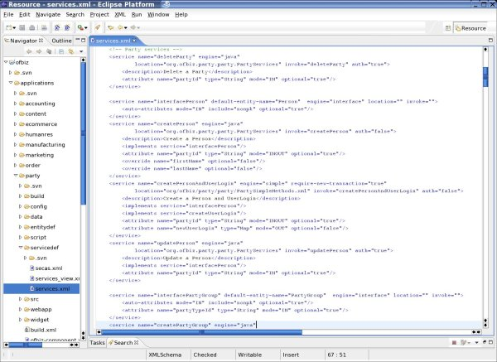
Here, services are declared, and they can be implemented in either Java (engine="java") or the OFBiz minilang (engine="simple".) Like Java, you can also define generic "interface" services which are implemented by other services. Each service has input and output parameter fields, and the fields have Java types. But the service engine goes a step further: you can also link a service directly to an entity, and OFBiz will figure out the parameters and requisite types for you. This not only saves a lot of typing but makes it unnecessary to modify a large number of services when an entity changes.
You can browse the services in OFBiz with the "Services Available" tool in Web Tools:
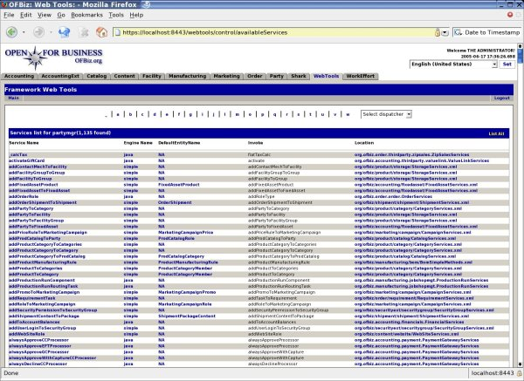
Services can be implemented in Java, and Java services follow a standard pattern, like this:
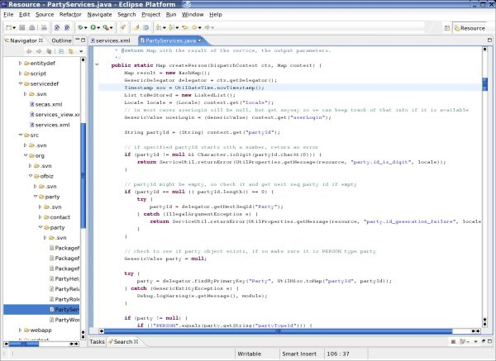
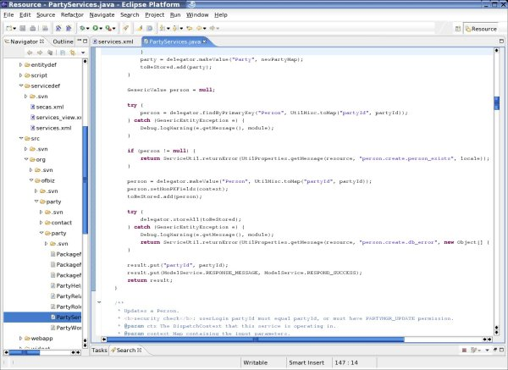
Every Java service is a public static method which takes two parameters, a DispatchContext and a Map called context, and returns a Map. The dispatch context will pass along tools such as the delegator and dispatcher (for running services, see below.) The context is a Map of all the parameters. The method also returns a Map with status of service (success or fail) and return parameters matching those defined in the XML file.
OFBiz also provides a scripting language called minilang or simple-method, which allows for more efficient coding of many tasks. It is specifically designed to work with the OFBiz entity and service engines and perform tasks such as look up, create, run services, or check permissions with simple directives. It is also interpreted and allows for iterative debugging. Here is an example:
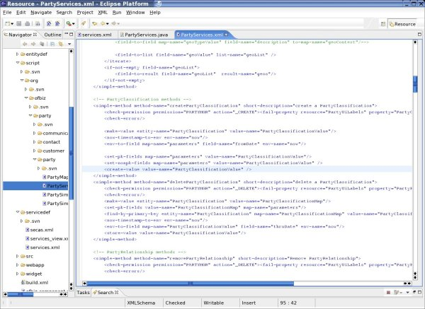
Finally, OFBiz services can be implemented in a number of other Java scripting languages, such as Jython, beanshell, Javascript, and potentially any BSF compatible scripting language. The idea is to work with the best tool for the project, given the nature of the task and background of your team.
We call services through an object (usually) called dispatcher, which is of a sub-class of the LocalDispatcher interface:
esh % result = dispatcher.runSync("createPerson", UtilMisc.toMap("firstName", "A", "lastName", "Person"));
bsh % print(result);
[partyId=10050, responseMessage=success]
Here we have just called a service synchronously (in the same thread) to create a Person. We could have also asked OFBiz to run the service asynchronously, or on a separate thread in parallel with our current task.
Some services require validation, and a UserLogin value must be passed in:
bsh % result = dispatcher.runSync("updatePerson", UtilMisc.toMap("partyId", "10050", "nickname", "some bloke"));
// Error: // Uncaught Exception: Method Invocation dispatcher.runSync : at Line: 26 : in file: : dispatcher .runSync ( "updatePerson" , UtilMisc .toMap ( "partyId" , "10050" , "nickname" , "some bloke" ) )

Target exception: org.ofbiz.service.ServiceAuthException: User authorization is required for this service: updatePerson

org.ofbiz.service.ServiceAuthException: User authorization is required for this service: updatePerson
at org.ofbiz.service.ServiceDispatcher.runSync(ServiceDispatcher.java:309)
at org.ofbiz.service.ServiceDispatcher.runSync(ServiceDispatcher.java:212)
at org.ofbiz.service.GenericDispatcher.runSync(GenericDispatcher.java:110)
at sun.reflect.NativeMethodAccessorImpl.invoke0(Native Method)
at sun.reflect.NativeMethodAccessorImpl.invoke(NativeMethodAccessorImpl.java:39)
at sun.reflect.DelegatingMethodAccessorImpl.invoke(DelegatingMethodAccessorImpl.java:25)
at java.lang.reflect.Method.invoke(Method.java:324)
at bsh.Reflect.invokeOnMethod(Reflect.java:117)
at bsh.Reflect.invokeObjectMethod(Reflect.java:91)
at bsh.Name.invokeMethod(Name.java:689)
at bsh.BSHMethodInvocation.eval(BSHMethodInvocation.java:55)
at bsh.BSHPrimaryExpression.eval(BSHPrimaryExpression.java:69)
at bsh.BSHAssignment.eval(BSHAssignment.java:58)
at bsh.Interpreter.run(Interpreter.java:436)
at bsh.util.SessiondConnection.run(Sessiond.java:97)
bsh % result = dispatcher.runSync("updatePerson", UtilMisc.toMap("partyId", "10050", "nickname", "some bloke", "userLogin", admin));
bsh % print(result);
[successMessage=person.update.success, responseMessage=success]
bsh % bloke = delegator.findByPrimaryKey("Person", UtilMisc.toMap("partyId", "10050"));
bsh % print(bloke.get("nickname"));
some bloke
And we see that a new Person was created and updated.
If you do not have the userLogin object but have a username and password, the magic words are login.username and login.password, like this:
result = dispatcher.runSync("updatePerson", UtilMisc.toMap("partyId", "10050", "nickname", "some bloke", "login.username", "admin", "login.password", "ofbiz"));
This is appropriate if you need to call the service remotely such as from an external application via SOAP or XML-RPC.
A final note: OFBiz will wrap services automatically in transactions, so there is no need (usually) to write your own.

Mutually Aware Interactions
The most powerful feature of the OFBizFramework is the fact that all the tools work together, including the entity engine, service engine, web controller, and front end user screen and form generation tools. For example, you can define an entity, and the service engine will automatically figure out what fields it needs. The controller can automatically parse user form inputs into the service engine. Even user screens can be automatically generated.
The result is a drastic reduction in the amount of duplicate code that must be written for normal applications. This not only reduces initial development time and costs but also long-term maintenance costs and risks, as business requirements change.

For more information
Visit the Documents page on ofbiz.org for more information on the entity and service engines, minilang, and various APIs.

三、Hello World

OFBiz Hello World Application Example

IMPORTANT: Please read about the recent changes before attempting this tutorial.
This tutorial will show you how to build a very simple OFBiz application. You will see how OFBiz application components and web applications are created, how web pages are created, and how an OFBiz controller helps direct web requests.
This tutorial was done on Linux, but OFBiz and these examples will work with any operating system with a Java SDK.

Creating an Application
In OFBiz, every application sits inside its own fully contained component, so your first step is to create a component. A component can sit inside the framework/, application/, specialized/, or hot-deploy/ directory. The advantage of the hot-deploy/ directory is that components here are loaded automatically when OFBiz starts. So, for our first step, let's create a sub-directory in hot-deploy/ for our new component, which we'll call hello1:
sichen@linux:~/eclipse/workspace/ofbiz> ls -l hot-deploy/
total 4
drwxrwxr-x 4 sichen users 136 2005-05-19 07:16 hello1
-rw-r--r-- 1 sichen users 127 2005-06-02 15:19 README.txt
(Note that everything in this tutorial is inside my eclipse/workspace/ directories because I use the Eclipse IDE, but in fact you can put ofbiz anywhere, and the directory structure is the same.)
Inside your new application component, there must be an ofbiz-component.xml file to tell OFBiz about your applicaton component: its data model (tables), business logic (services) and workflow, UI layer (web or GUI applications), any seed data it may have, and what other resources it requires. You can take a look at the ofbiz-component.xml files in other applications, which can be quite complex. For hello1, we just need to create a simple one that looks like this:
<?xml version="1.0" encoding="UTF-8"?>

<ofbiz-component name="hello1"
xmlns:xsi="http://www.w3.org/2001/XMLSchema-instance"
xsi:noNamespaceSchemaLocation="http://www.ofbiz.org/dtds/ofbiz-component.xsd">

<resource-loader name="main" type="component"/>
<webapp name="hello1"
title="My First OFBiz Application"
server="default-server"
location="webapp/hello1"
mount-point="/hello1"
app-bar-display="false"/>
</ofbiz-component>
What is this file telling OFBiz?
- That we have a component named "hello1"
- That it should use the "main" resource-loader
- That it has one web application, also called "hello1"
- The "hello1" web application should use the "default-server" web server
- The "hello1" web application is inside the webapp/ directory
- The "hello1" web application should be mounted at a URI of "/hello1"
- We don't want the app-bar, which shows all the applications available in OFBiz, to be displayed in our web app

Creating a Web Application
A web application is a UI component that interacts with the user over the web. An OFBiz application component can have several UI components, some of which are webapps.
Now that you have configured your new application, the next step is to create a webapp/ directory for its web applications. Inside this directory, create a hello1/ directory for the "hello1" web app you just named. When you are done, it should look like this:
sichen@linux:~/eclipse/workspace/ofbiz/hot-deploy/hello1> ls -l
total 4
-rw------- 1 sichen users 1733 2005-06-02 15:57 ofbiz-component.xml
drwxrwxr-x 3 sichen users 72 2005-06-02 15:54 webapp
sichen@linux:~/eclipse/workspace/ofbiz/hot-deploy/hello1> ls -l webapp/
total 0
drwxrwxr-x 3 sichen users 96 2005-06-02 16:10 hello1
Now we are ready to work inside the webapp/hello1 directory and create a web application. Remember that OFBiz is a Model-View-Controller framework, which means that a controller manages visitor requests and routes them to the appropriate pages and actions. Thus, separate pages and a master controller are needed.
Typically for Java web applications, pages which are viewable by visitors, such as HTML or JSPs, are inside a webapp/ directory, while private files, such as XML configuration files or Java servlets, are hidden inside a WEB-INF/ directory.
This is the case with OFBiz as well. We'll first create a WEB-INF/ directory and then create just one file to be displayed to our visitors, which we'll call main.ftl, for Freemarker template file. (Freemarker is a very easy, intuitive templating language that allows you to put basic controls, such as loops and if-then-else, around your HTML.) main.ftl is just a straightforward HTML file:
<html>
<head>
<title>Hello World</title>
</head>
<body>
<h1>HELLO</h1>
<p>Hello world!</p>
</body>
</html>
Now this would be your contents of your webapp/hello1/ directory:
sichen@linux:~/eclipse/workspace/ofbiz/hot-deploy/hello1/webapp/hello1> ls -l
total 4
-rw------- 1 sichen users 107 2005-06-02 16:23 main.ftl
drwxrwxr-x 2 sichen users 104 2005-06-02 16:17 WEB-INF
The final step is to create the files to configure the webapp. At a minimum, an OFBiz web application requires two configuration files, a controller.xml and a web.xml. controller.xml tells OFBiz what to do with various requests from visitors: what actions to take and what pages to render. web.xml tells OFBiz what resources (database and business logic access) are available for this web application and how to handle web-related issues, such as welcome pages, redirects, and error pages.
If you're starting a new application, both files can be copied from the WEB-INF/ directory of an existing application. I copied mine over from the catalog manager. web.xml can almost be used in place, with no modification, like this:

<?xml version="1.0"?>
<!DOCTYPE web-app PUBLIC "-//Sun Microsystems, Inc.//DTD Web Application 2.3//EN" "http://java.sun.com/dtd/web-app_2_3.dtd">

<web-app>

<display-name>Hello 1</display-name>
<description>The First Hello World Application</description>

<context-param>

<param-name>entityDelegatorName</param-name>
<param-value>default</param-value>
<description>The Name of the Entity Delegator to use, defined in entityengine.xml</description>
</context-param>
<context-param>
<param-name>localDispatcherName</param-name>
<param-value>hello1</param-value>
<description>A unique name used to identify/recognize the local dispatcher for the Service Engine</description>
</context-param>
<context-param>
<param-name>serviceReaderUrls</param-name>
<param-value>/WEB-INF/services.xml</param-value>
<description>Configuration File(s) For The Service Dispatcher</description>
</context-param>

<filter>

<filter-name>ContextFilter</filter-name>
<display-name>ContextFilter</display-name>
<filter-class>org.ofbiz.webapp.control.ContextFilter</filter-class>

<init-param>
<param-name>disableContextSecurity</param-name>

<param-value>N</param-value>
</init-param>
<init-param>
<param-name>allowedPaths</param-name>
<param-value>/control:/select:/index.html:/index.jsp:/default.html:
/default.jsp:/images:/includes/maincss.css</param-value>
</init-param>
<init-param>
<param-name>errorCode</param-name>
<param-value>403</param-value>
</init-param>
<init-param>
<param-name>redirectPath</param-name>
<param-value>/control/main</param-value>

</init-param>
</filter>
<filter-mapping>
<filter-name>ContextFilter</filter-name>
<url-pattern>/*</url-pattern>
</filter-mapping>

<listener><listener-class>
org.ofbiz.webapp.control.ControlEventListener</listener-class></listener>

<listener><listener-class>
org.ofbiz.webapp.control.LoginEventListener</listener-class></listener>
<!-- NOTE: not all app servers support mounting implementations of the HttpSessionActivationListener interface -->

<!-- <listener><listener-class>
org.ofbiz.webapp.control.ControlActivationEventListener</listener-class></listener> -->

<servlet>

<servlet-name>ControlServlet</servlet-name>
<display-name>ControlServlet</display-name>

<description>Main Control Servlet</description>
<servlet-class>org.ofbiz.webapp.control.ControlServlet</servlet-class>

<load-on-startup>1</load-on-startup>
</servlet>
<servlet-mapping>
<servlet-name>ControlServlet</servlet-name>
<url-pattern>/control/*</url-pattern>
</servlet-mapping>

<session-config>
<session-timeout>60</session-timeout> <!-- in minutes -->
</session-config>

<welcome-file-list>

<welcome-file>index.jsp</welcome-file>
<welcome-file>index.html</welcome-file>

<welcome-file>index.htm</welcome-file>
</welcome-file-list>

</web-app>
The controller.xml can also be copied but needs to be modified to reflect your needs: what your URI requests you want to allow in your webapp, and how you want OFBiz to process them. Here is the controller modified for hello1:
<?xml version="1.0" encoding="UTF-8" ?>

<site-conf xmlns:xsi="http://www.w3.org/2001/XMLSchema-instance"
xsi:noNamespaceSchemaLocation="http://www.ofbiz.org/dtds/site-conf.xsd">
<description>First Hello World Site Configuration File</description>

<owner>Open For Business Project (c) 2005 </owner>
<errorpage>/error/error.jsp</errorpage>

<handler name="java" type="request" class="org.ofbiz.webapp.event.JavaEventHandler"/>
<handler name="soap" type="request" class="org.ofbiz.webapp.event.SOAPEventHandler"/>
<handler name="service" type="request" class="org.ofbiz.webapp.event.ServiceEventHandler"/>
<handler name="service-multi" type="request" class="org.ofbiz.webapp.event.ServiceMultiEventHandler"/>
<handler name="simple" type="request" class="org.ofbiz.webapp.event.SimpleEventHandler"/>

<handler name="ftl" type="view" class="org.ofbiz.webapp.ftl.FreeMarkerViewHandler"/>
<handler name="jsp" type="view" class="org.ofbiz.webapp.view.JspViewHandler"/>
<handler name="screen" type="view" class="org.ofbiz.widget.screen.ScreenWidgetViewHandler"/>

<handler name="http" type="view" class="org.ofbiz.webapp.view.HttpViewHandler"/>

<preprocessor>
<!-- Events to run on every request before security (chains exempt) -->
<!-- <event type="java" path="org.ofbiz.webapp.event.TestEvent" invoke="test"/> -->
<event type="java" path="org.ofbiz.securityext.login.LoginEvents" invoke="checkExternalLoginKey"/>
</preprocessor>
<postprocessor>
<!-- Events to run on every request after all other processing (chains exempt) -->
<!-- <event type="java" path="org.ofbiz.webapp.event.TestEvent" invoke="test"/> -->
</postprocessor>

<!-- Request Mappings -->
<request-map uri="main">
<response name="success" type="view" value="main"/>
</request-map>

<!-- end of request mappings -->

<!-- View Mappings -->

<view-map name="error" page="/error/error.jsp"/>
<view-map name="main" type="ftl" page="main.ftl"/>

<!-- end of view mappings -->
</site-conf>
The OFBiz controller allows you to specify:
- handlers, which are Java classes that handle either requests or produce views in various formats. For example, the handler for "java" events routes requests to a Java servlet, while the "service" handler routes requests to the service engine, automatically parsing visitor input into service input parameters. The various view requests produce output to the browser based on Freemarker templates, velocity, JSP, or the OFBiz screen widget.
- pre- and post-processors, which are servlets that are run before and after every web request.
- request mappings, which map URI requests to either request or view handlers. Request mappings can also re-direct to other request mappings, allowing requests to be chained together.
- view mappings, which generate output to the visitor by specifying where the page is located. By default, view mappings reference files starting from the current web application's directory, in this case, webapp/hello1/.
In this simple controller, there are no pre- or postprocessor events to be run. Only one request is allowed, "/main", and it leads us to a view called "main", which uses main.ftl we created earlier to generate output back to the visitor.

Running our application
Now we are ready. Let's run our first application:
sichen@linux:~/eclipse/workspace/ofbiz> ./startofbiz.sh
sichen@linux:~/eclipse/workspace/ofbiz> tail -f logs/console.log
In Linux, the startup script runs OFBiz in the background, so you need tail to see the console output. In Windows, just do:
c:\ofbiz> startofbiz.bat
and the output is displayed on your screen. The log file is quite lengthy but you will see these lines:
...
1607 (main) [ ComponentContainer.java:153:INFO ] Auto-Loading component directory : [/home/sichen/eclipse/workspace/ofbiz/hot-deploy]
1619 (main) [ UtilXml.java:242:DEBUG] XML Read 0.011s: file:/home/sichen/eclipse/workspace/ofbiz/hot-deploy/hello1/ofbiz-component.xml
1620 (main) [ ComponentContainer.java:209:INFO ] Loading component : [hello1]
...
18571 (main) [ ContextFilter.java:300:INFO ] [ContextFilter.init] Getting Entity Engine Delegator with delegator name default
18573 (main) [ ServiceDispatcher.java:168:INFO ] Registered dispatcher: hello1
18575 (main) [ GenericDispatcher.java:85 :INFO ] [LocalDispatcher] : Created Dispatcher for: hello1
18577 (main) [ ControlServlet.java:74 :INFO ] [ControlServlet.init] Loading Control Servlet mounted on path /home/sichen/eclipse/workspace/ofbiz/hot-deploy/hello1/webapp/hello1/
18578 (main) [ RequestHandler.java:89 :INFO ] [RequestHandler Loading...]
18587 (main) [ UtilXml.java:242:DEBUG] XML Read 0.0080s: jndi:/0.0.0.0/hello1/WEB-INF/controller.xml
18588 (main) [ ConfigXMLReader.java:552:INFO ] ConfigMap Created: (4) records in 0.0010s
18588 (main) [ ConfigXMLReader.java:622:INFO ] HandlerMap Created: (2) records in 0.0s
18589 (main) [ ConfigXMLReader.java:302:INFO ] RequestMap Created: (1) records in 0.0s
18589 (main) [ ConfigXMLReader.java:411:INFO ] ViewMap Created: (2) records in 0.0s
...
21204 (main) [ CatalinaContainer.java:238:INFO ] Connector AJP/1.3 @ 8009 - not-secure [org.apache.jk.server.JkCoyoteHandler] started.
21204 (main) [ CatalinaContainer.java:235:INFO ] Connector HTTP/1.1 @ 8080 - not-secure [org.apache.coyote.http11.Http11Protocol] started.
21205 (main) [ CatalinaContainer.java:235:INFO ] Connector TLS @ 8443 - secure [org.apache.coyote.http11.Http11Protocol] started.
21209 (main) [ CatalinaContainer.java:242:INFO ] Started Apache Tomcat/5.5.9
Httpd started on port: 9989
Sessiond started on port: 9990
21467 (main) [ BeanShellContainer.java:109:INFO ] Started BeanShell telnet service on 9989, 9990
21467 (main) [ BeanShellContainer.java:110:INFO ] NOTICE: BeanShell service ports are not secure. Please protect the ports
31903 (org.ofbiz.service.jms.JmsListenerFactory@996b65) [ JmsListenerFactory.java:82 :INFO ] JMS Listener Factory Thread Finished; All listeners connected.
The first little block shows OFBiz auto-loading the hello1 component from within hot-deploy/. The second block shows it setting up the hello1 webapp, getting a delegator (for database access), a dispatcher (for running services), and loading up the controller. The last block is what you will see when all the webapps are loaded and Tomcat, the default embedded web server, is started.
From a browser, type in:
http://localhost:8080/hello1/control/main
and you will see this.

Final Touchups
Looks like we're done... but not yet. Try typing this in your browser:
http://localhost:8080/hello1/
and you will get this. The problem is that /control is a specific request to the control servlet through the web server, and there is no index page at the root of the webapp. This is simple to fix: just copy an index.jsp from one of the other webapps into /webapp/hello1/. The index.jsp just has one line:
sichen@linux:~/eclipse/workspace/ofbiz/hot-deploy/hello1/webapp/hello1> cat index.jsp

Now if you try it again, http://localhost:8080/hello1/ will also get you to the right page.
One last thing to try, type in:
http://localhost:8080/hello1/control/nonsense
You'd get a blank screen, because there is no error page right now. The location of your error page is specified in the beginning of your controller.xml above. You will need to make or copy over a /webapp/hello1/error/error.jsp page to show an error message to your visitors. It looks like this:
sichen@linux:~/eclipse/workspace/ofbiz/hot-deploy/hello1/webapp/hello1> cat error/error.jsp

<%@ page import="org.ofbiz.base.util.*" %>
<html>
<head>
<title>Open For Business Message</title>
<meta http-equiv="Content-Type" content="text/html; charset=iso-8859-1">
</head>

<% String errorMsg = (String) request.getAttribute("_ERROR_MESSAGE_"); %>

<body bgcolor="#FFFFFF">
<div align="center">
<br/>
<table width="100%" border="1" height="200">
<tr>
<td>
<table width="100%" border="0" height="200">
<tr bgcolor="#CC6666">
<td height="45">
<div align="center"><font face="Verdana, Arial, Helvetica, sans-serif" size="4" color="#FFFFFF"><b>:ERROR MESSAGE:</b></font></div>
</td>
</tr>
<tr>
<td>
<div align="left"><font face="Verdana, Arial, Helvetica, sans-serif" size="2"><%=UtilFormatOut.replaceString(errorMsg, "\n", "<br/>")%></font></div>
</td>
</tr>
</table>
</td>
</tr>
</table>
</div>
<div align="center"></div>
</body>
</html>
/html>
Now try the "nonsense" request again, and you should get this page. Note that this is a very different error page: it is not from Apache Tomcat, like the first one you got, but from OFBiz. This is because with "/control" in your URI (and the re-direct even if you didn't have it), every request is being processed by the OFBiz controller now.
This is the final content of your webapp directory:
sichen@linux:~/eclipse/workspace/ofbiz/hot-deploy/hello1/webapp/hello1> ls -l
total 8
drwxr-xr-x 2 sichen users 144 2005-06-03 06:01 error
-rw-r--r-- 1 sichen users 44 2005-06-03 05:52 index.jsp
-rw------- 1 sichen users 1355 2005-06-02 16:26 main.ftl
drwxrwxr-x 2 sichen users 232 2005-06-03 05:58 WEB-INF
sichen@linux:~/eclipse/workspace/ofbiz/hot-deploy/hello1/webapp/hello1> ls -l error/
total 4
-rw-r--r-- 1 sichen users 1003 2005-06-03 05:55 error.jsp
Click to see the complete files for this application.

Conclusions
So now you have created a fully self-contained ofbiz application, with its webapp, controller, page, and error page. This sure was a lot of work to display a simple web page. Obviously, if that's all you needed, OFBiz is way too complicated. But chances are, that's never all you needed to do. In future tutorials, we'll see how you can use OFBiz applications to develop your complex applications with a lot of different tables, pages, and complicated business logic. Then you will see the advantages of the OFBiz framework.

Extending your web app with screen-widget, decorator, and actions
by Si Chen

IMPORTANT: Please read about the recent changes before attempting this tutorial.
Now you've made your first web application. In the real world, though, you'd probably be creating applications with many, many pages which performed useful tasks. The OFBiz screen-widget allows you to create web apps which stitch together many pieces ("decorator pattern") and perform actions such as gathering and analyzing data ("actions.")

Throughout this tutorial, click on any image to enlarge it.
In this tutorial, we'll extend Hello World 1 to a second application, hello2. The first step is to copy hello1 into hello2 and change the names of the "hello1" webapp to "hello2", as well as references to it in ofbiz-component.xml:
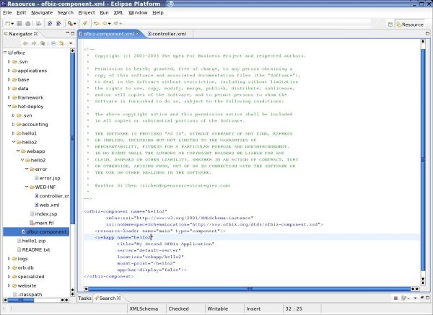

Creating Screens
The OFBiz screen-widget is used to put together complex pages with many smaller pieces of display elements. (If you've used earlier versions of OFBiz, it replaces JPublish and the regions framework.)
The first step is to create an includes/ directory in your webapp and create the headers and footers there. If you want to use a common stylesheet and graphics, this is a good place to put it. You will also want to remove the same code from the main.ftl:
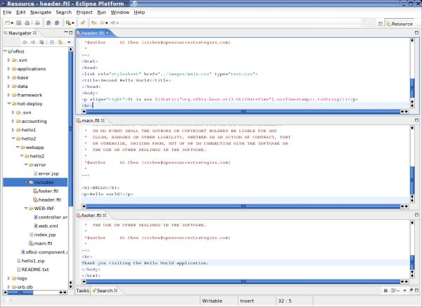
The second step is to stitch these pieces together using the screen-widget. Create a widget/ directory inside hello2/, next to webapp/. Inside widget/, create an XML file to define your screens:
sichen@linux:~/eclipse/workspace/ofbiz/hot-deploy/hello2> ls -l
total 4
-rw------- 1 sichen users 1747 2005-06-09 16:28 ofbiz-component.xml
drwxrwxr-x 3 sichen users 72 2005-06-09 16:07 webapp
drwxr-xr-x 2 sichen users 80 2005-06-09 17:02 widget
sichen@linux:~/eclipse/workspace/ofbiz/hot-deploy/hello2> ls -l widget/
total 4
-rw-r--r-- 1 sichen users 720 2005-06-09 17:02 HelloScreens.xml
The simplest screen definition is one which puts together several ftl pages together:
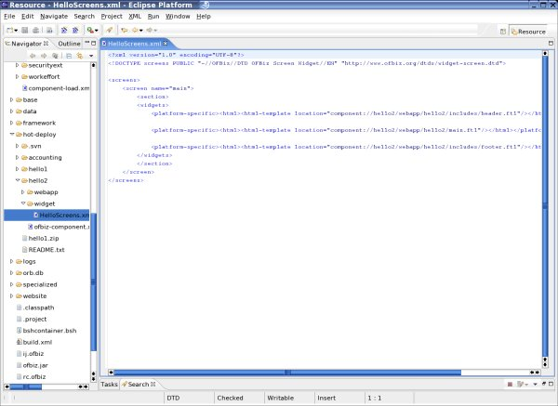
ERRATA:The screen shown uses the older DTD for the screen-widget, rather than the correct xmlns.
The final step is to reference tour screen definition rather than the Freemarker template directly in your controller:
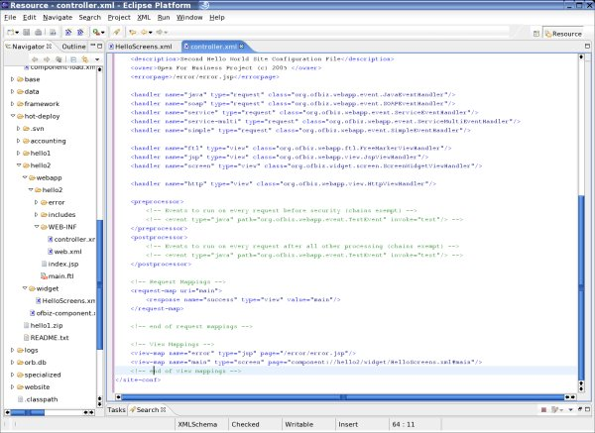
Now we're done! If you type in
http://localhost:8080/hello2/control/main
in your browser window, you will get this.
By allowing you to compose a page with many pieces, the screen-widget will help you as you build more complex applications.

Decorating Your Page
The decorator pattern allows you to piece a page together using many different sections, thus allowing you to reuse those sections across multiple pages. For example, you can have separate pages for your header, navigation bar, news panels, promotion offers, and footers.
For example, let's say that you wanted to create several pages with the same header and footer but different content. The screen-widget allows you to do this by creating multiple screens which re-use the same display element. To get started, first we create multiple requests and views in the controller.xml:
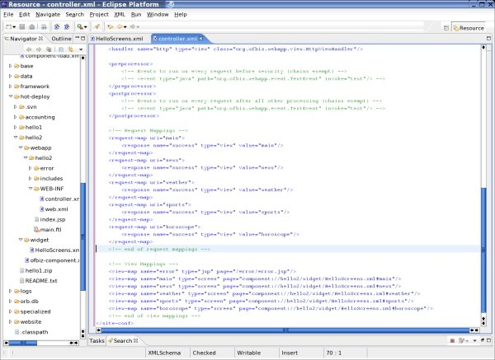
Next we create the additional pages and screens. In the screen-widget XML file, you can just copy each screen definition and change main.ftl to your page.
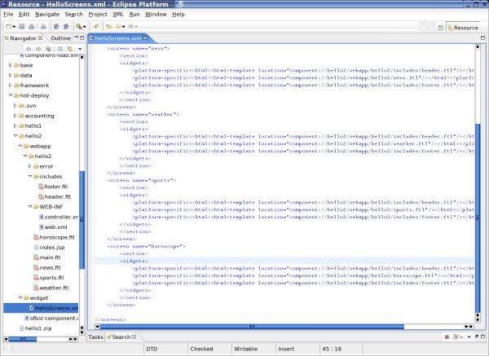
In the pages themselves, you no longer have to put in repetitive elements.
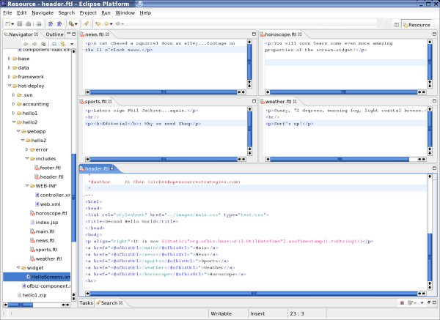
Note the <@ofbizUrl> tag in header.ftl (bottom.) This is used to generate your URL. These pages look like this.
As you build larger sites, however, repetitive layout commands can be a maintenance problem. Fortunately, the OFBiz screen-widget goes a step further by allowing you to define a template which is repeated for many screens. You do this by declaring a <decorator-section-include> inside a template screen (usually called a "CommonDecorator"). Then, in your other screens, you reference the template screen with a and declare their own content with a tag. This is what it would look like:
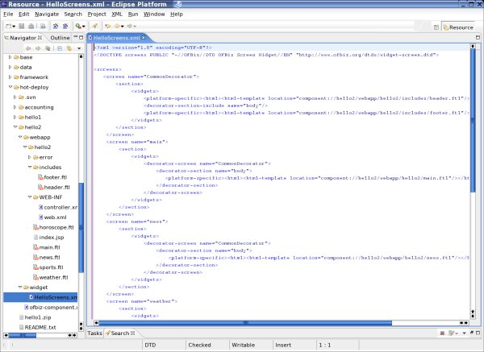
The web pages generated look the same as before. If, however, you got a request to, say, put a legal disclaimer on all the pages, it would be as simple as modifiying the layout of the CommonDecorator.

Adding Actions
Now you've seen the basics of building static sites with OFBiz. The next step is to mix in dynamic content. Typically, most web scripting languages allow you to put code on the page to do this. Freemarker allows you to do this as well, which is how I put in a date in the header. The creators of Freemarker, however, discourage this because they felt it would lead to pages which are overly complicated.
OFBiz avoids this problem by separating layout from actions or code, which gather and prepare data. By separating actions and presentation of a web page, you can allow separate people with different skills (programming vs design) to work on a web page. You can also reuse the same code for generating multiple views, such as a web page or a PDF of the same content.
To do this, you would first create an actions/ directory inside your WEB-INF directory. Then you would put in a beanshell script which would perform your actions. The beanshell script here is like a Java servlet, only it is dynamically typed and interpreted (rather than compiled.) Also, if you want to put objects back into the Freemarker pages to be displayed, you would put them into a Map (already created for you) called "context". Finally, you would need to declare this action for your screen, a new one that I've created here:
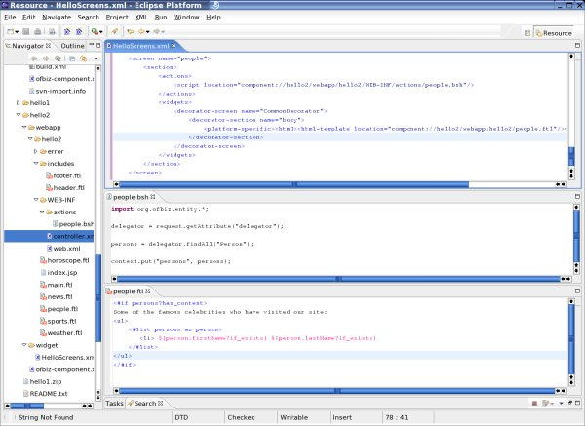
I also created an entry for it in controller.xml.
A lot is happening here. In HelloScreens.xml, you created a screen which uses people.ftl for presentation and people.bsh for actions related to the page, which in this case is data gathering. people.bsh is a simple script which got a delegator, looked up all the Person entities, and then put them into the context. (OFBiz puts this delegator into the request for you.) Finally, on the bottom, people.ftl displays all the names. (This is a good example of some of Freemarker's syntax.) And this is what you will see.
There is also a way to do basic lookups like this directly in the screen-wdiget using tags like <entity-one> instead of creating a separate script and writing Java code. I'll leave it for you to explore this.
Also, since there is a delegator object, can you just write to the database and do all your business logic in .bsh scripts? The answer is yes, but for larger applications this is not considered good practice. In fact, this is never done in any of the OFBiz applications.
Click to see the files created in this tutorial.

Summing Up
This should give you a basic idea on how to build web applications with OFBiz. There are many more tools available to help you, and I will leave it to you to explore the existing OFBiz applications to see what else you can do.
One tool that can be very helpful is the form widget, which allows you to generate standardized forms automatically based on the fields from your data model or from your business logic services. See this wiki page for more details.
Hello World 3

Building a Complete Application with OFBiz

IMPORTANT: Please read about the recent changes before attempting this tutorial.
In this third tutorial, we will build a complete application with OFBiz. Our application will allow users to sign in and create an entry about themselves, their various hobbies, and see other people who have visited the site and their hobbies and comments as well. It is a simple guest book website.
Please be sure that you have read all the previous tutorials, as I will not repeat the same information here.

Defining the Data Model
The first step is to define the data model. We want to track persons and their hobbies and lookup all the hobbies of a person (or, alternatively, all the people who share a hobby.) The data model thus calls for person, hobby, and person-hobby linkage.
With a relational database, you would define two tables, one for a person and one for a hobby, and link them together with a third table. The third table would allow you to associate as many hobbies as you would want with a person, and vice versa. You would define foreign-keys to constrain the third table so only actual persons and hobbies are present.
OFBiz works similarly. You would define two entities, which we will call HelloPerson and HelloHobby, and a linking entity, HelloPersonHobby, and establish a relationships between them. The relationships serve as foreign-key constraints but also allow you to go from one entity to another without having to remember yourself what their respective keys are (or change your code when keys change.)
NOTE: We are creating an application with completely self-contained data model here for illustration. If we were building a real application, the best practice would be to reuse as many existing OFBiz entities as possible, so instead of creating our own HelloPerson, we would be using the existing OFBiz Party/Person/PartyGroup entities.
To define data models, create an entitydef/ directory inside your application (hello3/ in this case) and create an entitymodel.xml and entitygroup.xml inside your entitydef/ directory:
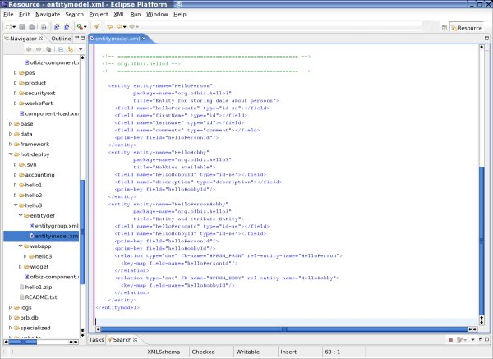
HelloPerson and HelloHobby each has a primary key, and HelloPersonHobby has two primary key fields, which it uses to link HelloPerson and HelloHobby. It is considered good practice to give your relations a foreign key name to make debugging easier and avoid accidental collision of foreign key names OFBiz generates for you.
It is also very important (but easy to forget) to define these entities in another file, entitygroup.xml, in the entitydef/ directory, so OFBiz will know which delegator, and thus database, to use for them):
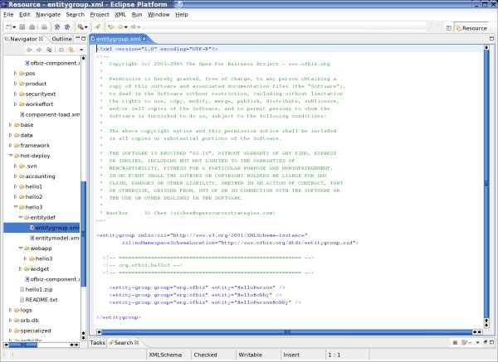
Otherwise, the entities will exist in OFBiz, but when you actually try to use them, you will get this error:
org.ofbiz.entity.GenericEntityException: Helper name not found for entity HelloPerson
Finally, you must add this line to your ofbiz-component.xml to let OFBiz know to use this entity as part of this application component, before the <webapp> directive:
<entity-resource type="model" reader-name="main" loader="main" location="entitydef/entitymodel.xml"/>
<entity-resource type="group" reader-name="main" loader="main" location="entitydef/entitygroup.xml"/>
Now start OFBiz. You will see the following lines in your console.log (Linux) or roll past you on your console (Windows), telling you that your entities were loaded:
5336 (main) [ UtilXml.java:242:DEBUG] XML Read 0.0070s: /home/sichen/eclipse/workspace/ofbiz/hot-deploy/hello3/entitydef/entitymodel.xml
5693 (main) [ UtilXml.java:242:DEBUG] XML Read 0.0050s: /home/sichen/eclipse/workspace/ofbiz/hot-deploy/hello3/entitydef/entitygroup.xml
When you go into webtools, you will see the entities:
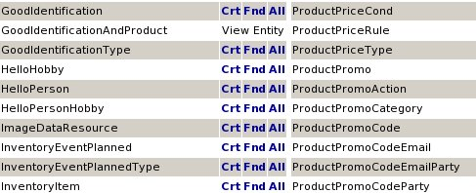
Click on "All" to the right HelloPerson and you will see its fields:
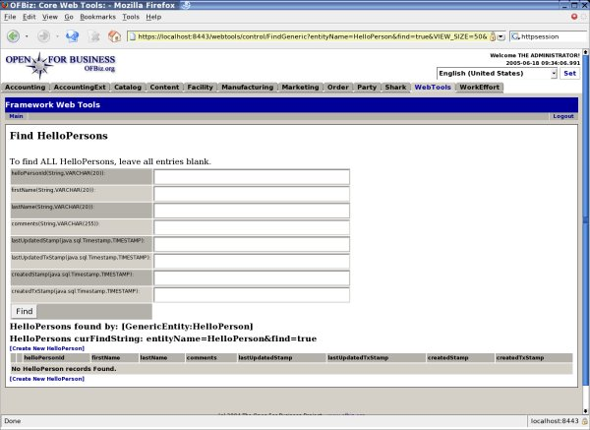
Notice that next to each field is the Java type and SQL type for this field. The SQL type is specified in the framework/entity/filedtype/ directory and varies depending on the database you are using (mine is Derby.) If there were any values for this entity, it would show below the fields.

Creating Seed Data
Now let's create some seed data for our hobbies. In most OFBiz applications, we would create a data/ directory inside our application and create an XML file for our seed data. Let's call ours HobbiesData.xml:
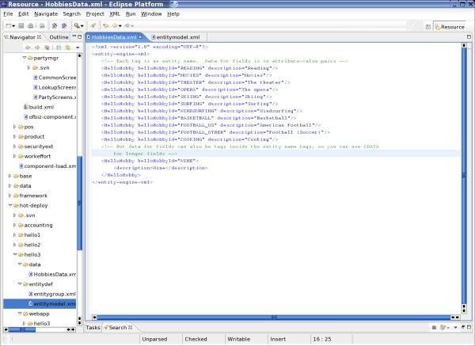
This file, which is called an entity engine XML file, is a standard OFBiz XML format for importing and exporting data. It is really quite simple. Use the name of the entity ("HelloHobby" in our case) for the tag name, and use the name of the fields as either attributes or as inner tags (see the last value for "WINE." The values for your fields can be the values of the attributes or inside the inner tags, where they can be inside CDATA sections as well, in case you have very long values. Also, the key fields do not have to be upper case or separated by _, but that is the norm in other OFBiz applications.
Now you are ready to load your seed data. Go to the Web Tools application's "Main" screen, and you will see links for "XML Import". Click on "XML Import" and on the next screen, it will prompt you for the name of your file, relative to your ofbiz/ directory. I usually don't click on any of the optional check boxes and just "Import". If you are successful, the same screen will come back and tell you at the bottom how many values were added:
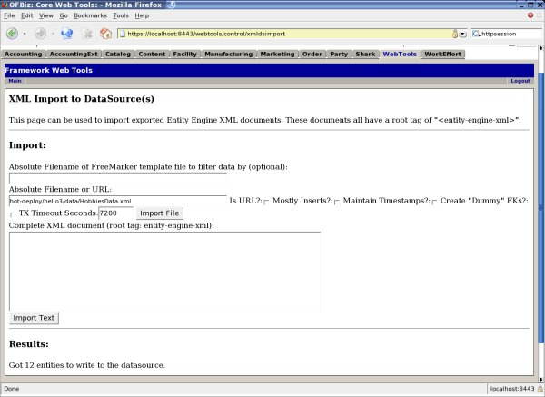
If your import failed, read the error message from your console.log file carefully. It is usually for one of these reasons:
- You used a value that was too long for a primary key. The OFbiz "id-ne" is a Java String, but for SQL it is a 20-char VARCHAR.
- You missed a required primary key field.
- You tried to insert a field which would violate foreign key integrity.
If you read the log carefully you can identify which value (GenericValue) OFBiz was trying to create and what the database error response was. It might also give you a somewhat cryptic foreign-key name to chase down the offending foreign key violation.
You may have also noticed a "XML Export" links on the "Main" page of Web Tools. These links can generate the entity XML files for you.
Now go to "Entity Maintenance" from the "Main" page, click on "All" next to HelloHobby, and you will see the hobbies that were just inserted:
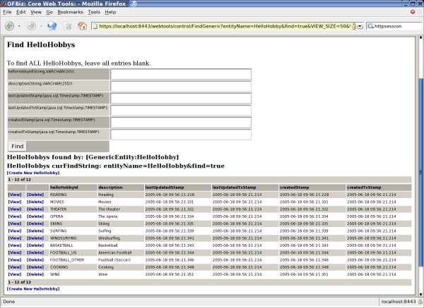
In addition to your fields and values, OFBiz also automatically creates timestamps of when your values were created and updated, for synchronizing data across multiple instances of OFBiz.
Finally, OFBiz can automatically install your seed data during the install process if you add this line to your ofbiz-component.xml file:
<entity-resource type="data" reader-name="seed" loader="main" location="data/HobbiesData.xml"/>
OFbiz actually lets you define whether your data is "seed", which means they are required for your app to run properly, and "demo", which means they are just for the demo.

Creating Business Logic
Now that we have the data model defined, we can of course write a simple application with a delegator to access the entities directly. Standard practice for OFBiz applications, however, calls for creating a separate layer for the business logic and for creating, updating, and removing entries. The delegator is used directly for looking up values, although more complex lookups are also coded as a service.
Creating services is a two step process. First, you define the service generically in an XML file, which tells the OFBiz service engine what parameters your service takes and where to find it (class and method or location of a script.) Then, you implement the service in Java, the OFBiz minilang, or another scripting language.
Service definitions are usually inside a servicedef/ directory in your application and consists of one or more services.xml files. Here is our services.xml file:
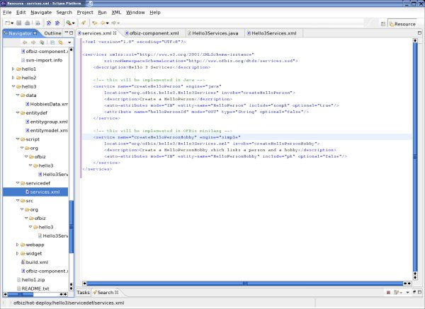
Notice how our services.xml references the entities they work with directly with the <auto-attributes> tag, rather than specifying them outright. This saves you time and makes your application easier to maintain.
You would also need to reference the service resource in your ofbiz-component.xml as well. In addition, you must create <classpath> directives in ofbiz-component.xml to tell it where to load up the apps. This is what our ofbiz-component file looks like, after adding the classpaths, entities definitions, service definitions, and seed data:
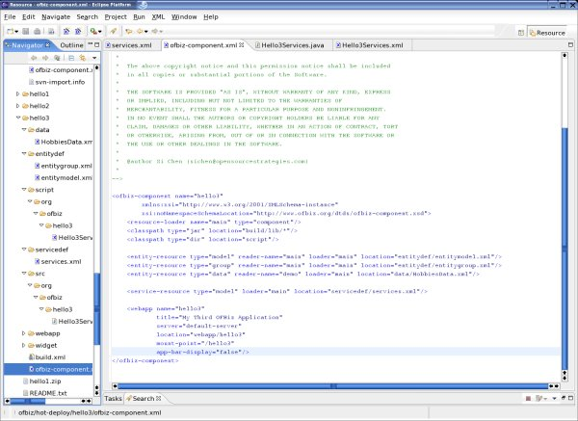
Now it looks like ofbiz-component.xml for other OFBiz components, doesn't it?
Now to create the services. A Java service goes inside a src/ directory in your application and is written in a standard fashion: A public class with public static methods which take two parameters, a DispatchContext for getting objects like delegators, dispatchers, locale, and security, and a Map called context which are your input parameters and returns a map of results:
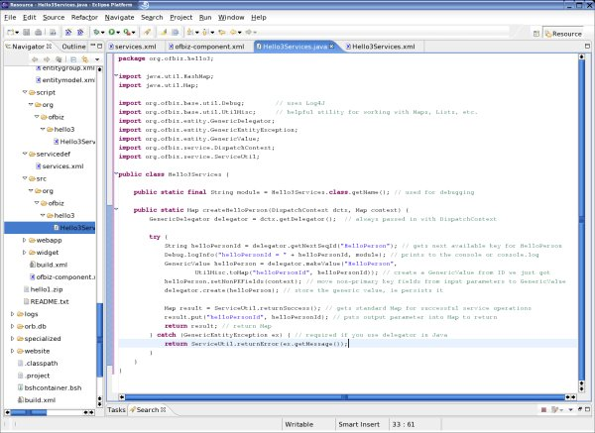
Java services will also need to be compiled, with knowledge of the proper classpaths for other OFBiz apps. This involves using ant and a build.xml build script, which you can usually copy over from another application. It is a standard file in all OFBiz applications and framework components and quite lengthy, so I won't include it here.
When you are done writing your service and creating the build.xml script, you can build your Java services like this:
sichen@linux:~/eclipse/workspace/ofbiz/hot-deploy/hello3> ant
Buildfile: build.xml

init:

clean-lib:
[delete] Deleting directory /home/sichen/eclipse/workspace/ofbiz/hot-deploy/hello3/build/lib

prepare:
[mkdir] Created dir: /home/sichen/eclipse/workspace/ofbiz/hot-deploy/hello3/build/classes
[mkdir] Created dir: /home/sichen/eclipse/workspace/ofbiz/hot-deploy/hello3/build/lib

classpath:

classes:
[javac] Compiling 1 source file to /home/sichen/eclipse/workspace/ofbiz/hot-deploy/hello3/build/classes

jar:
[jar] Building jar: /home/sichen/eclipse/workspace/ofbiz/hot-deploy/hello3/build/lib/ofbiz-party.jar

BUILD SUCCESSFUL

Total time: 2 seconds
The build process basically took all your files in the src/ directory, compiled them, and put them into the build/lib directory.
Minilang is much simpler by comparison. The simple minilang service goes inside a script/ directory and is an XML file with directives. Because it is designed especially for common OFBiz application tasks, such as lookup data, store data, check premissions, and work with existing entities and services, it can make those tasks very easy:
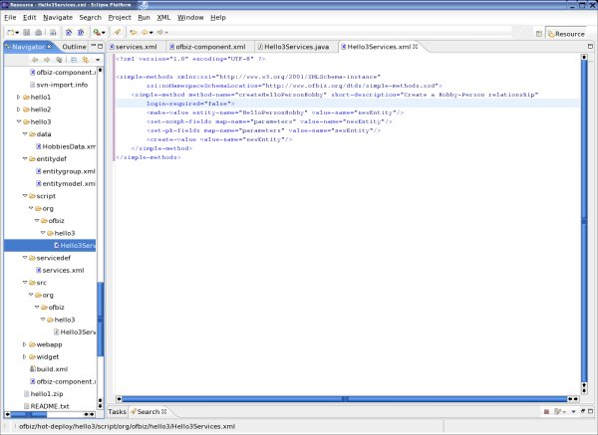
Finally, to test it, re-start OFBiz to load all the new definitions in ofbiz-component.xml and services.xml. Then, open a beanshell window and test our service (Note: you should first download bshcontainer.bsh and put it in your ofbiz/ directory):
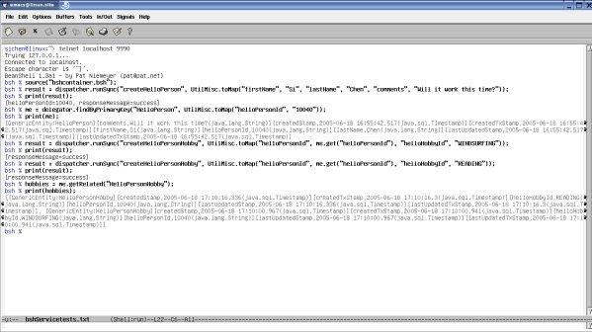
Here, beanshell called the service dispatcher to run the service, and they were successful, so the right values are created. (Ok, in reality it took about six tries, but I won't bore you with the details.)
So now you have created the data model and services for them. The next step is to put them into the web application.

Creating the Web Application
Our web application will show a guest list of people who have visited the site and allow you to add your name to this list. You can also click on a person and add a hobby for that person from a list of available hobbies. We will build our application with the OFBiz screen-widgets and form-widgets to show you how these tools can build web applications directly from the fields of your data model entities and business logic services, without repetitive HTML code or Java code.
First, let us create two new screens in the screen-widget for our page of people and hobbies. Within each page, there are two forms, one form showing the list of people or hobbies, the other for adding another entry:
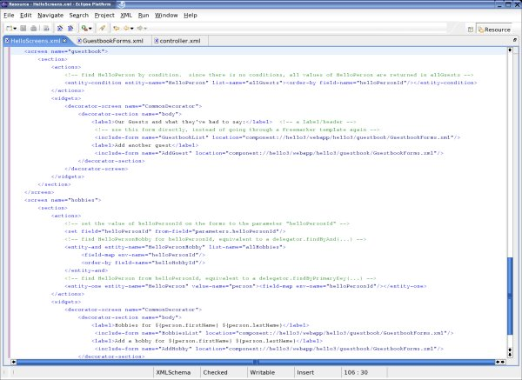
Notice here that I am not using a Freemarker page (.ftl) template but instead am calling a form directly. Also, instead of using a .bsh script to look up data from entities, I am using directives such as <entity-and> and <entity-one> in the <actions> part of the screen. Both tools were designed to streamline the process of creating standard forms by reducing the need for display code (such as FTL/HTML) or scripts to find data or call services.
The next step is to define the input elements using the OFBiz form-widget:
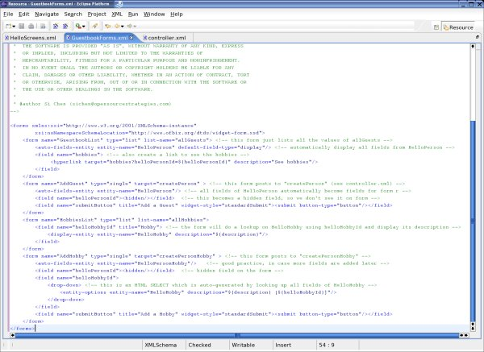
The form-widget allows you to define forms based on fields of an entity or parameters of a service, and you can define forms which display a single entity or show a list of data or submit single or multiple values to the controller. You can specify pull down menus and look up related entities, hide fields, place hyperlinks, even calendar buttons and other widgets. Finally, forms can automatically adjust when their related entity or service changes.
I will also take care of adding new requests and views to the controller and a link to the guest book in the header. I've already shown how to do this in the previous tutorial and won't repeat it here. What is different, though, is I need to add the requests to create person and add hobbies to the controller:
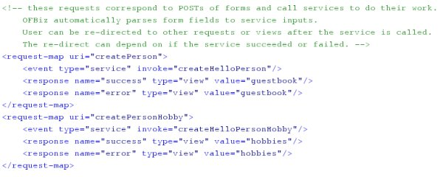
These requests go directly to the services we've just defined. There is no need to create your own event servlet method to parse form parameters--OFBiz will do that for you automatically.
Now our application is done. Here is the guestbook page:
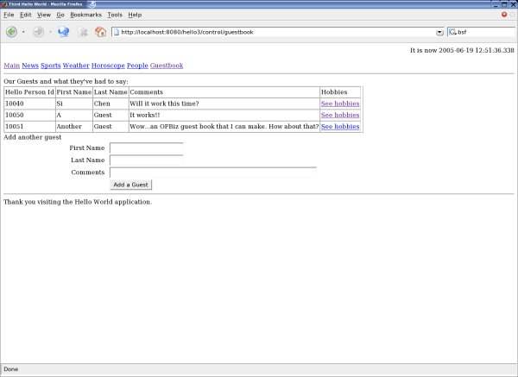
and here is the hobbies page:
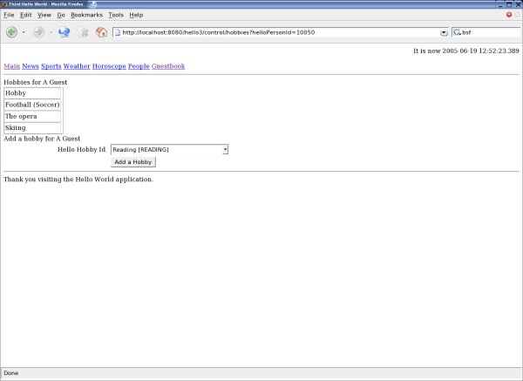
The look and feel for the site can be significantly improved with the use of stylesheets. All OFBiz display tools, including Freemarker, form-widget, and screen-widget, support stylesheets.
Click to see the list of files for this application.

Maintaining your Application
Finally, a word about maintenance. After your code is written, you've actually just started. Studies show that 50% or more of an application's lifetime costs is long-term maintenance, such as handling user requests for changes or new features. With OFBiz, because the tools from user interface to business logic to data model work together, such changes can be very easy.
For example, suppose that you need to add a new field, "middleName", to your entity for person. All you have to do is add one line for it in your data model, like this:
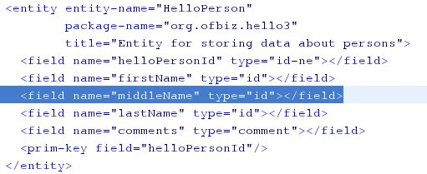
OFBiz will do the rest for you. When you re-start OFBiz, you will see these lines roll across your screen:
17149 (main) [ DatabaseUtil.java:277:WARN ] Entity "HelloPerson" has 9 fields but table "OFBIZ.HELLO_PERSON" has 8 columns.
17150 (main) [ DatabaseUtil.java:289:WARN ] Field "middleName" of entity "HelloPerson" is missing its corresponding column "MIDDLE_NAME"
17151 (main) [ DatabaseUtil.java:1477:INFO ] [addColumn] sql=ALTER TABLE OFBIZ.HELLO_PERSON ADD MIDDLE_NAME VARCHAR(20)
18013 (main) [ DatabaseUtil.java:302:INFO ] Added column "MIDDLE_NAME" to table "OFBIZ.HELLO_PERSO
It already modified the database for you. Then, when you go to your application again, you will see that the forms have all changed too:
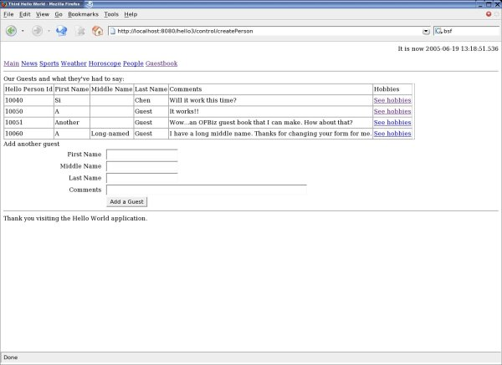
When you submit your request, the service will run with the new field as well.
In other words, with one change in the data model, OFBiz has changed your database, your business logic services, form handling in the controller, and your user interface forms. This is the advantage of using the OFBiz tools for data modeling, business logic, and front-end design as a package. Their mutually aware interactions will not only speed up your development cycle but also significantly reduce your application's long-term maintenance costs.

Conclusions
Now you have built your first complete web application with OFBiz. You have seen first hand how the data modeling, business logic, and user interface tools work together to create an efficient framework for building and, perhaps more importantly, maintaining such applications.

OFBiz Eclipse - Debugging OFBiz

Preliminary Setup
If you have not already done so, import ofbiz into Eclipse with File > Import > "Existing Projects into Workspace". Note that the name of the project and its name in .project file must be the same.
The next step is to enable Eclipse to work on your .xml, .ftl, and .bsh files. First, install an XML editor such as the free XMLBuddy. Then, install the Freemarker Eclipse plug-in. Finally, go to Windows > Preferences > General > Editors > File Associations and add "*.bsh" and associate it with the Scrapbook editor.
You should also set your editors to be compatible with OFBiz coding convention. For Java files, go to Windows > Preferences > Java > Code Style > Formatter and create a new profile. Set your tabs to 4 spaces. Similarly, go to Windows > Preferences > XMLBuddy > Formatting and click on "Use spaces for tabs", or configure your XMLZ editor likewise.
You can toggle between code view and directory/file view by switching Eclipse from "Java Perspective" our "Java Browsing" and "Resources". If you have new components, add them to your .classpath file as a <classpathentry> so they can be viewed in the Java views.

Java Debugging with Eclipse
Click on the green bug icon on the Eclipse toolbar, or click on "Run" on the top menu bar, then "Debug". Then click on "Java Application", click on "New" to create a new configuration for OFBIZ.
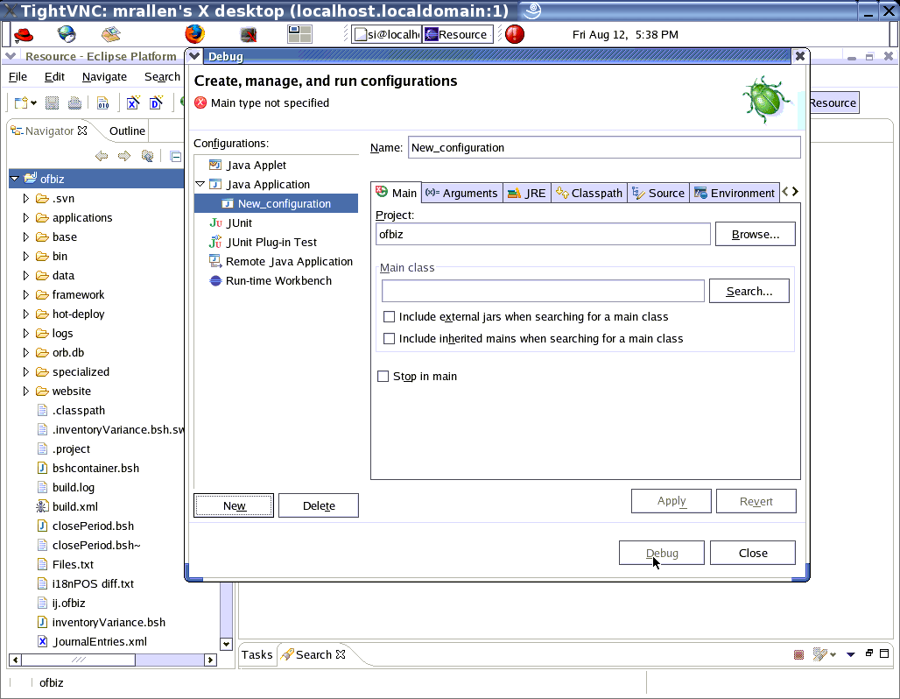

Type in the start class name. Then click "Apply" and "Close".
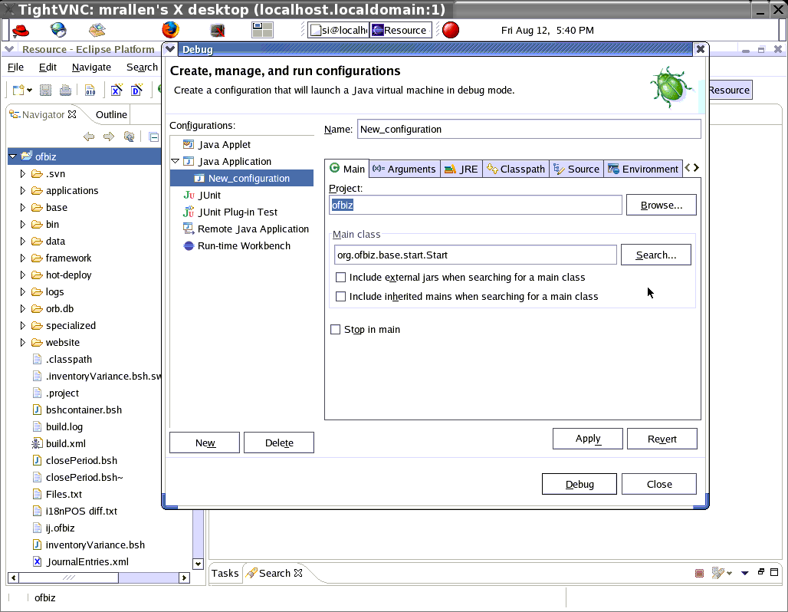

Now you need to fix all of these problems Eclipse has found (see box at the bottom):
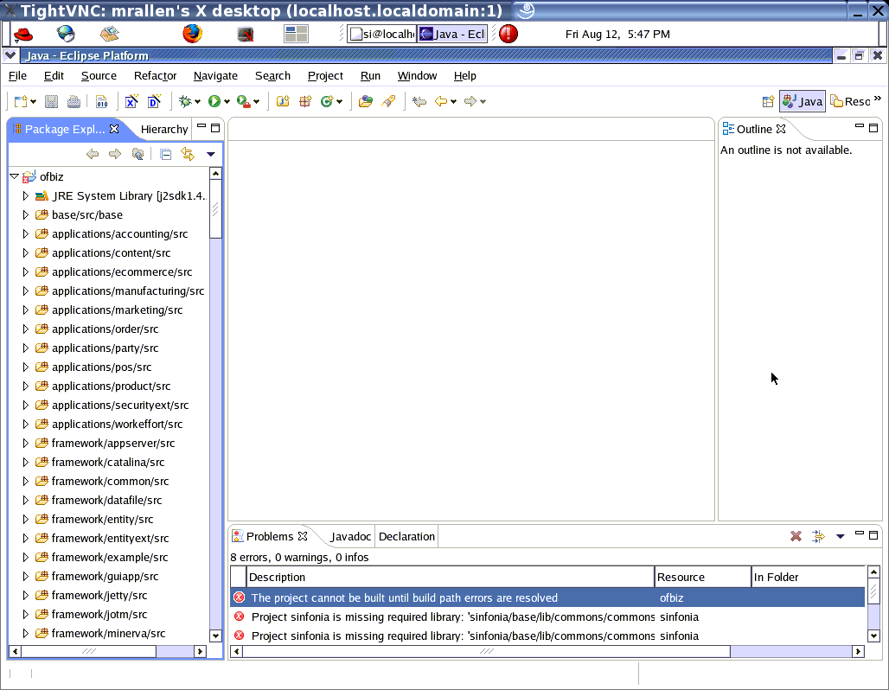

The most common problem involves missing class and libraries from the build classpath, which you add with Project > Properties > Java Build Path:
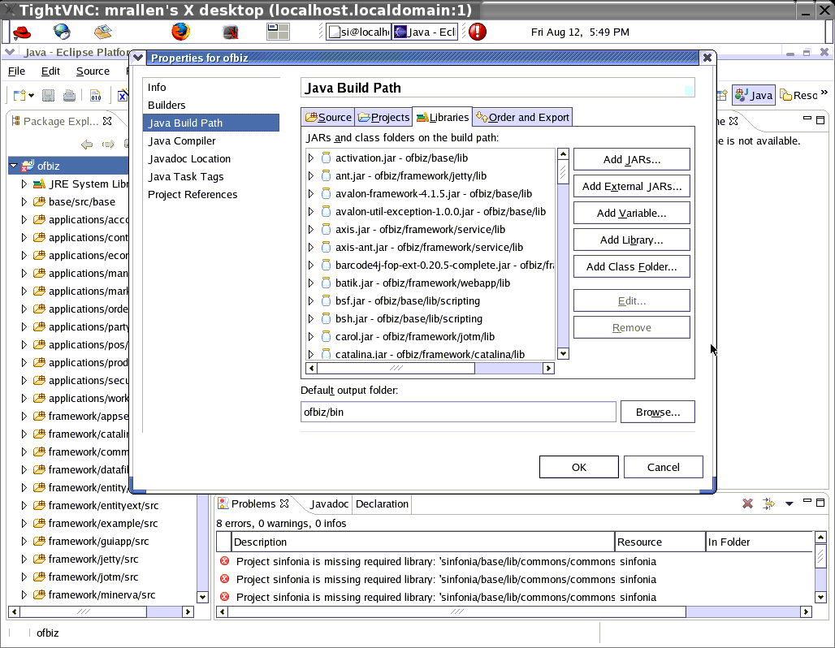
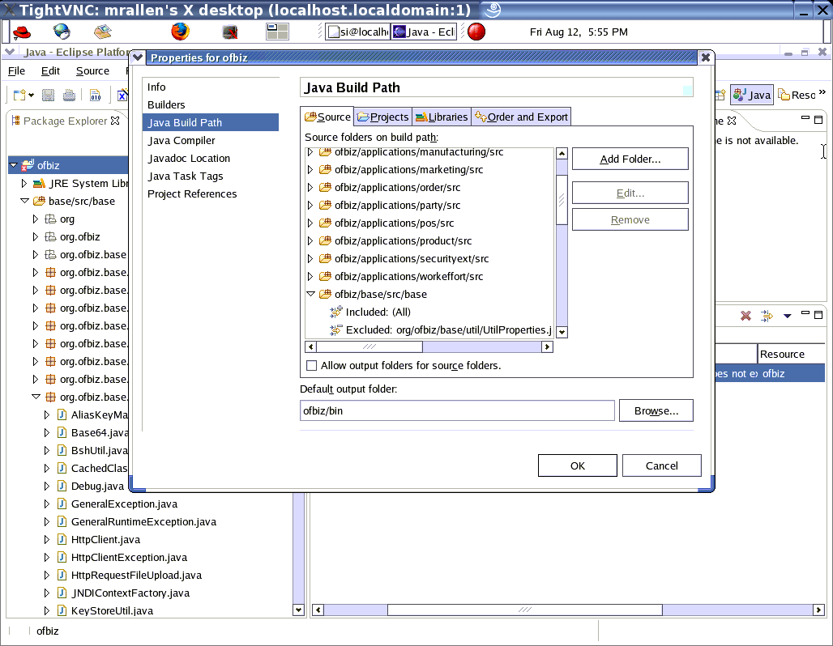

You may also have to exclude third party source file by editing .classpath in eclipse/workspace/ofbiz and adding <classpathentry excluding="org/ofbiz/securityext/thirdparty/truition/*" kind="src" path="applications/securityext/src"/>
You have to add the OFBiz base/config directory to your class path. Use Project > Properties > Java Build Path > Libraries > [Add Class Folder] and add the base/config directory:
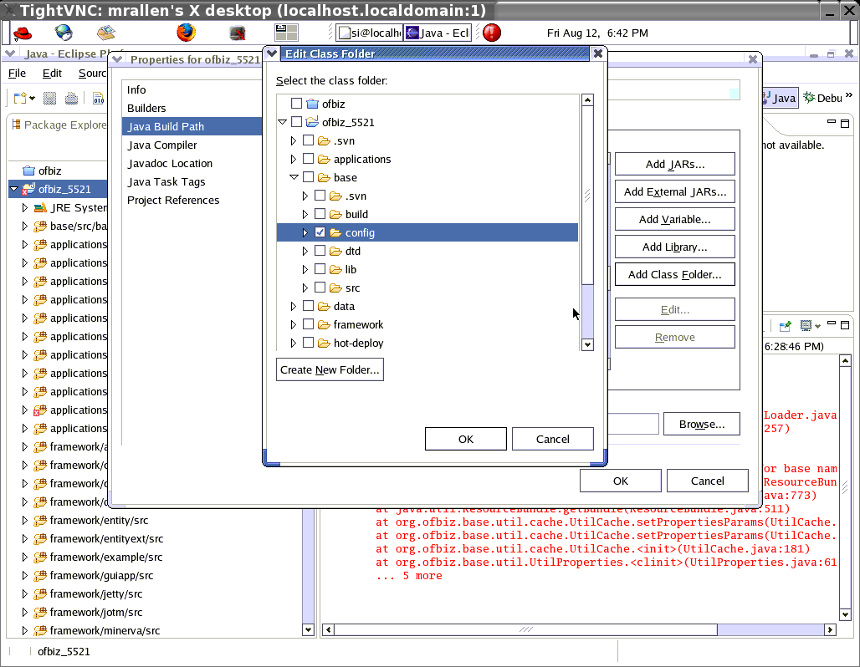

This is what it looks like with base/config added:
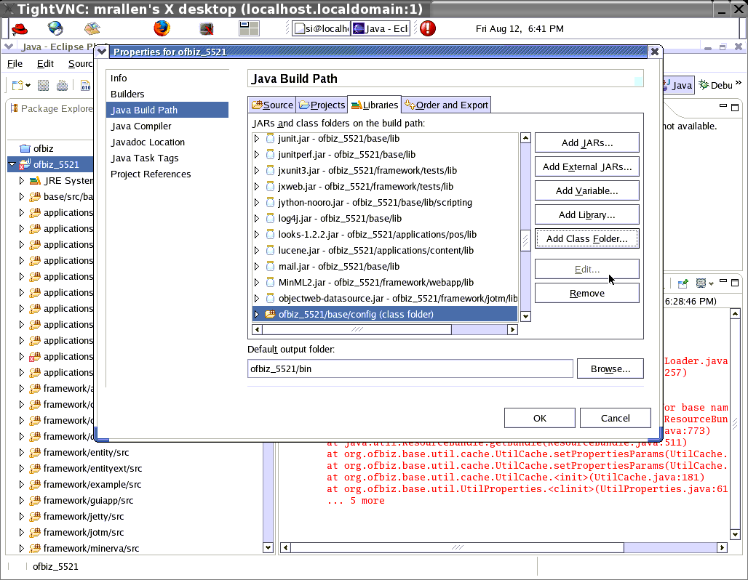

Now you need to add your JDBC library JARs to the Eclipse classpath. Use Project > Properties > Java Build Path > Libraries > [Add External JARs] and select the JARs from ofbiz/framework/entity/lib/jdbc. Here, we add the JARs for the embedded derby database:
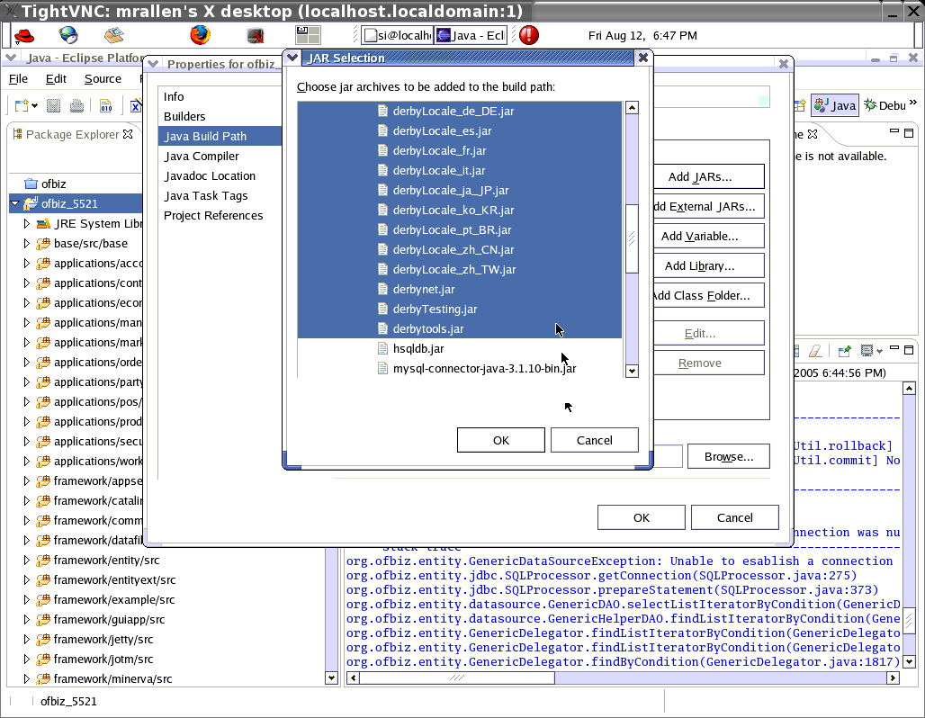

You also need to add the JARs for Tomcat from ofbiz/framework/catalina/lib. Note: Current versions of OFBiz have more JARs than on this screenshot. Add them all.
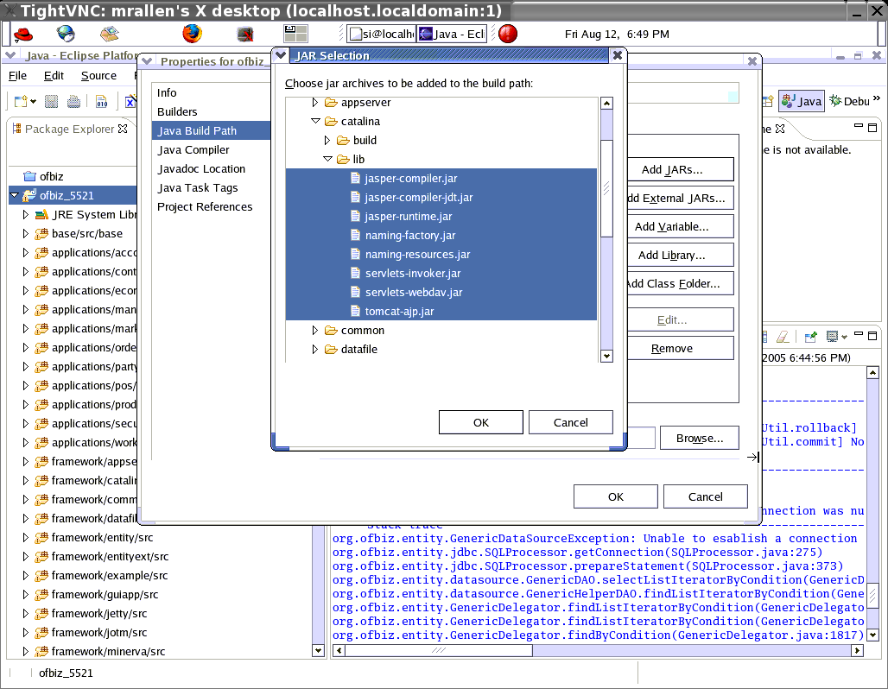

You may need to do this for compiling JSP's:
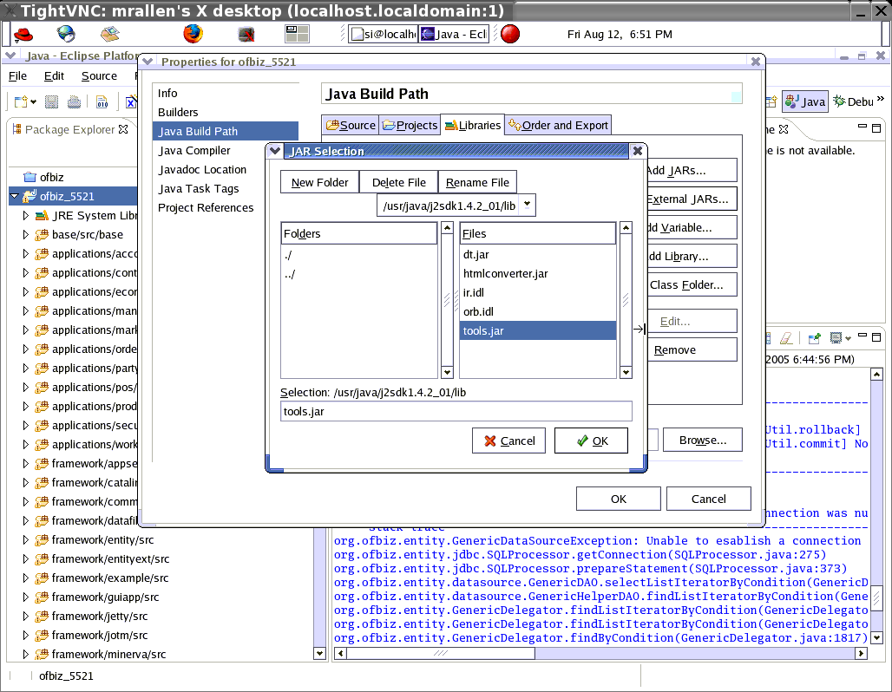

Now edit base/config/ofbiz-containers.xml and comment out both the rmi-dispatcher and the rmi-print-server (not shown here):
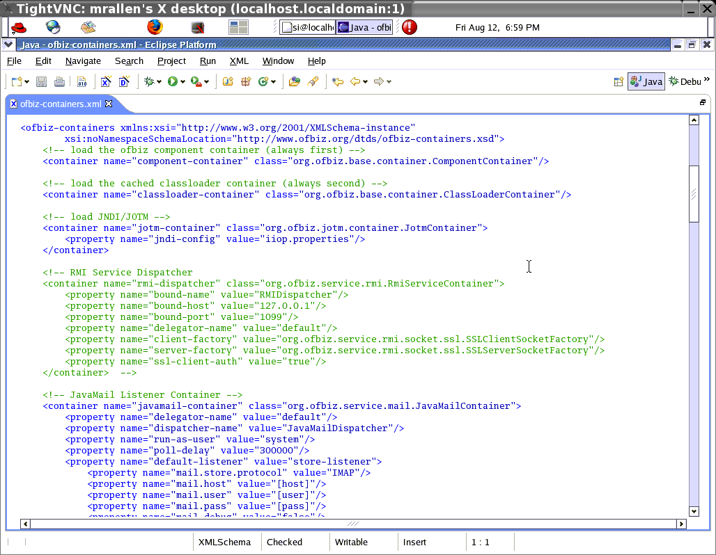

Now OFBiz should run in Eclipse. Here are some screenshots of debugging OFBiz with Eclipse:
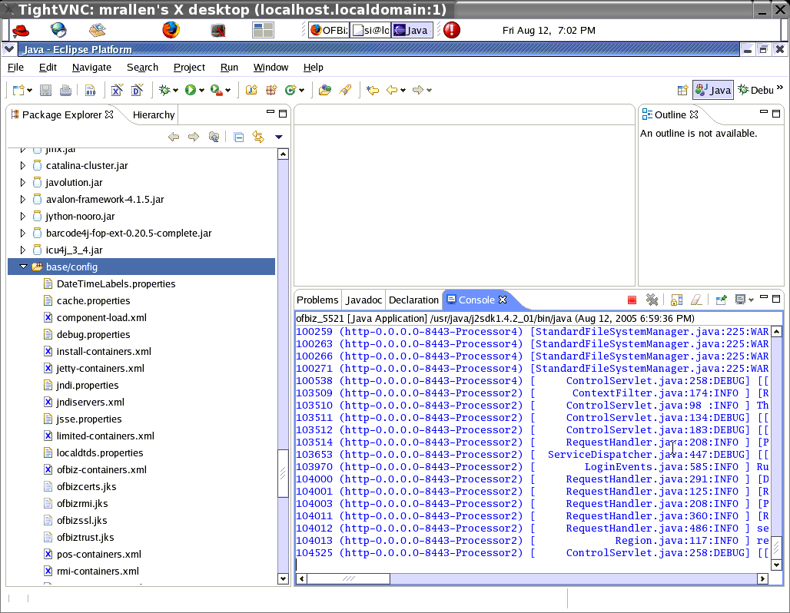
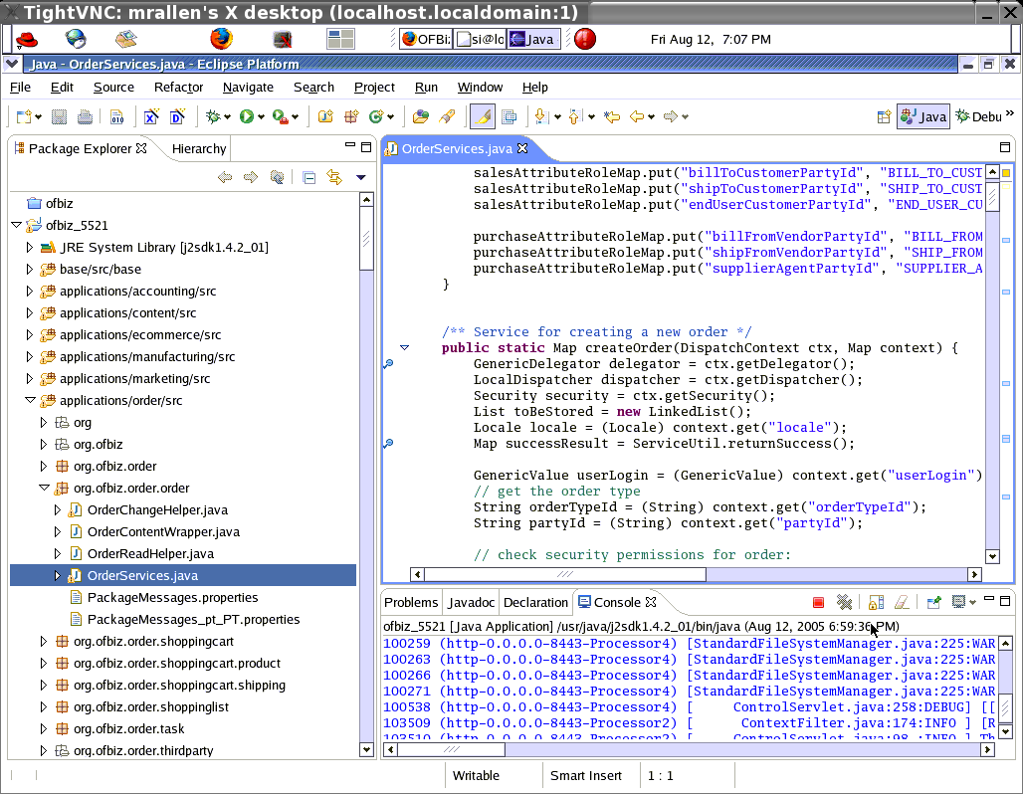
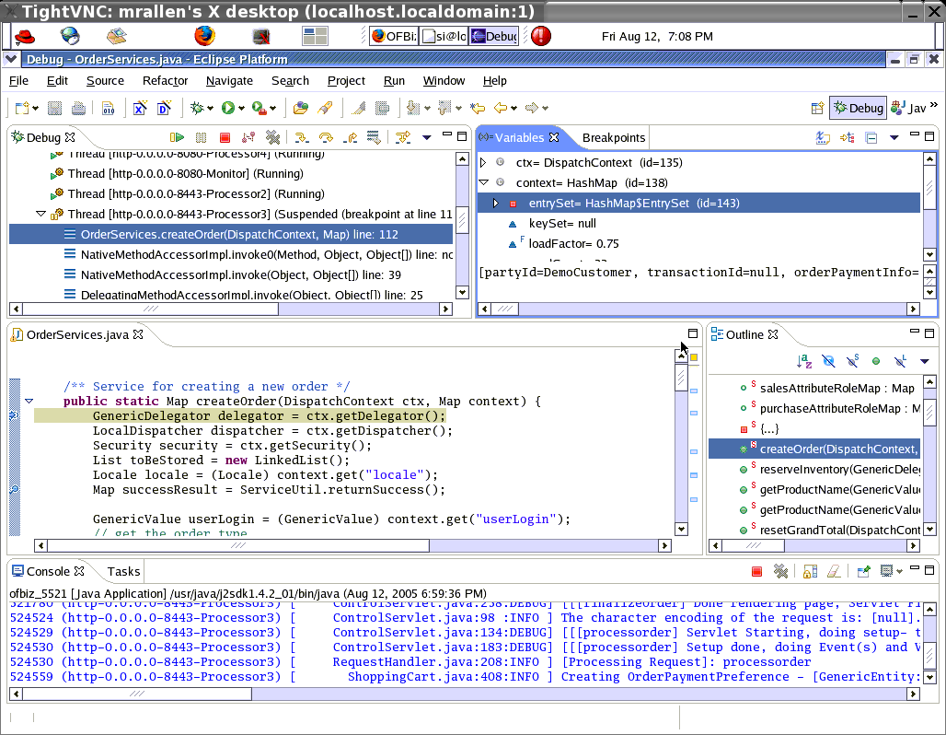
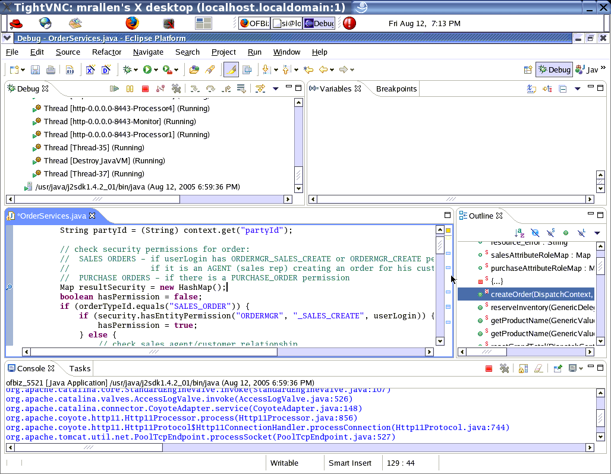

Miscellaneous Notes
When you update your code with an $ svn update, Eclipse does not know that new files are available. Thus, you may start to have build problems. Do a File > Refresh from within Eclipse to bring it up to date.
Make sure that ofbiz/ is not in your Project > Properties > Java Build Path > Source. Only ofbiz/applications/.., ofbiz/framework/.., ofbiz/hot-deploy/.. directories should be there, or you'll get an error like:

六、ofbiz相关默认口令和密码
https://127.0.0.1:8443/webtools/control/main
admin ofbiz

更新代码后运行 ant run-install

七、oracle数据库

八、bsh调试方法

