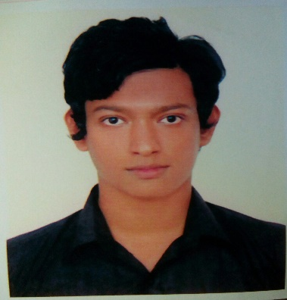

***Résumé of***

**Mahbubul Alam**

Address : 20 sukrabad, Dhaka-1207

Cell : +8801969-181699

E-Mail : mahbubrahman5676@gmail.com

**Career Objectives:**

Seeking a challenging position in an organization where I will be able to exploit and further enhance communication, documentation and human interaction skills. To work in an environment where there is an opportunity of self-assessment and self-improvement in both individual and group based work that will ultimately lead to the future development of the common people.

**Personal Details:**

Name : Mahbubul Alam

Nick Name : Mahbub

Father’s Name : Md.Ruhul Amin

Father’s Occupation : Business

Mother’s Name : Selina Akther

Mother’s Occupation : Teacher

Date of Birth : 28/06/1997

Permanent Address : Vill:Gazipur, Post: Chamohani, Upazilla: Madhabpur, District: Habigonj

Height : 5.08”

Marital Status : Single.

Sex : Male.

Nationality : Bangladeshi.

Religion : Islam.

Blood Group : A (+)

**Academic Credentials:**

**Bachelor of Science in Computer Science & Engineering (CSE)**  
 Name of the University : Daffodil International University

Subject : Computer Science & Engineering

Semester : 7 Semester Running

**Higher Secondary School Certificate (H.S.C)**

Name of the Institute : Shahjalal City College

Result : 4.20 Out of 5.00

Goup : Science

Board : Sylhet

Year : 2014

**Secondary School Certificate (S.S.C)**

Name of the Institute : Gobindapur Govt High School

Result : 4.94 Out of 5.00

Goup : Science

Board : Sylhet

Year : 20012

**Personal Attributes:**

Good interpersonal and communication skill. Quick learner as well as have an ability to resolve the problem. Have the ability to take a quick decision and good motivation skill, have the ability of leadership as well as handle the workload in the extreme Condition.

**Job Interest:**

Interested to join as an Web App Programmer

**Extra Credentials:**

**Computer Proficiency:**

* Applied skill at- MS Word (MS Office, MS Excel, MS PowerPoint), Internet Browsing & E-mailing.

**Lingual Competency:**

**Bengali**- Native,**English**- Spoken- Normal.

**Communication Skill:**

* Good interpersonal skill.
* Face-to-face negotiation.

**Hobby:**

* Research

**Favorite pass time:**

* Hang out with friends and eating delicious food.

**References:**

|  |  |
| --- | --- |
| **1. Prof. Dr. Syed Akhter Hossain**  Deft. Head at  **Daffodil International University**  Contact: +8801817-382645  E-Mail: aktarhossain@daffodilvarsity.edu.bd | **2. Ms. Farah Sharmin**  Senior Lecturer at  **Daffodil International University**  Contact:+88 01712-198775  E-Mail: farah@daffodilvarsity.edu.bd |

(**Mahbubul Alam**)

Date: 16/06/2017