目标："C:\Program Files (x86)\Windows Kits\10\Debuggers\x86\windbg.exe"

起始位置："C:\Program Files (x86)\Windows Kits\10\Debuggers\"

步骤：<https://bbs.pediy.com/thread-230083.htm>

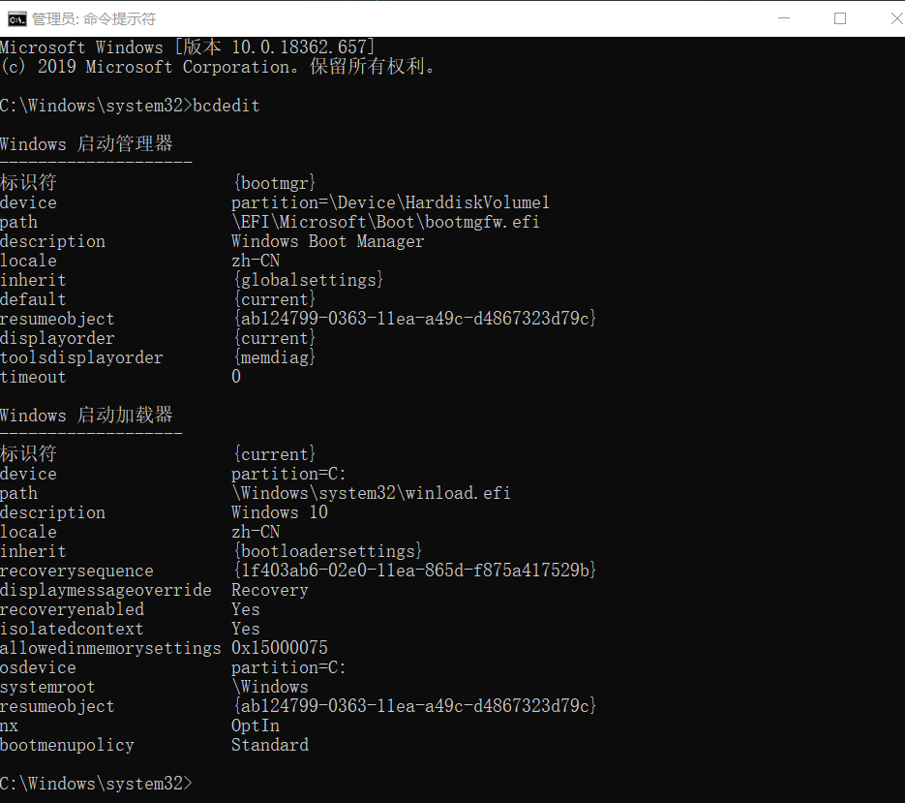

<https://bbs.pediy.com/thread-230083.htm>

<https://www.cnblogs.com/endenvor/p/8926688.html>