**Clear Bank  
Business Requirement Document**

Version 1.0

Drafted by P.Muralikkannan

27th, Nov 2016

Copyright Information

This document is the exclusive property of ClearBank. The recipient agrees that they may not copy, transmit, use or disclose the confidential and proprietary information in this document by any means without the expressed and written consent of ClearBank. By accepting a copy, the recipient agrees to adhere to these conditions to the confidentiality of ClearBank practices, procedures and to use these documents solely for responding to ClearBank methodology.

Revision History

|  |  |  |  |
| --- | --- | --- | --- |
| **Date** | **Version** | **Description** | **Author** |
| 27/11/2016 | 1.0 | Draft version of the document | Muralikkannan |
|  |  |  |  |
|  |  |  |  |
|  |  |  |  |
|  |  |  |  |

References

|  |  |
| --- | --- |
| **No** | **Description** |
|  |  |
|  |  |
|  |  |
|  |  |

Contents

Copyright Information 2

Revision History 2

References 2

Purpose of this document 4

Scope of this document 5

Definitions, Abbreviation and Acronym 5

1 Introduction 6

2 User Profiles 6

3 User Interface 6

4 Landing Screen 6

4.1 First Time Installation 6

4.2 Subsistent Access 7

4.3 Screen Elements 7

4.4 Screen Elements - Inputs 7

4.5 Spanish Text 8

5 Login and Registration 8

5.1 Provider Login 8

5.2 Login Screen Elements 9

5.3 PL – Inputs 9

5.4 PL – Request & Response 10

5.5 PL - Spanish Text 10

5.6 Provider Forgot Password - Inputs 10

5.7 PFP - Screen Elements 11

5.8 PFP – Request & Response 11

5.9 PFP - Spanish Text 12

5.10 Provider Registration 12

5.11 PR - Screen Elements 13

5.12 PR – Inputs 16

5.13 PR – Request & Response 17

5.14 PR - Spanish Text 18

5.15 Category Section – Screen Elements 20

5.16 CS – Inputs 20

5.17 CS – Request & Response 21

5.18 Service Cities – Screen Elements 22

5.19 SC – Inputs 22

5.20 SC – Request & Response 23

5.21 Provider Profile Update 23

5.22 First Time Login - Consumer Login 23

5.23 Consumer Login - Inputs 24

5.24 CL – Request & Response 24

5.25 CL - Screen Elements 25

5.26 CL - Spanish Text 26

5.27 Guest User – Registration 26

5.28 GUR – Request & Response 26

5.29 GUR – Screen Elements 27

5.30 Consumer Forgot Password 28

5.31 CFP - Inputs 28

5.32 CFP - Spanish Text 28

5.33 CFW - Screen Elements 28

5.34 Change Password 29

5.35 CP – Request & Response 29

5.36 CP – Screen Elements 30

5.37 GU Profile Update 31

5.38 GU Profile Update – Screen Elements 32

5.39 GU Profile Update - Spanish Text 33

5.40 GU Profile Update – Request & Response 33

Purpose of this document

The purpose of the document is to outline the ideas and flow for a ClearBank Portal and Mobile Application. Collect and analyze all assorted ideas that have come up to define the system, its requirements with respect to consumers. Also, we shall predict and sort out how we hope this product will be used in order to gain a better understanding of the project, outline concepts that may be developed later, and document ideas that are being considered, but may be discarded as the product develops.

Scope of this document

The scope of the document is to give detailed overview on technical and functionality of all services for ClearBank Portal and Mobile Application.

Definitions, Abbreviation and Acronym

The terms in use in the document are explained below

|  |  |
| --- | --- |
| **Acronym** | **Description** |
| ClearBank | CB |
| Mobile Application | Mobile App |
| UI | User Interface |
| AI | Admin Interface |
| BOA | Back Office Administrator |
| Cons | Consumer |
|  |  |
|  |  |
|  |  |
|  |  |
|  |  |
|  |  |

# 1 Introduction

This document is created as a part of detailing the Mobile App functionality. Technical overview will give the performance and better understanding of the Mobile App creation.

# 2 User Profiles

There are two types of users in the portal

1. **Consumer:** Anyone who have downloaded Mobile App and installed in their respective mobile device can use the application.
2. **Provider:** Anyone who have downloaded Mobile App and installed in their respective mobile device can use the application with a login.

# 3 User Interface

1. **Consumer**: Users are able to login the application, view listing, send message, make a call, review provider, access Inbox, update information and search listing.
2. **Provider**: Users are able to register and login the application, access Inbox, reply message, make a call and edit listing.
3. **Language**: All users can browse the application in two versions **English** and **Spanish**.

Both interfaces are detailed in latter sections.

# 4 Landing Screen

## 4.1 First Time Installation

**Workflow 1.1 – First time installation – Landing screen**

First Time Installation

Language Selection

Spanish

English

English Version

Spanish Version

Consumer/Provider

Provider   
Login Screen

Provider

Consumer

Listing screen

## 4.2 Subsistent Access

1. **Consumer**: Login will be saved and user will be allowed to directly view the listing.
2. **Provider**: Login will be saved and user will be allowed to directly view their Inbox.
3. **Language**: Language selection from the landing screen will be saved and influenced in all the screens until user manually updates the language.

## 4.3 Screen Elements

**Figure 1 – Landing screen**

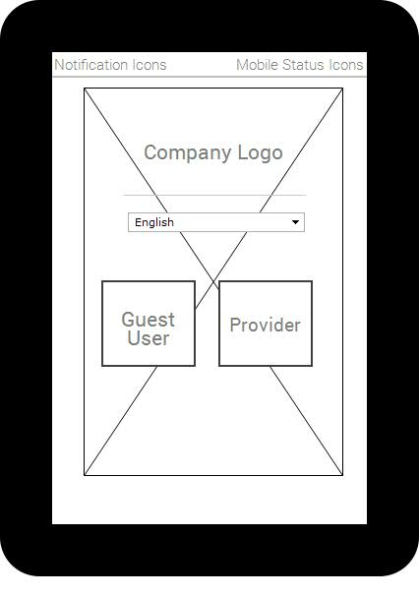

## 4.4 Screen Elements - Inputs

* On selection of language (English/Spanish), the screen will update to Spanish. The language preference will be stored in Service for the User until he manually changes it.
* Default language is English
* On clicking on Provider, user will be redirected to Provider login screen.
* On clicking on Guest User, user will be redirected Listing screen.
* **Mandatory :** Language Selection, Guest User/Service Provider

## 4.5 Spanish Text

Guest User - Usuario Invitado  
Service Provider - Proveedor de Servicios

# 5 Login and Registration

The user as to register for login process. The complete workflow screens for the login process.

## 5.1 Provider Login

The login screen consists of email and password entry for application login, New Registration link and Forgot password link.

**Workflow 1.2 – First time installation – Provider Login**

Provider Login

New Provider

Forgot Pwd

Provider Registration

Forgot Password Screen

Successful

Inbox

## 5.2 Login Screen Elements

**Figure 2 – Provider Login**

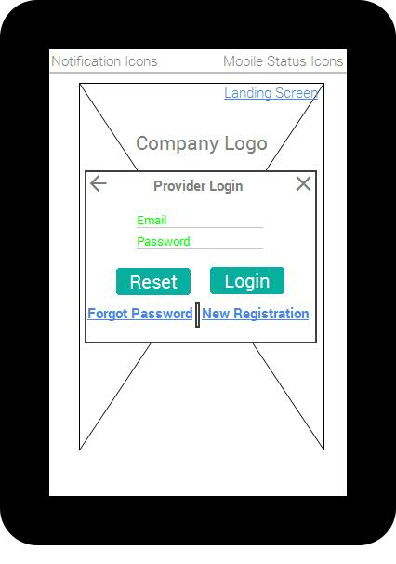

## 5.3 PL – Inputs

* Existing Provider can login the application, Provider can directly view the Inbox screen if he has already logged into the application (credentials stored)
* **Forgot Password link** will redirect the user to **Provider Forgot Password screen**.
* **New Registration link** will redirect the user to **Provider Registration screen**.
* **Validation :** Email (Email validation), Password (alphanumeric – Size: 8)
* **Mandatory :** Email, Password

## 5.4 PL – Request & Response

**Request:**

1. Email
2. Password
3. **Type** – Provider

**Response:**

1. Success / Error

**Client Validation:**

1. Email – Email Validation
2. Password - Alphanumeric : Size > 8

**Note:** Language Independent

## 5.5 PL - Spanish Text

Service Provider - Proveedor de Servicios  
Email - Correo electrónico  
Password - Contraseña  
Sign in - Registrarse  
Forgot password - Need to confirm  
New Registration - Nuevo Registro

## 5.6 Provider Forgot Password - Inputs

* Forgot password functionality will help provider to retrieve his password through is email.
* Email field is **prepopulated** and **read-only**, Provider will receive his password for the login and automatically the screen redirects to login screen.
* The password is **not auto generated**, it is the password provided by Provider while login.
* **Back to Login link** will redirect to **Provider Login screen**

## 5.7 PFP - Screen Elements

**Figure 3 – Provider Forgot Password**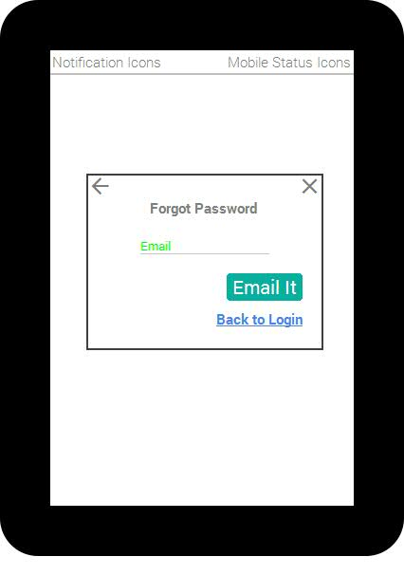

## 5.8 PFP – Request & Response

**Request:**

1. Email
2. **Type** – Provider

**Response:**

1. Provider Password emailed to Provider Email

**Note:** Language Independent

## 5.9 PFP - Spanish Text

Forgot password - Need to confirm  
Email - Correo electrónico  
Email it - Envíelo por correo electrónico  
Back to login - Atrás para iniciar sesión

## 5.10 Provider Registration

The provider registration screen consists of various information’s to be filled by provider for successful listing. The registration information to be filled by the provider is listed in **figure 4 & 5**.

**Workflow 1.3 – Provider Registration**

Provider Registration

Success

Welcome Email & Inform Verification Pending

Admin Verification

Verification in Progress

Success

Listing Verified Email & Service Listed

## 5.11 PR - Screen Elements

**Figure 4 – Provider Registration**

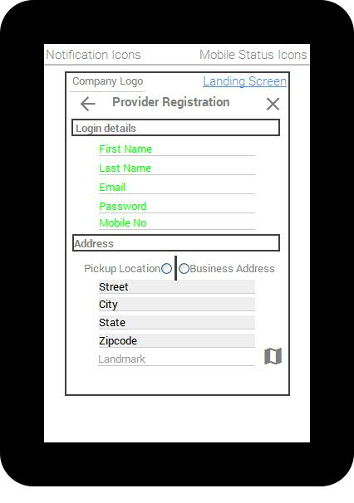

**Figure 5 – Provider Registration – Continuation**

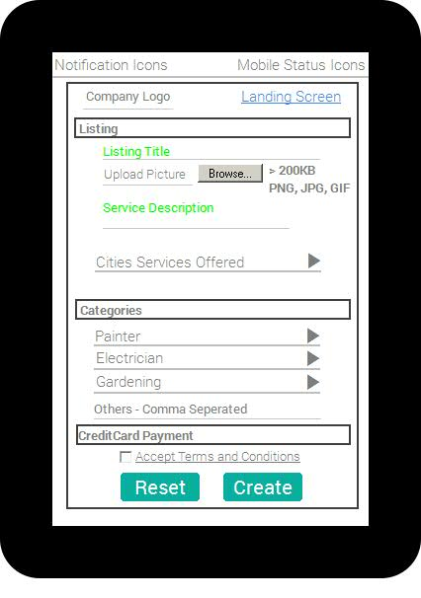

**Figure 6 – Provider Registration – Google Map**

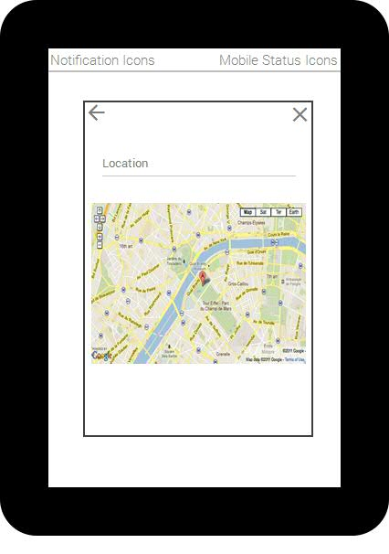

**Figure 7 – Provider Registration – Terms and Conditions**

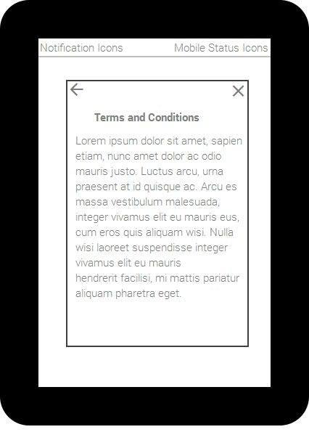

## 5.12 PR – Inputs

* **Login Details** Section all field are **mandatory**
* In **address section**, the Provider address will be prepopulated with Location services.  
  Provider has to select whether it is as **Pickup Location / Business Address**
* Provider can click on the **Google Map icon** right to Landmark field to select new address through Integrated Google map slide in.
* **Landmark field is optional**. All other fields in address section are **read only**.
* **Listing section**, **Mandatory Elements**: Listing Title, Service Description, Cities Services offered (covered in section 5.11, 5.12)
* Provider didn’t find his service listed in the **Category section**, he can add it in the **others textbox** as comma separated, will be saved to Service once Provider submits all his data.
* **Sub Categories** section (covered in section 5.9, 5.10)
* **Credit Card** section (will be covered in Sprint6)
* **Accept Terms and Condition** is Mandatory, validation should be done.
* Once Registration is completed, a **Welcome message** will be trigged to Provider Email.
* A **back office Admin** will approve the Provider Registration through Screen service in website.
* **Once the registration is approved**, the Provider will be listed
* Provider will be able to login the application and **access Inbox** **without admin approval**, but will not be listed.
* All the listing details such as Listing Title, Service Description, Category & Sub Category Manual listing will be translated manually through screen service in Website.

## 5.13 PR – Request & Response

**Request:**

1. Firstname
2. Lastname
3. Email - **Note :** Immediately Validated for availability
4. Password
5. Mobile
6. Pickup Address / Business Address
7. Street
8. City
9. State
10. Zipcode
11. Landmark
12. ListingTitle
13. Picture ( > 200KB) – **Format** - JPG / Gif / PNG
14. Service Description
15. Cities Offered – [Cities Array]
16. Categories - Main Categories with Sub Categories list
17. Type : Individual
18. Language

**Response:**

1. Record is created in service as individual
2. The Registration details are manipulated is Spanish and Vice versa
3. The Registration will have an approval status as “N”
4. Success message emailed to Provider Email

**Client Validation:**

1. Email - **Email Validation**
2. Password – **Alpha Numeric : < 8 Chars**
3. Mobile - **Numbers**
4. Pickup Address / Business Address – Business Address is preselected
5. Picture - (**Size > 200KB**) & **Format** - JPG / Gif / PNG
6. Service Description – **(< 50 Chars**)
7. Cities Offered – [Cities Array] – **At least one city to be selected**
8. Categories - Main Categories with Sub Categories list - **At least one Main Category** to be selected with **one Sub Category.** If the **main category** is entered in **others text** than **sub category** is not required**.**

## 5.14 PR - Spanish Text

Provider Registration - Registro de Proveedores  
Login Details - Entrar en detalles  
First Name - Nombre de pila  
Last Name - Apellido  
Email - Correo electrónico  
Password - Contraseña  
Mobile Number - Número de celular  
Address - Dirección  
Pickup Location - Lugar de recogida  
Business Address - Dirección de negocios  
Street - Calle  
City - Ciudad  
State - Estado  
Zipcode - Código postal  
Landmark - Punto de referencia  
Listing - Ficha  
Listing Title - Título del anuncio  
Upload Picture - Subir foto  
Browse - Navegar  
Service Description - Descripción del servicio  
Cities Services offered - Ciudades Servicios ofrecidos  
Categories - Categorías  
Credit Card Payment - Pago con tarjeta de crédito  
Accept Terms and Conditions - Aceptar terminos y condiciones  
Reset - Reiniciar  
Create - crear  
Other Service - Comma separated : Otro uso - separados por comas

**Categories**

Carpentry - Carpintería  
Cashier - Cajero  
Child Care - Cuidado de Niños  
Construction / Remodeling - Construcción / Remodelación  
Cook - Cocinar  
Custodian / Janitor - Custodio / Janitor  
Delivery service - Servicio de Envios  
Electrical - Eléctrico  
Events / Convention / Conference - Eventos / Convención / Conferencia  
Gardening / Landscaping - Jardinería / Paisaje  
Home & Office cleaning - Hogary Oficina de limpieza  
Junk removal / Tree removal - Eliminación de basura / Eliminación de árboles  
Loading / Unloading - Cargando / Descarga  
Packing / Unpacking - Embalaje / Desembalaje  
Painting - Pintor  
Plumbing - Plomería  
Waitress / Bartender - Mesera / Bartender  
Warehousing services - Servicios de almacenamiento  
Computer / Phone repair - Informática / reparación Teléfono  
Pet sitting / Dog walking - Cuidado de mascotas / perro caminando  
Adult / Senior care - Adultos / Senior Care  
Tutors / Trainers - Profesores / Entrenadores  
Moving / Delivery service - Servicio de mudanza / Entrega  
Music Teacher - Profesor de música  
Child Care / Baby Sitting - Cuidado Infantil / Guardería

## 5.15 Category Section – Screen Elements

**Figure 8 – Provider Registration – Category Selection**

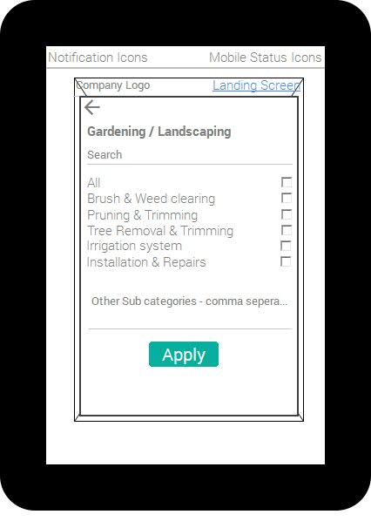

## 5.16 CS – Inputs

* Clicking on the **categories**, the slide in will show all the **sub categories** listed.
* Provider as to select **All** option or **the options** which match for his service.
* If Provider haven’t found his service in the Sub Category list, he can enter the **service comma separated**.
* The **services manually entered** by Provider will be added to the Sub Category list of the Main Category, he will be automatically subscribed to the service added.
* Apply button is clicked to save his entry for the particular category and display below the main category.
* Provider completes is category selection, he can move on to next section.
* When provider account is created, all his category and sub category data will be saved in the service.

## 5.17 CS – Request & Response

**Request:**

1. Main categories list with their Sub categories list
2. The Sub categories list is saved with subsequent Main categories
3. Text entered in Others - Sub categories list as comma separated will be subscribed and added automatically to Main categories list
4. Text entered in Others - Main categories list will be subscribed and added automatically

**Response:**

1. Sub categories are added to Database according to language and matched with Main categories
2. Main categories are saved in Database according to language

**Client Validation:**

1. At least one Sub categories should be selected / Sub categories should be entered in the other Text field
2. At least one Main categories should be selected / Main categories should be entered in the other Text field

## 5.18 Service Cities – Screen Elements

**Figure 9 – Provider Registration – Service Cities**

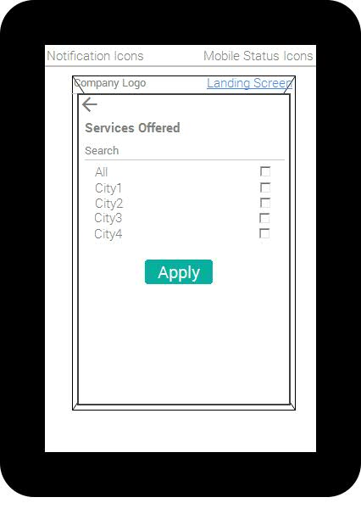

## 5.19 SC – Inputs

* Provider selects the cities he can service and apply his selection to be saved and submitted to the service
* All the cities will be in English

## 5.20 SC – Request & Response

**Request:**

1. The cities selected should be passed as an array to Service for Database update

**Response:**

1. The cities passed will be saved in Database as Provider preference

**Client Validation:**

1. At least one city for service should be selected
2. In search field, the city entered should be displayed below. The **auto suggest** text should work from minimum **3 characters**

## 5.21 Provider Profile Update

The features are same as Provider Registration screen. But the **Email field is Read-only**, Provider will not be able to update it

## 5.22 First Time Login - Consumer Login

Consumer can view the service listing without login, but consumer has to login before sending a text message / Click to Call Provider / reviewing provider.

Consumer can login through the application through

1. Email/Pwd
2. Facebook
3. Google Plus

The Facebook / Google+/ Email login should be unique and no duplicates are allowed

**Workflow 1.4 – Consumer Login**

Consumer Login

Error

Error

Email & Pwd Login

Facebook/Google+  
Login

Success

Success

Login Saved Consumer can continue his action

## 5.23 Consumer Login - Inputs

* Guest User can login through Facebook / Google plus / Custom login
* If GU id already exists as Facebook or Google Plus authorized, but now tries as Custom login. GU should get a message when he enters his email as “ User already Exist” will be automatically forwarded to GU Forgot Password screen
* GU have to create a new account to login through Custom login

## 5.24 CL – Request & Response

**Request:**

1. Custom Login – Email & Password
2. Facebook and Google Plus – Authentication

**Response:**

1. Details created in Database if new record
2. Details verified if existing record
3. Returns Success / Error Message

**Client Validation:**

1. Email – Email validation
2. Password - Alphanumeric : Size > 8

## 5.25 CL - Screen Elements

**Figure 10 – Consumer Login – First Time Installation**

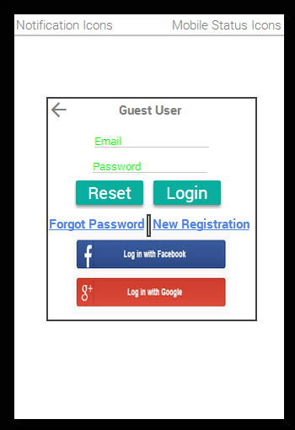

## 5.26 CL - Spanish Text

Guest User - Usuario Invitado  
Email - Correo electrónico  
Password - Contraseña  
Sign in - Registrarse  
Forgot password - Need to confirm  
Login with Facebook - Iniciar sesión con Facebook  
Login with Google+ - Iniciar sesión con Google+

## 5.27 Guest User – Registration

* GU will have to click on New Registration to create a new custom account

## 5.28 GUR – Request & Response

**Request:**

1. Email, Password, Name and Mobile

**Response:**

1. Details created in Database if new record
2. Details verified if existing record
3. Returns Success / Error Message

**Client Validation:**

1. Email – Email validation
2. Password Validation > 8 chars
3. Mobile Validation

## 5.29 GUR – Screen Elements

**Figure 11 – Guest User Registration**

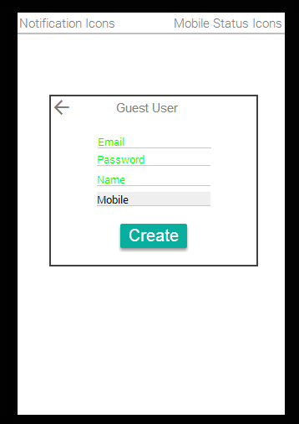

## 5.30 Consumer Forgot Password

Forgot password functionality will help consumer to retrieve his password through is email. Once consumer submit his email in the screen, he will receive his password for the login and automatically the screen redirects to login. This functionality can be used only for Custom login not for Social websites login. The password in **auto generated**.

## 5.31 CFP - Inputs

* Forgot password functionality will help GU to retrieve his password through is email.
* Email field is **prepopulated** and **read-only**, GU will receive his password for the login and automatically the screen redirects to login screen.
* The password is **auto generated**
* **Back to Login link** will redirect to **GU Login screen**

## 5.32 CFP - Spanish Text

Forgot password - Need to confirm  
Email - Correo electrónico  
Email it - Envíelo por correo electrónico  
Back to login - Atrás para iniciar sesión

## 5.33 CFW - Screen Elements

**Figure 12 – Consumer Forgot Password**



## 5.34 Change Password

* Change the password of the GU/Provider with this screen.

## 5.35 CP – Request & Response

**Request:**

1. Old and New password
2. User ID

**Response:**

1. Details are updated in Database
2. Returns Success / Error Message

**Client Validation:**

1. Password Validation > 8 chars
2. Password comparison

## 5.36 CP – Screen Elements

**Figure 13 – GU Profile Update**

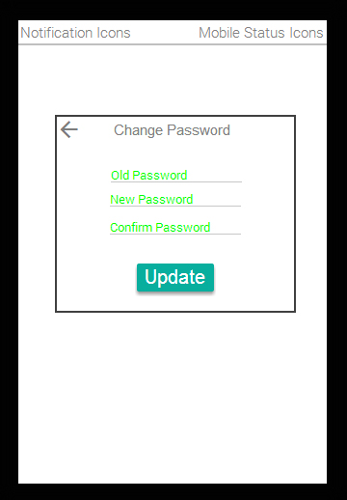

## 5.37 GU Profile Update

* GU profile can be updated
* Email field is Read-only others fields such as Password, Mobile and Name can be updated
* Mobile and Name are not mandatory fields

## 5.38 GU Profile Update – Screen Elements

**Figure 14 – GU Profile Update**

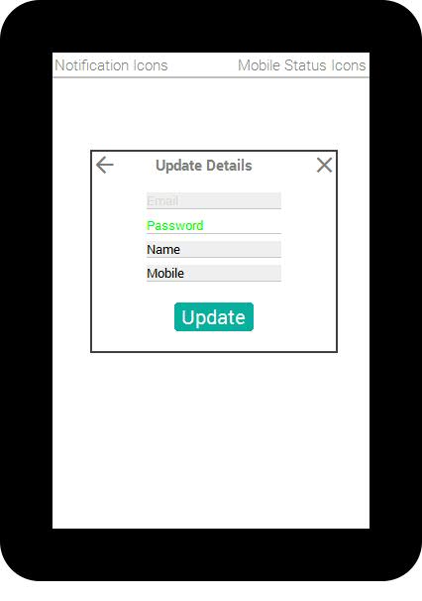

## 5.39 GU Profile Update - Spanish Text

Update details - Detalles de la actualización  
Password - Contraseña  
Update - Actualización  
Name - Nombre  
Mobile - Número de cellular

## 5.40 GU Profile Update – Request & Response

**Request:**

1. Email
2. Password
3. Mobile
4. Name

**Response:**

1. Record updated in Database
2. Success / Error message

**Client Validation:**

1. Password – Alphanumeric : Size > 8
2. Mobile – Number validation

Contact Information

Muralikkannan P

Email: muralik.kannan@gmail.com

Phone: 91 9663500115