**UPDATE**

In this update, I am going to describe the workflow of the GDELT API for Fang Protective Service.

[gdeltproject.org](https://gdeltproject.org/#_blank) does provide an interface to some of its data services - specifically its [DOC](https://blog.gdeltproject.org/gdelt-doc-2-0-api-debuts/#_blank), [GEO](https://blog.gdeltproject.org/gdelt-geo-2-0-api-debuts/#_blank) and [Television](https://blog.gdeltproject.org/gdelt-2-0-television-api-debuts/#_blank) APIs.

Using this site you can do things like:

* search in English for global content in any or all languages on a particular topic
* search for specific content or published in the past hour from eg. Japan, or in Japanese, or referencing a Japanese location
* find content based on features and text in its imagery
* investigate and compare media trends over time

comparing the GDELT DOC API. Here, I am going to compare

* 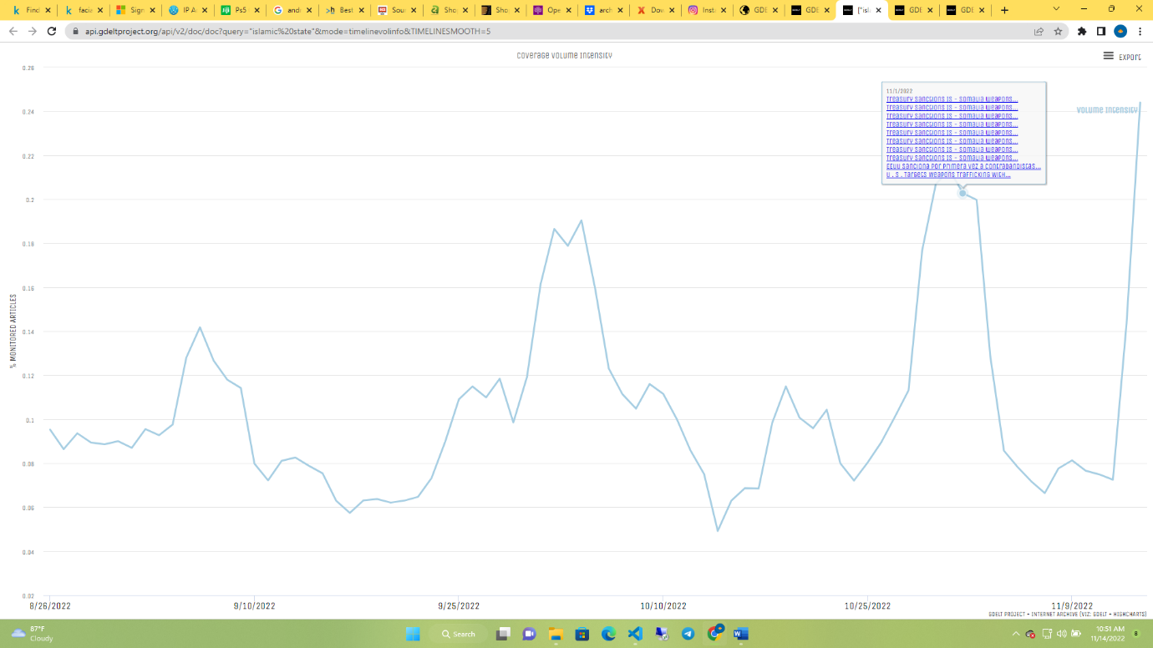URL: <https://api.gdeltproject.org/api/v2/doc/doc?query=%22islamic%20state%22&mode=timelinevolinfo&TIMELINESMOOTH=5> from GDELT site to our FPS-GDELT API.

In the figure above, it is the data from gdelt api url. (Islamic) query from the Timeline.

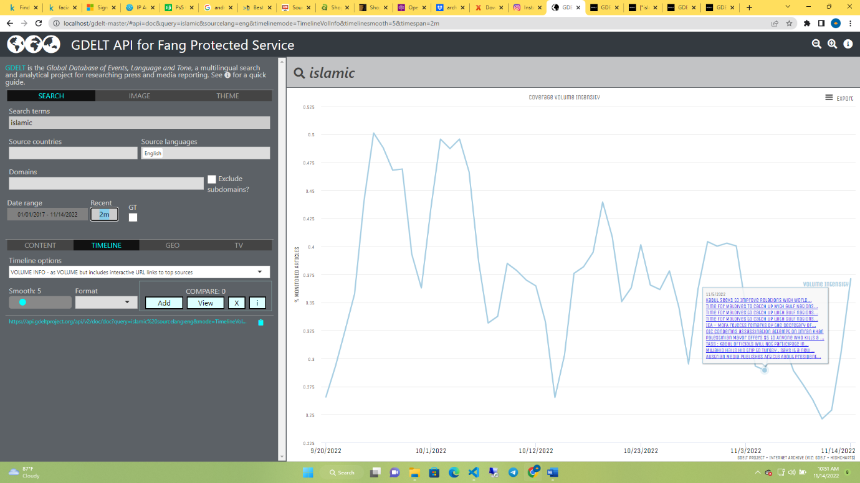the figure above is the api that pulls data from gdelt. With same query (Islamic) and same mode(timeline) and selected 2months behind.

Moving forward, we are comparing the GEO API query from GDELT to FPS API

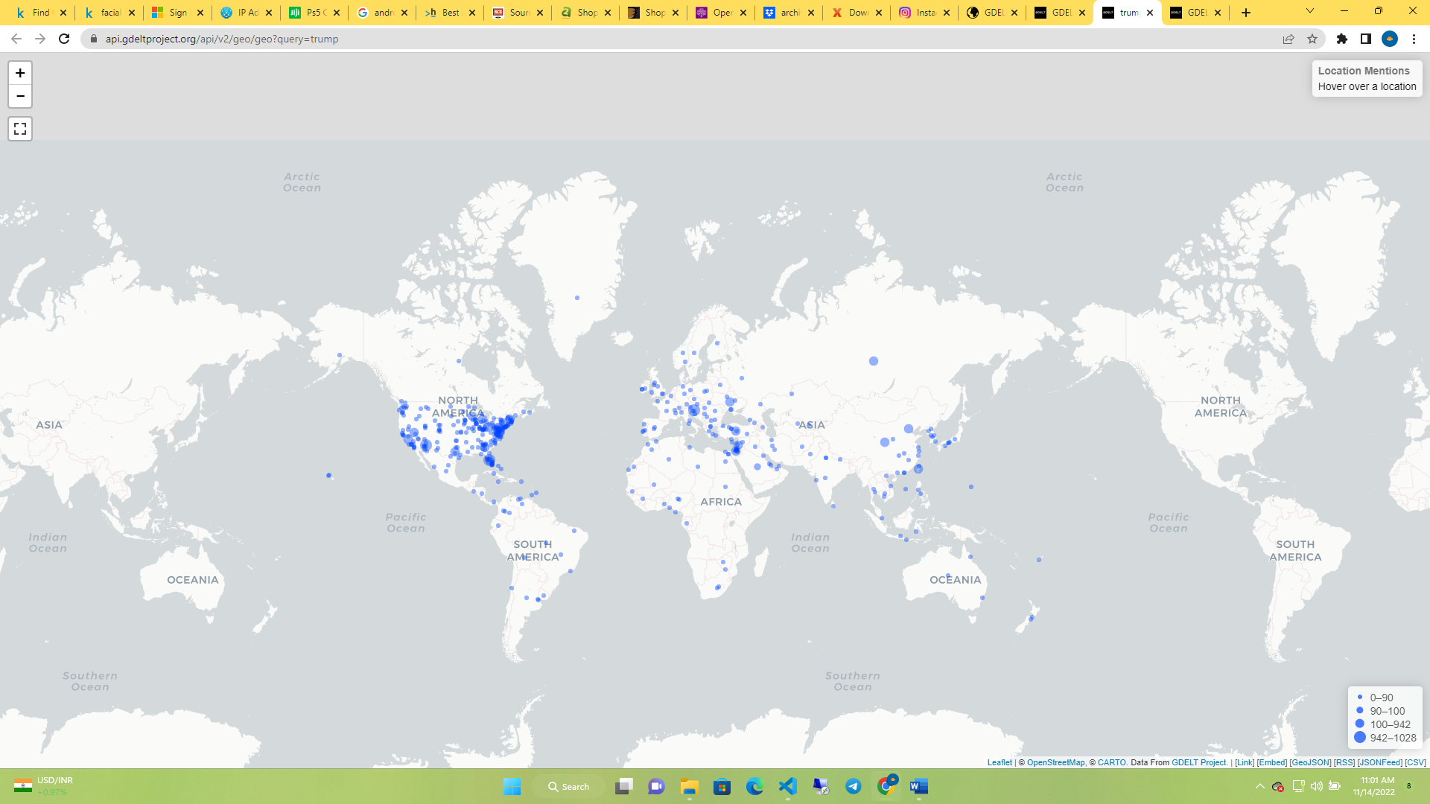

* The map figure above is the source from URL: <https://api.gdeltproject.org/api/v2/geo/geo?query=trump> from GDELT official site. It pin point to the location of the location.

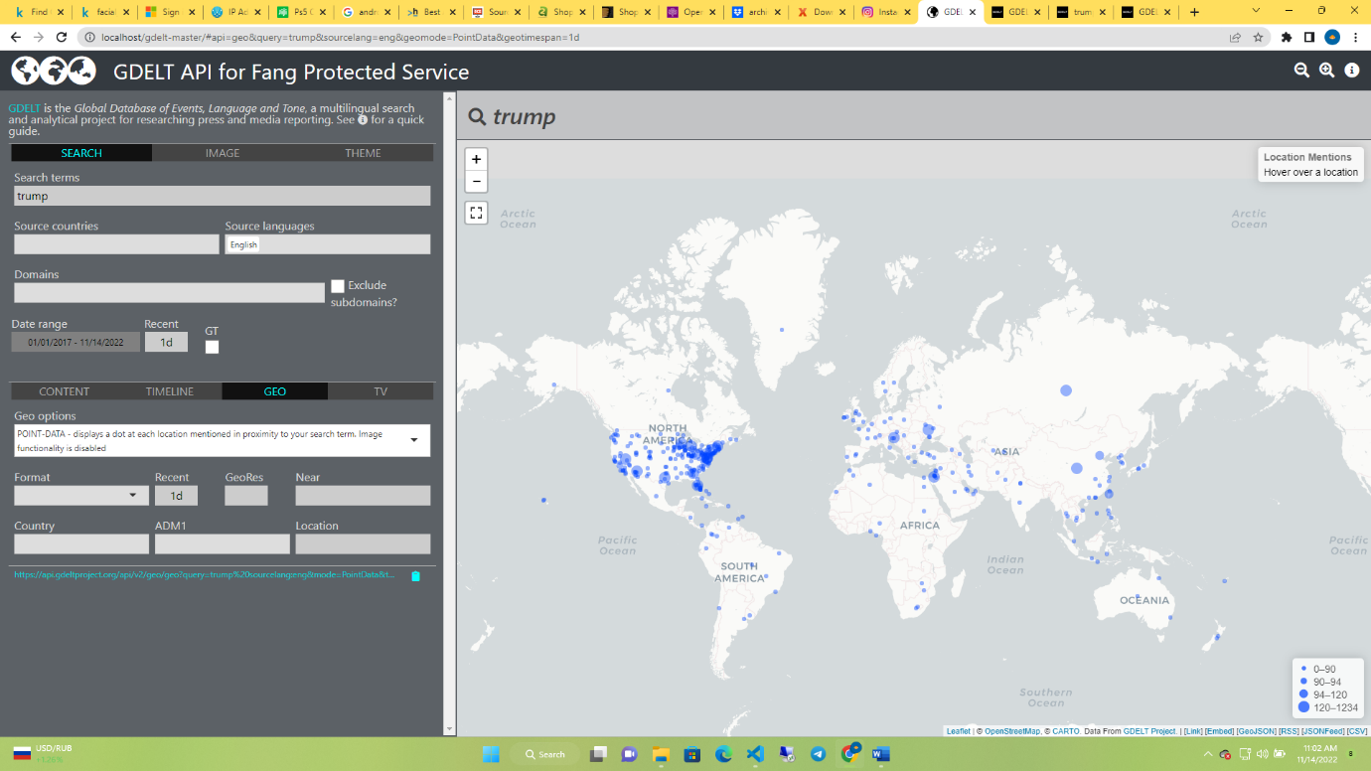

The figure above is the API for FPS. As we can see, it provided same result as gdelt provides. In this case, I select 1d which is 1day. And it has produced the results for in a day. Being it 8hrs or 30mins ago.

Next, lets look at the API for Television.

* URL: <https://api.gdeltproject.org/api/v2/tv/tv?query=trump%20market:%22National%22&mode=timelinevol&format=html&datanorm=perc&timelinesmooth=0&datacomb=sep&last24=yes&timezoom=yes>

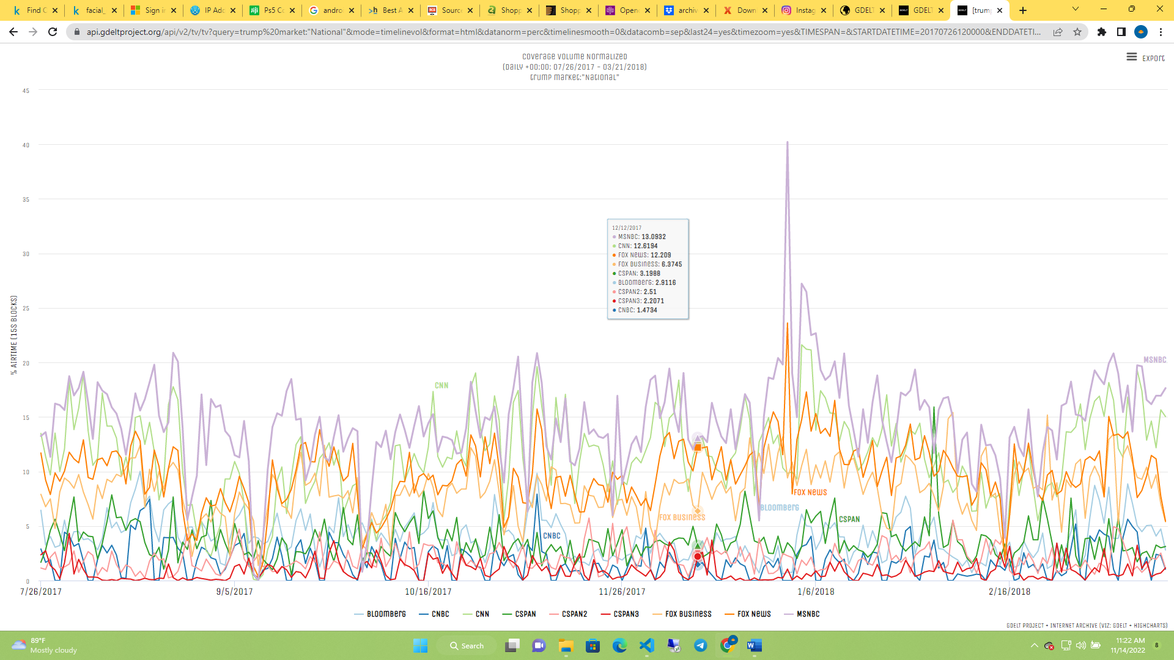

This is screenshot from GDELT from television query (trump) API. It has networks which it takes information from. (cnbc, cnn, fox business, fox news…). Comparing to our FPS API;

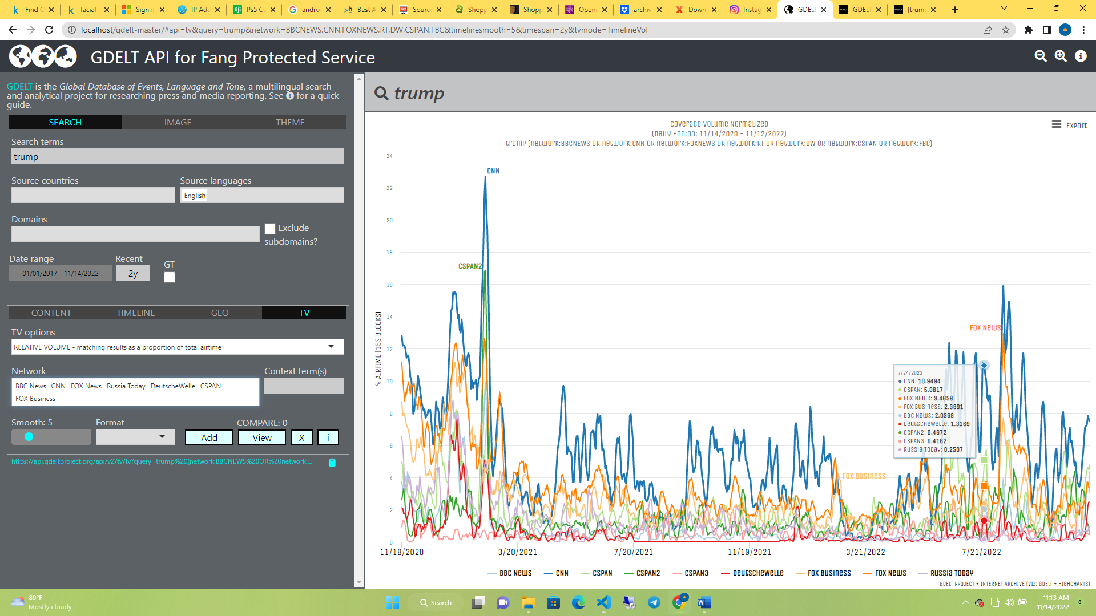

The figure above is the output from FPS API. We can also tell from here that we have the same output.

Now, lets make our own analysis for our Ethiopian client. The case was about “DRONE”. I will select from DRONE Themelist and try to pull information and see if we could have foreseen it.

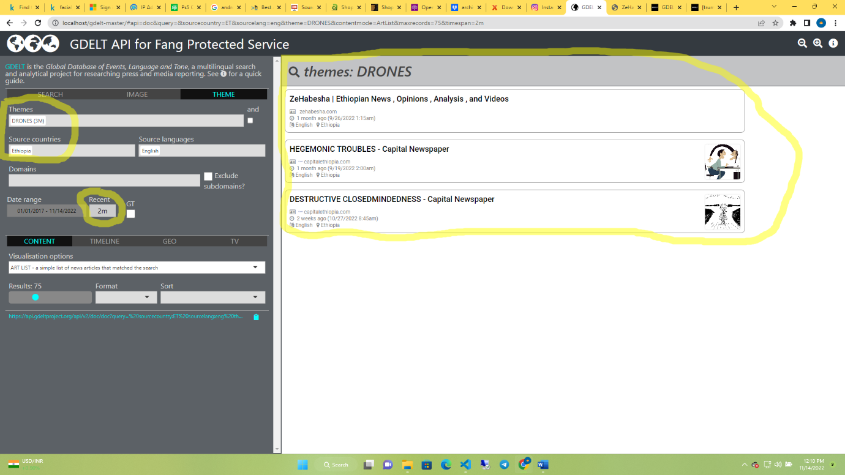

In this screenshot, I selected 2months behind and we have those feedback. Information coming from zehabesha.com and capitalethiopia.com. zehabesha updated it 1 month ago and capitalethiopia updated 1 week ago. At the moment, capital Ethiopia has been shutdown information for drones. But we can still get information from zehabesha.

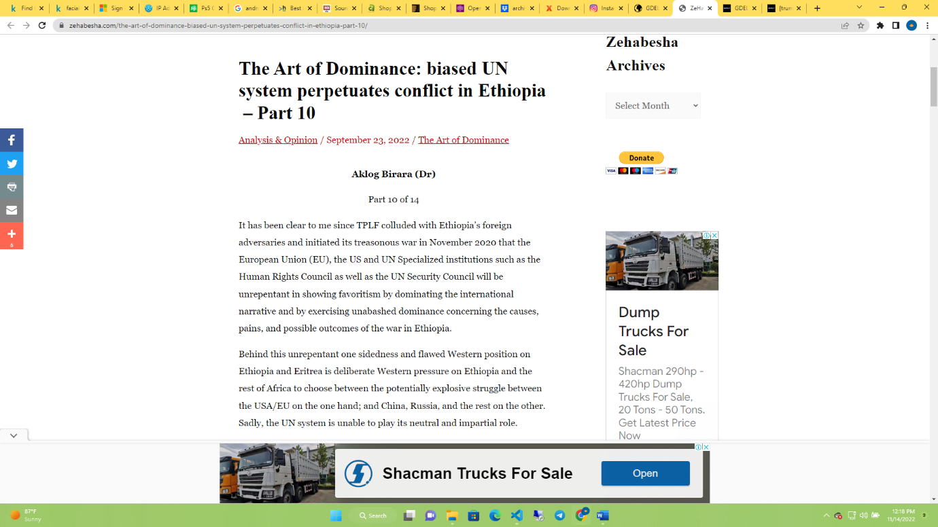

<https://zehabesha.com/the-art-of-dominance-biased-un-system-perpetuates-conflict-in-ethiopia-part-10/>

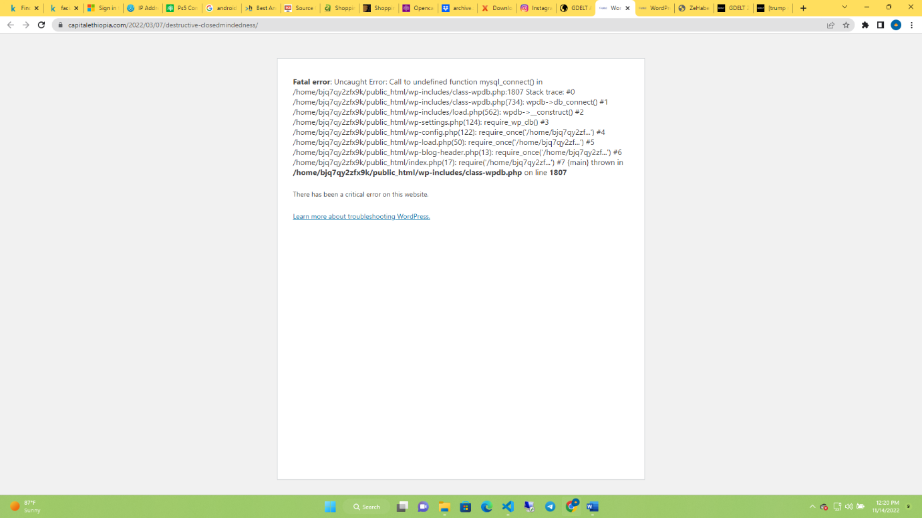

<https://www.capitalethiopia.com/2022/03/07/destructive-closedmindedness/>

this is the result from capitalethiopia but their site has been shutdown.

Gdelt.org would not provide the interface for these information that our FPS API would provide