Exercise 9.2 - Chrome Developer Tools

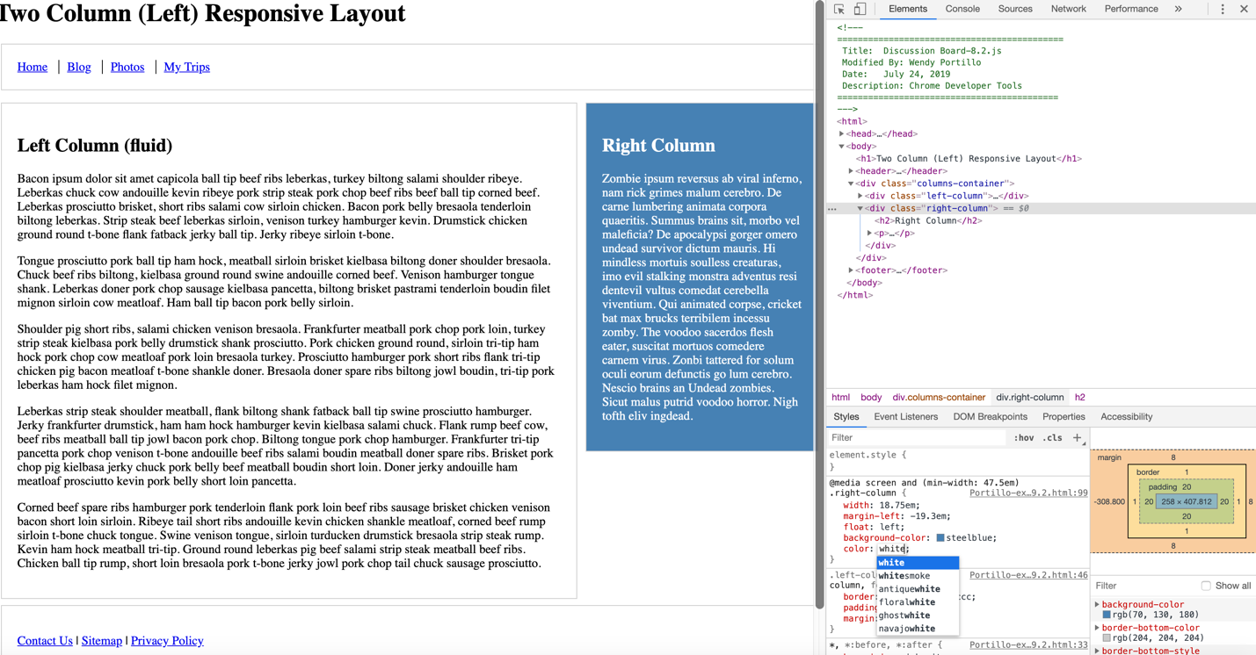

* Open the Console
* Right click what you want to change.
* Select inspect you will be directed the code page which you can change from there.