Exercise 9.3 - Firefox Developer Tools

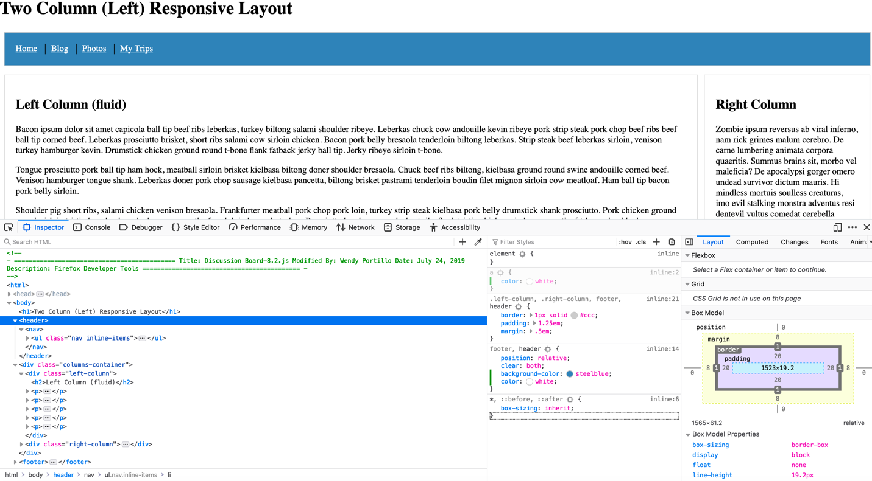

* Open the Console
* Right click what you want to change.
* Select inspect you will be directed the code page which you can change from their input the background color in the footer header.
* On the filter Style you will add + meaning it will add a new rule.
* You’ll add a to which you’ll add style a to color white.