Wendy Portillo

January 9, 2020

WEB-425 Exercise 2.4

Home page:

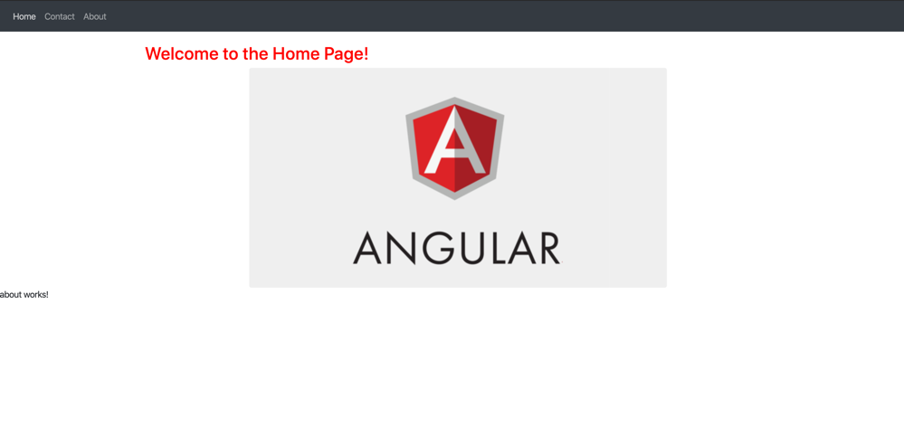

About page

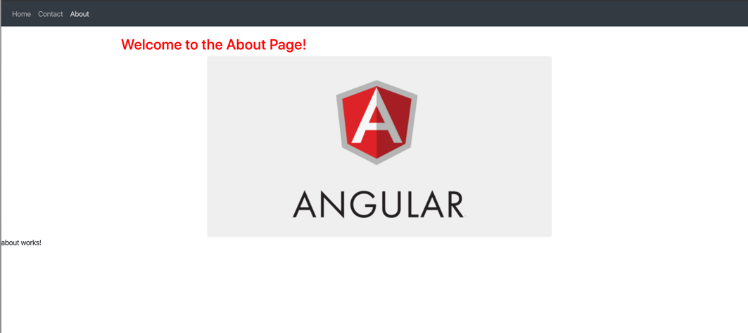

Contact page

