**EXPRIMENT 4**

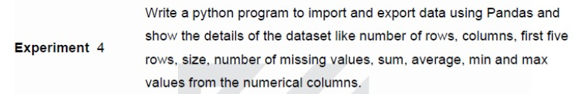

**CSV FILE:** It contains 4 columns (Name, Age, Salary, Department) and 5 rows.

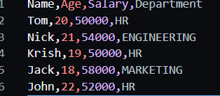

**CODE:**

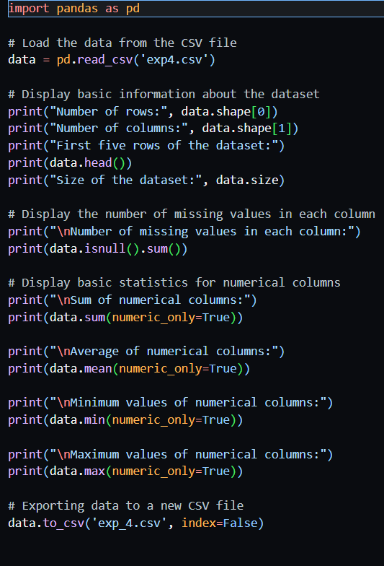

**OUTPUT:**



