ITE1002 – Web Technologies

A1 – Vijayan R

DA – 1

Social Media Website – VITgram

Group:

1. Abhimanyu Singh – 18BIT0105
2. Nitin Sharma – 18BIT0145

Introduction

VITgram is a social media website with all the relevant modern features.

It contains the following parts:

* User authentication:

Login page and Registration page.

Logout.

* User feed:

All the new posts are displayed in an orderly manner of upload time with the number of likes, comments and a comment and like option. Also, the picture’s original creator’s info like display picture and name are displayed.

* Search:

User can search other users by their name or username.

* Upload:

User can upload a new picture with location info.

* Recents:

All recent post and user related activities such as likes and comments on posts along with follow information is displayed in 3 neatly distinct blocks.

* Profile:

User display picture, name, username, about section and all posts are displayed to the user.

This will be extended to search using backend with the next version to view other users’ profile.

Follow button is present on the profile to follow the person.

Codes

Login.html:

<!doctype html>

<head>

<title>Login</title>

<style>

html {

background: #B3FFAB;

/* fallback for old browsers */

background: -webkit-linear-gradient(to right, #12FFF7, #B3FFAB);

/* Chrome 10-25, Safari 5.1-6 */

background: linear-gradient(to right, #12FFF7, #B3FFAB);

/* W3C, IE 10+/ Edge, Firefox 16+, Chrome 26+, Opera 12+, Safari 7+ */

font-family: 'Montserrat', sans-serif;

}

h1 {

text-align: center;

}

.myForm {

display: grid;

grid-template-columns: [labels] auto [controls] 1fr;

grid-auto-flow: row;

grid-gap: .8em;

background: #eee;

padding: 1.2em;

width: 50%;

justify-content: center;

align-content: center;

align-items: center;

margin: 0 auto;

}

.myForm>input,

.myForm>button {

grid-column: controls;

grid-row: auto;

border: none;

padding: 1em;

}

p{

text-align: center;

}

</style>

</head>

<body>

<h1>Login</h1>

<form class="myForm">

<input type="text" name="username" id="username" placeholder="UserName">

<input type="pass" name="pass" id="pass" placeholder="Password">

<button>Submit</button>

</form>

<p>New User? <a href="register.html"> Register</a>

</p>

</body>

</html>

Register.html:

<!doctype html>

<title>Register</title>

<style>

html {

background: #B3FFAB;

/* fallback for old browsers */

background: -webkit-linear-gradient(to right, #12FFF7, #B3FFAB);

/* Chrome 10-25, Safari 5.1-6 */

background: linear-gradient(to right, #12FFF7, #B3FFAB);

/* W3C, IE 10+/ Edge, Firefox 16+, Chrome 26+, Opera 12+, Safari 7+ */

font-family: 'Montserrat', sans-serif;

}

h1 {

text-align: center;

}

.myForm {

display: grid;

grid-template-columns: [labels] auto [controls] 1fr;

grid-auto-flow: row;

grid-gap: .8em;

background: #eee;

padding: 1.2em;

width: 50%;

justify-content: center;

align-content: center;

align-items: center;

margin: 0 auto;

}

.myForm>input,

.myForm>button {

grid-column: controls;

grid-row: auto;

border: none;

padding: 1em;

}

</style>

<h1>Register</h1>

<form class="myForm">

<input type="text" name="fname" id="fname" placeholder="Enter First Name">

<input type="text" name="lname" id="lname" placeholder="Enter Last Name">

<input type="text" name="username" id="username" placeholder="Enter UserName">

<input type="pass" name="pass" id="pass" placeholder="Enter Password">

<input type="cpass" name="cpass" id="cpass" placeholder="Confirm Password">

<button>Submit</button>

</form>

Home.html:

<!DOCTYPE html>

<html>

<head>

<title>VITgram | Home</title>

<link rel="stylesheet" type="text/css" href="C:\Users\Nitin Sharma\Desktop\Webtech_Project-master\public\stylesheets\home.css">

</head>

<body>

<div id="topbar">

<a href="home.html" id="homebut"><img class ="icon" src="C:\Users\Nitin Sharma\Desktop\Webtech_Project-master\public\images\home.png"></a>

<a href="search.html" id="searchbut"><img class ="icon" src="C:\Users\Nitin Sharma\Desktop\Webtech_Project-master\public\images\search.png"></a>

<a href="upload.html" id="uploadbut"><img class ="icon" src="C:\Users\Nitin Sharma\Desktop\Webtech_Project-master\public\images\plus.png"></a>

<a href="recents.html" id="recentbut"><img class ="icon" src="C:\Users\Nitin Sharma\Desktop\Webtech_Project-master\public\images\heart.png"></a>

<a href="profile.html" id="profbut"><img class ="icon" src="C:\Users\Nitin Sharma\Desktop\Webtech_Project-master\public\images\user.png"></a>

</div>

<div id="body">

<br>

<div id="post">

<div id="info">

<div id="infopic"><img class="profpic" src="C:\Users\Nitin Sharma\Desktop\Webtech_Project-master\public\images\ranbir.jpg"></div>

<div id="infoetc">

<div id="profile">nitinsharma</div>

<div id="loc">Location</div>

</div>

<div id="time">

<div id="uptime">1hr</div>

</div>

</div>

<div id="pic">

<img class="photo" src="C:\Users\Nitin Sharma\Desktop\Webtech_Project-master\public\images\ranbir.jpg">

</div>

<div id="likecomment">

<div id="likes">

<div id="likebutton"><button id="like" onclick=""><img class="icon" src="C:\Users\Nitin Sharma\Desktop\Webtech_Project-master\public\images\heart2.png"></button>

</div>

<div id="nlikes">23 likes</div>

</div>

<div id="comment">

<ul type="none">

<li>

<div id="commenter">nitinsharma</div>

<div id="cominfo">Bole toh ek number</div>

</li>

<li>

<div id="commenter">abhimanyu</div>

<div id="cominfo">Sanju baba roks</div>

</li>

</ul>

</div>

<div id="addcom">

<div id="writecom">

<input type="text" name="combyprof" placeholder="Write a comment">

</div>

</div>

</div>

</div>

</div>

</body>

</html>

Home.css:

html{

background: linear-gradient(to right, #12FFF7, #B3FFAB);

}

#body{

padding: 50px;

height: 100%;

width: 92.75%;

margin: 5px 5px 5px 5px;

}

#post{

border:1px solid #ccc;

font-family: montserrat;

background-color: #FAFAFA;

margin: auto;

width: 50%;

padding:5px;

}

#topbar{

background-color: #FAFAFA;

border-bottom: 0.5px solid #ccc;

position: fixed;

width: 100%;

top: 0;

left: 0;

z-index: 1;

}

#topbar a{

display: inline-block;

width: 20%;

margin-left: -4px;

text-align: center;

padding: 0px;

box-sizing: border-box;

}

#topbar a:hover{

background-color: #ccc;

}

#topbar img{

width: 50px;

height: 50px;

}

#info{

border-bottom:1px solid #ccc;

padding:2px;

}

#infopic{

display: inline-block;

padding: 5px;

width:20px;

height: 20px;

}

#infoetc{

position: relative;

display: inline-block;

}

#profile{

font-size: 12px;

}

#loc{

font-weight: 80;

font-size:10px;

}

#time{

position: relative;

display: inline-block;

float: right;

padding: 7px;

font-weight: 50;

}

#info a{

padding: 5px;

text-align: left;

box-sizing: border-box;

display: inline-block;

}

#info img{

border: 1px solid #3287a8;

padding: 1px;

border-radius: 50%;

width: 20px;

height: 20px;

}

#pic img{

width: 100%;

}

#likecomment a{

display: inline-block;

margin-left: -1px;

text-align: center;

padding: 0px;

box-sizing: border-box;

}

#likebutton{

width: 18px;

height: 18px;

display: inline-block;

padding: 2px;

}

#likebutton button{

border:none;

background-color: #FAFAFA;

outline: none;

}

#likebutton img{

width: 17px;

height: 17px;

}

#nlikes{

position: relative;

display: inline-block;

font-size: 12px;

padding: 5px;

}

#commenter{

font-size:12px;

display:inline-block;

}

#cominfo{

font-size: 10px;

font-weight: 90;

display:inline-block;

}

#writecom{

margin-left: 40px;

}

input{

width: 100%;

font-family: montserrat;

border-style: none;

background-color: #FAFAFA;

outline: none;

}

Search.html:

<!DOCTYPE html>

<html>

<head>

<title>VITgram | Search</title>

<link rel="stylesheet" type="text/css" href="C:\Users\Nitin Sharma\Desktop\Webtech_Project-master\public\stylesheets\search.css">

</head>

<body>

<div id="topbar">

<a href="home.html" id="homebut"><img class ="icon" src="C:\Users\Nitin Sharma\Desktop\Webtech_Project-master\public\images\home.png"></a>

<a href="search.html" id="searchbut"><img class ="icon" src="C:\Users\Nitin Sharma\Desktop\Webtech_Project-master\public\images\search.png"></a>

<a href="upload.html" id="uploadbut"><img class ="icon" src="C:\Users\Nitin Sharma\Desktop\Webtech_Project-master\public\images\plus.png"></a>

<a href="recents.html" id="recentbut"><img class ="icon" src="C:\Users\Nitin Sharma\Desktop\Webtech_Project-master\public\images\heart.png"></a>

<a href="profile.html" id="profbut"><img class ="icon" src="C:\Users\Nitin Sharma\Desktop\Webtech_Project-master\public\images\user.png"></a>

</div>

<div id="body">

<div id="searchbar">

<input type="text" id="searchitem" placeholder="Search a Username/Name">

</div>

<div id="result">

<ul id="searchresult" type="none">

<div id="rslt">

<li>

<div id="dp"><img class="profpic" src="C:\Users\Nitin Sharma\Desktop\Webtech_Project-master\public\images\ranbir.jpg"></div>

<div id="uname">nitinsharma</div>

<div id="follow"><button id="fllw">Follow</button>

</li>

</div>

<br>

<div id="rslt">

<li>

<div id="dp"><img class="profpic" src="C:\Users\Nitin Sharma\Desktop\Webtech_Project-master\public\images\ranbir.jpg"></div>

<div id="uname">abhimanyu</div>

</li>

</div>

</div>

</div>

</body>

</html>

Search.css:

html{

background: linear-gradient(to right, #12FFF7, #B3FFAB);

}

#topbar{

background-color: #FAFAFA;

border-bottom: 0.5px solid #ccc;

position: fixed;

width: 100%;

top: 0;

left: 0;

z-index: 1;

}

#topbar a{

display: inline-block;

width: 20%;

margin-left: -4px;

text-align: center;

padding: 0px;

box-sizing: border-box;

}

#topbar a:hover{

background-color: #ccc;

}

#topbar img{

width: 50px;

height: 50px;

}

#body{

position: absolute;

padding: 50px;

height: 100%;

width: 92.5%;

margin-right: 0px;

}

#searchbar{

margin:0px auto;

left: 0;

padding: 10px;

background-color: #FAFAFA;

width: 70%;

}

input{

margin:0px auto;

width: 50%;

font-family: montserrat;

border-style: none;

background-color: #FAFAFA;

outline: none;

}

#result{

text-align: left;

width: 50%;

margin: auto;

height: 100%;

background-color: transparent;

padding: 10px;

}

#rslt{

background-color: #FAFAFA;

border:1px solid #ccc;

border-radius: 2px;

margin:auto;

padding-bottom: 1px;

width: 100%;

}

#dp{

display: inline-block;

padding: 5px;

width:20px;

height: 20px;

}

#uname{

position: relative;

display: inline-block;

vertical-align: middle;

}

#follow{

display: inline-block;

vertical-align: middle;

}

#fllw{

border:1px solid #ccd;

background-color: #ccd;

border-radius: 2px;

font-family: montserrat;

outline: none;

float: right;

}

#fllw button:hover{

background-color: #ccc;

}

#result img{

display: inline-block;

border: 1px solid #3287a8;

border-radius: 50%;

width: 20px;

height: 20px;

vertical-align: middle;

}

Upload.html:

<!DOCTYPE html>

<html lang="en">

<head>

<meta charset="UTF-8">

<meta name="viewport" content="width=device-width, initial-scale=1.0">

<meta http-equiv="X-UA-Compatible" content="ie=edge">

<title>Create a new post</title>

<style>

html {

background: #B3FFAB;

/* fallback for old browsers */

background: -webkit-linear-gradient(to right, #12FFF7, #B3FFAB);

/* Chrome 10-25, Safari 5.1-6 */

background: linear-gradient(to right, #12FFF7, #B3FFAB);

/* W3C, IE 10+/ Edge, Firefox 16+, Chrome 26+, Opera 12+, Safari 7+ */

font-family: 'Montserrat', sans-serif;

}

#container {

padding-top:20px;

display: flex;

flex-direction: column;

flex-wrap: wrap;

justify-content: center;

align-items: center;

}

h1 {

padding-top: 50px;

text-align: center;

border-bottom;: 1px solid #cccccc;

width: 50%;

margin-left: auto;

margin-right: auto;

}

#submit {

width: 100%;

border: none;

border-radius: 10px;

outline: none;

font-family: montserrat;

}

#topbar{

background-color: #FAFAFA;

border-bottom: 0.5px solid #ccc;

position: fixed;

width: 100%;

top: 0;

left: 0;

z-index: 1;

}

#topbar a{

display: inline-block;

width: 20%;

margin-left: -4px;

text-align: center;

padding: 0px;

box-sizing: border-box;

}

#topbar a:hover{

background-color: #ccc;

}

#topbar img{

width: 50px;

height: 50px;

}

#post{

font-family: montserrat;

}

</style>

</head>

<body>

<div id="topbar">

<a href="home.html" id="homebut"><img class ="icon" src="C:\Users\Nitin Sharma\Desktop\Webtech_Project-master\public\images\home.png"></a>

<a href="search.html" id="searchbut"><img class ="icon" src="C:\Users\Nitin Sharma\Desktop\Webtech_Project-master\public\images\search.png"></a>

<a href="upload.html" id="uploadbut"><img class ="icon" src="C:\Users\Nitin Sharma\Desktop\Webtech_Project-master\public\images\plus.png"></a>

<a href="recents.html" id="recentbut"><img class ="icon" src="C:\Users\Nitin Sharma\Desktop\Webtech_Project-master\public\images\heart.png"></a>

<a href="profile.html" id="profbut"><img class ="icon" src="C:\Users\Nitin Sharma\Desktop\Webtech_Project-master\public\images\user.png"></a>

</div>

<h1>Add a new post</h1>

<hr style="color: #cccccc; width:50%;">

<div id="container">

<form action="/new" method="GET" enctype="multipart/form-data">

<input type="file" name="post" id="post">

<br>

<br>

<input id="submit" type="submit" value="Upload">

</form>

</div>

</body>

</html>

Recents.html:

<!DOCTYPE html>

<html lang="en">

<head>

<meta charset="UTF-8">

<meta name="viewport" content="width=device-width, initial-scale=1.0">

<meta http-equiv="X-UA-Compatible" content="ie=edge">

<title>Notifications</title>

<link rel="stylesheet" href="../public/stylesheets/notifstyle.css">

<link href="https://fonts.googleapis.com/css?family=Montserrat&display=swap" rel="stylesheet">

</head>

<body>

<div id="topbar">

<a href="home.html" id="homebut"><img class ="icon" src="C:\Users\Nitin Sharma\Desktop\Webtech_Project-master\public\images\home.png"></a>

<a href="search.html" id="searchbut"><img class ="icon" src="C:\Users\Nitin Sharma\Desktop\Webtech_Project-master\public\images\search.png"></a>

<a href="upload.html" id="uploadbut"><img class ="icon" src="C:\Users\Nitin Sharma\Desktop\Webtech_Project-master\public\images\plus.png"></a>

<a href="recents.html" id="recentbut"><img class ="icon" src="C:\Users\Nitin Sharma\Desktop\Webtech_Project-master\public\images\heart.png"></a>

<a href="profile.html" id="profbut"><img class ="icon" src="C:\Users\Nitin Sharma\Desktop\Webtech_Project-master\public\images\user.png"></a>

</div>

<div id="head"><h1>Recents</h1></div>

<div class="flex-container">

<div id="div1">

<h3>Follows</h3>

<p>A followed you.</p>

<p>B followed you.</p>

</div>

<div id="div1">

<h3>Likes</h3>

<p>A liked B's post</p>

</div>

<div id="div2">

<h3>Comments</h3>

<p>B commmented on your post - Pog</p>

</div>

</div>

</body>

</html>

Profile.html:

<!DOCTYPE html>

<html>

<head>

<title>My Profile</title>

<link rel="stylesheet" href="../public/stylesheets/style.css">

<link href="https://fonts.googleapis.com/css?family=Montserrat&display=swap" rel="stylesheet">

</head>

<body>

<div id="topbar">

<a href="home.html" id="homebut"><img class ="icon" src="C:\Users\Nitin Sharma\Desktop\Webtech_Project-master\public\images\home.png"></a>

<a href="search.html" id="searchbut"><img class ="icon" src="C:\Users\Nitin Sharma\Desktop\Webtech_Project-master\public\images\search.png"></a>

<a href="upload.html" id="uploadbut"><img class ="icon" src="C:\Users\Nitin Sharma\Desktop\Webtech_Project-master\public\images\plus.png"></a>

<a href="recents.html" id="recentbut"><img class ="icon" src="C:\Users\Nitin Sharma\Desktop\Webtech_Project-master\public\images\heart.png"></a>

<a href="profile.html" id="profbut"><img class ="icon" src="C:\Users\Nitin Sharma\Desktop\Webtech_Project-master\public\images\user.png"></a>

</div>

<div id="header">

<img id="dp"

src="dp.jpg"

alt="Profile Picture">

<div id="desc">

<p>nitin.sh125 <span><button id="follow">Follow</button></span></p>

<h3>Nitin Sharma</h3>

<span id="bio">

<p>I am a cool, hot boy</p>

</span>

</div>

</div>

<br>

<hr style="color: #cccccc;">

<div id="timeline">

<div class="post">

<img src="image1.jpg">

</div>

<div class="post">

<img src="image2.jpg">

</div>

<div class="post">

<img src="image3.jpg">

</div>

</div>

</body>

</html>

Style.css:

html {

background: #B3FFAB;

/* fallback for old browsers */

background: -webkit-linear-gradient(to right, #12FFF7, #B3FFAB);

/* Chrome 10-25, Safari 5.1-6 */

background: linear-gradient(to right, #12FFF7, #B3FFAB);

/* W3C, IE 10+/ Edge, Firefox 16+, Chrome 26+, Opera 12+, Safari 7+ */

font-family: 'Montserrat', sans-serif;

}

#header{

padding-top: 50px;

}

#desc{

padding-top: 50px;

}

body {

padding: 10px;

width: 75%;

margin: 0 auto;

}

#topbar{

background-color: #FAFAFA;

border-bottom: 0.5px solid #ccc;

position: fixed;

width: 100%;

top: 0;

left: 0;

z-index: 1;

}

#topbar a{

display: inline-block;

width: 20%;

margin-left: -4px;

text-align: center;

padding: 0px;

box-sizing: border-box;

}

#topbar a:hover{

background-color: #ccc;

}

#topbar img{

width: 50px;

height: 50px;

}

#desc p{

font-size: 30px;

font-weight: 90;

margin-bottom: 0px;

}

h3{

margin-bottom: 0%;

font-weight: normal;

letter-spacing: 0.5px;

word-spacing: 3.5px;

}

#follow{

border:1px solid #ccd;

background-color: #ccd;

border-radius: 2px;

font-family: montserrat;

outline: none;

vertical-align: middle;

margin-left: 15px;

}

#follow button:hover{

background-color: #ccc;

}

#bio p{

font-size: 12px;

margin-top: 2px;

}

#dp {

border: 2px solid #3287a8;

border-radius: 50%;

height: 200px;

width: 200px;

}

#desc {

position: absolute;

width: 50%;

top: 0px;

left: 450px;

margin: 0px;

}

/*

#header{

border-bottom: 2px solid #cccccc;

} */

#timeline {

display: grid;

grid-template-columns: auto auto auto;

margin: 50px;

}

.post {

padding: 0;

margin: 20px;

width: 232.67px;

height: 232.67px;

border: 2px solid #cccccc;

}

.post img {

width: 232.67px;

height: 232.67px;

}

Output Screenshots

Login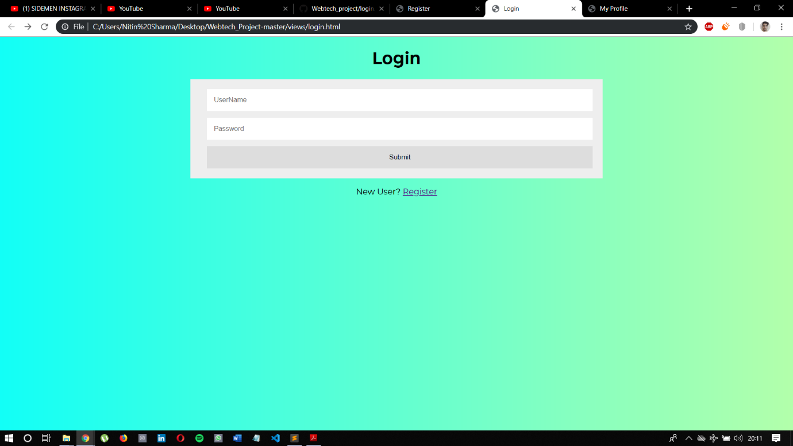

Register

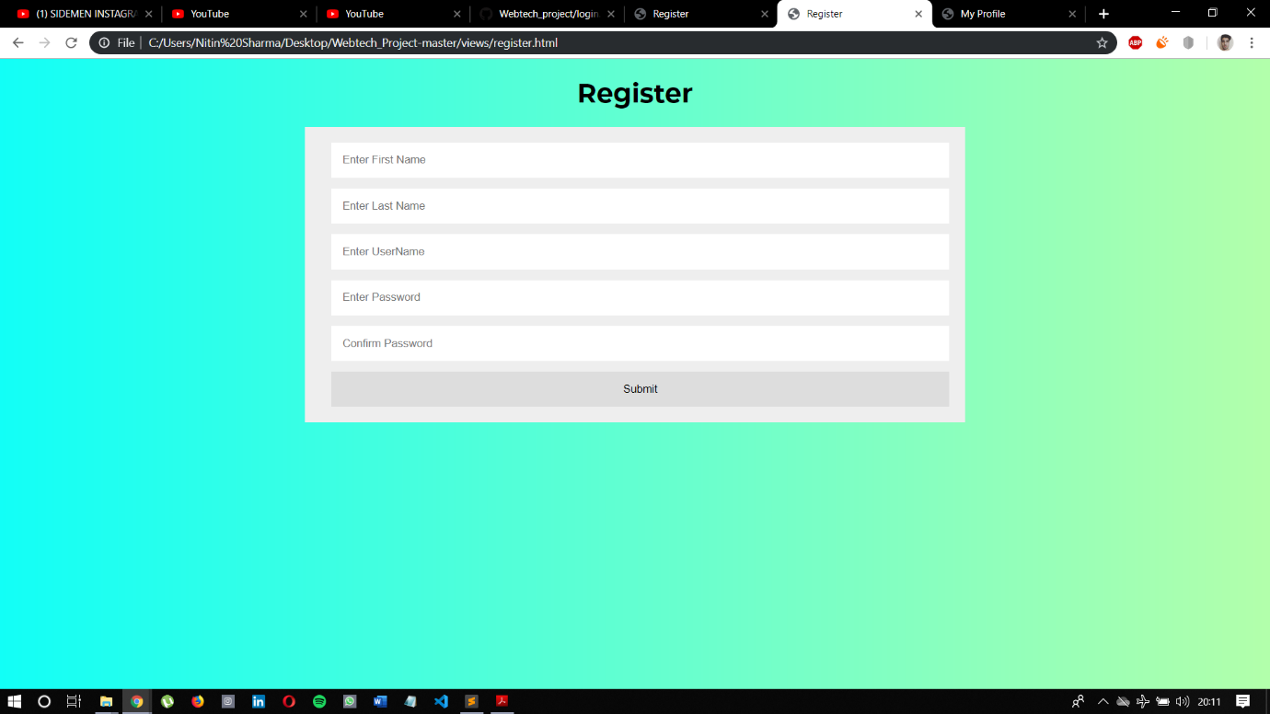

Home

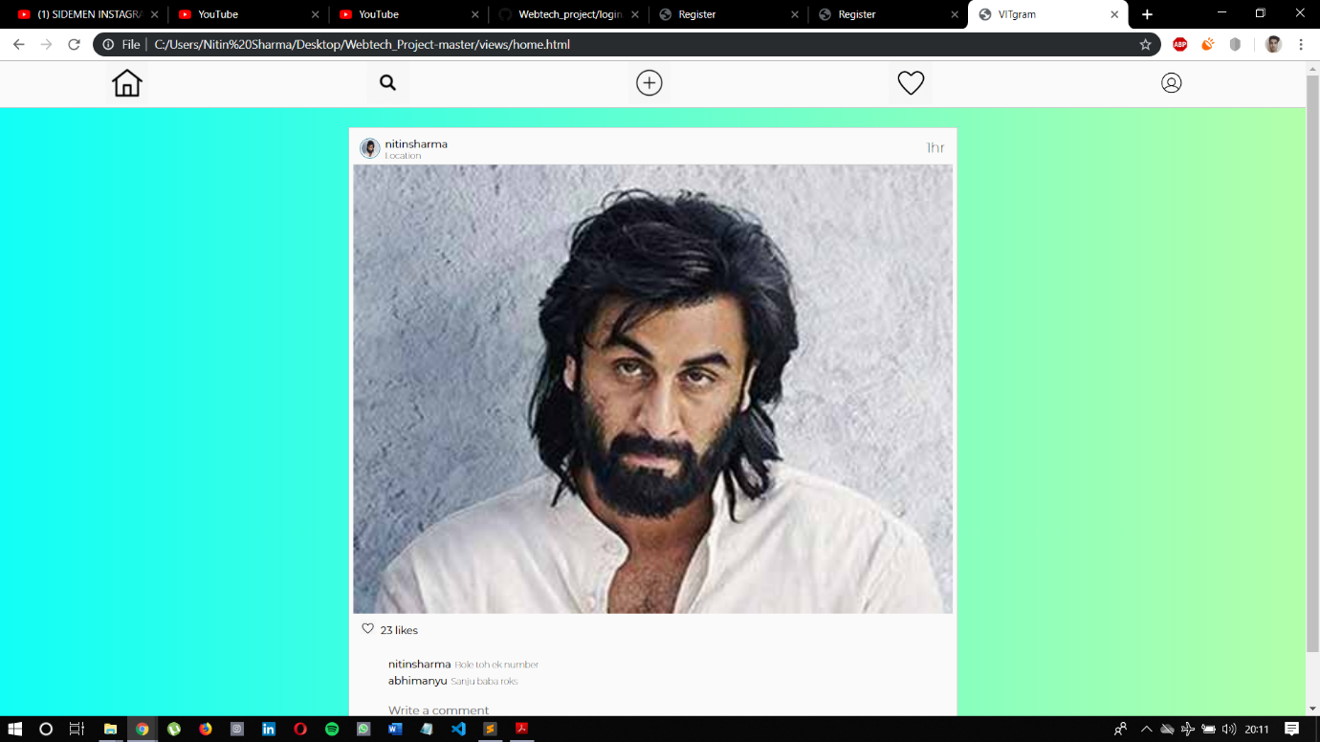

Search

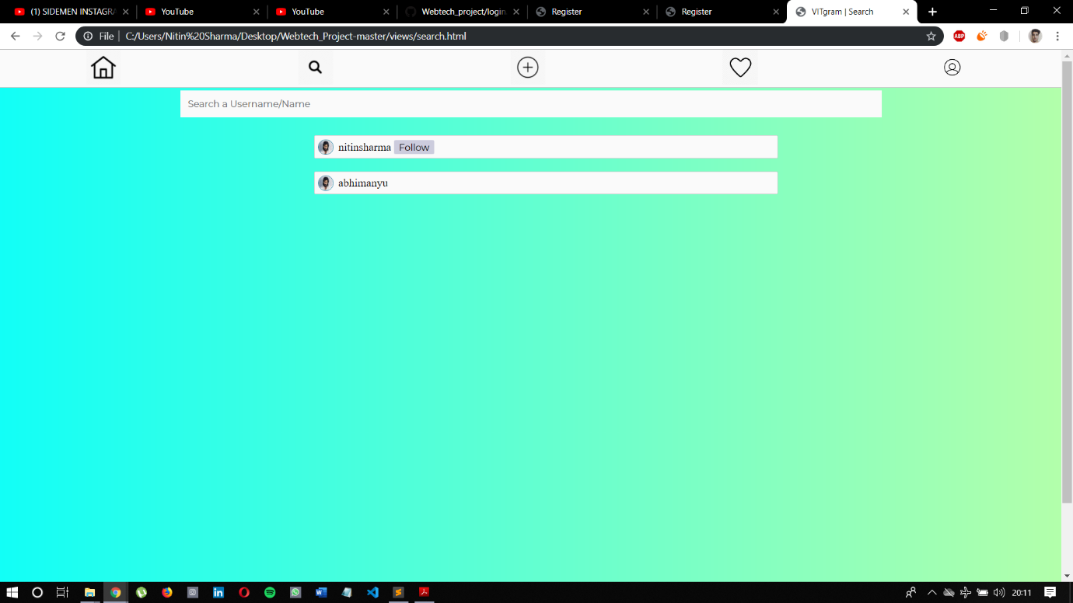

Upload

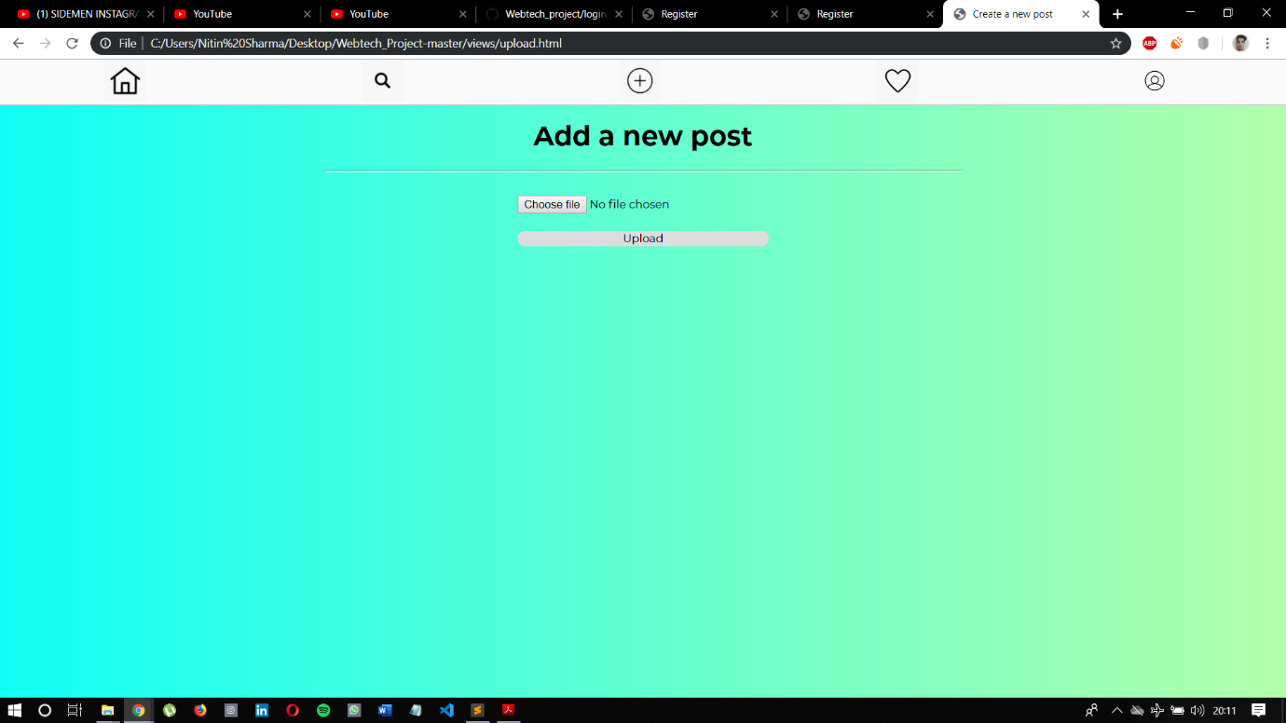

Recents

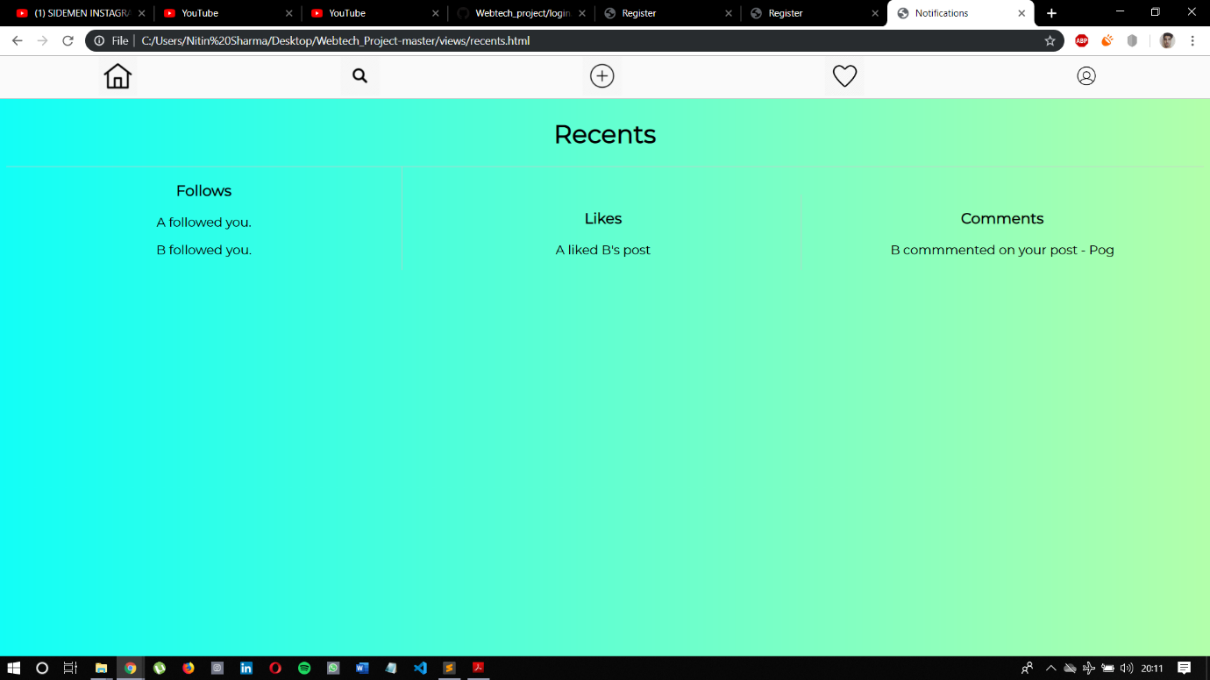

Profile

