
A Project Report On
“Job and Internships Management”
Submitted to

Savitribai Phule Pune University
DEVELOPED BY
1. Gadekar Samarth
2. Awate Santosh
In the partial Fulfillment of the degree of
Bachelor of Vocational (Software Development) (Sem- III)
(2026 -2027 )
Under the Guidance Of
Manisha Y. Khairnar.
Pune District Educations Association’s
Baburaoji Gholap College,
Department of Software Development
Sangvi, Pune-411027.
P.D.E.A’s
Baburaoji Gholap College, Sangvi, Pune - 27.
Department of Software Development
Certificate
Savitribai Phule Pune University
This is to certify that the project entitled
“Job & Internship Management”
has been successfully completed by
1. Gadekar Samarth
2. Awate Santosh
as a requirement of examination of B.Voc Software Development course of Savitribai Phule, Pune University Year(2026-2027)

Project Guide Ms. S. A. Kadam
Head Dept. of B.Voc(SD)
Manuscript
This manuscript has been read satisfactorily for “Job & Internship Management” of the project requirements for the Examination.
Examination committee
Date Name Signature

- ________________________

- ________________________

- ________________________

ACKNOWLEDGEMENT
It is our privilege to express our sincerest regards to our project guide, Manisha Y. Khairnar for valuable input, guidance, encouragement, wholehearted cooperation and constructive criticism throughout the duration of our project.
We deeply express our sincere thanks to our Head of Department Ms. S. A. Kadam for encouraging and allowing us to present the project on the topic “Job & Internship Management” at our department premises for the partial fulfillment of the requirements leading to the award of B.Voc (Software Development).
We take this opportunity to thank all our lecturers who have directly or indirectly helped with our project. We pay our respects and love to our parents and all other family members and friends for their love and encouragement throughout our career. Last but not the least we express our thanks to our friends for their cooperation and support.
We are also grateful to Savitribai Phule Pune University and Baburaoji Gholap College, Sangvi, for providing the academic environment, laboratory facilities and learning resources that made it possible to plan, develop and test this project. The knowledge gained through the B.Voc (Software Development) curriculum formed the foundation on which FresherFlow was built.
Finally, we thank everyone who took the time to review the application, share their suggestions and point out improvements. Their feedback helped us refine the features, the interface and this report.

Index
P.D.E.A.’S BABURAOJI GHOLAP COLLEGE, SANGVI, PUNE
Sr. No. | Title
1 | Introduction  1.1 Motivation  1.2 Problem Statement  1.3 Purpose/Objective and goals  1.4 Literature survey  1.5 Project scope and limitations
2 | System analysis  2.1 Existing Systems  2.2 Scope and limitations of existing systems  2.3 Project perspective, features  2.4 Stakeholders  2.5 Requirement analysis – Functional, performance and security requirements
3 | Implementation details – software/hardware specifications
4 | System Design  4.1 Design constraints – Normalized Database Design and Data Dictionary  4.2 Data Model – FDD, ER, Architecture, DFD Level 0, Use Case and Login Flowchart  4.3 User Interfaces  4.3.1 Menus  4.3.2 Input Screens using sample data  4.3.3 Output Screens  4.4 Reports and Graphs using sample data
5 | Testing – Black Box Testing / Data Validation and White Box / Functional Validation Test Cases
6 | Conclusion and Recommendations
7 | Future Scope
8 | Bibliography and References

1. Introduction
FresherFlow is a web-based recruitment portal designed to connect students seeking opportunities with employers posting vacancies. It provides a centralized platform for job discovery, applications, resume submission, saved jobs, and application tracking.
The application is built with Python, Flask, and SQLite, with HTML, CSS, and JavaScript for the user interface. It supports student, employer, and administrator roles, each with role-appropriate features for managing profiles, vacancies, applications, and platform activity.
The main objective of this project is to simplify recruitment workflows, improve access to job opportunities, and organize hiring information in one convenient platform.
The portal is designed around three types of users. Students build a profile, discover vacancies, save jobs, upload resumes and apply. Employers maintain an organization profile, publish vacancies one by one or in bulk from a spreadsheet, and review the applications they receive. Administrators supervise the platform by moderating vacancies, managing employer companies and monitoring activity. Each role sees only the features that are relevant to it.
This report documents the development of FresherFlow, from the problem and the requirements to the design, implementation, testing, conclusion and future scope.

1.1 Motivation:
FresherFlow was motivated by the difficulty fresh graduates face when finding suitable entry-level opportunities and the effort employers spend managing vacancies and applications across disconnected channels.
The portal offers a centralized way for students to discover relevant jobs and track applications while employers can publish and manage vacancies. It aims to reduce friction, improve organization, and make early-career recruitment more accessible.
Entry-level hiring is different from hiring experienced professionals. A fresh graduate has no work history to show, so the profile, the skills listed and the resume submitted become the main basis for the employer's decision. A graduate may also not know where to look, which vacancies are open to freshers, or whether an application has actually been seen.
Small and medium employers face the mirror image of this problem. They often lack a dedicated recruitment team or applicant tracking software, so vacancies are posted on social media, applications arrive by email and messaging apps, and resumes are scattered across inboxes.
Key factors that motivated the project:
- Lack of a single, trusted place where fresh graduates can find entry-level openings.
- Time employers spend collecting and replying to applications from different channels.
- Interest in applying Python, Flask and database concepts to a practical, useful application.

1.2 Problem Statement:
Job seekers often rely on scattered websites, social media posts, and informal referrals to find suitable opportunities. Employers may receive applications through multiple channels, making vacancy management and application tracking difficult.
FresherFlow addresses these problems through a web-based portal where students can search and save jobs, submit applications with resumes, and monitor application status, while employers can manage vacancies and review applications.
Problems faced by students:
- Vacancies are spread across job boards, social media pages, company websites and referrals, so important openings are easily missed.
- Many listings do not clearly state the requirements, location or deadline, which makes it hard to judge whether a role is suitable.
- The same personal and educational details have to be entered again and the resume attached again for every application.
- After applying, there is usually no clear way to know whether the application is in review, shortlisted or rejected.
Problems faced by employers:
- Applications arrive through email, forms and messages, which makes it difficult to keep one organized record.
- Vacancies must be posted separately on several platforms, and updating or closing them everywhere is tedious.
- Reviewing resumes and tracking the progress of each candidate manually is slow and error-prone.
- Publishing a large number of roles one at a time takes considerable effort.
Problems faced by administrators:
- Without a central system there is no easy way to verify employers, moderate vacancies or monitor activity across the platform.
- Inaccurate or inappropriate listings can reach students if no review step exists before a vacancy goes live.
Proposed solution:
FresherFlow brings these activities onto a single, role-based web portal. Students get one place to search, save and apply for jobs and to follow the status of every application. Employers get tools to publish vacancies individually or in bulk and to review applicants. Administrators get a moderation and oversight dashboard. By keeping all records in one database, the portal reduces duplication, improves transparency and saves time for everyone involved.

1.3 Purpose / Objectives and Goals:
The purpose of FresherFlow is to provide an accessible and organized platform for students, employers, and administrators to manage the recruitment process.
Objectives and Goals:
- To maintain student records and personal information systematically.
- To manage vacancy plans, employers, and vacancy expiry dates.
- To record and monitor applications and pending amounts.
- To maintain student application tracking records.
- To create and manage saved jobs for students.
- To manage recruitment portal vacancies, applications, and student platform activity.
- To provide separate login facilities for administrators and students.
- To reduce manual work, minimize errors, and improve the overall efficiency of recruitment portal management.
In more detail, the goals of the project can be described separately for each group of users and for the technical side of the system.
Goals for students:
- Provide a simple registration process and a profile that captures education, skills and preferred location.
- Let students upload a resume, save jobs for later and apply with a few clicks.
- Show the status of every application so that students always know where they stand.
Goals for employers and administrators:
- Help employers maintain an organization profile and publish, edit and close vacancies, including bulk publishing from a spreadsheet.
- Give employers a single list of applications with applicant information for quick review.
- Enable administrators to moderate vacancies, manage employer companies and monitor platform activity.
Technical goals:
- Build the application with Python, Flask and SQLite using a clean, maintainable structure.
- Design a normalized database with proper keys and relationships to avoid duplication.
- Apply password hashing, CSRF protection, input validation and role-based access to protect the system.

1.4 Literature Survey:
Recruitment platforms demonstrate how centralized web applications can make job discovery and hiring more efficient. Informal and disconnected methods make it difficult for students to find suitable opportunities and for employers to organize applications. A role-based recruitment portal can bring vacancy listings, resumes, and application status into one place.
Python, Flask, SQLite, and standard web technologies support lightweight, database-driven recruitment applications. Security practices such as password hashing, CSRF protection, input validation, and role-based access help protect user accounts and submitted information.
Based on these concepts, FresherFlow brings together student profiles, employer accounts, job vacancies, resume uploads, saved jobs, applications, application tracking, and administrative moderation in a single web application.
Technologies studied:
- Python: a high-level, readable programming language with a rich standard library. Its clear syntax makes it well suited for building the application logic of a web portal.
- Flask: a lightweight web framework that provides routing, request handling and templating while leaving the choice of other components to the developer. It is widely used for small and medium web applications.
- SQLite: a self-contained, serverless relational database stored in a single file. It needs no separate installation, which makes it ideal for development and modest deployments.
- HTML, CSS and JavaScript: the standard technologies used to structure, style and add interactivity to the pages that users see in the browser.
- Security practices: password hashing, CSRF protection, input validation and role-based access control, which are commonly recommended for web applications that store personal data.
Study of existing recruitment portals:
Online job portals generally offer profile creation, job search with filters, resume upload, application submission and employer dashboards. They are effective at connecting large numbers of people, but many are designed for the whole job market and can feel crowded or complex for a fresh graduate or for a small employer who only wants to post a few openings. Features such as bulk publishing, simple moderation and a clear application pipeline are not always easy to find in one place.
Findings of the survey:
- A centralized portal reduces the effort of searching and tracking opportunities.
- Role-based access is essential so that students, employers and administrators see only what they need.
- A lightweight stack such as Flask with SQLite is sufficient for a focused recruitment application.
- Security measures must be part of the design from the beginning rather than added later.

1.5 Project Scope and Limitations:
Project Scope:
FresherFlow is a web-based recruitment portal. Its scope includes:
- Student registration, login, and profile management.
- Employer registration and management of employer profiles.
- Job vacancy creation, editing, publishing, and closing.
- Job search and browsing with relevant listing details.
- Resume upload and job application submission.
- Saving jobs and tracking submitted applications.
- Employer review of applications and applicant information.
- Administrator moderation and employer management.
Limitations:
- The portal requires a compatible device and web browser to access the application.
- SQLite is suitable for development and modest deployments; larger deployments may require a production database and additional operational configuration.
- The quality of search and application results depends on accurate information supplied by students and employers.
- The portal supports recruitment workflows but does not guarantee job placement or independently verify every vacancy or resume.
- Advanced integrations such as third-party applicant tracking systems, automated interview scheduling, and external identity verification may require future development.
Assumptions and dependencies:
- Users have access to a modern web browser and an internet or local network connection.
- Students and employers provide accurate and up-to-date information in their profiles and vacancies.
- Resumes are uploaded in the file formats supported by the portal.
- Administrators review vacancies and employer accounts as part of normal platform operation.
Outside the current scope:
- Online payments, video interviews and automated background verification.
- A dedicated native mobile application.
- Integration with external applicant tracking systems.

2. System Analysis
System analysis studies the existing recruitment process, identifies its problems, and defines requirements for an improved solution. It clarifies the users, features, and technical needs of the proposed portal.
FresherFlow is a web application built with Python, Flask, and SQLite, with HTML, CSS, and JavaScript for its interface. It supports student, employer, and administrator roles and provides job listings, resume uploads, applications, saved jobs, and application tracking.
The analysis focuses on the challenges of scattered job information and manual application handling, and defines how a centralized portal can improve access, organization, and recruitment workflow visibility.
Approach followed for the analysis:
The analysis began with a study of how students and employers currently search for and manage vacancies. The problems found in this process were listed and converted into requirements. The requirements were then grouped by user role so that every feature could be designed, implemented and tested against a clear need.
- Study of the existing recruitment process.
- Identification of its limitations and pain points.
- Identification of stakeholders and their needs.
- Specification of functional, performance and security requirements.
- Review of the requirements against the proposed design.

2.1 Existing Systems
In many existing recruitment workflows, students search across multiple job boards, social media pages, and company websites. Employers may manage vacancies and candidate responses using separate forms, email, or spreadsheets.
These approaches can make it difficult to find relevant openings, keep application records organized, and understand the current status of each application.
Existing job platforms offer varying features, coverage, and access models; students and employers may still need several tools to complete the recruitment process.
FresherFlow provides a single portal for job discovery and application tracking for students, vacancy management for employers, and moderation tools for administrators.

2.2 Scope and Limitations of Existing Systems:
Scope of Existing Systems:
Existing recruitment systems commonly support activities such as:
- Creating job seeker profiles and storing contact details.
- Publishing vacancies and describing role requirements.
- Searching listings and submitting applications.
- Uploading resumes and reviewing candidate information.
- Tracking application status and managing recruitment records.
Limitations of Existing Systems:
- Disconnected channels require users to check multiple sources.
- Duplicate or inconsistent vacancy information can cause confusion.
- Application status may be difficult to track when communication is scattered.
- Finding suitable entry-level roles can take time.
- Email and spreadsheet records may be misplaced or become outdated.
- Some platforms may be expensive, complex, or unsuitable for the needs of fresh graduates and small employers.
FresherFlow aims to reduce these limitations with a centralized, role-based recruitment portal.
Comparison between existing methods and FresherFlow:
Aspect | Existing methods | FresherFlow
Job discovery | Search across several job boards and social media pages | Browse and search vacancies in one portal
Applying | Fill separate forms or send emails each time | Apply from the portal using the uploaded resume
Status tracking | Depends on replies by email or phone | Application status is visible to the student
Vacancy posting | Post separately on each platform or channel | Publish one role or many roles in bulk
Record keeping | Spreadsheets and inboxes that become outdated | Centralized database of vacancies and applications
Moderation | Usually informal or absent | Administrator approves or rejects vacancies

2.3 Project Perspective and Features
Project Perspective:
FresherFlow is a web-based recruitment portal built with Python and Flask, SQLite for data storage, HTML, CSS, and JavaScript for the user interface. Separate student, employer, and administrator roles provide access to relevant features.
Key Features:
- User Authentication: Secure login and role-appropriate access for students, employers, and administrators.
- Student Profiles: Maintain student details and job-seeking information.
- Employer Profiles: Allow employers to maintain organization and contact information.
- Vacancy Management: Create, update, and manage job listings.
- Job Search: Browse and discover available opportunities.
- Resume Upload: Attach resume files to applications.
- Job Applications: Submit applications and review application records.
- Saved Jobs: Bookmark vacancies for later reference.
- Application Tracking: View the status of submitted applications.
- Employer Tools: Review applications and manage vacancy responses.
- Admin Dashboard: Manage platform users and oversee recruitment activity.
- Moderation: Support review of vacancies and employer accounts where required.
These features help organize recruitment activities and improve visibility for students and employers.
Role-wise summary of features:
Role | Main features available
Student | Register and sign in, maintain profile, browse and search vacancies, save jobs, upload resume, apply, track application status.
Employer | Maintain organization profile, post and manage vacancies, bulk publish from an Excel file, review applications, change password.
Administrator | View platform overview, moderate vacancies, review applications, add and manage employer companies.

Operating environment:
FresherFlow runs as a Flask application on a computer or server with Python 3.11 or later. Users access it through a modern web browser, and all data is stored in an SQLite database file. The same code can be run on Windows, macOS or Linux.

2.4 Stakeholders:
Stakeholders are the people who interact with or benefit from FresherFlow.
The main stakeholders of the project are:
- Student: Creates a profile, searches for vacancies, saves jobs, uploads a resume, applies, and tracks application status.
- Employer: Maintains an employer profile, posts vacancies, and reviews submitted applications.
- Administrator: Oversees user accounts, supports moderation, and maintains platform integrity.
- Project Developer: Designs, develops, tests, and maintains the application.
Needs and expectations of the stakeholders:
Stakeholder | What they expect from the system | How they use the system
Student | Easy discovery of suitable entry-level roles and clear visibility of application status. | Registers, builds a profile, searches, saves jobs, uploads a resume and applies.
Employer | A simple way to publish vacancies and to review applicants in an organized manner. | Maintains the organization profile, posts or bulk publishes roles, reviews applications.
Administrator | Control over the quality of vacancies and the accounts present on the platform. | Moderates jobs, manages companies and monitors overall activity.
Project Developer | A maintainable code base and a reliable database design. | Designs, develops, tests and maintains the application.

The interaction between these stakeholders is what drives the portal. Employers publish vacancies, administrators review them, students discover and apply to them, and employers then review the applications they receive. FresherFlow keeps a record of every step in this cycle so that each stakeholder can see the information that concerns them.

2.5 Requirement Analysis:
Requirement analysis identifies the hardware, software, functional, performance, and security requirements needed to develop and operate FresherFlow.
1. Hardware Requirements
- Processor: Dual-core processor or higher
- RAM: Minimum 4 GB
- Storage: At least 1 GB of free disk space
- Device: Desktop computer or laptop
2. Software Requirements
- Operating System: Windows, macOS, or Linux
- Programming Language: Python 3.11 or later
- Web Framework: Flask 3.x
- Database: SQLite
- Frontend: HTML, CSS, JavaScript
- Code Editor: Visual Studio Code or another Python-compatible editor
- Web Browser: Google Chrome, Microsoft Edge, Mozilla Firefox, or another modern browser
3. Functional Requirements
The system should provide the following functions:
- Register and authenticate students, employers, and administrators.
- Maintain student and employer profiles.
- Create, edit, publish, and manage job vacancies.
- Search and browse vacancies and view job details.
- Upload resumes and submit applications.
- Save jobs and track application status.
- Allow employers to review applications and manage vacancy responses.
- Provide administrative oversight and moderation features.
4. Non-Functional Requirements
- Usability: The interface should be clear and straightforward for all user roles.
- Security: Protect accounts and restrict features according to user roles; use password hashing, CSRF protection, and input validation.
- Reliability: Store and retrieve profiles, vacancies, and application records accurately.
- Performance: Common browsing and submission operations should complete in a reasonable time.
- Maintainability: Keep the application structured so features can be tested and updated.
5. Performance Requirements
- Pages such as the dashboards, vacancy lists and application lists should load quickly under normal usage.
- Searching and filtering vacancies should return results without noticeable delay.
- Form submissions, including resume upload and application submission, should complete in a reasonable time.
- The application should handle several users working at the same time within the limits of the chosen database.
6. Security Requirements
- Passwords must be stored only as secure hashes and never as plain text.
- Forms must be protected against cross-site request forgery (CSRF).
- All user inputs must be validated before being processed or stored.
- Role-based access must ensure that students, employers and administrators can open only their own pages.
- Uploaded resume files must be checked for the allowed type before they are accepted.
7. Other Requirements
- Portability: the system should run on Windows, macOS and Linux without changes to the code.
- Data integrity: applications and saved jobs must always refer to valid students and vacancies.
- Scalability: the structure should allow a move from SQLite to a production database in the future.
8. Design Constraints and Assumptions
- The system is developed with Python, Flask and SQLite and runs in a web browser.
- Users are assumed to provide accurate information in their profiles and vacancies.
- Uploaded resumes must be in the file types accepted by the portal.
- The portal supports the recruitment process but does not verify every vacancy or resume independently.

3. Implementation details-software/hardware specifications
FresherFlow is implemented as a web application using Python and Flask. SQLite stores application data, while HTML, CSS, and JavaScript provide the user interface. The portal supports student, employer, and administrator workflows.

3.1 Software Specifications
The following software technologies are used in the project:
- Operating System: Windows, macOS, or Linux
- Programming Language: Python 3.11+
- Web Framework: Flask 3.x
- Database: SQLite
- Frontend Technologies: HTML, CSS, JavaScript
- Code Editor: Visual Studio Code
- Web Browser: Google Chrome, Microsoft Edge, Mozilla Firefox, or another modern browser
- Security: Password hashing, CSRF protection, validation, and role-based access
Purpose of each technology:
Component | Technology | Purpose in FresherFlow
Programming language | Python 3.11+ | Application logic, validation and communication with the database
Web framework | Flask 3.x | Routing, request handling, sessions and rendering of pages
Database | SQLite | Storage of users, profiles, vacancies, resumes, saved jobs and applications
Front end | HTML, CSS, JavaScript | Layout, styling and interactivity of the user interface

Why these technologies were chosen:
- Python and Flask are easy to learn, well documented and suitable for a complete web application with a small code base.
- SQLite needs no separate server installation, so the project can be set up and demonstrated on any computer.

3.2 Hardware Specifications
The minimum hardware requirements for running the application are:
- Processor: Dual-core processor or higher
- RAM: 4 GB or more
- Storage: At least 1 GB of free disk space
- Device: Desktop computer or laptop
- Input Devices: Keyboard and mouse
- Display: Standard monitor or laptop display
- Network: Internet or local network connectivity, depending on deployment
The storage requirement grows with the number of uploaded resumes and the size of the database. For a small deployment such as a college placement activity, the minimum configuration is sufficient. Larger deployments should use more memory and storage and a production database, as described in the future scope.

3.3 Implementation Overview
Flask handles application routing, request processing, and application logic. SQLite stores records related to users, employers, vacancies, resumes, saved jobs, and applications. Access is controlled according to the user’s role.
HTML, CSS, and JavaScript are used to create the web interface. Student features focus on job discovery and applications, employer features support vacancy and applicant management, and administrative features support oversight and moderation.
Together, these technologies provide a lightweight and maintainable solution for early-career recruitment workflows.
Layers of the application:
- Presentation layer: HTML, CSS and JavaScript pages that display forms, tables and dashboards.
- Application layer: Flask routes and Python functions that process requests, validate data and apply the rules of each role.
- Data layer: SQLite tables that store all records and keep them connected through keys and relationships.
Every request follows the same path: the browser sends the request to a Flask route, the user's login status and role are checked, the validation and logic are executed, the database is read or updated, and a response page is returned. Because the role check comes first, a student cannot open employer pages and an employer cannot open administrator pages.

3.4 Module Description
FresherFlow is divided into modules that correspond to the three user roles. Each module contains the screens and functions required by that role.
Student Module
- Registration and sign in with education details, skills, preferred location and resume.
- Dashboard with available jobs, applications, shortlisted and selected counts and saved jobs.
- Find Opportunities page to browse vacancies, save jobs and apply.
- My Applications and My Profile pages to track status and view academic and career details.
Employer Module
- Dashboard showing live vacancies, applications received, shortlisted and selected candidates.
- Post Vacancy and My Vacancies pages to create, edit, publish and close roles.
- Bulk Publish page to upload an Excel (.xlsx) file or enter several roles in a table.
- Applications, Organization Profile and Change Password pages.
Administrator Module
- Overview dashboard showing companies, total jobs, pending reviews and applications.
- Job Moderation to search, filter, approve or reject vacancies with an optional note.
- Applications list, Add New Employer and Companies pages to manage the platform.

3.5 Security Implementation
Security is treated as a core part of the implementation because the portal stores personal details, resumes and login credentials. The following measures are applied.
- Authentication: users must sign in with valid credentials before opening protected pages.
- Password hashing: passwords are stored as hashes, never as plain text.
- Role-based access control: each page and action is available only to the roles allowed to use it.
- CSRF protection: forms are protected so that requests cannot be forged from another website.
- Input validation: required fields, formats and permitted values are checked before data is saved.
- File handling: uploaded resumes are checked for type and linked to the correct student and application.

4. System Design

4.1 Design Constraints – Normalized Database Design and Data Dictionary:
FresherFlow uses SQLite to store and manage application data. The database organizes user accounts, student and employer profiles, vacancies, saved jobs, resume details, and applications into related records.
The main design constraints are:
- Data Integrity: Records must be stored accurately and consistently.
- Data Redundancy: Unnecessary duplication of information should be minimized.
- Primary Keys: Each record is identified using a unique primary key.
- Foreign Keys: Related tables are connected using foreign keys.
- Referential Integrity: Applications and saved jobs are linked to the relevant user and vacancy records.
- Optional Relationships: Some profile or resume details may be optional depending on the workflow.
- Data Security: Authentication, role-based access, password hashing, CSRF protection, and validation help protect user actions and information.
B. Normalized Database Design
The database separates related information into tables to reduce duplication and simplify data management.
The main tables are:
- User: Stores account credentials and role information.
- StudentProfile: Stores student profile and job-seeking details.
- EmployerProfile: Stores employer and organization details.
- Job: Stores vacancy title, description, requirements, location, and publication status.
- Application: Stores the student, vacancy, resume reference, submission date, and application status.
- SavedJob: Stores vacancies bookmarked by students.
- Resume: Stores resume file metadata and its association with a student.
- EmployerImport: Supports vacancy data imported by an employer, including spreadsheet-based imports where enabled.
- Admin records: Support administrative oversight and moderation actions.
- Security and validation logic helps maintain consistent data and restrict access to authorized users.
The database uses keys and relationships to connect accounts, profiles, vacancies, saved jobs, resumes, and applications. This structure supports the major functions of FresherFlow.
Normalization applied:
- First normal form: every field holds a single value and every table has a primary key, so there are no repeating groups.
- Second normal form: every non-key field depends on the whole primary key of its table.
- Third normal form: fields that describe another entity, such as an employer's organization details, are kept in their own table and linked by a foreign key.
C. Data Dictionary
A data dictionary describes the tables, fields, and purposes of the database.

1. User Table
Field | Description
id | Primary key
username | Login username
password | Secure password hash
email | User email address
role | Role: STUDENT, EMPLOYER, or ADMIN
Note: Account credentials should be stored using secure password hashing; raw passwords should never be stored.

2. StudentProfile Table
Field | Description
id | Primary key
user_id | Foreign key referencing User
full_name | Student’s full name
skills | Skills and qualifications
location | Preferred location

3. EmployerProfile Table
Field | Description
id | Primary key
user_id | Foreign key referencing User
organization | Employer organization
contact_email | Employer contact email
website | Organization website

4. Job Table
Field | Description
id | Primary key
employer_id | Foreign key referencing EmployerProfile
title | Job title
description | Job description
location | Job location
status | Vacancy status

5. Application Table
Field | Description
id | Primary key
student_id | Foreign key referencing StudentProfile
job_id | Foreign key referencing Job
resume_id | Resume reference
applied_at | Application submission date
status | Application status
notes | Additional application details
updated_at | Last update date
source | Application source
reviewed_by | Authorized reviewer

6. SavedJob Table
Field | Description
id | Primary key
student_id | Foreign key referencing StudentProfile
job_id | Foreign key referencing Job
saved_at | Date job was saved
Constraint: Application and saved-job records should reference valid users and vacancies to preserve data integrity.

7. Resume Table
Field | Description
id | Primary key
student_id | Foreign key referencing StudentProfile
file_name | Uploaded resume filename
file_path | Stored file reference
uploaded_at | Upload date
file_type | Resume file type
is_active | Indicates current resume

8. EmployerImport Table
Field | Description
id | Primary key
employer_id | Foreign key referencing EmployerProfile
file_name | Imported spreadsheet filename
imported_at | Import date and time
status | Import processing status
rows_processed | Number of rows processed

9. AdminActivity Table
Field | Description
id | Primary key
user_id | Foreign key referencing User
action | Administrative action
created_at | Action date and time
details | Additional action details
status | Review status

10. Feedback Table
Field | Description
id | Primary key
user_id | Foreign key referencing User
message | Feedback or report message
created_at | Submission date and time
D. Database Relationships
- One user account is associated with one student profile.
- One employer profile can publish multiple job vacancies.
- Each job vacancy belongs to one employer profile and can receive multiple applications.
- One student profile can submit multiple applications for different vacancies.
- Each application links one student profile to one job vacancy and stores its application status.
- One student profile can save multiple jobs, and each job can be saved by multiple students through SavedJob records.
- One student profile can have multiple resume records, with an active resume identified where applicable.
- Employer imports, administrative activity, and feedback are stored as separate records linked to the relevant employer or user account.
The database design provides a structured way to store recruitment information, maintain relationships between records, and support the major functions of FresherFlow.

4.2 Data Model
The data model of FresherFlow describes the structure, functionality, and flow of information within the portal. It includes functional decomposition, entity relationships, system architecture, data flow, use cases, and the login flow.
1. FDD Diagram:
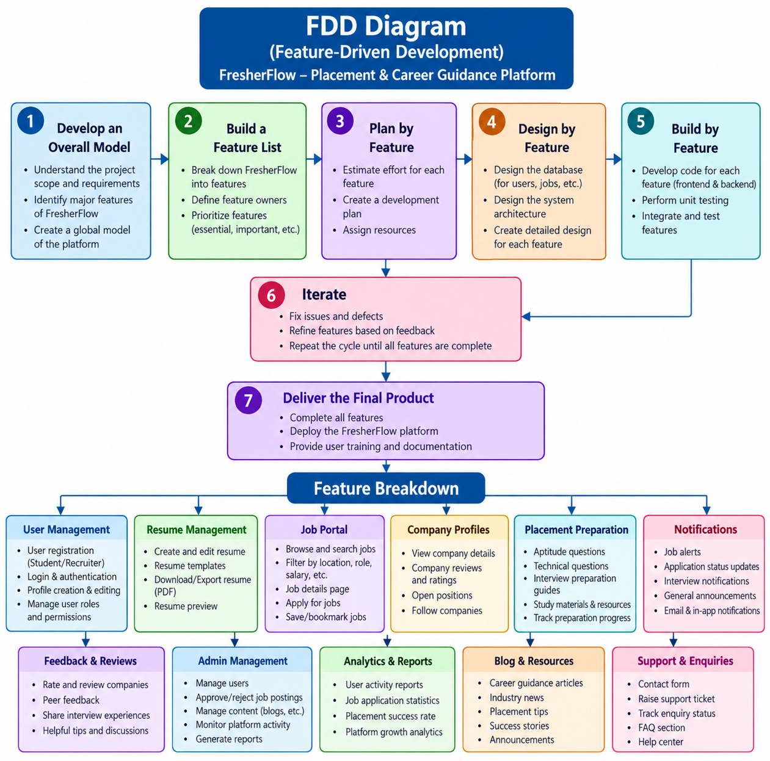
Figure 4.2: Functional Decomposition Diagram of Job & Internship Management
The functional decomposition diagram breaks the portal down from the main system into its major functions and then into smaller sub-functions. It shows at a glance which activities belong to students, employers and administrators and helps in planning the modules described in Chapter 3.

2. Entity Relationship (ER) Diagram
The ER diagram shows the main entities of FresherFlow (Student, Application, Vacancy, Employer, Company, User Account, Admin, Education, Skill, Notification and To-Do), their attributes, and the relationships between them with one-to-many cardinality. Primary keys are underlined.
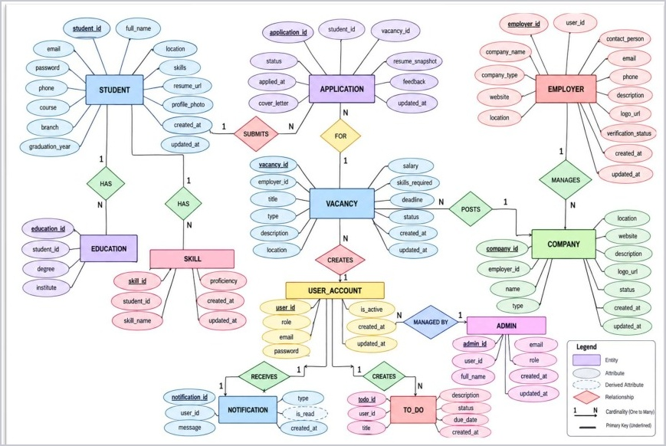
How to read the ER diagram:
- Rectangles represent entities, such as Student, Vacancy, Application and Employer.
- Ovals represent the attributes of an entity, and the primary key of each entity is underlined.
- Lines represent relationships, and their cardinality is one-to-many in most cases.
- Examples: one employer can post many vacancies, one student can submit many applications, and one vacancy can receive many applications.
These relationships are implemented in the database through foreign keys, as described in the data dictionary and the database relationships earlier in this chapter.

3. System Architecture Diagram
The system follows a web-based architecture in which users interact with the frontend, Flask processes requests, and SQLite stores application data.
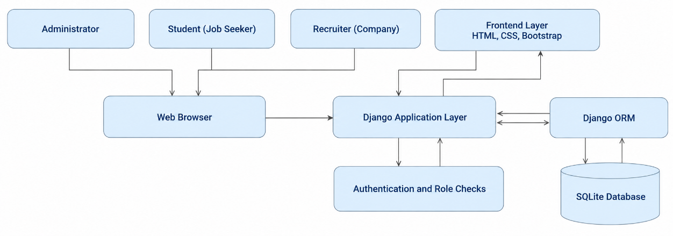
Layers shown in the architecture:
- Users and browser: students, employers and administrators interact with the pages shown in a web browser.
- Flask application: receives each request, checks the user's role, validates the data and prepares the response.
- SQLite database: stores users, profiles, vacancies, resumes, saved jobs and applications.

4. Data Flow Diagram (DFD) Level 0
The Level 0 DFD shows FresherFlow as one main process and illustrates the exchange of information between students, employers, administrators, and the portal.
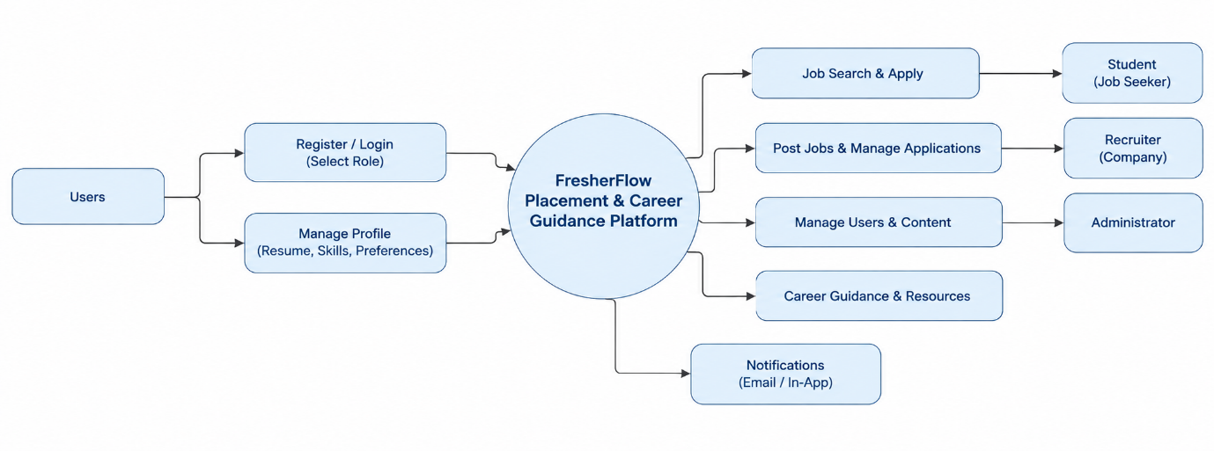
Data flows shown in the Level 0 DFD:
- Students send registration, sign-in, profile, resume and application data and receive vacancy details and application status.
- Employers send organization details and vacancies and receive the applications submitted for their roles.
- Administrators send moderation decisions and employer details and receive overview and activity information.

5. Use Case Diagram
The use case diagram identifies the main activities performed by students, employers, and administrators.
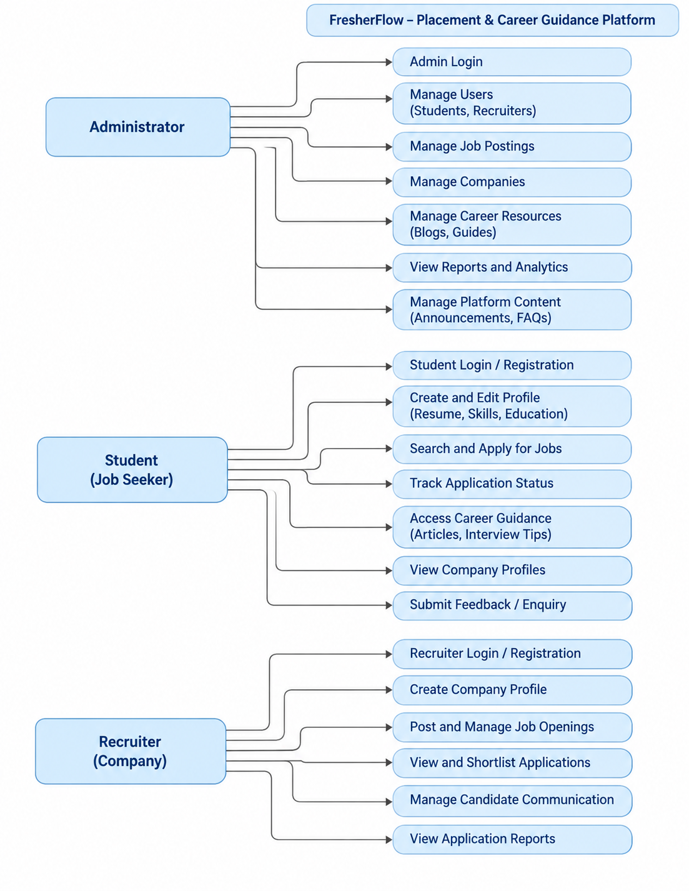
Students search, save and apply for jobs and track applications. Employers post vacancies, bulk publish and review applications. Administrators moderate vacancies and manage companies.

6. Login Flowchart
The login flowchart illustrates how the portal validates credentials and checks the user’s role before allowing access.
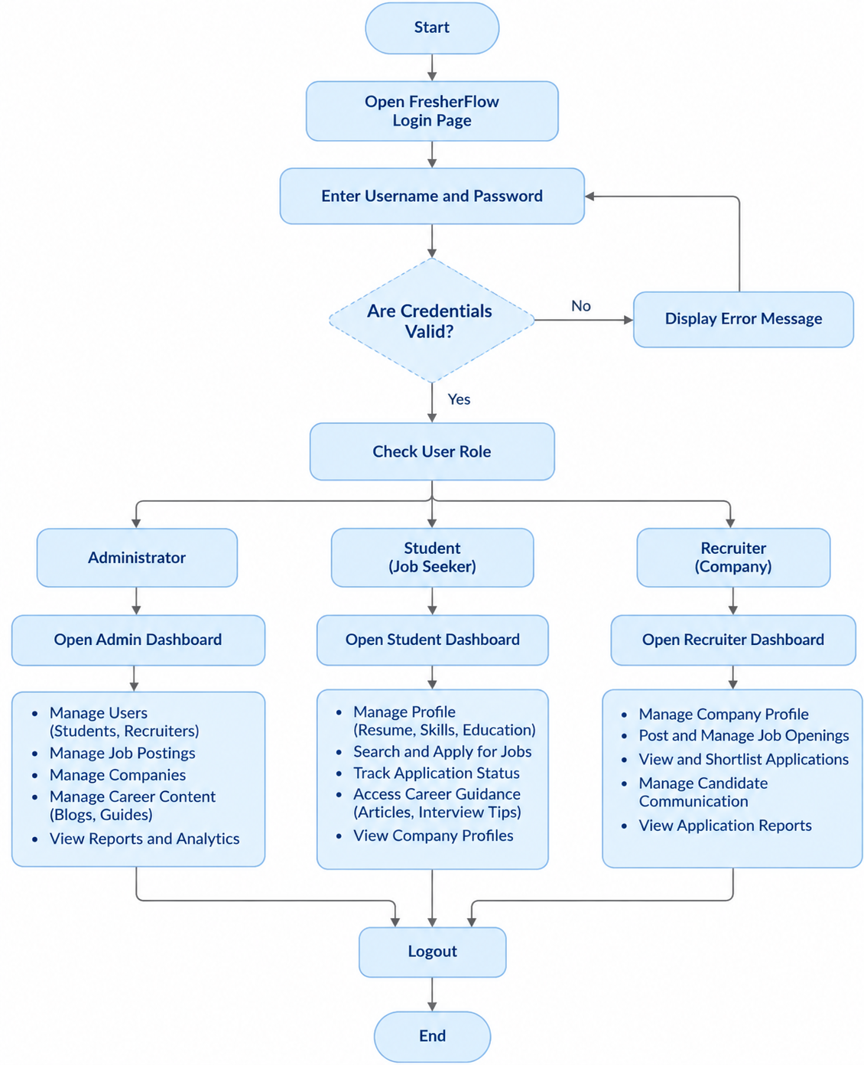
The user enters the sign-in details and the system validates them. Invalid credentials return an error message; valid credentials lead to the student, employer or administrator dashboard according to the role.

4.3 User Interfaces
FresherFlow provides a straightforward web interface built with HTML, CSS, and JavaScript. The interface exposes features according to whether the user is a student, employer, or administrator.

4.3.1 Menus:
The navigation menu changes according to the user’s authentication status and role, providing access to the relevant recruitment features.
1. Administrator Menu
The administrator menu contains options for moderating vacancies, reviewing applications, and managing employer companies.
- Overview
- Job Moderation
- Applications
- Add New Employer
- Companies
- Log out
2. Employer Menu
- Dashboard
- My Vacancies
- Post Vacancy
- Bulk Publish
- Applications
- Organization Profile
- Change Password
- Log out
3. Student Menu
- Dashboard
- Find Opportunities
- My Applications
- My Profile
- Log out
4. Login Navigation Menu
For users who are not logged in, the navigation bar of the home page provides the following options:
- Features
- How it works
- Sign in
- Get started
Navigation options depend on the user’s role. Students can search and apply for jobs, employers can manage vacancies and applicants, and administrators can oversee platform activity.
FresherFlow contains forms that allow students, employers, and administrators to enter and manage recruitment information. The following screens demonstrate the data-entry functionality of the system.

4.3.2 Input Screens using sample data

1. Student Registration and Sign In
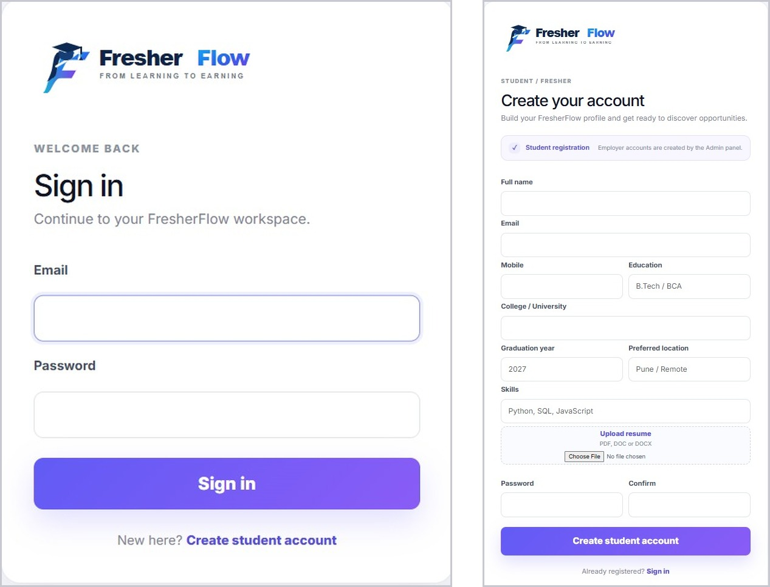
The right screen allows a new student to create an account by entering the full name, email, mobile number, education, college or university, graduation year, preferred location, skills, resume, and password. The left screen allows users to sign in to their FresherFlow workspace using their email and password.

2. Organization Profile
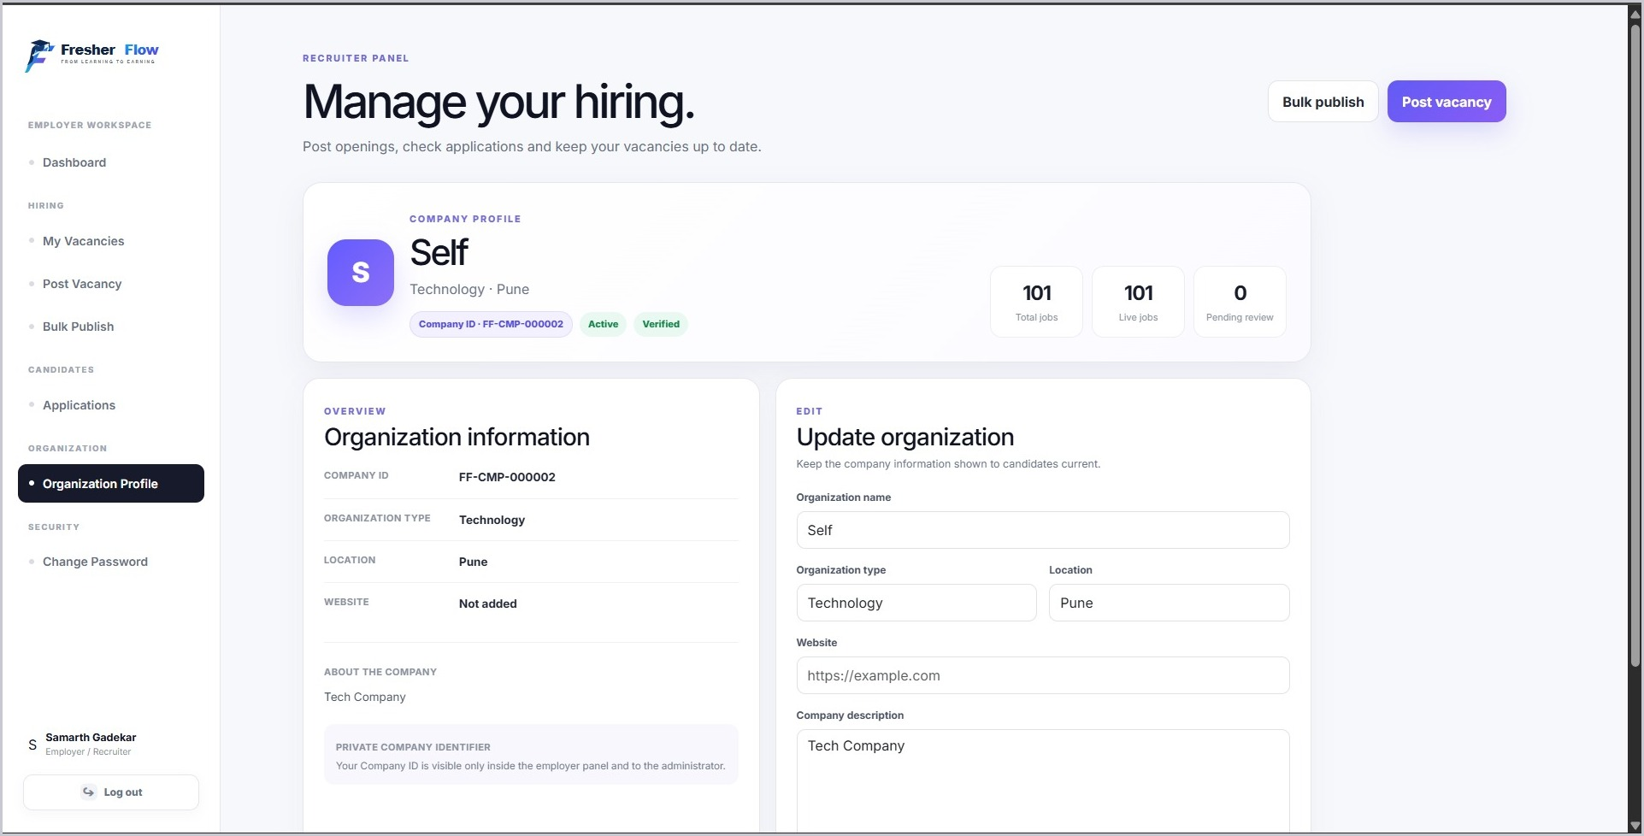
This screen allows an employer to view and update organization details such as the organization name, type, location, website, and company description.

3. Bulk Publish Vacancies
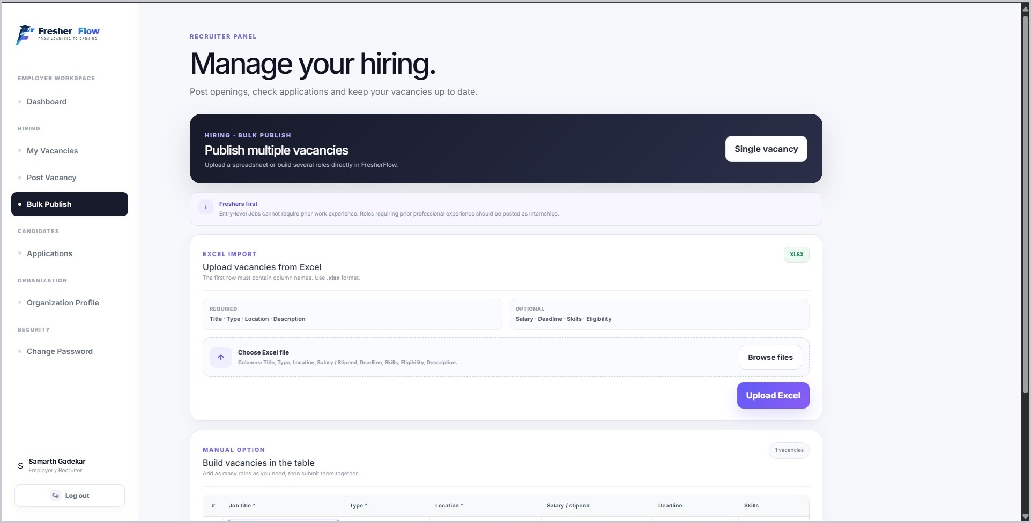
This screen allows an employer to publish multiple vacancies by uploading an Excel (.xlsx) file with the required columns (Title, Type, Location, Description) and optional columns (Salary, Deadline, Skills, Eligibility), or by entering several roles manually in a table.

4. Add New Employer
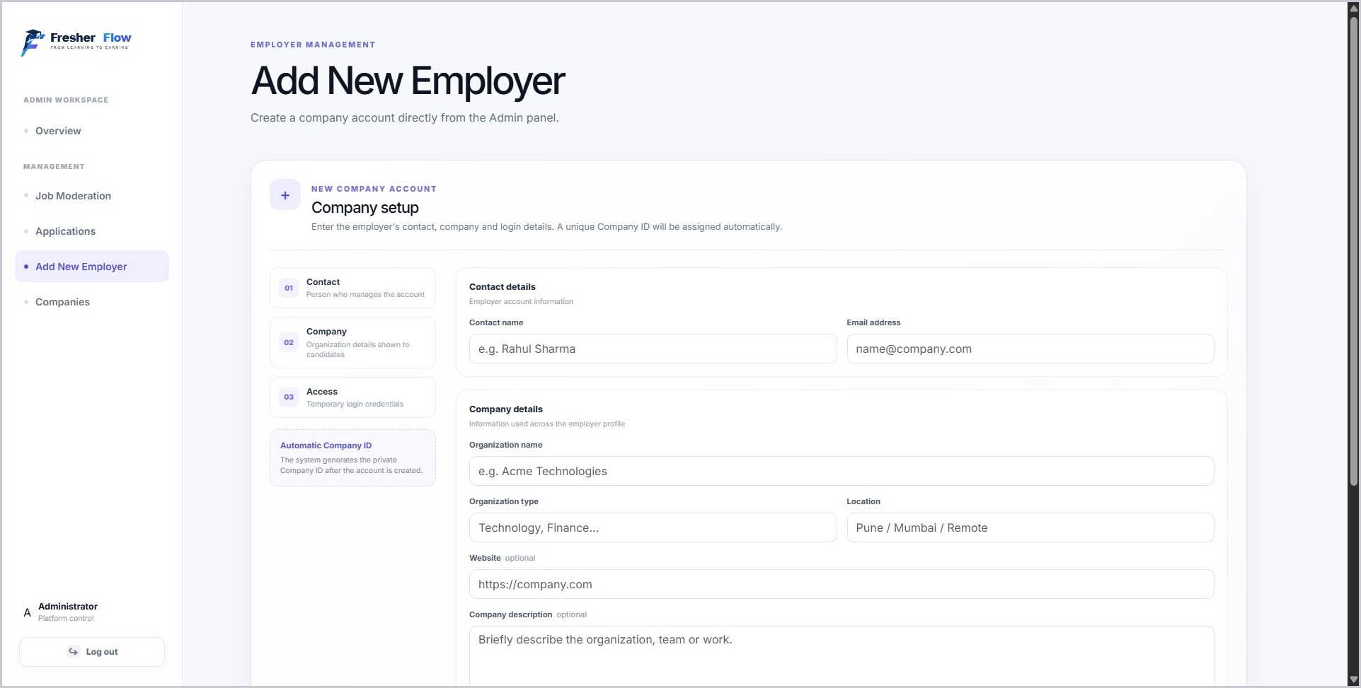
This screen allows the administrator to create a company account by entering contact details, company details, and temporary login credentials. A unique Company ID is assigned automatically.
Common behavior of the input screens:
- Required fields are checked before the form is submitted, and a message is shown when information is missing.
- Forms are protected against forged requests, and the entered data is validated before it is saved.
- Sample data is used on these screens only to illustrate how each form is filled in.
- After a successful submission, the user is shown the updated record or a confirmation.

4.3.3 Output Screens
Public Output Screens

1. Home Page
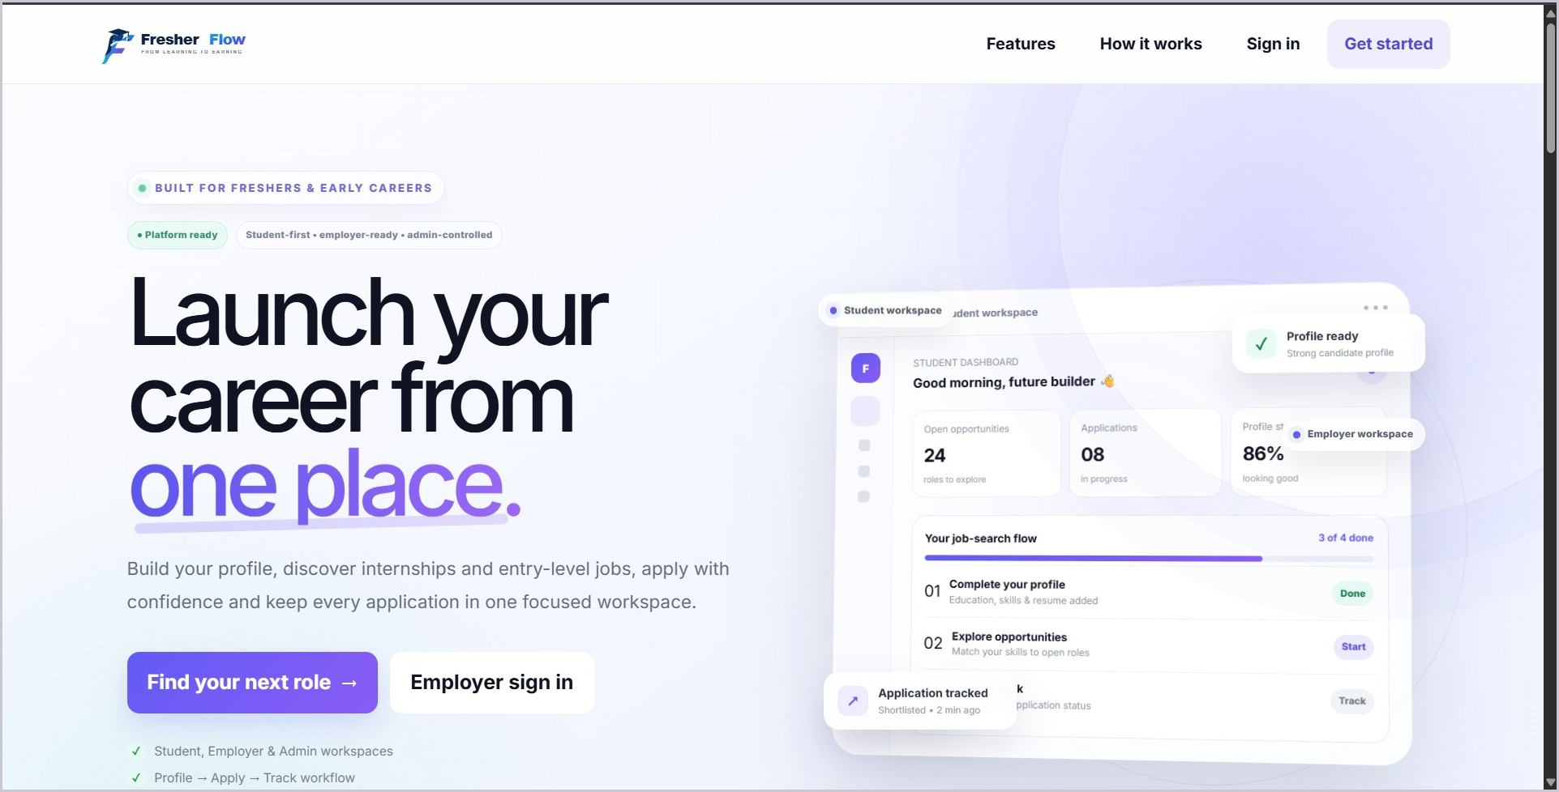
The home page introduces FresherFlow and provides links to Features, How it works, Sign in, and Get started, along with options for students to find a role and for employers to sign in.
Main elements of the home page:
- Navigation bar with Features, How it works, Sign in and Get started.
- Call-to-action buttons for students to find a role and for employers to sign in.
- A short introduction to the platform and its benefits for both students and employers.
Admin Output Screens
The administrator output screens display information overseen by platform administrators. They support monitoring companies, vacancies, applications, and other recruitment activity.

1. Admin Overview
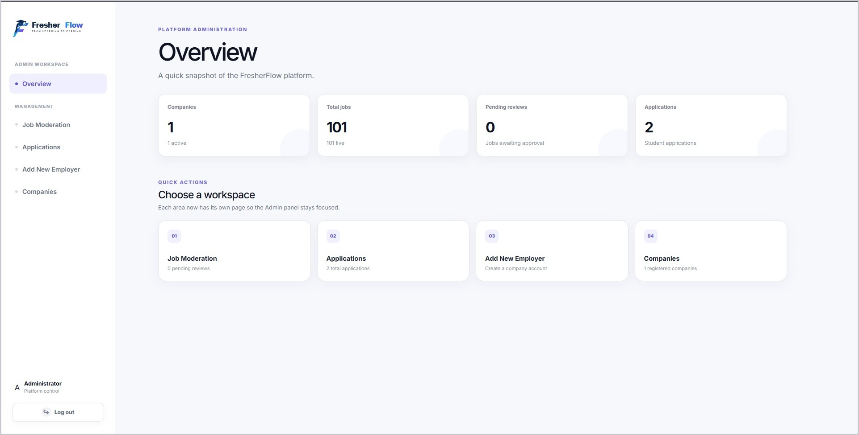
The overview dashboard summarizes platform activity, including the number of companies, total jobs, pending reviews, and applications, and provides quick actions for Job Moderation, Applications, Add New Employer, and Companies.

2. Job Moderation
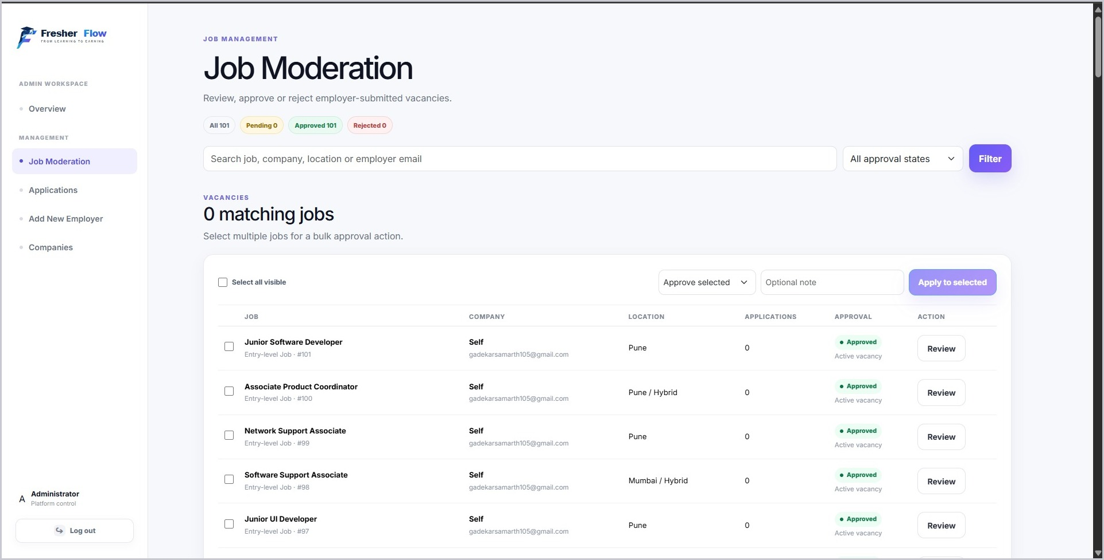
This screen allows the administrator to search and filter vacancies by approval state, review each job, and approve or reject selected vacancies with an optional note.

3. Applications List
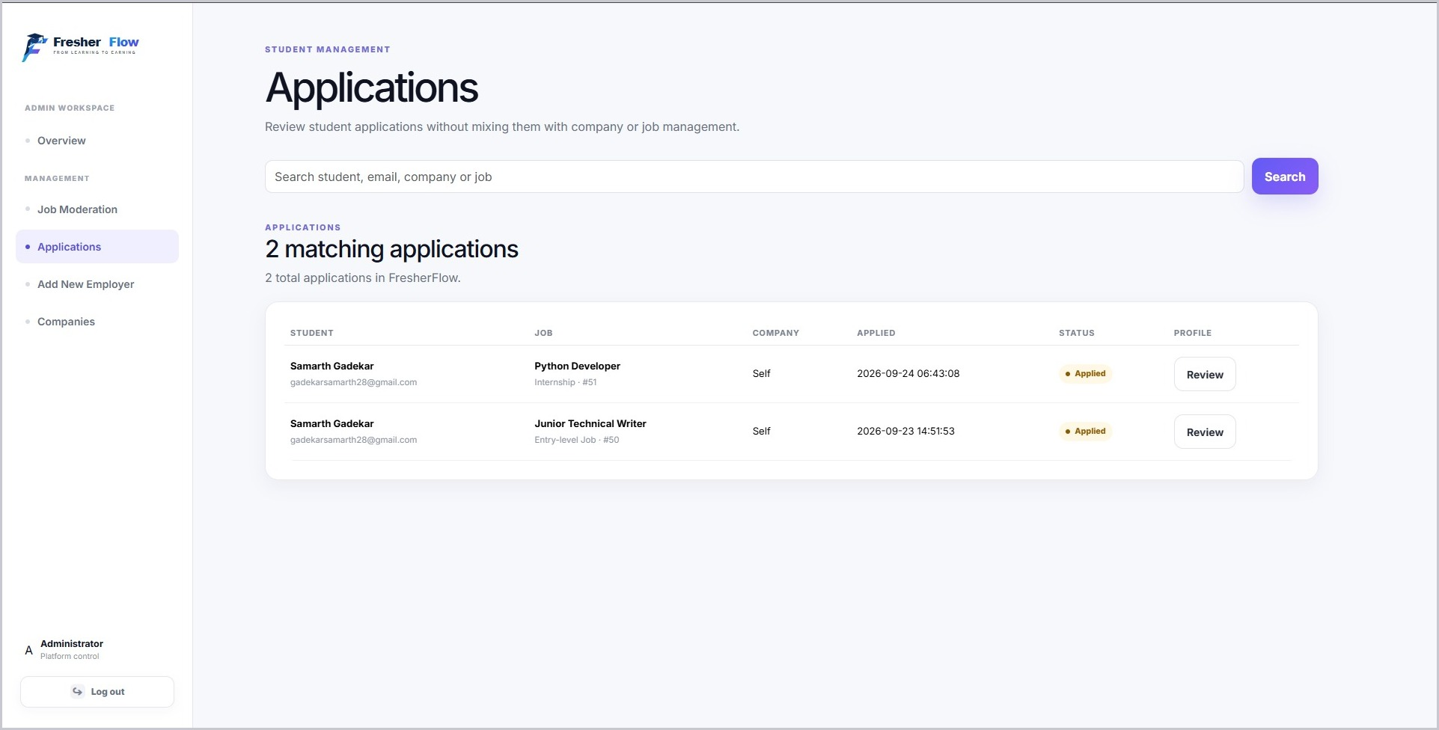
This screen displays submitted applications, including the student name and email, job, company, applied date and time, and application status, with a Review option for each application.

4. Companies List
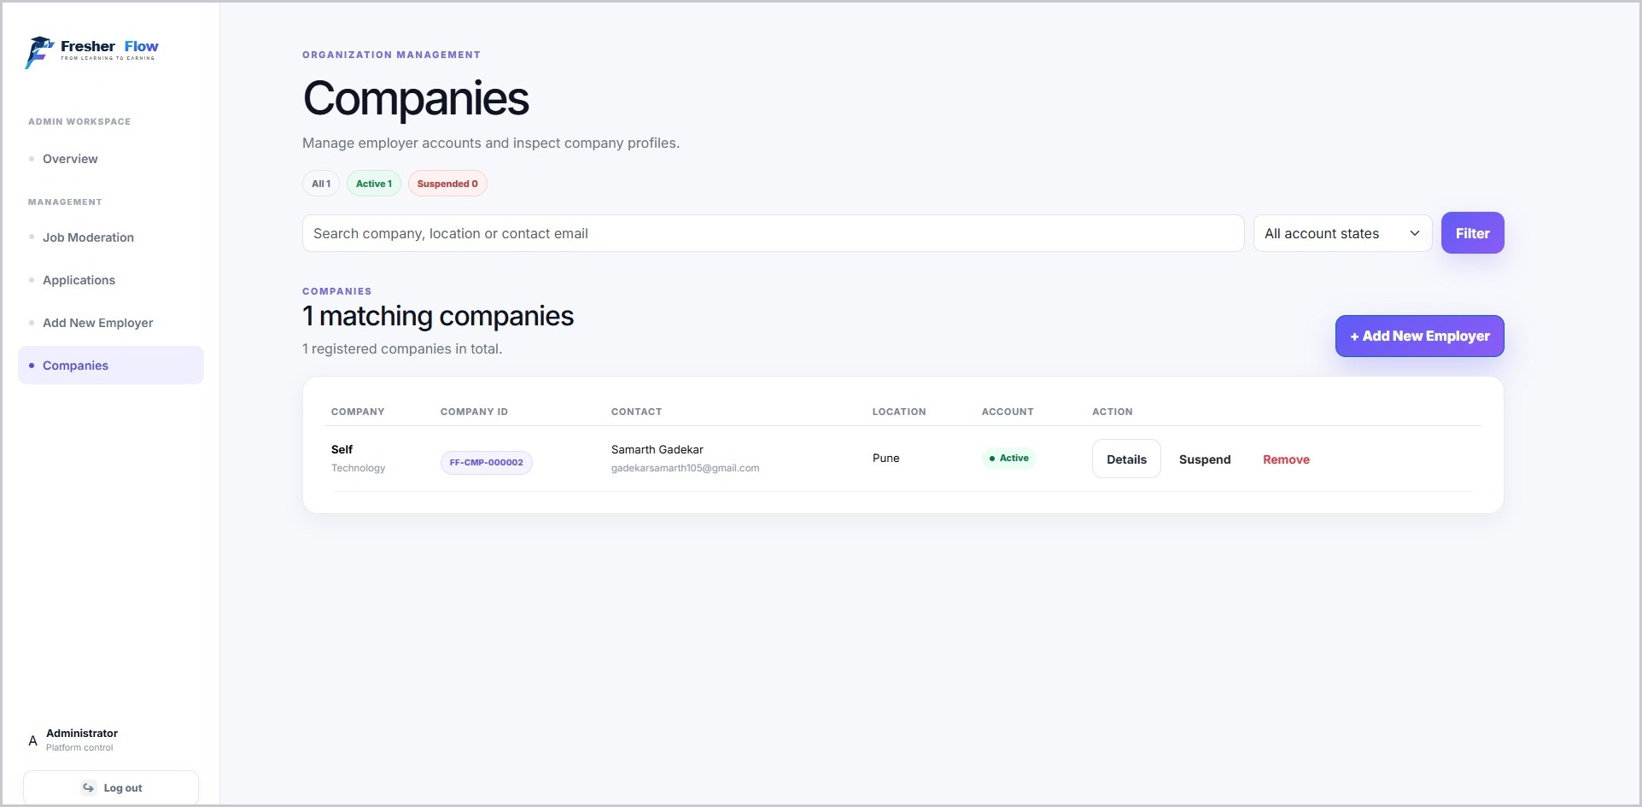
This screen displays registered employer companies with their Company ID, contact person, location, and account status. The administrator can view details, suspend, or remove a company, or add a new employer.
Employer Output Screens
The employer output screens allow recruiters to monitor vacancies and applications and to manage their posted roles.

1. Employer Dashboard
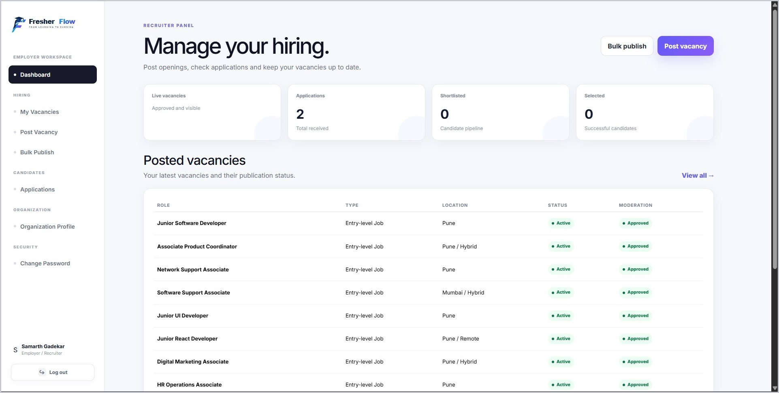
The dashboard shows live vacancies, applications received, shortlisted candidates, and selected candidates, along with a table of posted vacancies showing role, type, location, status, and moderation status.

2. My Vacancies
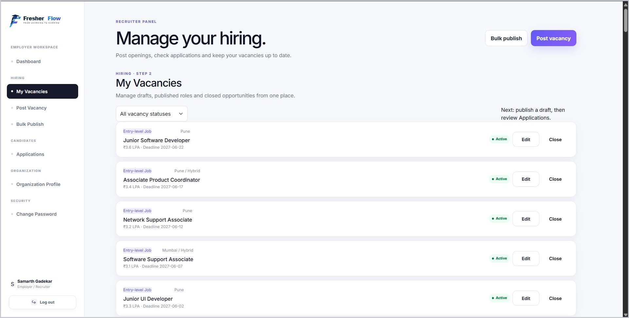
This screen lists the employer’s drafts, published roles, and closed opportunities with salary and deadline details. Vacancies can be filtered by status, edited, or closed.
Student Output Screens
Student output screens allow students to review available opportunities, their applications, and their profile information. They provide convenient access to job-search activity.

1. Student Dashboard
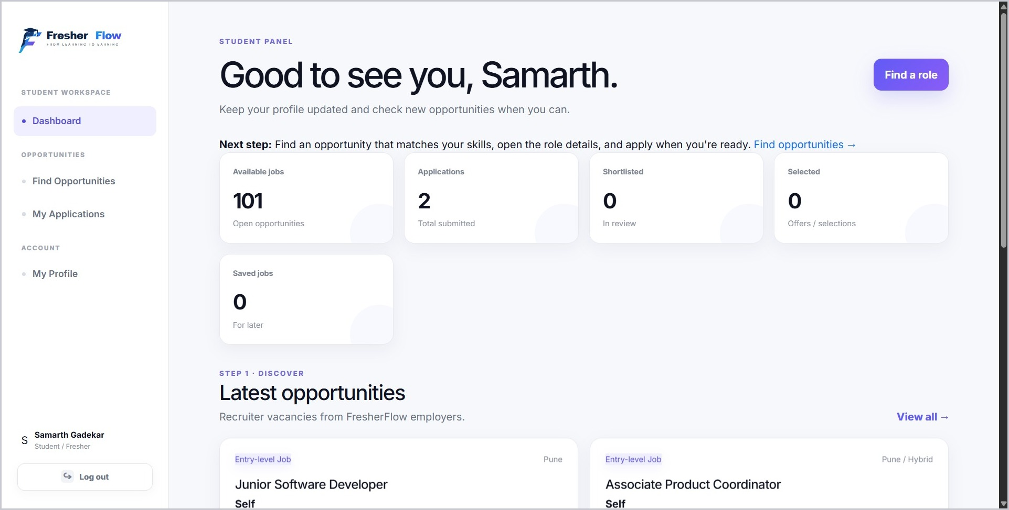
The dashboard provides an overview of the student’s account, including available jobs, applications, shortlisted and selected counts, saved jobs, and the latest opportunities posted by employers.

2. My Applications
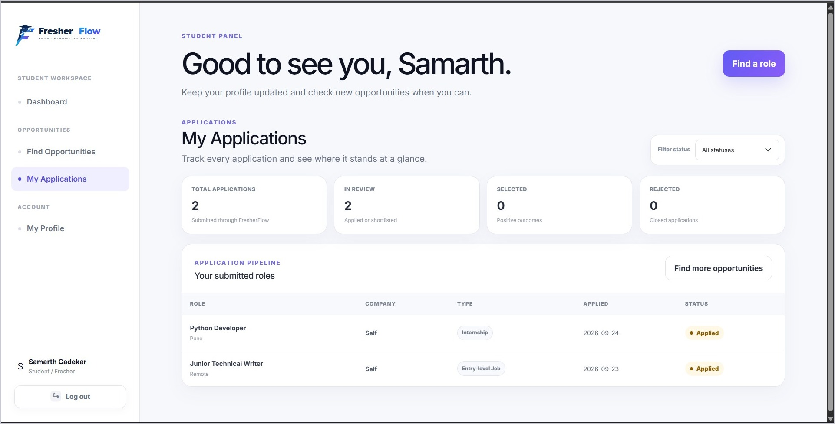
This screen displays the total, in-review, selected, and rejected application counts and an application pipeline table showing the role, company, type, applied date, and status. Applications can be filtered by status.

3. My Profile
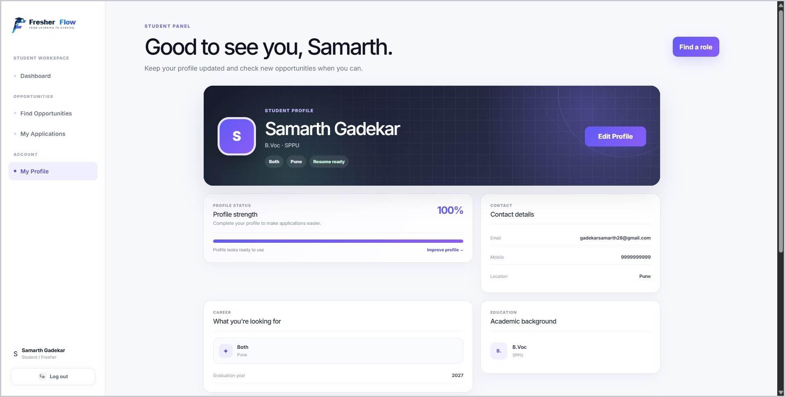
This screen displays the student’s profile, including profile strength, contact details, career preferences, and academic background, with an Edit Profile option.
These screens illustrate how students can access recruitment information through FresherFlow.
Summary of the output screens by role:
Role | Output screens provided
Public | Home Page with links to Features, How it works, Sign in and Get started.
Administrator | Overview, Job Moderation, Applications List and Companies List for oversight of the platform.
Employer | Employer Dashboard and My Vacancies to monitor applications and manage posted roles.
Student | Student Dashboard, My Applications and My Profile to follow opportunities and applications.

All output screens are generated from the records stored in the database, so the information shown always reflects the latest activity on the portal.

4.4 Reports and Graphs using sample data
1. Admin Dashboard Report
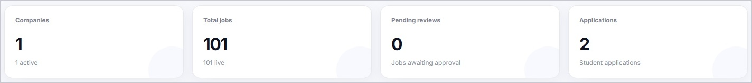
The administrator overview summarizes key platform statistics, including:
- Companies: Number of registered and active employer companies.
- Total Jobs: Number of job vacancies available on the platform.
- Pending Reviews: Number of jobs awaiting administrator approval.
- Applications: Number of student applications received through the portal.
2. Employer Dashboard Report
The employer dashboard summarizes the hiring activity of one organization. It reports the number of live vacancies, the applications received, the candidates shortlisted and the candidates selected, together with a table of the posted vacancies and their moderation status.
3. Student Dashboard Report
The student dashboard summarizes the job-search activity of one student. It reports the available jobs, the number of applications submitted, the shortlisted and selected counts and the saved jobs, and lists the latest opportunities posted by employers.
4. Application Status Report
- Total: the number of applications submitted by the student.
- In review: applications that employers have not yet decided on.
- Selected: applications for which the student has been selected.
- Rejected: applications that were not successful.
These reports are generated from the records stored in the database, so they always reflect the latest activity on the portal.

5. Testing
Testing verifies whether FresherFlow works as expected. Test cases can cover login, role-based access, profile forms, vacancy management, resume uploads, applications, and data validation.

5.1 Test Plan – Black Box Testing / Data Validation Test Cases
Black Box Testing checks the portal by providing inputs and verifying expected outputs without examining the internal code.
The tests were run in a web browser on a development computer using Python and Flask with an SQLite database. Both valid and invalid inputs were considered.
Test Cases
Test Case 1 – Student Login
- Input: Correct student username and password.
- Expected Result: The student dashboard should open.
- Actual Result: The student dashboard opened successfully when tested.
- Status: Pass
Test Case 2 – Employer Login
- Input: Correct employer username and password.
- Expected Result: The employer dashboard should open.
- Actual Result: The employer dashboard opened successfully when tested.
- Status: Pass
Test Case 3 – Create Vacancy
- Input: Enter valid vacancy details in the vacancy form.
- Expected Result: The vacancy should be saved and shown to authorized users.
- Actual Result: The vacancy was saved successfully when tested.
- Status: Pass
Test Case 4 – Required Field Validation
- Input: Submit a form without required information.
- Expected Result: A validation message should be displayed.
- Actual Result: Validation feedback was displayed when tested.
- Status: Pass
Test Case 5 – Resume Upload
- Input: Upload a supported resume file.
- Expected Result: The resume should be accepted and associated with the relevant application.
- Actual Result: The resume upload workflow was checked.
- Status: Pass
Test Case 6 – Job Application
- Input: Submit an application for a published vacancy.
- Expected Result: The application record should be saved.
- Actual Result: The application workflow was checked.
- Status: Pass
Test Case 7 – Application Tracking
- Input: Open the student’s submitted applications.
- Expected Result: The current status of each application should be displayed.
- Actual Result: Application tracking was checked.
- Status: Pass
Test Case 8 – Invalid Login
- Input: Correct username with a wrong password.
- Expected Result: Login should be refused and an error message should be shown.
- Actual Result: The login was refused and an error message was displayed when tested.
- Status: Pass
Test Case 9 – Unauthorized Page Access
- Input: Open an employer or administrator page while signed in as a student.
- Expected Result: Access should be denied or the user should be redirected.
- Actual Result: Restricted pages were not opened by the student account.
- Status: Pass
Test Case 10 – Bulk Publish
- Input: Upload an Excel (.xlsx) file with the required columns.
- Expected Result: The vacancies in the file should be created for the employer.
- Actual Result: The bulk publish workflow was checked.
- Status: Pass
Test Case 11 – Vacancy Moderation
- Input: Approve or reject a vacancy from the administrator Job Moderation screen.
- Expected Result: The moderation status of the vacancy should be updated.
- Actual Result: The moderation workflow was checked.
- Status: Pass

5.2 White Box Testing / Functional Validation Test Cases and Results
White Box Testing examines the application’s internal logic, including validation, database operations, file handling, and access-control conditions.
Functional Test Cases
Test Case 1 – Student Profile
- Function: Student Profile Management
- Validation: Student details are validated before saving.
- Result: The profile workflow was reviewed.
- Status: Pass
Test Case 2 – Vacancy Validation
- Function: Vacancy Management
- Validation: Required vacancy fields and permitted employer actions are checked.
- Result: Vacancy validation logic was reviewed.
- Status: Pass
Test Case 3 – Resume Handling
- Function: Resume Upload
- Validation: File type, file handling, and association with the correct user/application are checked.
- Result: Resume handling was reviewed.
- Status: Pass
Test Case 4 – Application Status
- Function: Application Management
- Validation: Application records and status changes are restricted to authorized roles.
- Result: Application status handling was reviewed.
- Status: Pass
Test Case 5 – Role-Based Access
- Function: Student, Employer, and Admin Login
- Validation: Users are directed to role-appropriate pages and restricted pages are protected.
- Result: Role-based access checks were reviewed.
- Status: Pass
Test Case 6 – Saved Jobs
- Function: Saved Job Management
- Validation: A saved job is linked to a valid student and a valid vacancy.
- Result: Saved job handling was reviewed.
- Status: Pass
Test Case 7 – Form Protection and Validation
- Function: Form Submission
- Validation: Forms are protected against forged requests and inputs are validated before saving.
- Result: Form protection and validation checks were reviewed.
- Status: Pass
Testing Result
Core FresherFlow workflows should be evaluated using valid and invalid inputs. Test coverage includes authentication, profile management, vacancy creation, resume upload, application submission, status tracking, and role-based access. Results should be recorded from actual execution before final submission.
Testing helps identify defects, verify data handling, and improve the reliability and usability of the portal.
Test Summary
Test Type | Area Covered | Test Cases | Result
Black Box | Login, vacancy creation, validation, resume upload, applications, tracking, access control, bulk publish, moderation | 11 | All Pass
White Box | Profile, vacancy rules, resume handling, application status, role-based access, saved jobs, form protection | 7 | All Pass

6. Conclusion and Recommendations
Conclusion:
FresherFlow was developed to provide a centralized recruitment portal for students, employers, and administrators. The application uses Python, Flask, SQLite, and standard web technologies to support job discovery and application workflows.
Students can manage their profiles, browse and save vacancies, upload resumes, submit applications, and track application status. Employers can maintain their profiles, publish vacancies, and review applications. Administrators support platform oversight and moderation.
The portal organizes recruitment information in one place and helps users follow job-search and hiring activity more conveniently. Its role-based structure separates student, employer, and administrative functions.
The project demonstrates how a lightweight web application and relational database can support a practical recruitment workflow. Functional and security testing should be performed against the actual deployed build.
Overall, FresherFlow is intended to make early-career recruitment more organized and accessible by connecting students with employers through a centralized portal.
Recommendations:
The following improvements may be considered as the project evolves:
- Email Notifications: Add notifications for new vacancies, application updates, and employer responses.
- Advanced Search: Improve filtering by skills, location, employment type, and experience level.
- Analytics: Provide reports on vacancies, applications, and recruitment activity.
- Mobile-Friendly Interface: Ensure convenient use on smartphones, tablets, and desktop computers.
- Resume Parsing: Explore extracting skills and experience from uploaded resumes with appropriate user consent.
- Cloud Deployment: Deploy the portal to a reliable hosting platform with secure configuration.
- Database Improvements: Consider PostgreSQL for larger deployments and concurrent usage.
- Backup and Security: Implement regular backups, secure file storage, logging, and appropriate access controls.
- Bulk Vacancy Import: Improve spreadsheet import validation and error reporting for employers.
- Application Workflow: Add clearer status transitions and communication between students and employers.

7. Future Scope
FresherFlow can be enhanced with additional features to make recruitment more efficient, secure, and convenient. The current portal focuses on student and employer accounts, vacancies, resumes, saved jobs, applications, and application tracking. Future enhancements may include the following.
1. Automated Notifications
Email notifications can inform students about application updates and relevant vacancies and notify employers when new applications arrive.
2. Mobile Application
A dedicated mobile application could let students search vacancies, manage profiles, upload resumes, and track applications from their smartphones.
3. Advanced Job Matching
Search and recommendation features could use skills, location, and stated preferences to help students find relevant opportunities.
4. Interview Scheduling
Employers could coordinate interview dates and share interview details with shortlisted applicants.
5. Analytics and Reports
The portal could provide reports showing vacancy activity, application volume, employer engagement, and recruitment outcomes.
6. Resume Parsing
Resume parsing could help structure skills and experience information, subject to clear consent and secure handling of uploaded files.
7. Student Progress Tools
Students could track application activity, save career preferences, and maintain a structured record of their job search.
8. Cloud Deployment
The application could be deployed on a reliable cloud platform so authorized users can access it online.
9. Improved Database Management
The database could be upgraded to a production-ready solution such as PostgreSQL when data volume and concurrent usage increase.
10. Enhanced Security and Backup
Additional security controls, regular backups, secure file handling, and monitoring can protect account and application data.

8. Bibliography and References
Online References
References
- Flask Documentation
URL: https://flask.palletsprojects.com/
Use: Web application development.

- Python Documentation
URL: https://docs.python.org/3/
Use: Python programming.

- SQLite Documentation
URL: https://www.sqlite.org/docs.html
Use: Database management.

- MDN Web Docs
URL: https://developer.mozilla.org/
Use: HTML, CSS and JavaScript.

- W3Schools
URL: https://www.w3schools.com/
Use: Programming fundamentals.

