PROFESSIONAL DEVELOPMENT

“COMMANDERS ARE RESPONSIBLE FOR A LEADER DEVELOPMENT PROGRAM AND A CLIMATE IN WHICH LEARNING OCCURS TO BUILD STRONGER SUBORDINATES. LEADER DEVELOPMENT IS A CONTINUOUS AND PURPOSEFUL PROCESS THAT CAN INCLUDE ASSIGNED PROFESSIONAL READINGS, A LEADER PROFESSIONAL DEVELOPMENT (LPD) PROGRAM, STAFF RIDES, AND OTHER CAREER ENHANCING ACTIVITIES.” TC 6-0.2

THE COMMANDER DRIVES PROFESSIONAL DEVELOPMENT THROUGH CONTINUOUS ENGAGEMENT. THIS IS DONE IN CONJUNCTION WITH ROUTINE PERFORMANCE COUNSELINGS AND EVALUATIONS THAT CONTINUOUSLY ASSIST SOLDIERS WITH PERSONAL DEVELOPMENT GOALS.

THE COMMANDER IS CHARGED AS THE ACADEMIC DRIVER OF THEIR UNIT. PROFESSIONAL DEVELOPMENT EVENTS INCORPORATE ALL UNIT LEADERS; FROM THE SQUAD LEADER TO THE FIRST SERGEANT.

DATE: AUGUST 2021

Department of the Army
PRESCRIBED HEADER OF UNIT ISSUING GUIDANCE HERE

ALPHA COMPANY, 1ST BATTALION, 78TH INFANTRY REGIMENT

1st Brigade Combat Team, 12th Infantry Division

Fort Popcorn, Atropia 98765
REPLY TO
ATTENTION OF

MEMORANDUM FOR RECORD

SUBJECT: Leader Development Program; Unit Training Plan Supplement

References.

(a) Company Annual Training Guidance, FY56
REFERENCE MATERIAL CITED IN THIS DOCUMENT

(b) FM 6-22, Leader Development.

(b) ADP 6-22, Army Leadership and the Profession.

- Purpose: The most important training we do in this unit and in the military is develop leaders. Leader development is the process through which we develop the skills, knowledge, and attitudes needed to lead, train, and employ units and organizations at increasing levels of responsibility. Alpha Company honors the military profession and works to develop leaders under the Be, Know, Do framework and core competencies as outlined in Army Field Manual 6-22 and Army Doctrine Publication 6-22. In conjunction with performance counseling, company leader development programs, self-development, and institutional development, this program aims to increase readiness in the leader domain.
FIRST PARAGRAPH OUTLINES THE PURPOSE OF THIS DOCUMENT

Method: Alpha’s Leader Development Program Course Outline covers the period from FY55Q4 through FY56Q1 and consists of 9 LDP Events. These events are led by the Platoon Leaders/Platoon Sergeants and Company Commander. All members of the company are encouraged to attend in conference. The glidepath for these events is depicted below (Fig 1.1) and is designed around the continued development of attributes and competencies as defined in the Army Leadership Requirements Model (Fig 1.2). A sample method for presenting material and creating dialogue between the host and attendees is included in Enclosures 1 and 2. The 8-Step Training Model is used to develop each event. Events should last from 1 to 1.5 hours and allow ample time for dialogue between the host and attendees. The material for presentation will be sent to the company executive officer for review no later than 10 days prior to the event with a final read-ahead sent to all attendees 7 days prior to each event, to include time, location and uniform. An After Action Review will be filed with the final product on record within the company website and digital records database no later than 7 days following completion of each event.
SECOND PARAGRAPH OUTLINES THE COMMANDER’S APPROACH TO CONDUCTING LPD WITHIN THE UNIT.

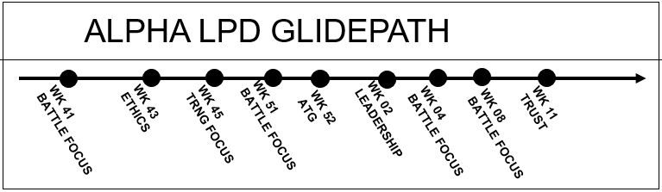
THIS GLIDEPATH IS OUTLINED IN THE COMPANY ANNUAL CALENDAR AS WELL.
Fig 1.1 LPD Glidepath.

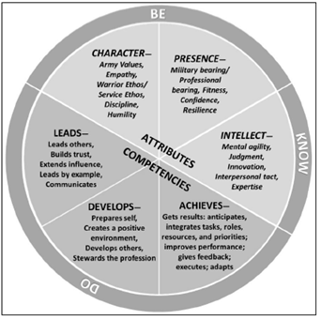

Fig 1.2 Army Leadership Requirements Model (ADP 6-22)

3. Event Outline: Each event and their corresponding training week is outlined in Fig 1.3 below. The designated leader scheduled to conduct the event will conduct the event during regularly scheduled battle rhythm LDP time slots or request adjustment as necessary. When time adjustments are needed, the host will keep the LDP scheduled within the training week designated.
THIS SECTION OUTLINES THE SPECIFIC WEEKS WHEN THESE EVENTS WILL BE EXECUTED AND WHAT THE TOPICS WILL COVER. THE COMMANDER DESIGNATES A PROJECT MANAGER FOR EACH EVENT DURING TRAINING MEETINGS.

DATE | HOST | FOCAL TOPIC | SOURCE
WK41 |  | Battle Centric, Agility | <white paper title source here>
WK43 |  | Empathy & Resilience | <white paper title source here>
WK46 |  | Training, Tasks, Resources | <white paper title source here>
WK51 |  | Battle Centric, Defense | <white paper title source here>
WK52 |  | Training, Tasks, Resources | <white paper title source here>
WK02 |  | Leadership | <white paper title source here>
WK04 |  | Battle Centric, Innovation | <white paper title source here>
WK08 |  | Battle Centric, Logistics | <white paper title source here>
WK11 |  | Trust and Leadership | <white paper title source here>
Figure 1.3

4. The point of contact for this guidance is the Battalion S-3 Office.

Peter Parker
CPT, IN
Commanding

Encl:
Enclosure 1
THESE ENCLOSURES CAN INCLUDE EXAMPLES OF HOW TO RUN A PROFESSIONAL DEVELOPMENT SEMINAR/EVENT.
Enclosure 2

