Insert your centre number, name and candidate number into the header above.
Save this evidence document as evidence_ followed by your centre number_ candidate number. For example: evidence_ zz999_9999
Screenshots or program listings must be copied into appropriate cells in the following table.
Examiners must be able to read the contents including any screenshots without the use of a magnifying glass. Answers that are not readable or missing will not be awarded any marks.
Save this evidence document at regular intervals, for example every 10 minutes.
Question 1
Part 1(a)
# Initialise an array to player name and their high scores.

LIST_LENGTH = 10
player_data = [[None for i in range(2)] for j in range(LIST_LENGTH + 1)]
Part 1(b)
def read_high_scores(file_name):
try:
file = open(file_name, "r")
name = True
count = 0
for line in file:
if name:
player_data[count][0] = line.strip()
name = False
else:
player_data[count][1] = int(line.strip())
name = True
count += 1
file.close()
except FileNotFoundError:
print("file not found!")
Part 1(c)
def output_high_score():
for i in range(LIST_LENGTH):
print(player_data[i][0], player_data[i][1])

Part 1(d)(i)
read_high_scores("HighScore.txt")
output_high_score()

Part 1(d)(ii)
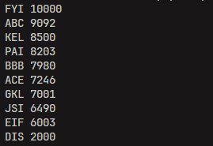

Part 1(e)(i)
NAME_LENGTH = 3
MIN_SCORE = 1
MAX_SCORE = 100000

name = str(input("name: "))
while len(name) != NAME_LENGTH:
print(f"name must be {NAME_LENGTH} letters only!")
name = str(input("name: "))

score = int(input("score: "))
while score < MIN_SCORE or score > MAX_SCORE:
print(f"score must be between {MIN_SCORE} and {MAX_SCORE} inclusive!")

Part 1(e)(ii)
new_player_data = player_data

def create_new_list(name, score):
if new_player_data[LIST_LENGTH - 1][1] > score:
return
else:
new_player_data[LIST_LENGTH][0] = name
new_player_data[LIST_LENGTH][1] = score
swap = False
for i in range(LIST_LENGTH + 1):
for j in range(LIST_LENGTH - i):
if new_player_data[j][1] < new_player_data[j + 1][1]:
tmp = new_player_data[j]
new_player_data[j] = new_player_data[j + 1]
new_player_data[j + 1] = tmp
swap = True
if not swap:
break
Part 1(e)(iii)
print(player_data)
create_new_list(name, score)
print(new_player_data)

Part 1(e)(iv)
{Copy and paste the screenshot for question 1(e)(iv) here}

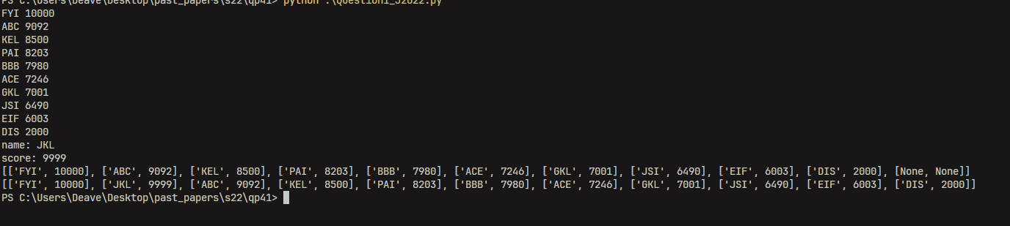

Part 1(f)
def write_top_ten(file_name):
try:
file = open(file_name, "w")
for i in range(LIST_LENGTH):
for j in range(2):
file.write(str(new_player_data[i][j]) + "\n")
file.close()
except FileNotFoundError:
print("file not found!")

write_top_ten("NewHighScore.txt")

