Screenshots or program listings must be copied into appropriate cells in the following table.
Save this evidence document as evidence_ followed by your centre number_ candidate number, for example, evidence_ zz999_9999 and insert your name, centre number and candidate number into the header above.
Examiners must be able to read the contents including any screenshots without the use of a magnifying glass. Answers that are not readable or are missing will not be awarded any marks.
Save this evidence document at regular intervals, for example every 10 minutes.
Question 1
Part 1(a)(i)
data_array = []

Part 1(a)(ii)
try:
file = open("Data.txt", "r")
for line in file:
data_array.append(int(line))
file.close()
except FileNotFoundError:
print("file not found!")

Part 1(b)(i)
def print_array(array):
for item in data_array:
print(item, end=" ")
print()

Part 1(b)(ii)
{print_array(data_array)

Part 1(b)(iii)
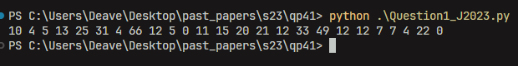

Part 1(c)
def linear_search(array, value):
count = 0
for item in data_array:
if item == value:
count += 1
return count

Part 1(d)(i)
MIN_VALUE = 0
MAX_VALUE = 100

number = int(input("number: "))
while number > MAX_VALUE or number < MIN_VALUE:
print(f"number must be between {MIN_VALUE} and {MAX_VALUE}!")
number = int(input("number: "))

result = linear_search(data_array, number)
print(f"The number is {number} is found {result} times.")

Part 1(d)(ii)


