Insert your name, centre number and candidate number into the header above.
Save this evidence document as evidence_ followed by your centre number_ candidate number. For example: evidence_ zz999_9999
Screenshots or program listings must be copied into appropriate cells in the following tables.
Examiners must be able to read the contents including any screenshots without the use of a magnifying glass. Answers that are not readable or missing will not be awarded any marks.
Save this evidence document at regular intervals, for example, every 10 minutes.
Question 2
Part 2(a)
# Declare the global 1D array, arrayData, with ten elements.
arrayData = [10, 5, 6, 7, 1, 12, 13, 15, 21, 8]
arrayLength = len(arrayData)

Part 2(b)(i)
# Define a function called linearSearch.
def linearSearch(value):
for i in range(arrayLength):
if arrayData[i] == value:
return True
return False

Part 2(b)(ii)
# Get input from user.
number = int(input("number: "))

# Output appropriate message.
if linearSearch(number):
print("found")
else:
print("not found")

Part 2(b)(iii)
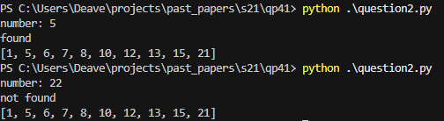

Part 2(c)
def bubbleSort():
temp = None
for i in range(arrayLength):
for j in range(arrayLength - 1):
if arrayData[j] >= arrayData[j + 1]:
temp = arrayData[j]
arrayData[j] = arrayData[j + 1]
arrayData[j + 1] = temp

bubbleSort()
print(arrayData)

