Insert your name, centre number and candidate number into the header above.
Save this evidence document as evidence_ followed by your centre number_ candidate number, for example: evidence_ zz999_9999.doc
Screenshots or program listings must be copied into appropriate cells in the following tables.
Examiners must be able to read the contents including any screenshots without the use of a magnifying glass. Answers that are not readable or are missing will not be awarded any marks.
Save this evidence document at regular intervals, for example, every 10 minutes.
Question 1
Part 1(a)
# Question 1(a)
# Initialise array with space for 100 integers.
data_array = [0] * 100

Part 1(b)
# Question 1(b)
# Read the numbers in file ands tore in data_array.
def read_file(file_name):
try:
file = open(file_name, "r")
for line in file:
data_array.append(int(line.strip()))
file.close()
except:
print("error")

Part 1(c)
# Question 1(c)
# Count the number of times the number appears in the file.
def find_values(file_name):
value = int(input("number (1-100): "))
while value > 100 or value < 1:
print("number must be between 1-100 inclusive!")
value = int(input("number (1-100): "))
count = 0
file = open(file_name, "r")
for line in file:
if int(line.strip()) == value:
count += 1
return count

Part 1(d)(i)
# Question 1(d)(i)
read_file("IntegerData.txt")
count = find_values("IntegerData.txt")
print("count:", count)

Part 1(d)(ii)
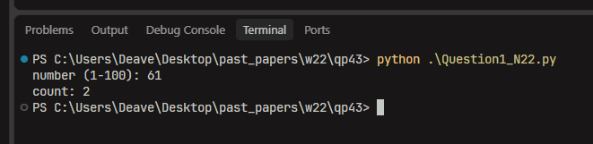

Part 1(e)
# Question 1(e)
def bubble_sort(array):
swap = False
for i in range(len(array)):
for j in range(len(array) - i - 1):
if array[j] > array[j + 1]:
tmp = array[j]
array[j] = array[j + 1]
array[j + 1] = tmp
swap = True
if not swap:
break

bubble_sort(data_array)

