SALON SERVICE MANAGEMENT SYSTEM
Comprehensive Functional Requirements Specification
Software Engineering – Whole Semester Continuous Assessment
Expanded from the existing Functional Requirements baseline

Table of Contents
1. Introduction
2. System Overview
3. Actors and Roles
4. Functional Requirements
5. Business Rules
6. Booking Lifecycle
7. Payment & Financial Lifecycle
8. DFD Design Structure
9. Level-0 DFD
10. Level-1 DFD
11. Level-2 DFDs
12. Level-3 DFD
13. Data Dictionary
14. Data Flow Dictionary
15. Requirement-to-DFD Traceability
16. Consistency & Validation Notes

1. Introduction
This document upgrades the existing Salon Service Management System Functional Requirements into a comprehensive functional baseline for an advanced salon and home-service marketplace. The existing twelve core requirements are retained and expanded. The specification is intended to remain at the requirements-analysis/design level: it defines actors, inputs, outputs, processing rules, exceptions and resulting system state without prescribing a specific programming language, database engine or UI technology.
The platform supports customer bookings for salon-based and home-service appointments, service providers/beauticians, salons/businesses, administrators and external services such as payment, notification and location services. All functional requirements are designed to trace into the DFD processes and data stores included later in this document.

2. System Overview
The system operates as a marketplace and service-management platform. Customers discover services, select a salon/provider or request an appropriate provider, choose a time slot and service location, complete payment where required, receive notifications, and review completed services. Providers and salons manage profiles, services, availability, bookings and earnings. Administrators govern users, providers, salons, services, promotions, disputes, reports and audit records.
The system supports both salon-based service and home-service booking where the selected service, provider and service area permit it.

3. Actors and Roles
Actor | Responsibilities
Customer | Searches services, manages profile/addresses, creates and manages bookings, pays, uses wallet/loyalty/membership benefits, raises support requests and submits reviews.
Service Provider / Beautician | Registers, submits verification information, maintains skills/services/availability, accepts or rejects assignments, executes services and views earnings/performance.
Salon / Business | Registers a business, manages profile, services, staff, pricing, operating hours, capacity, bookings, inventory and business performance.
Administrator | Manages users, approvals, catalog, bookings, finance, promotions, memberships, support, reports, configuration and audit records.
Payment Gateway | External service that authorizes payment and returns transaction/refund results.
Notification Service | External delivery service for supported notification channels; returns delivery status.
Map / Location Service | External service for location validation, geocoding, distance/service-area checks and navigation-related information where required.

4. Functional Requirements
Each requirement follows the same structure: Description, Actors, Preconditions, Input, Processing / Business Rules, Output, Error / Exception Conditions, and Postconditions.

Functional Requirements – Detailed Specification

4.1 User Registration
Description: Creates accounts for customers, service providers, salons/businesses and authorized administrative users.
Actors: Customer; Service Provider; Salon / Business; Administrator
Preconditions: Required registration fields are supplied and the selected role is permitted.
Input: Name, email/mobile number, password, address/location where applicable, requested role, consent information.
Processing / Business Rules: Validate required fields and uniqueness of email/mobile; create the appropriate role record; associate profile data; keep authentication secrets as securely protected credentials rather than plaintext passwords.
Output: Registration confirmation, account ID and account status.
Error / Exception Conditions: Duplicate email/mobile, invalid data, unsupported role, missing fields, account creation failure.
Postconditions: A user/business account exists with an appropriate initial status such as Active, Pending Verification or Pending Approval.

4.2 Provider Registration
Description: Onboards a service provider/beautician so that the provider can later be verified, mapped to services and assigned jobs.
Actors: Service Provider; Administrator
Preconditions: The applicant is not already registered as the same provider.
Input: Personal details, contact details, skills, experience, service categories, service area, availability preferences.
Processing / Business Rules: Create provider and user records; set verification status to Pending where KYC/approval is required; prevent duplicate provider identities.
Output: Provider registration confirmation and verification status.
Error / Exception Conditions: Duplicate provider, invalid contact information, unsupported service, incomplete application.
Postconditions: Provider profile exists and is awaiting or has completed the required verification stage.

4.3 Salon / Business Registration
Description: Registers a salon/business as a marketplace business entity.
Actors: Salon / Business; Administrator
Preconditions: Required business information is available.
Input: Business name, owner/admin details, address, operating hours, services, contact information, requested service modes.
Processing / Business Rules: Create salon record; associate owner/admin; validate location and required fields; place the salon into verification status where applicable.
Output: Salon registration confirmation and verification status.
Error / Exception Conditions: Duplicate business, invalid address, missing mandatory information, unauthorized registration.
Postconditions: Salon/business record exists with an appropriate status.

4.4 User Login and Logout
Description: Authenticates registered users and provides role-appropriate access.
Actors: Customer; Service Provider; Salon / Business; Administrator
Preconditions: Account exists and is not blocked or deactivated.
Input: Email/mobile and password; logout request.
Processing / Business Rules: Validate credentials, account status and role; create an authenticated session; apply permissions; terminate session on logout.
Output: Login status and role-appropriate access; logout confirmation.
Error / Exception Conditions: Invalid credentials, inactive/blocked account, missing credentials, authentication failure.
Postconditions: Successful login creates an authenticated session; logout invalidates the session.

4.5 Password Management and Verification
Description: Supports password change/reset and email/mobile verification.
Actors: Customer; Service Provider; Salon / Business; Administrator
Preconditions: Account exists; reset/change operation is requested through an authorized flow.
Input: Current password where required, new password, verification code/OTP or reset token.
Processing / Business Rules: Validate verification factor, token expiry and password policy; securely replace the credential; invalidate obsolete reset tokens.
Output: Password changed/reset confirmation and verification status.
Error / Exception Conditions: Expired/invalid OTP or token, incorrect current password, weak/invalid new password, excessive verification attempts.
Postconditions: Credential state and verification status are updated.

4.6 Profile and Address Management
Description: Allows users to maintain profile information and multiple service addresses.
Actors: Customer; Service Provider; Salon / Business; Administrator
Preconditions: Authenticated user has permission to modify the relevant profile.
Input: Profile details, address details, address label, location coordinates where available.
Processing / Business Rules: Validate fields; maintain multiple customer addresses; distinguish stored address from current location; prevent unauthorized modification.
Output: Updated profile/address and status.
Error / Exception Conditions: Invalid address, unsupported location, unauthorized modification, missing mandatory field.
Postconditions: Profile and address records reflect the latest valid changes.

4.7 Role-Based Access and Permission Management
Description: Controls which operations are available to customers, providers, salons and administrators.
Actors: Administrator; System
Preconditions: A user role exists.
Input: Role, permission, account status, requested operation.
Processing / Business Rules: Check role and permission before sensitive operations; deny unauthorized actions; record important administrative changes in the audit log.
Output: Access granted or denied.
Error / Exception Conditions: Unauthorized operation, inactive role, missing permission.
Postconditions: Only authorized operations are completed.

4.8 Customer Management
Description: Maintains customer profile, preferences, favourites, booking history, wallet, loyalty and membership references.
Actors: Customer; Administrator
Preconditions: Customer account exists.
Input: Preferences, favourite services/providers, profile changes, history requests, membership/wallet requests.
Processing / Business Rules: Store customer-specific data; present upcoming/completed/cancelled bookings; maintain references to wallet, loyalty and membership records.
Output: Updated customer profile or requested customer information.
Error / Exception Conditions: Invalid customer, unauthorized access, invalid preference or favourite operation.
Postconditions: Customer information is updated or retrieved without changing unrelated records.

4.9 Service Catalog Management
Description: Maintains service categories, subcategories and individual salon services.
Actors: Administrator; Salon / Business
Preconditions: Authorized user is logged in.
Input: Service name, category, description, duration, base price, requirements, media reference, status.
Processing / Business Rules: Create/update/deactivate catalog records; validate price and duration; support categories without hard-coding the platform to a fixed list of salon services.
Output: Service created/updated/deactivated and catalog status.
Error / Exception Conditions: Duplicate service, invalid price/duration, missing category, unauthorized operation.
Postconditions: Catalog contains the latest valid service definition.

4.10 Service Package and Add-on Management
Description: Supports packages/bundles and optional add-on services.
Actors: Administrator; Salon / Business
Preconditions: Base services exist and the user is authorized.
Input: Package name, included services, add-ons, package price, duration, eligibility and status.
Processing / Business Rules: Validate included services; calculate package/add-on pricing; ensure inactive services cannot be sold in new packages.
Output: Package/add-on details and availability status.
Error / Exception Conditions: Invalid service reference, duplicate package, inconsistent price/duration, inactive service.
Postconditions: Package/add-on configuration is stored and available according to status.

4.11 Salon Management
Description: Manages salon profile, location, services, staff, operating hours, holidays, capacity, pricing and business status.
Actors: Salon / Business; Administrator
Preconditions: Salon exists and the actor has management permission.
Input: Profile, address, operating hours, holidays, staff, capacity, salon-specific pricing and service configuration.
Processing / Business Rules: Validate business data; maintain salon-specific service mappings and pricing; prevent bookings outside permitted hours/capacity.
Output: Updated salon information and management status.
Error / Exception Conditions: Invalid schedule, conflicting hours, invalid staff assignment, unauthorized update.
Postconditions: Salon records reflect approved configuration.

4.12 Provider Management
Description: Manages provider profile, skills, services, experience, verification/KYC, service radius, status, earnings and performance.
Actors: Service Provider; Administrator
Preconditions: Provider account exists.
Input: Skills, experience, service mapping, documents, KYC data, service radius, status and payout information.
Processing / Business Rules: Store provider data; enforce verification/approval rules; prevent unverified providers from receiving restricted assignments; maintain performance and earnings references.
Output: Provider profile/status, service mapping, earnings or performance information.
Error / Exception Conditions: Invalid KYC, missing documents, unsupported service, unauthorized status change, invalid payout information.
Postconditions: Provider is correctly represented with a current status.

4.13 Provider Assignment and Matching
Description: Assigns a suitable provider to a booking or requests acceptance from a selected provider.
Actors: System; Customer; Service Provider; Administrator
Preconditions: Booking exists and service/provider requirements are known.
Input: Booking, service, address, time, provider capability, availability, service radius, provider status, assignment preference.
Processing / Business Rules: Filter by capability, location/service radius, availability and status; support customer-selected, system-assisted and manual admin assignment; support reassignment when a provider becomes unavailable.
Output: Assignment request, provider acceptance/rejection and assignment status.
Error / Exception Conditions: No eligible provider, provider rejects, provider becomes unavailable, invalid assignment.
Postconditions: Booking has a valid assignment state or an explicit pending/unassigned state.

4.14 Availability and Scheduling Management
Description: Manages provider and salon working hours, breaks, holidays, capacity and appointment slots.
Actors: Service Provider; Salon / Business; Administrator
Preconditions: Provider/salon record exists.
Input: Working hours, breaks, holidays, slot duration, capacity, date/time, service duration.
Processing / Business Rules: Generate or update available slots; prevent overlaps; account for existing bookings, breaks, holidays and capacity; maintain slot status.
Output: Availability status and available appointment slots.
Error / Exception Conditions: Overlapping schedule, invalid time range, unavailable date, capacity conflict.
Postconditions: Availability data is updated and can be used during booking.

4.15 Service Browsing and Search
Description: Allows customers to discover services, salons and providers using service and location criteria.
Actors: Customer
Preconditions: Catalog and service-area information are available.
Input: Service/category search, location/address, date/time, filters and sort criteria.
Processing / Business Rules: Return only active services and eligible providers/salons; apply service-area and availability filters where requested.
Output: Matching services, providers, salons, prices, duration and availability information.
Error / Exception Conditions: Invalid search criteria, unsupported location, no matching service.
Postconditions: Search results are returned or an explicit no-result response is generated.

4.16 Service Booking
Description: Creates an appointment for a service at a salon or customer location.
Actors: Customer; Service Provider; Salon / Business; System
Preconditions: Customer is authenticated; service is active; a valid service mode and slot are available.
Input: Customer ID, service ID, provider/salon selection, address, date/time, add-ons/package, coupon/membership/loyalty references.
Processing / Business Rules: Validate customer, service, provider/salon, location, slot, price and eligibility; calculate base price, discounts, taxes/fees; create booking; initiate assignment/confirmation workflow.
Output: Unique booking ID, booking amount, booking status and confirmation.
Error / Exception Conditions: Service unavailable, invalid provider/salon, out-of-area address, slot conflict, invalid offer, price calculation failure, booking persistence failure.
Postconditions: Booking is stored with an initial lifecycle status and appropriate payment/assignment state.

4.17 Booking Rescheduling
Description: Allows an eligible booking to be moved to another date/time or provider where permitted.
Actors: Customer; Administrator; Service Provider where authorized
Preconditions: Booking exists and is in a reschedulable state.
Input: Booking ID, new date/time, optional provider selection, reason.
Processing / Business Rules: Validate cancellation/rescheduling policy, new slot availability, provider/salon availability and price-impact rules; update booking history.
Output: Updated appointment details and rescheduling status.
Error / Exception Conditions: Invalid booking, non-reschedulable status, unavailable slot, policy violation, provider unavailable.
Postconditions: Booking reflects the new appointment or remains unchanged after a rejected request.

4.18 Booking Cancellation and No-Show Management
Description: Handles customer/provider/admin cancellation and no-show outcomes.
Actors: Customer; Service Provider; Salon / Business; Administrator
Preconditions: Booking exists.
Input: Booking ID, actor, cancellation reason, timestamp, no-show action.
Processing / Business Rules: Apply cancellation policy; determine applicable refund/fee outcome; release slot; update booking status; create audit/support information where necessary.
Output: Cancellation/no-show status and applicable refund/fee information.
Error / Exception Conditions: Cancellation window exceeded, invalid actor, booking already completed/cancelled, no-show action not permitted.
Postconditions: Booking is cancelled/no-show and downstream payment/notification actions are triggered as applicable.

4.19 Service Execution and Status Management
Description: Tracks service execution from provider travel/arrival through completion.
Actors: Service Provider; Customer; Salon / Business; System
Preconditions: Booking is assigned/confirmed and actor is authorized.
Input: Booking ID, provider ID, status, timestamp, optional location confirmation and completion details.
Processing / Business Rules: Enforce valid state transitions; record timestamps; prevent unauthorized or out-of-order transitions; allow customer confirmation where required.
Output: Current service status and timestamp.
Error / Exception Conditions: Invalid booking, unauthorized provider, invalid transition, missing completion information.
Postconditions: Booking/service status is updated only through an allowed transition.

4.20 Payment Management
Description: Processes customer payment for a booking and records the transaction.
Actors: Customer; Payment Gateway; Administrator
Preconditions: Booking is payable and the amount has been calculated.
Input: Booking ID, amount, payment method, payment details/token, customer ID.
Processing / Business Rules: Validate amount and booking; initiate gateway authorization; record transaction ID and payment status; support retry for eligible failures.
Output: Payment confirmation, transaction ID and payment status.
Error / Exception Conditions: Invalid amount, invalid payment details, gateway rejection, timeout, duplicate transaction.
Postconditions: Payment record is stored with an auditable status and booking payment state is updated.

4.21 Refund and Partial Refund Management
Description: Processes refunds caused by cancellations, disputes, failed service or approved administrative actions.
Actors: Customer; Administrator; Payment Gateway
Preconditions: A refundable payment exists and refund authority is established.
Input: Payment ID, booking ID, refund amount, reason, refund request.
Processing / Business Rules: Validate refundable balance; support full/partial refunds; send request to gateway; record refund transaction and status.
Output: Refund confirmation/status and updated financial record.
Error / Exception Conditions: Non-refundable payment, refund exceeds balance, gateway failure, invalid request.
Postconditions: Refund record is auditable and payment/booking state reflects the result.

4.22 Wallet and Credit Management
Description: Maintains customer wallet balance and credit transactions such as promotional credits or approved refunds.
Actors: Customer; Administrator; System
Preconditions: Customer account exists.
Input: Credit/debit amount, source, reason, transaction reference.
Processing / Business Rules: Validate balance and transaction type; maintain immutable wallet transaction history; prevent negative balance unless explicitly supported by a defined business rule.
Output: Updated wallet balance and transaction status.
Error / Exception Conditions: Invalid amount, insufficient balance, duplicate transaction, unauthorized credit/debit.
Postconditions: Wallet balance and ledger are consistent.

4.23 Commission, Earnings and Settlement Management
Description: Calculates platform fees, provider/salon commission, earnings and settlement records.
Actors: Administrator; Service Provider; Salon / Business
Preconditions: A payable/completed transaction exists.
Input: Booking amount, discount, tax/fee components, commission rules, payout information.
Processing / Business Rules: Calculate settlement basis; record gross/net amounts, commission and payout status; support approval/reconciliation.
Output: Earnings, commission and settlement status/details.
Error / Exception Conditions: Missing transaction, invalid commission rule, payout information error, reconciliation mismatch.
Postconditions: Financial settlement record exists with an auditable calculation.

4.24 Coupon and Promotion Management
Description: Creates and applies promotional campaigns, coupons and discounts.
Actors: Administrator; Salon / Business; Customer
Preconditions: Authorized promotion manager exists; customer has an eligible booking context.
Input: Coupon code, validity dates, usage limits, eligibility rules, service/salon scope, discount rules.
Processing / Business Rules: Validate expiry, usage count, user/service/salon eligibility and stacking rules; record usage only after successful application.
Output: Coupon validation result and discount amount.
Error / Exception Conditions: Expired coupon, usage limit reached, ineligible customer/service, invalid code, stacking conflict.
Postconditions: Valid usage is recorded and invalid usage is rejected without altering the booking.

4.25 Membership and Subscription Management
Description: Manages membership plans, purchase, benefits, renewal, expiry and cancellation.
Actors: Customer; Administrator
Preconditions: Membership plan exists and customer account is active.
Input: Plan ID, customer ID, purchase/renewal request, validity period, payment reference, cancellation request.
Processing / Business Rules: Validate eligibility and payment; activate membership; apply benefits during booking; handle renewal/expiry/cancellation.
Output: Membership status and benefits.
Error / Exception Conditions: Invalid plan, failed payment, expired membership, duplicate active subscription, unauthorized cancellation.
Postconditions: Membership record reflects the correct lifecycle state.

4.26 Loyalty and Referral Management
Description: Maintains loyalty points and referral rewards.
Actors: Customer; Administrator; System
Preconditions: Customer account exists and the relevant transaction qualifies.
Input: Booking/payment reference, points rule, referral code, referred customer.
Processing / Business Rules: Calculate earned points, redemption, expiry and referral reward; prevent duplicate/self-referral or repeated reward where prohibited.
Output: Loyalty balance, transaction history and referral status.
Error / Exception Conditions: Invalid referral, duplicate reward, insufficient points, expired points.
Postconditions: Loyalty/referral ledger remains consistent.

4.27 Location and Geo-Service Management
Description: Manages service addresses, location validation, service-area checks and distance calculations.
Actors: Customer; Service Provider; Salon / Business; Map / Location Service
Preconditions: Location data is supplied or stored.
Input: Address, coordinates, provider location where applicable, service radius, route/distance request.
Processing / Business Rules: Distinguish stored address, selected location and current provider location; validate service area; calculate distance only when needed by workflow.
Output: Validated address, distance/service-area result or navigation information.
Error / Exception Conditions: Invalid/unresolvable address, unsupported service area, map service failure.
Postconditions: Location record/result is available for the requesting workflow.

4.28 Review, Rating and Feedback Management
Description: Allows eligible customers to rate and review completed services, providers and salons.
Actors: Customer; Service Provider; Salon / Business; Administrator
Preconditions: The booking/service is completed and the customer is eligible to review.
Input: Booking ID, rating, review text, target provider/salon/service.
Processing / Business Rules: Enforce review eligibility and one-review rules; moderate/report content where required; permit authorized provider response.
Output: Review submission status and published/pending-moderation review.
Error / Exception Conditions: Invalid booking, incomplete service, invalid rating, duplicate review, moderation rejection.
Postconditions: Review is stored with the correct status and association.

4.29 Notification and Communication Management
Description: Generates notifications for important system events and communicates them through supported channels.
Actors: Customer; Service Provider; Salon / Business; Administrator; Notification Service
Preconditions: A notification-triggering event occurs.
Input: Recipient, event type, message/template data, channel preference, related booking/payment ID.
Processing / Business Rules: Select enabled channel(s), generate notification, submit to delivery service and record delivery status; do not assume all channels are mandatory.
Output: Notification record and delivery status.
Error / Exception Conditions: Invalid recipient, template failure, delivery failure, unsupported channel.
Postconditions: Notification is recorded with delivery status.

4.30 Customer Support and Dispute Management
Description: Handles complaints, support tickets, booking/payment disputes, refund requests and escalation.
Actors: Customer; Service Provider; Salon / Business; Administrator
Preconditions: A valid support/dispute request exists.
Input: Ticket type, booking/payment reference, description, evidence/notes, priority.
Processing / Business Rules: Classify ticket, assign support/admin, investigate using relevant records, resolve/refund/escalate and maintain history.
Output: Ticket status, resolution details and escalation/refund status.
Error / Exception Conditions: Invalid reference, unauthorized ticket access, insufficient evidence, unresolved escalation.
Postconditions: Ticket remains traceable through creation, assignment, investigation, resolution and closure.

4.31 Inventory Management
Description: Maintains salon/business inventory and service-related product usage.
Actors: Salon / Business; Administrator
Preconditions: Salon inventory module is enabled and authorized user exists.
Input: Product, category, supplier, stock quantity, stock-in/out, adjustment, service usage.
Processing / Business Rules: Record stock movements; calculate current stock; generate low-stock alerts; distinguish business inventory from platform-level data.
Output: Updated stock balance, movement status and inventory report.
Error / Exception Conditions: Invalid product, negative stock where not permitted, duplicate movement, unauthorized adjustment.
Postconditions: Inventory ledger and stock balance are updated consistently.

4.32 Reporting and Analytics
Description: Generates customer, provider, salon and platform reports and analytics.
Actors: Administrator; Salon / Business; Service Provider where permitted
Preconditions: Relevant records exist and requester has report permission.
Input: Report type, date range, filters, dimensions and output preference.
Processing / Business Rules: Validate range and filters; aggregate from operational data; provide summary/detail results; maintain report metadata where required.
Output: Report/analytics output and report status.
Error / Exception Conditions: Invalid report type, invalid date range, no data, unauthorized report.
Postconditions: Report result is generated or an explicit no-data/error status is returned.

4.33 Administration and Governance
Description: Provides centralized administration for users, approvals, catalog, bookings, finance, promotions, support, service areas and configuration.
Actors: Administrator
Preconditions: Administrator is authenticated and authorized.
Input: Management action, target entity, configuration values, approval/rejection decision.
Processing / Business Rules: Validate permissions; execute the requested administrative action; record significant changes in audit logs.
Output: Management status and updated entity/configuration.
Error / Exception Conditions: Unauthorized action, invalid target, conflicting configuration, failed update.
Postconditions: Administrative action is completed and auditable.

4.34 Security Event and Audit Management
Description: Records significant security and administrative events for traceability.
Actors: System; Administrator
Preconditions: An auditable event occurs.
Input: User ID, role, event type, target entity, timestamp, action/result, relevant reference.
Processing / Business Rules: Record important authentication, authorization, financial, approval and administrative events; prevent unauthorized alteration of audit records.
Output: Audit record and audit-query results for authorized administrators.
Error / Exception Conditions: Audit write failure, unauthorized audit access, invalid query.
Postconditions: A traceable audit entry exists for successful auditable actions where required.

5. Business Rules
Rule ID | Business Rule
BR-01 | Authentication secrets must be stored and processed as protected credentials; plaintext passwords are not represented as a data field.
BR-02 | Role and permission checks must occur before sensitive customer, provider, salon, financial or administrative operations.
BR-03 | Only active catalog services may be offered in new bookings.
BR-04 | A booking slot must satisfy service duration, provider/salon availability, holidays, breaks, capacity and existing booking constraints.
BR-05 | A provider may be assigned only when the provider is eligible for the service and permitted to operate in the service area.
BR-06 | A booking must retain an auditable status history when its status changes.
BR-07 | Cancellation and refund outcomes must be determined from the applicable cancellation/refund policy and payment state.
BR-08 | A payment transaction must not be recorded as successful solely because a payment request was initiated; gateway confirmation is required.
BR-09 | Refund amounts must not exceed the refundable balance.
BR-10 | Coupon usage must be recorded only after successful validation/application.
BR-11 | Loyalty and wallet transactions must be traceable to a source transaction or approved administrative action.
BR-12 | A review is normally permitted only for an eligible completed booking and must respect the configured duplicate-review rule.
BR-13 | Provider and salon verification status controls whether restricted operations such as assignment or publication are permitted.
BR-14 | Current provider location, when used, is distinct from a stored provider address and should be requested only when the workflow requires it.
BR-15 | External services are modeled as external entities in DFDs; they are not internal data stores.
BR-16 | Important administrative, security and financial actions must create audit records.
BR-17 | Inventory movements must be recorded as transactions rather than silently overwriting stock history.
BR-18 | Reports must respect role-based access and the requested date/filter scope.

6. Booking Lifecycle
The recommended booking lifecycle is designed to support both salon-based and home-service operations:
Stage | Meaning
1 | Requested
2 | Pending Assignment
3 | Assigned
4 | Provider Accepted
5 | Confirmed
6 | Provider En Route
7 | Provider Arrived
8 | Service Started
9 | Service Completed
10 | Payment Completed
11 | Closed
Alternative/exception states include: Rejected, Cancelled, Rescheduled, Failed, No-Show, Disputed and Refunded. State transitions are controlled by actor permissions and the business rules above.

7. Payment & Financial Lifecycle
Stage | Description
1 | Payment Pending
No. | Stage | Description
1 | Payment Pending | A payable booking exists but payment is not yet confirmed.
2 | Payment Initiated | The system has submitted a payment request.
3 | Authorized / Successful | The gateway has confirmed successful payment.
4 | Failed / Retry Eligible | Payment failed but an allowed retry may be attempted.
5 | Refund Requested | An authorized refund has been requested.
6 | Refunded / Partially Refunded | The refund result has been recorded.
7 | Settlement Pending | The successful transaction is awaiting provider/salon settlement.
8 | Settled | The settlement has been recorded as completed.

8. DFD Design Structure
The DFD hierarchy below replaces the earlier basic DFD structure. The numbering is deliberately aligned across levels: Level-1 processes are decomposed in Level-2 using the same parent number, and Level-3 further decomposes process 7.7 Create Booking. The diagrams use external entities, processes, data stores and labelled data flows; they do not use UML class/sequence notation.
Level | Decomposition | Scope
Level-0 | 0 Salon Service Management System | Customer; Service Provider; Salon/Business; Administrator; Payment Gateway; Notification Service; Map/Location Service
Level-1 | 1.0–17.0 | User & Identity; Customer; Service Catalog; Salon; Provider; Availability & Scheduling; Booking; Provider Assignment; Payment & Financial; Promotion/Coupon/Membership; Service Execution; Review/Rating; Notification; Support/Dispute; Inventory; Reporting; Administration/Audit
Level-2 | 7.0 Booking Management | Validate customer; validate service/provider; location; availability; price; offers; booking creation; assignment; confirmation; notifications
Level-2 | 9.0 Payment & Financial Management | Validate booking; amount; payment; gateway; payment record; failure/retry; refund; commission; settlement
Level-2 | 5.0 Provider Management | Registration; profile/skills; KYC; verification; service mapping; availability; assignments; performance/earnings
Level-2 | 4.0 Salon Management | Registration; profile; verification; services/pricing; staff; operating hours; capacity/calendar; revenue/performance
Level-2 | 10.0 Promotion, Coupon & Membership | Campaigns/coupons; eligibility; discounts; usage; membership; loyalty/referral
Level-2 | 14.0 Support & Dispute Management | Ticket; classification; assignment; investigation; resolution/refund/escalation; closure
Level-3 | 7.7 Create Booking | Customer; service; provider/salon; location; slot; price; package/add-ons; coupon; taxes/fees; record; assignment; confirmation; notifications

9. Level-0 DFD – Context Diagram
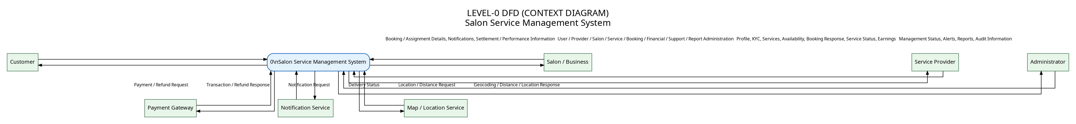
Figure 1. Level-0 context diagram for the Salon Service Management System.

10. Level-1 DFD
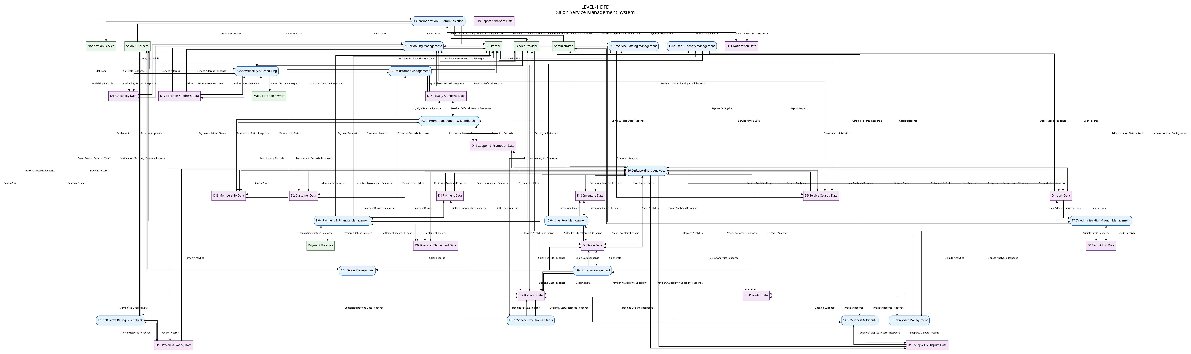
Figure 2. Level-1 decomposition of the complete platform.

11.1 Level-2 DFD – Booking Management
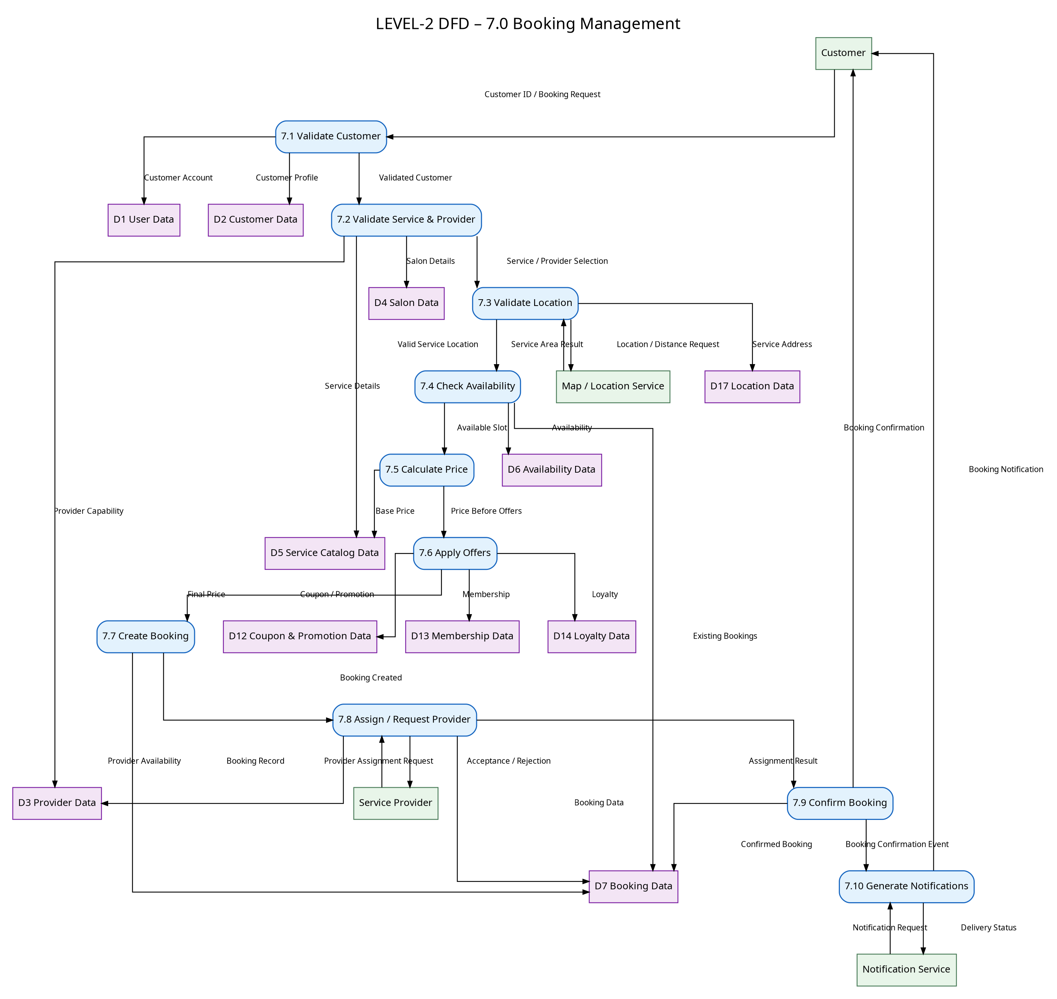
Figure 3. Decomposition of 7.0 Booking Management.

11.2 Level-2 DFD – Payment & Financial Management
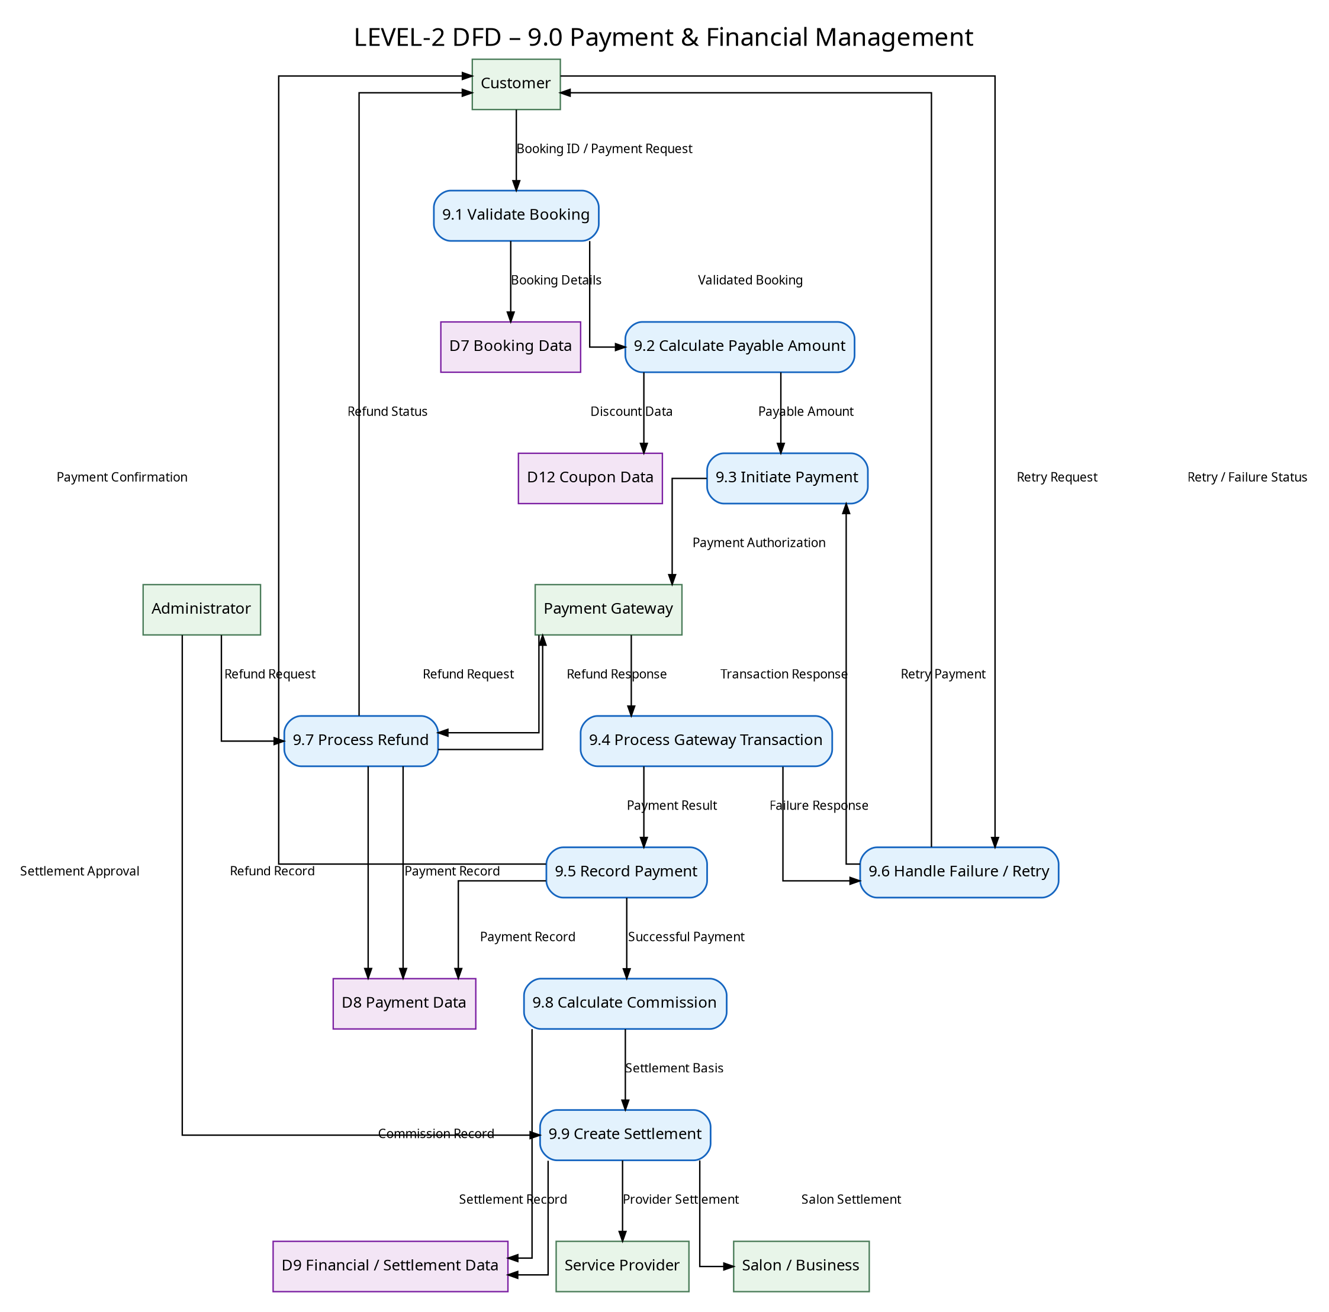
Figure 4. Decomposition of 9.0 Payment & Financial Management.

11.3 Level-2 DFD – Provider Management
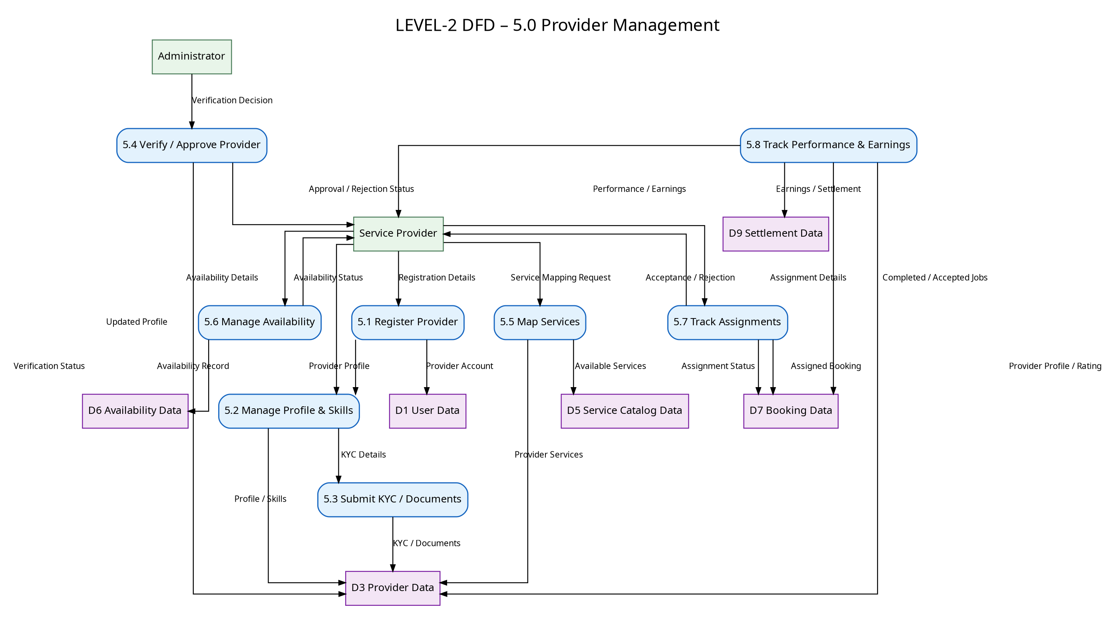
Figure 5. Decomposition of 5.0 Provider Management.

11.4 Level-2 DFD – Salon Management
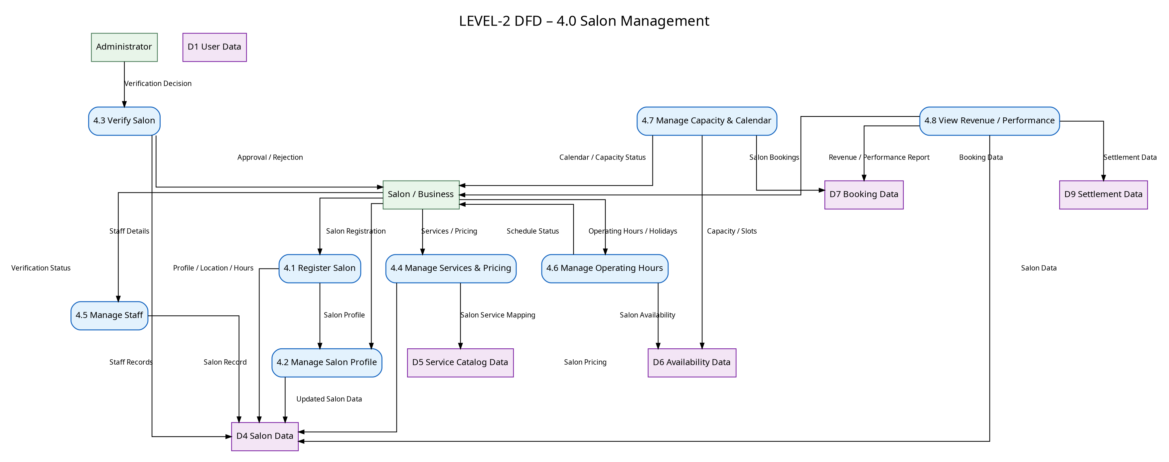
Figure 6. Decomposition of 4.0 Salon Management.

11.5 Level-2 DFD – Promotion, Coupon & Membership Management
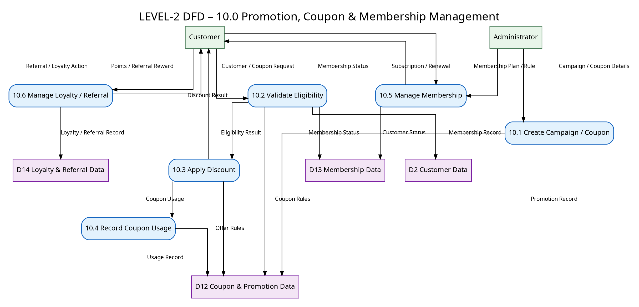
Figure 7. Decomposition of 10.0 Promotion, Coupon & Membership Management.

11.6 Level-2 DFD – Support & Dispute Management
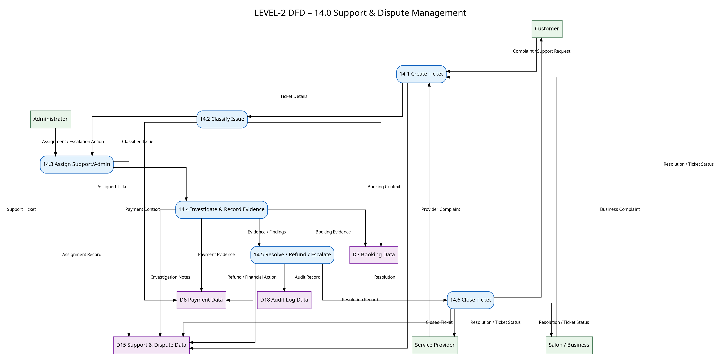
Figure 8. Decomposition of 14.0 Support & Dispute Management.

12. Level-3 DFD – Create Booking
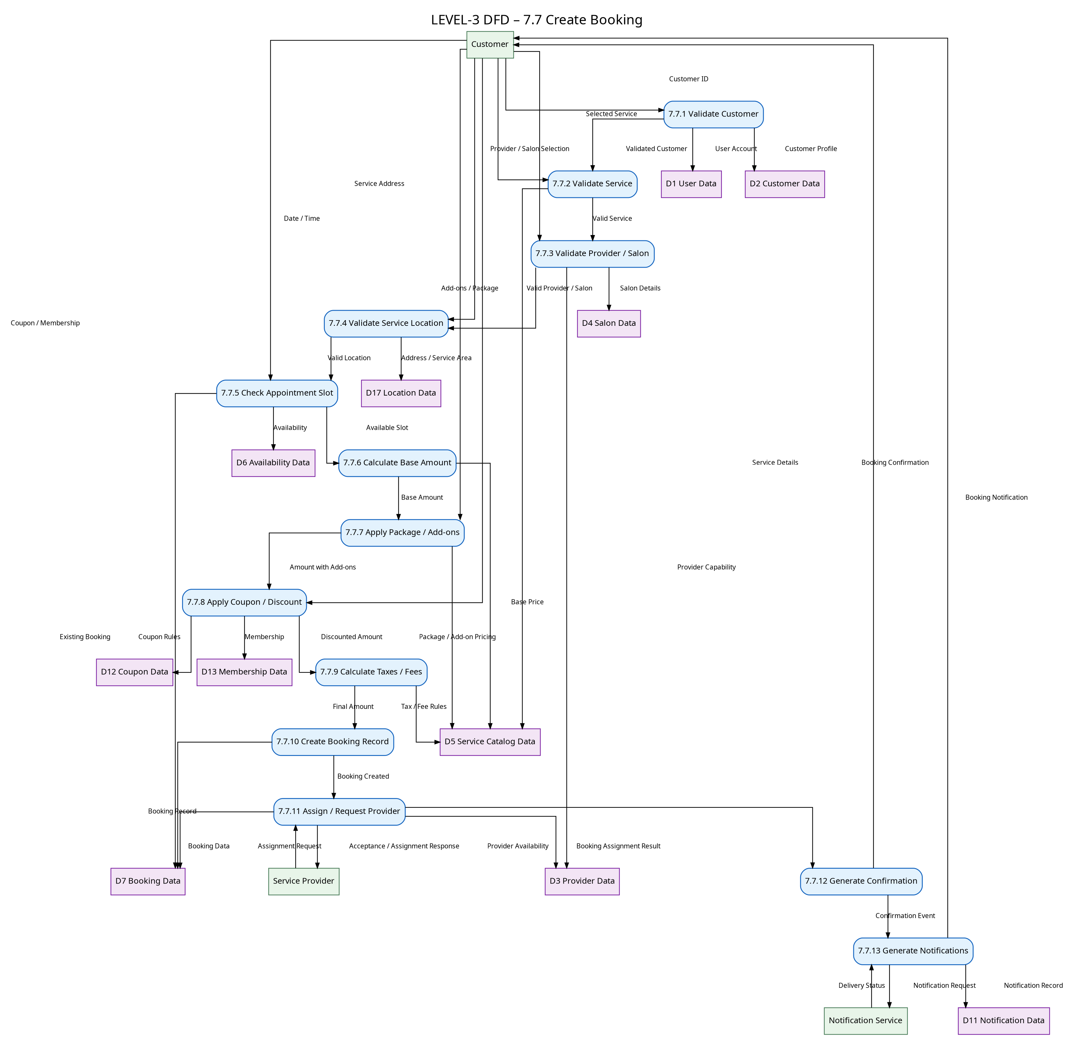
Figure 9. Level-3 decomposition of 7.7 Create Booking.

13. Data Dictionary
Name | Type | Description | Composition | Source | Destination | Format
User Data (D1) | Data Store | Stores identity, authentication status and role information. | {User ID, Name, Email/Mobile, Protected Credential Reference, Role, Status, Verification Status, Created Date} | 1.0, 17.0 | 1.0, 2.0, 16.0, 17.0 | Text / Number / Date
Customer Data (D2) | Data Store | Stores customer-specific profile, preferences and customer-management data. | {Customer ID, User ID, Preferences, Favourites, Booking Summary, Wallet Reference, Membership Reference, Loyalty Reference} | 2.0 | 2.0, 7.0, 10.0, 12.0, 14.0, 16.0 | Text / Number
Provider Data (D3) | Data Store | Stores provider profile, skills, verification, service mapping, status and earnings references. | {Provider ID, User ID, Skills, Experience, KYC Status, Service IDs, Service Radius, Status, Rating, Earnings Reference} | 5.0 | 5.0, 7.0, 8.0, 11.0, 12.0, 16.0 | Text / Number / Date
Salon Data (D4) | Data Store | Stores salon/business profile, location, services, staff, pricing, capacity and status. | {Salon ID, Owner User ID, Name, Address ID, Hours, Holidays, Service IDs, Staff IDs, Capacity, Verification Status, Status} | 4.0 | 4.0, 7.0, 8.0, 15.0, 16.0 | Text / Number / Date
Service Catalog Data (D5) | Data Store | Stores categories, subcategories, services, packages, add-ons, duration, price and requirements. | {Service ID, Category ID, Name, Description, Duration, Base Price, Requirements, Media Reference, Status, Package/Add-on References} | 3.0, 4.0 | 3.0, 4.0, 7.0, 8.0, 10.0, 16.0 | Text / Number / Date
Availability Data (D6) | Data Store | Stores provider/salon schedules, breaks, holidays, slots and capacity. | {Availability ID, Provider/Salon ID, Date, Start Time, End Time, Breaks, Capacity, Slot Status} | 6.0, 4.0, 5.0 | 6.0, 7.0, 8.0, 4.0, 5.0, 16.0 | Text / Date / Time / Number
Booking Data (D7) | Data Store | Stores appointment, assignment, status, pricing and booking history information. | {Booking ID, Customer ID, Service ID, Provider ID, Salon ID, Address ID, Appointment Date, Start Time, End Time, Base Amount, Discount, Tax, Fee, Total Amount, Payment Status, Booking Status, Cancellation Reason, Created Date, Updated Date} | 7.0, 8.0, 9.0, 11.0, 12.0, 14.0, 16.0 | 7.0, 8.0, 9.0, 11.0, 12.0, 14.0, 16.0 | Text / Number / Date / Time
Payment Data (D8) | Data Store | Stores payment, transaction and refund records. | {Payment ID, Booking ID, Customer ID, Amount, Method, Transaction ID, Payment Status, Refund Amount, Refund Status, Timestamp} | 9.0, 14.0 | 9.0, 14.0, 16.0 | Text / Number / Date
Financial / Settlement Data (D9) | Data Store | Stores commission, earnings, settlement and payout records. | {Settlement ID, Booking ID, Gross Amount, Commission, Net Amount, Provider/Salon ID, Payout Reference, Settlement Status, Settlement Date} | 9.0 | 9.0, 5.0, 4.0, 16.0 | Text / Number / Date
Review & Rating Data (D10) | Data Store | Stores ratings, written reviews, moderation status and responses. | {Review ID, Booking ID, Customer ID, Provider ID, Salon ID, Service ID, Rating, Comment, Status, Response, Created Date} | 12.0 | 12.0, 16.0 | Text / Number / Date
Notification Data (D11) | Data Store | Stores generated notifications and delivery status. | {Notification ID, User ID, Event Type, Message/Template Data, Channel, Related Reference, Delivery Status, Created Date} | 13.0 | 13.0, 16.0 | Text / Number / Date
Coupon & Promotion Data (D12) | Data Store | Stores campaigns, coupon rules, eligibility and usage. | {Promotion ID, Coupon Code, Scope, Discount Rule, Valid From, Valid To, Usage Limit, Eligibility Rule, Usage Count, Status} | 10.0 | 10.0, 7.0, 16.0 | Text / Number / Date
Membership Data (D13) | Data Store | Stores membership plans, subscriptions, benefits and lifecycle status. | {Membership ID, Plan ID, Customer ID, Start Date, End Date, Benefits, Payment Reference, Status} | 10.0 | 10.0, 2.0, 7.0, 16.0 | Text / Number / Date
Loyalty & Referral Data (D14) | Data Store | Stores loyalty points and referral transactions. | {Transaction ID, Customer ID, Type, Points, Source Reference, Referral Code, Reward, Expiry Date, Status} | 2.0, 10.0 | 2.0, 10.0, 7.0, 16.0 | Text / Number / Date
Support & Dispute Data (D15) | Data Store | Stores support tickets, complaints, disputes, evidence, assignments and resolutions. | {Ticket ID, Customer/Provider/Salon ID, Booking ID, Payment ID, Type, Priority, Status, Assigned To, Notes, Resolution, Escalation, Created Date} | 14.0 | 14.0, 16.0, 17.0 | Text / Number / Date
Inventory Data (D16) | Data Store | Stores salon/business inventory and stock movement records. | {Product ID, Salon ID, Category, Supplier, Quantity, Reorder Level, Movement Type, Quantity Changed, Reference, Timestamp} | 15.0 | 15.0, 16.0 | Text / Number / Date
Location / Address Data (D17) | Data Store | Stores service addresses and location/service-area references. | {Address ID, Owner ID, Label, Address Text, Latitude, Longitude, Service Area, Validation Status} | 2.0, 4.0, 6.0, 7.0 | 6.0, 7.0, 8.0, 16.0 | Text / Number
Audit Log Data (D18) | Data Store | Stores auditable security, administrative and sensitive-operation events. | {Audit ID, User ID, Role, Event Type, Target Entity, Target ID, Action, Result, Timestamp, Reference} | 17.0, 14.0, 9.0 | 17.0, 16.0 | Text / Number / Date
Report / Analytics Data (D19) | Data Store | Stores report metadata, generated report references and analytics snapshots where required. | {Report ID, Report Type, Date Range, Filters, Generated By, Summary Reference, Status, Created Date} | 16.0 | 16.0, 17.0 | Text / Number / Date

14. Data Flow Dictionary
Name | Type | Description | Composition | Source | Destination | Format
Registration Details | Data Flow | Details submitted to create an account. | {Name, Email/Mobile, Password Input, Address, Role, Consent} | Customer / Provider / Salon | 1.0 | Text / Number
Login Credentials | Data Flow | Credentials used for authentication. | {Email/Mobile, Credential Input, Verification Factor} | Customer / Provider / Salon / Admin | 1.0 | Text
Service Search Request | Data Flow | Request to discover services/providers/salons. | {Category, Service, Location, Date/Time, Filters} | Customer | 3.0 | Text / Date / Time
Service Details | Data Flow | Catalog information returned to a customer or management process. | {Service ID, Name, Description, Duration, Price, Status} | 3.0 / D5 | Customer / 7.0 / 8.0 | Text / Number
Provider Details | Data Flow | Provider profile/capability information. | {Provider ID, Skills, Services, Rating, Status, Service Radius} | 5.0 / D3 | Customer / 8.0 / 7.0 | Text / Number
Availability Details | Data Flow | Provider/salon availability and slots. | {Entity ID, Date, Start Time, End Time, Breaks, Capacity, Slot Status} | 6.0 / D6 | Customer / 7.0 / 8.0 | Text / Date / Time
Booking Request | Data Flow | Request to create an appointment. | {Customer ID, Service ID, Provider/Salon ID, Address ID, Date, Time, Add-ons, Offer References} | Customer | 7.0 | Text / Number / Date / Time
Booking Confirmation | Data Flow | Successful booking confirmation. | {Booking ID, Service, Provider/Salon, Date, Time, Amount, Status} | 7.0 | Customer / Provider / Salon | Text / Number / Date
Provider Assignment | Data Flow | Request/result for provider assignment. | {Booking ID, Provider ID, Assignment Status, Response, Timestamp} | 8.0 | Provider / 7.0 | Text / Number / Date
Payment Request | Data Flow | Request to authorize payment. | {Booking ID, Amount, Currency, Method, Payment Token/Reference} | 9.0 | Payment Gateway | Text / Number
Payment Response | Data Flow | Gateway result for payment/refund. | {Transaction ID, Status, Amount, Gateway Reference, Timestamp} | Payment Gateway | 9.0 | Text / Number / Date
Refund Request | Data Flow | Authorized refund instruction. | {Payment ID, Booking ID, Refund Amount, Reason} | 9.0 / 14.0 | Payment Gateway | Text / Number
Refund Status | Data Flow | Refund processing result. | {Refund ID, Payment ID, Amount, Status, Timestamp} | Payment Gateway / 9.0 | Customer / 14.0 | Text / Number / Date
Service Status Update | Data Flow | Provider-reported service lifecycle update. | {Booking ID, Provider ID, Status, Timestamp, Optional Location Confirmation} | Provider | 11.0 | Text / Number / Date
Review Submission | Data Flow | Customer review and rating. | {Booking ID, Rating, Comment, Target Entity} | Customer | 12.0 | Text / Number
Notification Information | Data Flow | Event information used to create notifications. | {Recipient, Event Type, Template Data, Channel Preference, Reference ID} | 1.0 / 7.0 / 9.0 / 11.0 / 12.0 / 14.0 / 10.0 | 13.0 | Text / Number
Notification Request | Data Flow | Message delivery request to an external notification service. | {Recipient, Channel, Message/Template, Reference} | 13.0 | Notification Service | Text
Support Ticket | Data Flow | Complaint/dispute/support request. | {Ticket Type, Requester, Booking/Payment Reference, Description, Evidence} | Customer / Provider / Salon | 14.0 | Text / Number
Settlement Details | Data Flow | Provider/salon settlement information. | {Settlement ID, Gross, Commission, Net, Payout Reference, Status} | 9.0 | Provider / Salon / Admin | Text / Number / Date
Report Request | Data Flow | Request to generate a report. | {Report Type, Date Range, Filters} | Administrator / authorized Salon / Provider | 16.0 | Text / Date
Report Details | Data Flow | Generated report or analytics result. | {Report ID, Summary, Detail Reference, Status, Date Range} | 16.0 | Requester | Text / Number / Date
Inventory Update | Data Flow | Stock movement or adjustment. | {Product ID, Movement Type, Quantity, Reference, Timestamp} | Salon / Business | 15.0 | Text / Number / Date
Location Request | Data Flow | Request for geocoding, distance or service-area check. | {Address/Coordinates, Provider Location, Service Radius, Operation} | 6.0 / 7.0 | Map / Location Service | Text / Number
Location Response | Data Flow | Validated location or distance/service-area result. | {Coordinates, Distance, Service Area Result, Validation Status} | Map / Location Service | 6.0 / 7.0 | Text / Number

15. Requirement-to-DFD Traceability Matrix
Requirement ID | Functional Requirement | Primary DFD Process | Primary Data Store(s)
4.1 | User Registration | 1.0 | D1
4.2 | Provider Registration | 5.0 | D1, D3
4.3 | Salon / Business Registration | 4.0 | D1, D4
4.4 | User Login and Logout | 1.0 | D1
4.5 | Password Management and Verification | 1.0 | D1, D18
4.6 | Profile and Address Management | 2.0 / 4.0 / 5.0 / 6.0 | D2, D4, D3, D17
4.7 | Role-Based Access and Permission Management | 1.0 / 17.0 | D1, D18
4.8 | Customer Management | 2.0 | D2, D13, D14
4.9 | Service Catalog Management | 3.0 | D5
4.10 | Service Package and Add-on Management | 3.0 / 10.0 | D5, D12
4.11 | Salon Management | 4.0 | D4, D5, D6
4.12 | Provider Management | 5.0 | D3, D6, D9
4.13 | Provider Assignment and Matching | 8.0 | D3, D4, D6, D7
4.14 | Availability and Scheduling Management | 6.0 | D6
4.15 | Service Browsing and Search | 3.0 | D5, D6, D17
4.16 | Service Booking | 7.0 | D2, D5, D6, D7, D12, D13, D14, D17
4.17 | Booking Rescheduling | 7.0 | D6, D7
4.18 | Booking Cancellation and No-Show Management | 7.0 / 9.0 | D7, D8, D18
4.19 | Service Execution and Status Management | 11.0 | D7
4.20 | Payment Management | 9.0 | D7, D8
4.21 | Refund and Partial Refund Management | 9.0 / 14.0 | D8, D15
4.22 | Wallet and Credit Management | 2.0 / 9.0 | D2, D8
4.23 | Commission, Earnings and Settlement Management | 9.0 | D9
4.24 | Coupon and Promotion Management | 10.0 | D12
4.25 | Membership and Subscription Management | 10.0 | D13
4.26 | Loyalty and Referral Management | 10.0 | D14
4.27 | Location and Geo-Service Management | 6.0 / 7.0 | D17
4.28 | Review, Rating and Feedback Management | 12.0 | D10
4.29 | Notification and Communication Management | 13.0 | D11
4.30 | Customer Support and Dispute Management | 14.0 | D15, D7, D8
4.31 | Inventory Management | 15.0 | D16
4.32 | Reporting and Analytics | 16.0 | D19
4.33 | Administration and Governance | 17.0 | D18 plus affected operational stores
4.34 | Security Event and Audit Management | 17.0 | D18

16. Consistency & Validation Notes
Check | Validation Result
Requirement coverage | All original twelve core requirements are retained and expanded; advanced modules are represented by additional functional requirements.
Actor consistency | Customer, Service Provider, Salon/Business and Administrator are distinct roles. Payment, Notification and Map/Location services are external entities.
DFD hierarchy | Level-0 represents the whole system; Level-1 decomposes the system; Level-2 diagrams decompose selected complex Level-1 processes; Level-3 decomposes 7.7 Create Booking.
Data-store consistency | D1–D19 are numbered once and reused consistently across the diagrams and Data Dictionary.
External-service treatment | Payment Gateway, Notification Service and Map/Location Service are external entities, not internal data stores.
Booking consistency | Booking states and related payment/refund/assignment actions are defined separately and linked through Booking Data.
Security consistency | Authentication/authorization and audit behavior are represented functionally; sensitive credentials are not represented as plaintext in the Data Dictionary.
Traceability | Each functional requirement is mapped to one or more DFD processes and data stores.
Implementation neutrality | The document does not prescribe a programming language, database engine or UI technology.
Readability | The diagrams are separated by level/process so complex flows do not need to be compressed into one unreadable image.
Baseline note: This specification systematically extends the previously prepared Functional Requirements document while preserving its original twelve requirement foundation and the academic structure requested for the project.
Diagram note: The generated diagrams are reference designs for recreation in StarUML. The final StarUML submission should preserve the same numbering, entities, stores and labelled flows.

