Debajyoti Banerjee (Cognizant)

Debajyoti.Banerjee@cognizant.com

Set up

This document gives the overview of how to set up the application in the local machine for the development.

Project manager

Project Manager Web App Local set-up guide

Contents

Introduction 2

Software Requirements and Technology details 2

Required Software 2

Technology Details 2

Setting up the application 2

Taking checkout 2

Folder Structure 3

Client Project 3

Server Project 3

Running the application 3

# Introduction

This document describes the setup of the application “**Project Manager**” in the local machine for development and debugging purpose.

# Software Requirements and Technology details

## Required Software

These are the list of the software installed in the system to debug/develop and run the application:

1. Spring Tool Suite
2. Visual Studio Code (preferable latest version)
3. MySQL
4. Google Chrome
5. Node JS v 8.12.0
6. GIT BASH and GIT UI (for connecting to the repository)

## Technology Details

These are the list of the technologies used in the application:

1. Angular 4 (UI)
2. HTML (UI)
3. CSS3 and BOOTSTRAP (UI)
4. Java, Spring Boot
5. Rest Service

# Setting up the application

## Taking checkout

1. Visit the URL <https://github.com/deb82banerjee/ProjectManager> where the code is checked in.
2. Click on the “**Clone or download**” button.
3. Once a small pop-up opens, click on the “**Download ZIP**” button.  
   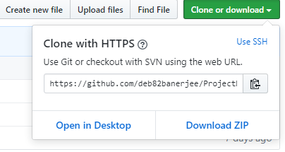
4. Open the downloaded file and extract the folder (**ProjectManager-master**) to some path on the system.

## Folder Structure

In the main folder **ProjectManager-master** there are two folders.

1. Client:   
   This folder contains the angular part of the code.
2. ProjectManager:   
   This folder contains the Spring Boot part of the code.

### Client

1. Go to the path **ProjectManager-master/client** where you can see the file ***angular.json***
2. Open command prompt
3. Copy the path from Step No. 1
4. Traverse to the path of Step 1 in the command prompt
5. Once you are in this path, run this command “npm install –g -f @angular/cli”
6. After this installation is done, run this command “npm install -f”
7. Let all the npm packages install in the project
8. Once the installation is done you will be able to see a folder “*node_modules*” in your system
9. Don’t close the command window yet

### Server

1. Import ProjectManager project in STS as maven project and build the project.
2. Right click on the project and select run as Spring Boot Application.
3. The application will keep on running on port 8081.

# Running the application

Once the build is succeeded:

1. Open the command prompt and run the command “npm start”
2. Once the node modules are built after the step 1, open Google Chrome and enter the URL “**localhost:4200**”