SPICE Simulation C2S0155

Here the signal CSB1_in and CSB2_in are given manually(in tb schematic) by giving the voltage source and outputs are as marked.CSB1_in output is CSB1_out and the CSB2_in output is CE_out.
Simulation period:200ns
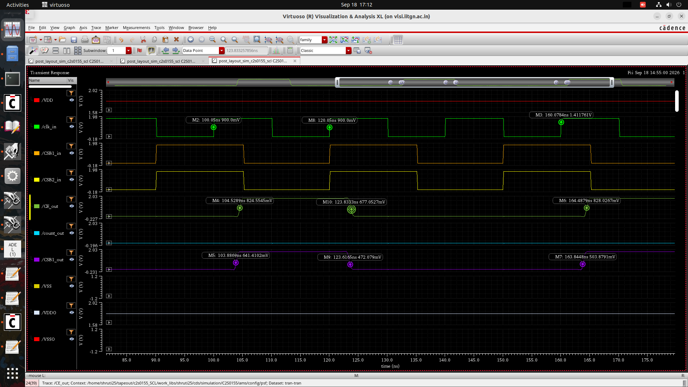

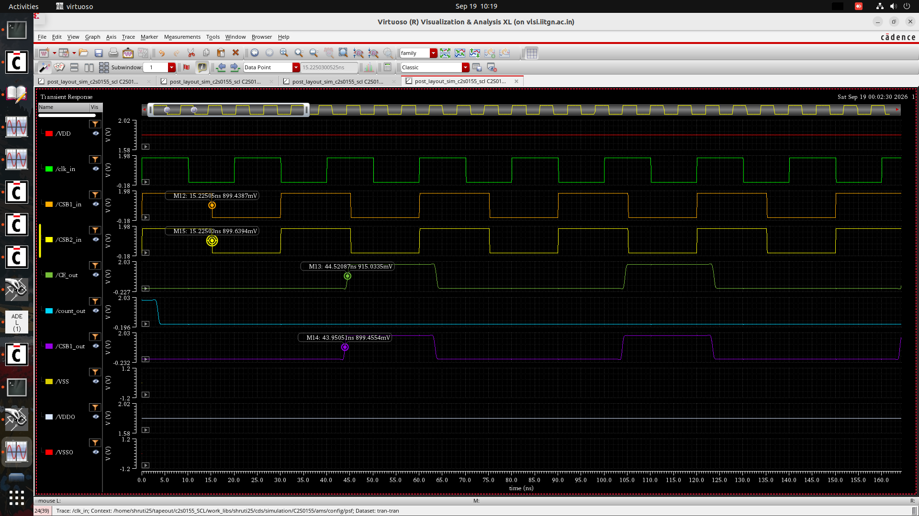

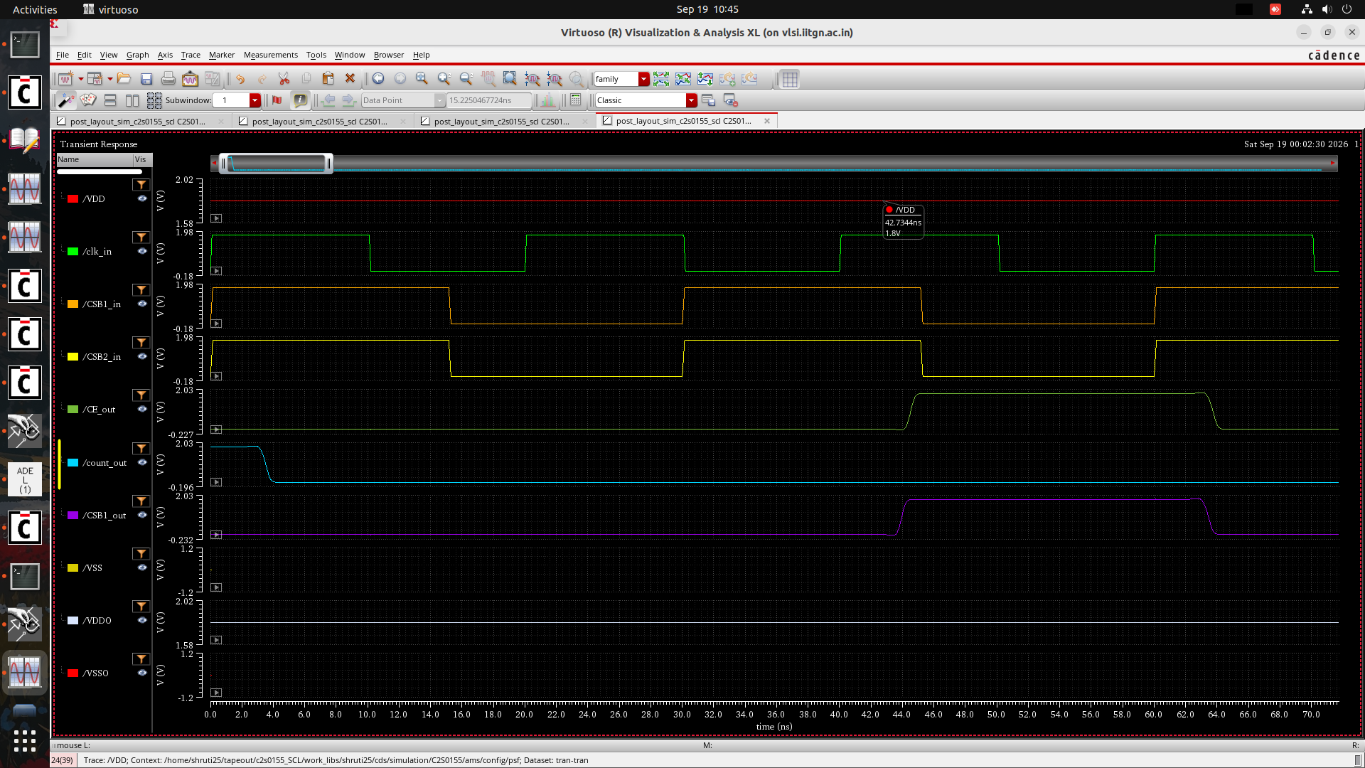

Results of simulation of SPRAM64x32:
Simulation period:800ns
At address 0, the data 1010 is being read from the SPRAM64x32.
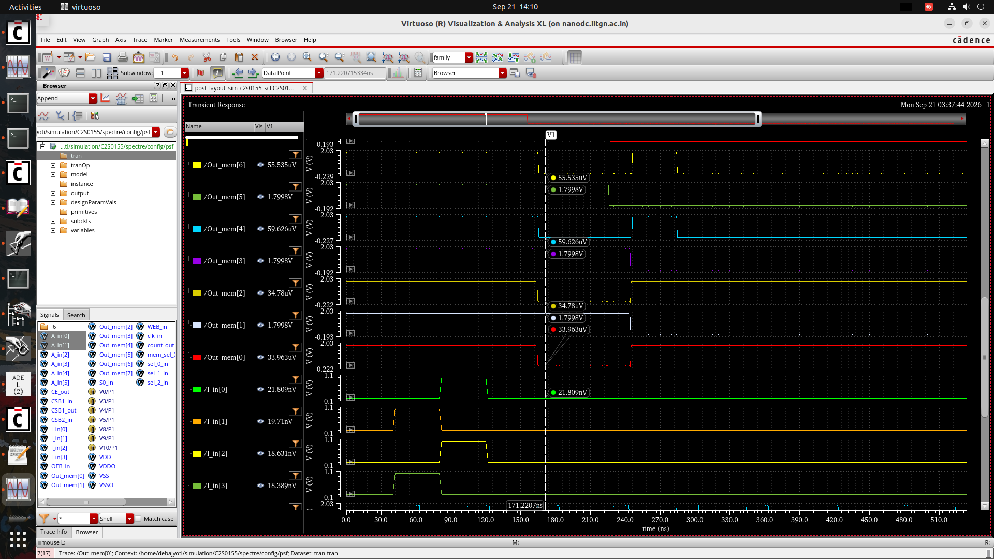

At A_in[0],Out_mem[7:4], the output data 1010 is generated.
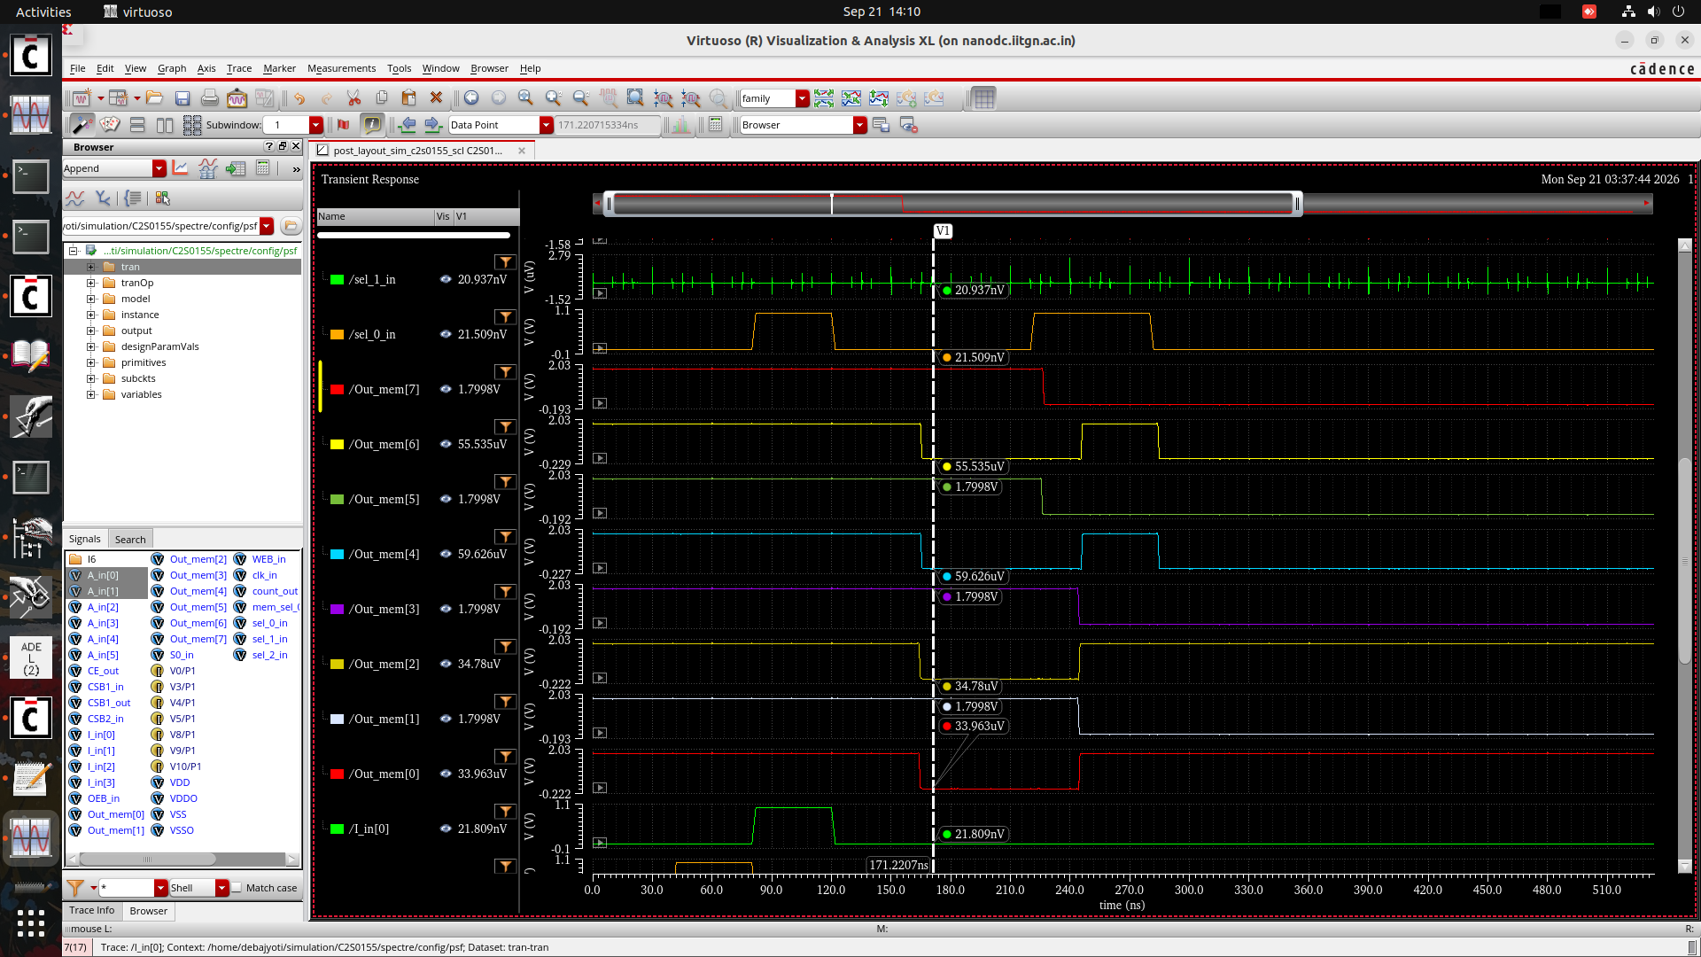

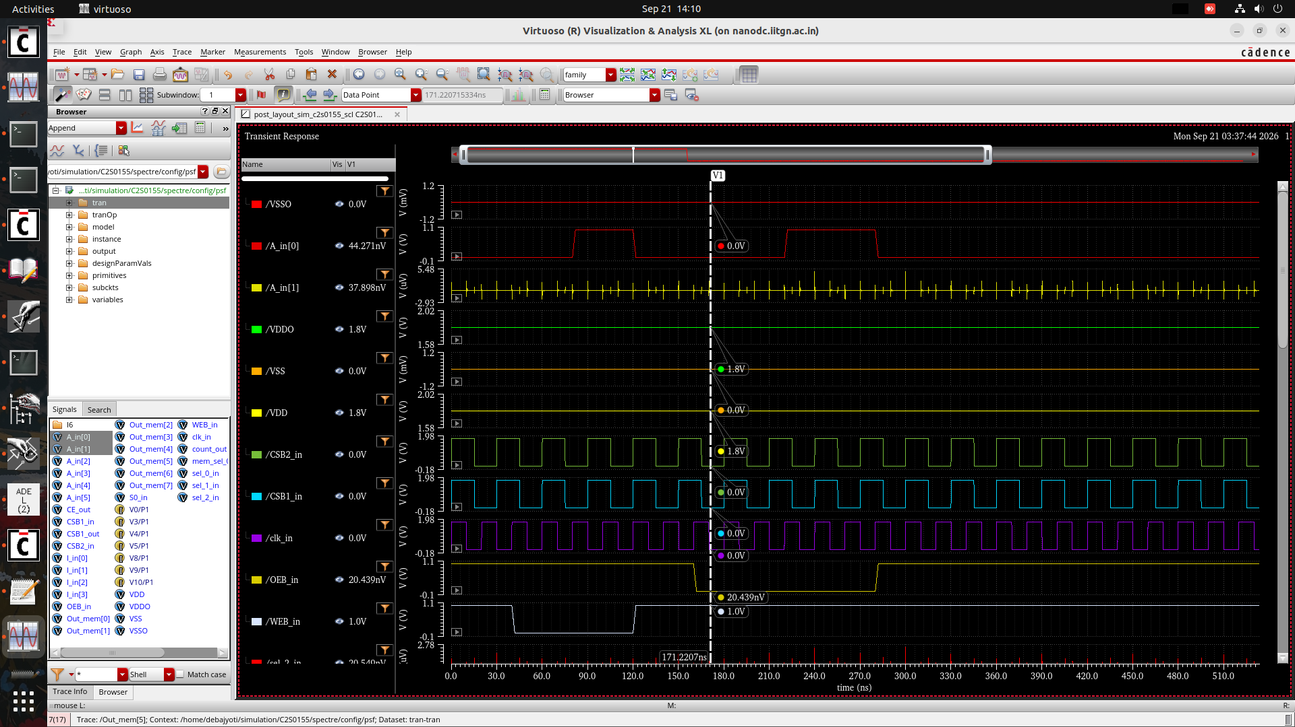

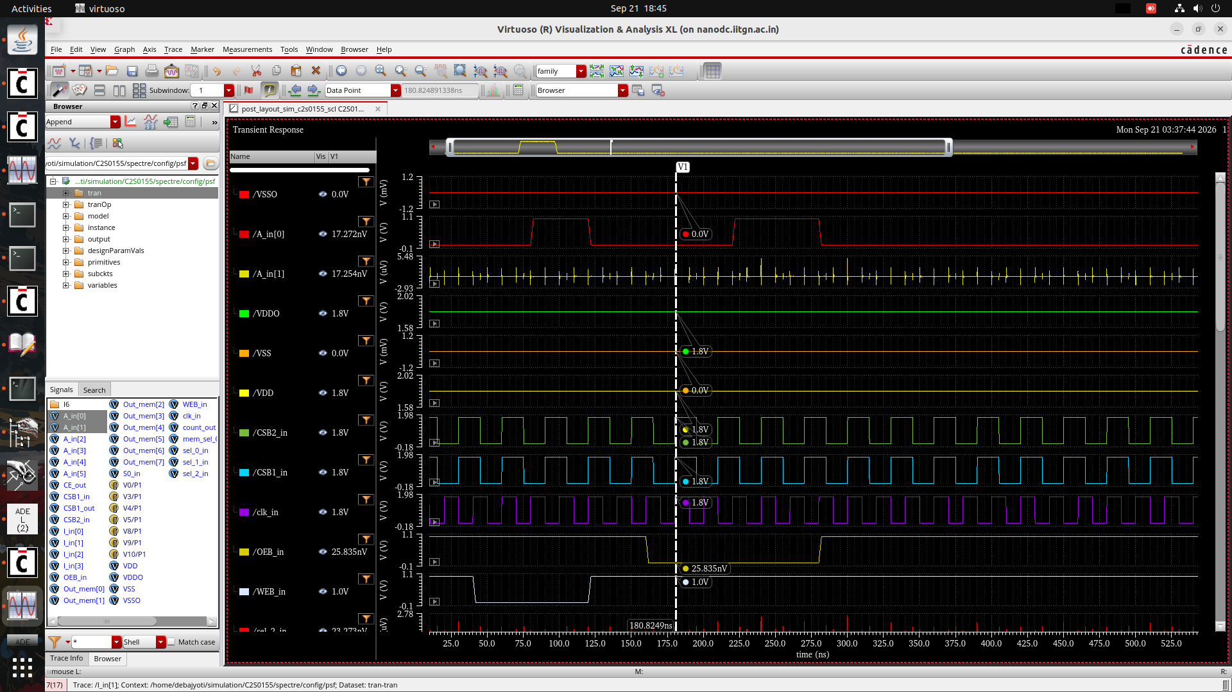

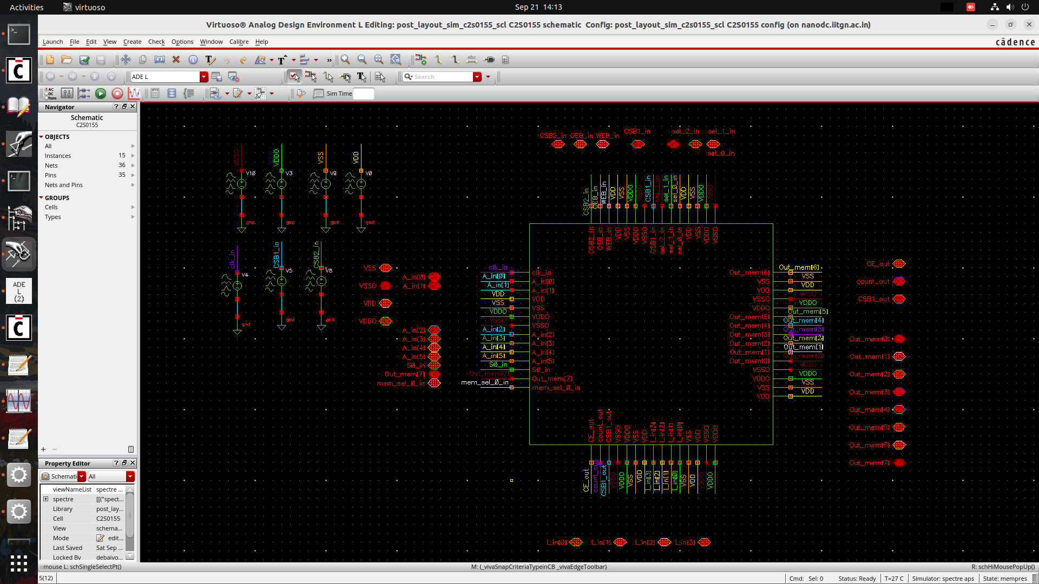
Fig:Test_bench schematic used for SPRAM64x32

Results of simulation of SPRAM_16x4:

Simulation Period:800ns
Voltage by mistake in vec file:1.0V so i/ps are 1.0V

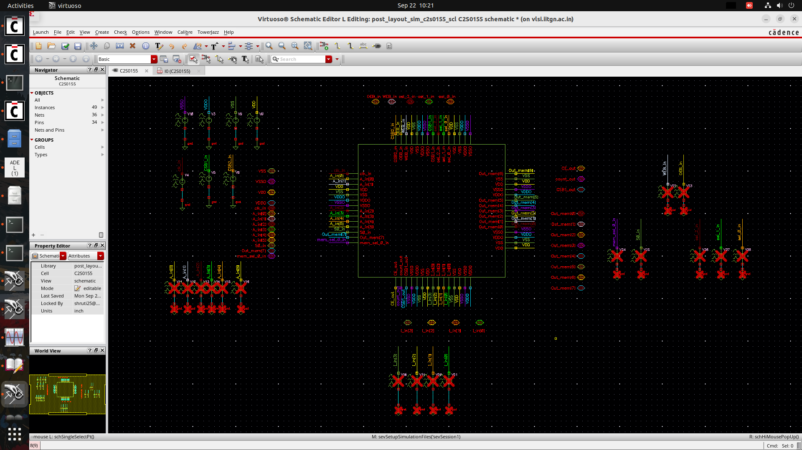
Fig:Test_bench schematic used for SPRAM16x4

Here in the below simulation:
For the write cycle
At address 0, 1010 is written where the WEB_in signal is active low and the OEB_in is now high(inactive).
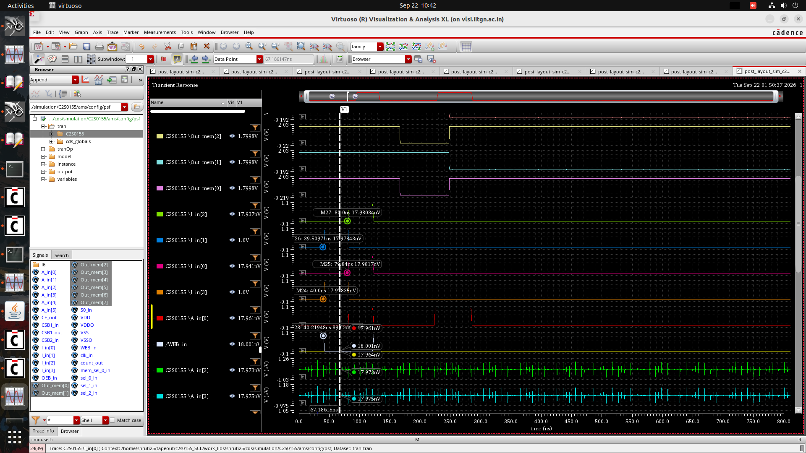
At address 1, 0101 is written where the WEB_in signal is active low and the OEB_in is now high(inactive).
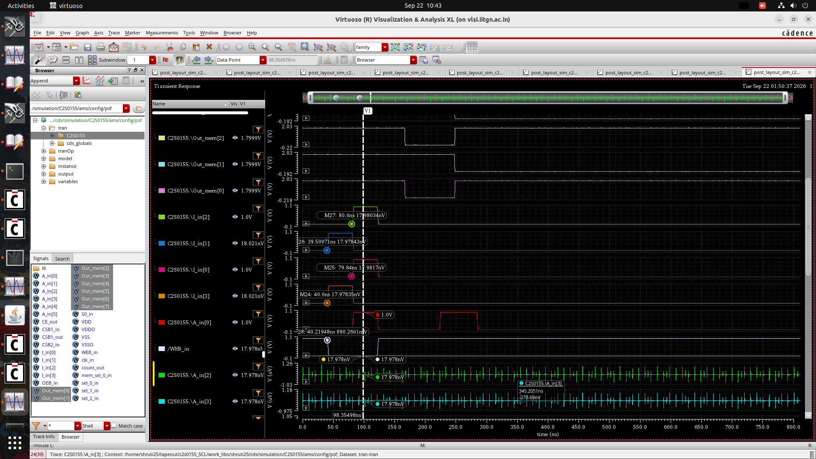

For the Read cycle:
Now, when WEB_in is high (inactive) and OEB_in is low (active), the data at address 0 (1010) is read,of SPRAM16x4.
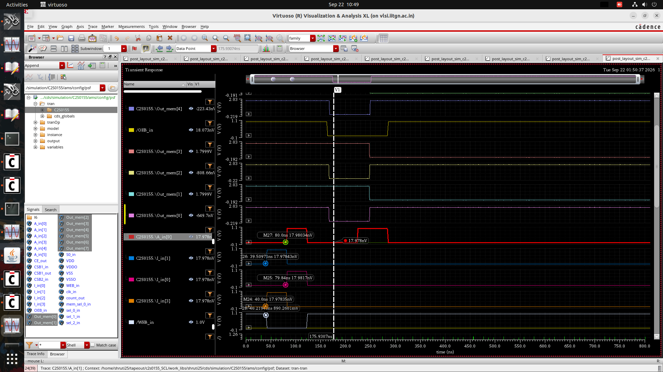

Now, when WEB_in is high (inactive) and OEB_in is low (active), the data at address 1 (0101) is read, of SPRAM16x4.
